
Encoding Guide
for Documentary Editions
Dániel Balogh & Arlo Griffiths

Version 2, 2026


This project has received funding from the European Research Council (ERC)
under the European Union’s Horizon 2020 research and innovation programme
(grant agreement No 809994).

Contents
1. Introduction 6
1.1. Version history 6
1.2. Acknowledgements 6
1.3. Scope 6
1.4. Further reading 7
1.5. Software 7
1.6. Note on the examples 7
1.7. Abbreviations 8
2. Theoretical framework 9
2.1. Terminology for the analysis of writing 9
2.2. Terminology for encoding 10
2.2.1. Markup 10
2.2.2. XML elements 10
2.2.3. Character entity references 12
2.2.4. XML hierarchy 12
2.2.5. Well-formedness and validity 13
2.3. The framework of an EpiDoc edition 13
2.3.1. Technical specifications 13
2.3.2. The TEI header 14
2.3.3. The body of the document 14
3. Intrinsic structure 16
3.1. Representing intrinsic structure 16
3.1.1. Numeration for reference 17
3.2. Encoding with block-level containers 17
3.2.1. Prose containers 17
3.2.2. Verse containers 18
3.2.3. Interrupted container boundaries 20
3.2.4. Container boundaries interrupting the text 22
3.2.5. Good encoding practice for block-level elements 26
3.3. Encoding metre in verse 27
3.3.1. Encoding an abstract prosodic template with @met 27
3.3.2. Encoding an actual prosodic realisation with @real 27
3.3.3. Metres not associated with a clear name 27
3.3.4. Metrical complications 29
4. Extrinsic structure 32
4.1. Representing extrinsic structure 32
4.1.1. Numeration for reference 35
4.2. Boxlike partitions 35
4.2.1. Encoding as textpart divisions 36
4.3. Encoding with milestones 38
4.3.1. Milestone units 38
4.3.2. Milestones interrupting the text 39
4.3.3. Good encoding practice for milestone elements 40
4.4. Pagelike partitions 42
4.4.2. Marking up genuine pages 43
4.4.3. Marking up other pagelike zones 44
4.4.4. Numbered elements in pagelike partitions 45
4.5. Physical lines 45
4.5.1. Marking up line beginnings 46
4.5.2. Numbering lines 47
4.6. Gridlike partitions 48
4.6.1. Marking up gridlike partitions 48
4.7. Dealing with the realities of extrinsic structure 49
4.7.1. Peripheral inscribed zones 49
4.7.2. Pagination or foliation: “forme work” 52
4.7.3. When to use textpart divisions 54
4.7.4. When to use pagelike partitions 56
4.7.5. When to use gridlike partitions 60
4.7.6. Untidy extrinsic structure 64
5. The received text 70
5.1. Phonographic graphemes 70
5.1.1. Tagging target graphemes as one akṣara 70
5.1.2. Tagging parts of phonographic glyphs 70
5.1.3. Unusual spatial arrangement in conjuncts 71
5.1.4. Complex glyphs deliberately split over an intervening feature 72
5.1.5. Phonographic glyphs in a different function 74
5.2. Numeral signs 74
5.2.1. Glyph encoding for numerals 74
5.2.2. Numeral signs and their context 75
5.2.3. Numeral glyphs in a non-numeral function 75
5.3. Peripheral graphemes 76
5.3.1. Representing peripheral graphemes in a digital edition 76
5.3.2. Classifying symbols by function 77
5.3.3. Transliterating peripheral graphemes 78
5.3.4. Glyph encoding for peripheral graphemes 78
5.3.5. Multiple peripheral graphemes 82
5.3.6. Peripheral graphemes and their context 82
5.4. Space left blank in the original 83
5.4.1. Space for semantic segmentation 83
5.4.2. Other kinds of space 85
5.4.3. The size of spaces 87
5.4.4. Spaces and their context 87
5.5. Premodern scribal intervention 88
5.5.1. Scribal deletion 88
5.5.2. Scribal addition 89
5.5.3. Scribal correction 91
5.5.4. Good practice in encoding scribal intervention 92
6. Legibility issues 94
6.1. Representing legibility issues in TEI/EpiDoc 94
6.2. Damage not impeding legibility 95
6.3. Unclear readings 95
6.3.1. Encoding unclear text 95
6.3.2. Encoding ambivalent text 97
6.3.3. Good practice in encoding unclear readings 98
6.4. Editorial restoration 99
6.4.1. The reason for a restoration 99
6.4.2. Tentative restoration 100
6.4.3. The basis of restoration 100
6.5. Lacunae 100
6.5.1. Encoding lacunae 100
6.5.2. Managing inline lacunae 102
6.5.3. Managing line-level lacunae 106
6.5.4. Managing massive lacunae 107
6.5.5. Managing incomplete copperplate sets 112
7. Editorial intervention 115
7.1. Distinguishing correction from normalisation 115
7.1.1. Erroneous readings 115
7.1.2. Non-standard readings 115
7.2. Encoding editorial intervention 116
7.2.1. Encoding tools for anomalous readings 116
7.3. Ignoring anomalous readings 117
7.4. Flagging anomalous readings 118
7.4.1. Flagging erroneous and uninterpretable readings 118
7.4.2. Flagging non-standard readings 118
7.5. Rectifying anomalous readings 119
7.5.1. Substitution 120
7.5.2. Suppression: editorial deletion of superfluous text 121
7.5.3. Restitution: editorial addition of omitted text 121
7.6. Encoding scribal omission without editorial restoration 122
7.7. Good practice in editorial intervention 122
7.7.1. Manipulating graphemes 122
7.7.2. The scope of editorial intervention 124
7.7.3. The precision of editorial intervention 125
7.7.4. Editorial intervention in metrical verse 126
7.7.5. Nesting correction and normalisation 128
7.8. Editorial curation 129
7.8.1. Editorial spacing 129
7.8.2. Editorial hyphenation 130
7.8.3. Supplied punctuation 130
7.8.4. Supplied avagraha 132
7.8.5. Distinction of short and long e/o in Dravidian languages 132
7.8.6. Shortened vowels in Sanskrit loanwords 133
7.9. Highlighting for review 133
8. Language, script and visual characteristics 134
8.1. Source language 134
8.1.1. The language of the edition 134
8.1.2. Multilingual inscriptions 134
8.2. Script 135
8.2.1. Encoding source script with @rendition 135
8.2.2. The script of the edition 136
8.2.3. Multiscript inscriptions 136
8.3. Scribal hands 137
8.4. Lettering 138
8.5. Line layout 138
8.5.1. Alignment 138
8.5.2. Directionality and orientation 140
9. Interpretive and analytical markup 141
9.1. Numbers 141
9.1.1. Encoding numbers 141
9.1.2. When and how to encode numbers 141
9.1.3. Difficulties in reading numbers 143
9.1.4. Editorial intervention and numerals 144
9.2. Abbreviations 144
9.2.1. Tagging abbreviations 144
9.2.2. Expanding abbreviations 144
10. The critical apparatus 146
10.1. Encoding the critical apparatus 146
10.1.1. Textpart divisions in the apparatus 147
10.2. Indicating location in apparatus entries 148
10.3. Lemmas 149
10.3.1. The extent of lemmas 149
10.3.2. The content of lemmas 149
10.3.3. The source of lemmas 150
10.4. Alternative readings, restorations and emendations 150
10.4.1. The extent of alternative readings 150
10.4.2. The content of alternative readings 150
10.4.3. The source of alternative readings 151
10.5. Identical lemmas, identical readings 151
10.6. XML markup within lemmas and readings 152
10.7. Freeform apparatus notes 153
11. The translation 154
11.1. Encoding the translation 154
11.1.1. Textpart divisions in the translation 154
11.1.2. Crediting the author of the translation 155
11.1.3. Attaching multiple translations 155
11.2. Structuring the translation 156
11.2.1. Reflecting extrinsic structure in the translation 156
11.2.2. Reflecting intrinsic structure in the translation 156
11.2.3. Headings in translations 157
11.3. Indicating correspondence to the source 157
11.3.1. Referring to lines and stanzas of the source 158
11.4. Markup within translations 158
11.4.1. Globally available markup 158
11.4.2. Supplied text in the translation 159
11.4.3. Gaps in the translation 160
11.4.4. Tentative translation 161
11.4.5. Incorrect or unexpected text 162
11.4.6. Bitextual translation 162
11.4.7. Original space in the translation 162
11.5. Reproducing a published translation 162
11.5.1. Adapting a previous translation 162
11.5.2. Adopting a previous translation verbatim 162
11.5.3. Adopting and adapting notes to a translation 163
12. The commentary 164
12.1. Encoding the commentary 164
12.1.1. Textpart divisions within the commentary 164
12.2. Indicating reference to the text 164
12.3. Markup within the commentary 165
13. The bibliography 166
13.1. Encoding the bibliography 166
13.2. The epigraphic lemma 166
13.2.1. Markup within the epigraphic lemma 167
13.3. The structured bibliography 167
13.3.1. The primary bibliography 168
13.3.2. The secondary bibliography 168
13.3.3. Bibliographic sigla 168
14. Globally available markup outside the edition 170
14.1. Using editorial markup outside the edition 170
14.2. Character formatting 170
14.2.1. Emphasis 171
14.2.2. Subscript and superscript 171
14.2.3. Grantha script 171
14.2.4. Highlighting for review 171
14.3. Block-level containers outside the edition 171
14.3.1. Paragraphs 171
14.3.2. Verse containers 172
14.3.3. Block quotes 172
14.3.4. Lists 172
14.4. Languages 174
14.4.1. Encoding language 174
14.4.2. Tagging foreign languages outside the edition 175
14.5. Notes 176
14.5.1. Encoding notes 176
14.5.2. The content of notes 177
14.6. Citation, quotation and reference 177
14.6.1. Encoding bibliographic citations 177
14.6.2. Crediting publications with @source 182
14.6.3. Quotation 182
14.6.4. Referring to web resources 183
14.6.5. Crediting a DHARMA contributor with @resp 184
14.6.6. Identifying elements with @xml:id 184
14.7. Analytical and interpretive markup 184
14.7.1. Encoding titles 185
14.7.2. Encoding names 185
14.7.3. Other interpretive and analytical encoding 186
15. The TEI Header 187
15.1. Describing the XML document 187
15.1.1. The title 187
15.1.2. The responsibility statement(s) 187
15.1.3. The publication statement 189
15.2. Describing the original document 189
15.2.1. The hand description 189
15.3. Keeping track of file history 190
16. Good encoding practice 192
16.1. White space 192
16.2. Top to bottom hierarchy 193
16.2.1. Tier 1, block-level elements representing XML structure and extrinsic structure 193
16.2.2. Tier 2, block-level elements representing intrinsic structure 193
16.2.3. Tier 2A, phrase-level elements representing semantic information 193
16.2.4. Tier 3, empty elements representing extrinsic structure 194
16.2.5. Tier 4, empty elements representing local features 194
16.2.6. Tier 5, phrase-level elements representing changes to the text 194
16.2.7. Tier 6, unclear 195
16.3. Graphemes and the granularity of encoding 195
16.3.1. Grapholinguistic recap 195
16.3.2. Encoding Indic documents in Romanised transliteration 196
Appendix A. Case Studies in encoding complex layout 199
Appendix A.1. Slab in two non-contiguous fragments 199
Appendix A.2. Copperplate charter with seal and other goodies 200
Appendix A.3. Copperplate charter with a lost plate reconstructed 202
Appendix A.4. Copperplate charter with a lost plate not reconstructed 203
Appendix A.5. Four-faced stele 204
Appendix A.6. Stele with two inscribed faces, an incipit and quasi-columns 205
Appendix B. Titling conventions 208
Appendix C. Creating DHARMA editions from other editions 210
Appendix C.1. Converting CII/EI markup conventions to EpiDoc 210
Appendix C.2. Assimilating Pre-existing Corpora into DHARMA 211
Appendix C.2.1. Crediting the previous digital editor(s) 211
Appendix C.2.2. Referring to the ingested digital edition 211
Appendix C.2.3. Manual revision of the encoding 212
References 213

Introduction

Version history
Version | Authors | Changes | Date
0.1 | Balogh | Redaction of the first draft | 2019-07
0.8 | Balogh, Griffiths, with Janiak & Francis | Expansion and revision for release | to 2019-12
0.9 | Balogh, Griffiths | Redaction for release | to 2020-03-17
1.0 | Balogh, Griffiths | Revision after feedback and discussion | 2020-07-05
(no release) | Balogh | ongoing revision of online copy | to 2024-07
2.0 | Balogh, with Griffiths, Francis & Meyer | major overhaul and finalisation | 2026-09
This is the final and definitive public release version of the DHARMA Encoding Guide for Documentary Editions, which supersedes the first release version (Balogh and Griffiths 2020b, then called Encoding Guide for Diplomatic Editions).
Practical experience since the first release has shown that project members primarily consult the online soft copy of the Guide. This was useful because ongoing revisions have been discussed and introduced in that copy. With the release of this final version, no further revision is planned, so the online copy shall serve only for quick access. Moreover, the online copy’s layout is sub-par and its cross-references may be occasionally incorrect, so only this archived release can be considered definitive. When citing the Guide in a publication, please refer only to the release version.
No detailed changelog is included here, because this version incorporates all changes accumulated over the years since the last public release.

Acknowledgements
Many people in addition to the authors noted above have helped in the creation of this guide; the most significant contributors have been Axelle Janiak, Emmanuel Francis, Michaël Meyer and Annette Schmiedchen.

Scope
This Guide is for the EpiDoc compliant encoding of original sources for the DHARMA project. The Guide has been composed primarily with epigraphic texts in mind, but is also applicable to the encoding of texts transmitted as manuscripts, when these are edited “as documents” (rather than “as works” in the form of a critical edition). We also hope that the solutions recommended here gain currency beyond the scope of the DHARMA project. All encoders are strongly encouraged at least to skim it from cover to cover, to obtain a general idea of the topics covered in it. This guide presupposes that you are already familiar with version 4 of the DHARMA Transliteration Guide, released together with the present guide.

Further reading
This Guide is a constrained and detailed adaptation of the EpiDoc guidelines, which are themselves a constrained and detailed adaptation of the TEI guidelines. A good general introduction to EpiDoc can be found in Bodard 2010. If you are entirely new to XML or the idea of computer markup, we recommend Roueché and Flanders (n. d.) and Birnbaum (2015) for an introduction.

Software
The XML editor recommended throughout the project is Oxygen, but you are free to use any editor to produce your marked-up texts. Visual Studio Code is in particular recommended as a powerful free alternative to Oxygen. Editing software will usually be able to colour-code XML and may also be able to check the well-formedness of the markup or even to validate against a schema.
Working in Oxygen, you will need to set a suitable font for the Editor.
- the setting is found at Options/Preferences/Appearance/Fonts
- what makes a font suitable?
  - it can correctly display all the diacritical characters you work with
  - it is easy on the eye
  - it is preferably one in which the characters | (vertical bar), l (lowercase L) and I (uppercase i) are all easily distinguishable
  - it is preferably not too wide, so that you can see plenty of text even when not working on a full screen
- some fonts we have tested and liked include:
  - Google’s free Noto Serif and Noto Sans
  - Microsoft’s Cambria and Consolas
- note that fonts continue to develop
  - if a font is attractive but causes display problems, check whether you have the latest version and if not, replace your version with that to see if the problems go away
Further instructions for XML editing software in the project:
- for using Oxygen with the DHARMA XML schema: https://github.com/erc-dharma/project-documentation/blob/66167c20f4be621256460be1640cb7a727104854/schema/README.md
- for setting up Oxygen to create human-readable HTML from an XML edition: https://github.com/erc-dharma/project-documentation/blob/master/stylesheets/README.md
- for using Visual Studio Code: https://erc-dharma.github.io/project-documentation/visual-code/UsingVS_v01

Note on the examples
We use generic English text to illustrate layout and other details where the meaning of the text is not relevant. The text excerpts used for other examples are mostly Sanskrit from India. Many of the illustrations have been drawn from actual inscriptions, but to eliminate distractions, details irrelevant to the topic at hand are often silently normalised, restored, corrected or altered in such illustrations.
XML <elements> mentioned in discussion or used in illustrations are set apart from regular text by typeface, text colour and a shaded background. XML @attributes, when mentioned on their own, are prefixed with an @ sign and highlighted with text colour and background shading. To eliminate distractions, encoding details irrelevant to the topic at hand (such as end-tags, attributes and text content) are often omitted in illustrations even though they may be mandatory in actual practice.

Abbreviations
In addition to some straightforward abbreviations, this Guide uses the following acronyms to refer to other DHARMA guides, always in the version concurrent with this release.
EGC the DHARMA Encoding Guide for Critical Editions
EGD the DHARMA Encoding Guide for Documentary Editions (the present document)
TG the DHARMA Transliteration Guide
VG the DHARMA Versification Guide
ZG the DHARMA Zotero Guide

Theoretical framework
Familiarity with terminology pertaining to epigraphy and textual studies is generally taken for granted, but some definitions and explanations are given in the body of the Guide when deemed necessary. Terms and concepts relevant to versification are defined in VG §1.2.

Terminology for the analysis of writing
The grapholinguistic terms used in this section are defined more fully in TG §1.6 and elaborated in TG §2; the present document’s §16.3 summarises the implications of these definitions as regards work on Indic texts in Romanised transliteration.
- graphemes are a finite set of signs belonging to a writing system, comprised of a signifier that is a graphic feature and a signified that is a minimal unit of abstract linguistic information pertinent to analytic interest
- graphs are an infinite set of graphic signs belonging to a script, which are the concrete graphic instantiations of graphemes, such as |A|, |A|, |अ|, |अ|
- graphotactics is (the study of) the ways in which graphemes and graphs combine into sequences
- allographs are graphs which instantiate the same grapheme
  - graphetic allographs are allographs which do not signify any linguistic information other than that contained in the grapheme, such as Devanagari |अ|, |अ| and |अ|
  - graphotactic allographs are allographs of which only one is permitted in a given graphotactic context (in a given sequence of graphemes), such as the graphs corresponding to the grapheme <r> in Devanagari |र्क|=|rka| and |क्र|=|kra|
  - graphemic allographs are allographs which potentially signify linguistic information in addition to, and at a different level than, that inherent in the grapheme, such as Devanagari |उ| | versus |ु|
- homographs are identical or nearly identical graphs which instantiate different graphemes
- a character is the minimal graphetically autonomous unit of a writing system, for example, <A>, <T>, <t·>, <ka> and <rtsnyai> are characters of the Indic writing system
- a glyph is the concrete manifestation of a character, for example, |अ|, |त्|, |क| and |र्त्स्न्यै| are glyphs of the Devanagari script
- the term akṣara can refer to either the characters or the glyphs of an aksharic writing system
- a component is a visually discernible graph in a complex glyph, such as the graphs |t| and |e| in |ते|
  - a marker is a graph which can only manifest as a component, and never as an independent glyph, such as the |e| in |ते|
- a (graphic) element is any salient part of a graph or glyph that is not itself a graph, i.e. which has no graphemic signification of its own
  - a stroke is a graphic element which can be written as a single stroke of the writing instrument
- core graphemes are those to which we dedicate a unique transliteration equivalent, and this identifies the grapheme precisely enough for our purposes
  - our core graphemes are the Indic writing system’s phonographic graphemes (including the inherent vowel and the virāma) and its numeral signs, along with a small number of miscellaneous graphemes such as the avagraha and the abbreviation mark
- peripheral graphemes, also called simply symbols, are those which we transliterate by means of a placeholder, which identifies the grapheme in a vague manner, while more precise identification may be added through encoding
  - our peripheral graphemes include the Indic writing system’s non-numeral ideograms, its marks other than the avagraha and the abbreviation mark, and its abstract symbols

Terminology for encoding
This section clarifies terms and concepts essential for encoding texts in XML.

Markup
- markup traditionally means annotation within a text to convey information about the presentation of the text, including among others
  - markings in a modern manuscript to instruct a typesetter, for instance underline to indicate conversion to italics
  - various brackets and other signs used in philology and epigraphy, for instance to indicate that certain parts of a text are tentatively read or supplied by the editor
  - machine-readable markup, i.e. encoding
- the TEI guidelines define encoding and markup as synonymous and applicable in a widely generalised sense to “any means of making explicit an interpretation of a text” and including typographic devices, punctuation marks and even spaces
- in the more circumscribed usage of this guide,
  - markup may refer to shorthand used in the transliteration (TG §3.3), to editorial signs used in a printed edition, or to XML encoding
  - encoding refers specifically to the method of encoding texts in XML
- conceptual markup (also called descriptive markup and semantic markup) essentially means tagging content for what it is, as opposed to other types of markup (which are only mentioned here for contrast, but which you need not worry about), namely
  - presentational markup, which tags content for what it should look like, as in simple WYSIWYG word processing where you can apply bold, italic, font choice, colour, etc. to bits of text
  - procedural markup, which tags content for what an algorithm should do with it, as for instance in TeX (as opposed to LaTeX, which mostly uses conceptual markup)
- conceptual markup allows a separation of concerns: instructions for what a processing algorithm should do to items tagged in a particular way, as well as instructions for how these items should be rendered on screen or in print, are kept separate from the actual text
- a markup language is a coherent set of markup conventions
- XML (eXtensible Markup Language) is a machine-readable markup language used for a wide variety of purposes and independent of hardware or software platform
- the TEI (Text Encoding Initiative) is a standard for the machine-readable encoding of texts (understood in a very broad sense) to facilitate text documentation, text representation, text analysis and interpretation
  - TEI has been developed and is maintained by the eponymous Text Encoding Initiative Consortium
  - TEI defines a versatile and massive set of XML conventions for marking up texts
- EpiDoc is a subset of TEI-compliant markup rules specifically devised for marking up epigraphic documents

XML elements
- the structural units of XML are known as elements
- within an XML document, elements take the form of tags: words of code distinguished from the textual content by being always wrapped in angle brackets <>
- an XML element may be either
  - empty, containing neither text nor further elements
    - taking the form of a single tag ending with a slash to show that the element ends with the tag
      - e.g. <lb/>
  - or non-empty, containing any mixture of text and/or further (empty or non-empty) XML elements
    - taking the form of a pair of tags
      - a start-tag which identifies the element, e.g. <unclear>
      - and an end-tag which includes the slash and repeats the element name, e.g. </unclear>
  - optionally, empty elements can also be represented by a pair of tags with nothing in between
    - e.g. <lb></lb>
- for our purposes, non-empty elements are distinguished into two basic types:
  - block-level elements or chunks, which, together, must contain all text within an edition
    - these serve in TEI to encode the intrinsic structure of a text (§3)
  - phrase-level elements, which must be entirely contained within a block-level element
    - these serve to mark up local features of the text, for example uncertain readings, editorial alterations, segments in a different script and numerals
- XML element names are case-sensitive: e.g. <unclear> cannot be substituted with <Unclear> or <UNCLEAR>
- XML elements can have attributes, whose function is to record additional information about an element
    - attributes have a name and a value, which are incorporated into the tag for an empty element, or into the start-tag of a non-empty element, e.g.
      - <space quantity="3" unit="character"/>
      - <unclear cert="low">...</unclear>
    - one element may have any number of attributes
    - attributes must be separated by spaces from each other and from the element name
    - attributes may appear in any order within an element
      - e.g. <space unit="character" quantity="3"/> is entirely identical in meaning to the above example with the same attributes in an inverted order
    - the attribute name is followed by an equals sign and the value in double quote marks
      - note that these must be plain typewriter-style quote marks (i.e. " "), not printer’s quote marks (“ ”)
    - attributes always qualify only the element to which they belong and have no influence on any other elements such as neighbouring ones or elements of the same type elsewhere in the XML structure
      - however, attributes may be inherited by elements further down in the hierarchy, so that if an attribute is used in an element that contains further elements to which that attribute can apply, then the attribute and value encoded in the ancestor element will also pertain to the descendant elements
    - when attributes are discussed in human-readable text without being cited as full XML tags, they are conventionally prefixed with an @ (“at”, implying “attribute”) sign; thus, in the above examples
      - the element <space> has the attributes @quantity and @unit, while the element <unclear> has the attribute @cert
- in addition to text and elements proper, XML documents may contain some other items, of which one is relevant to us:
  - an XML comment is anything that is not considered to be part of the document and will be ignored by computers processing an XML file
    - an XML comment must begin with the characters <!-- and end with the characters -->
    - comments may be added by editors as notes to other team members to explain their choice of code or to discuss problems in the edition, e.g. <!--I'm not sure how to mark this up-->
    - comments may also be used to “switch off” parts of an XML document without deleting them: any XML code placed within the comment opening and closing sequence will become invisible to computer processing

Character entity references
In addition to elements and text, XML documents may contain a few other items which need not concern you generally, except for one item type that you should be aware of: XML allows the use of character entity references. These are short code words preceded by an & (ampersand) and followed by a ; (semicolon). The purpose of character entity references is to allow the typing, display and processing of characters which are either not supported on certain platforms (such as accented characters, but this case need not bother you) or reserved for a special function in XML (which is what matters to us). As a consequence,
- should you need to use the < character (which an XML processing engine would interpret as the beginning of an XML tag), you must instead use the entity reference &lt; (where “lt” stands for “less than”)
- should you need to use the & character (which an XML processing engine would interpret as the beginning of an entity reference), you must instead use the entity reference &amp; (where “amp” stands for “ampersand”)
- in Oxygen, whenever you enter an &, the software will automatically suggest a list of pre-defined entity references (starting with &amp;) so all you need do is select and accept the suggestion for the character you need
- if during validation you encounter unexpected errors, consider if you may have used the characters &, < or > inadvertently, for example because you have copy-pasted text from a word processor

XML hierarchy
- the structure of an XML document hierarchical, consisting of “boxes within boxes within boxes” or more accurately an ordered hierarchy of content objects
- every XML document must be wrapped in a root element which serves as a container for the document as a whole
  - all other elements (except for some instructions at the beginning of the document) are nested either directly within the root element, or at a lower level of the hierarchy
- if an element is embedded directly within another element, then the former is referred to as a child of the latter, and the latter as the parent of the former
- if an element is embedded at any depth within another element, then the former is a descendant of the latter, and the latter is the ancestor of the former
Exhibit 2.2.A:
XML hierarchy
<A>
<B>
<C></C>
<D></D>
</B>
<E>
<F></F>
</E>
</A>
  - thus, in Exhibit 2.2.A,
    - B and E are children of A (the root element)
    - C and D are children of B
    - F is the child of E
    - B, C, D, E and F are all descendants of A
- such a conceptual model is well suited for representing the structure of texts as works (e.g. text in paragraphs in chapters in books)
- however, it faces a problem when it is desirable to encode additional structures within the same text, such as the extrinsic structure of a text as document (e.g. text in lines on pages in sheaves)
  - such situations are referred to as overlapping hierarchies: although both are ordered hierarchies, the structures overlap (for instance, a stanza or paragraph may begin in one inscribed line and end in the next)
    - other overlapping hierarchies relevant to textual studies include
      - syntactical structure
      - semantically distinguished segments (such as names or colophons)
      - the location of spots of damage in a physical support
      - lemmas to which apparatus entries or commentarial notes may need to be anchored
- since XML elements must never overlap, the primary structure of an XML document can represent no more than one hierarchy relevant to the encoded text
  - in our EpiDoc editions, the primary hierarchy is that of the text’s intrinsic (as opposed to physical) structure
- any alternative hierarchies must be represented in XML using one of two basic methods:
  - by using dedicated empty elements (called milestones) as pointlike markers of transitions in the alternative hierarchy, instead of non-empty elements as containers for items of the hierarchy
    - thus in our editions, transition points in physical structure are marked with empty elements instead of treating lines and other extrinsic units as elements of the primary hierarchy
  - by deploying linking mechanisms to establish a connection between items located in disparate points of the primary hierarchy
    - in our editions this method is most prominently used in the critical apparatus, which is built using standoff markup, where the apparatus is located in a section of the XML document separate from the text edition
  - alternative hierarchies may also be disregarded in XML editions; thus
    - we do not, at the present stage, use any markup to represent the syntactical structure of a text
    - where physical features of the inscription, such as spots of damage which render the text unclear or illegible, overlap with the intrinsic structure, we use separate XML elements to mark up stretches of the same physical feature divided between two separate elements of the primary hierarchy (see §16.2), and do not use any linking to indicate that the two are in fact a single continuous spot of damage (though such linking would be possible)

Well-formedness and validity
- an XML document is said to be well-formed if it follows the above structural requirements, i.e.
    - the entire document is enclosed in a root element
    - there is no overlap between any elements
    - the start and end of each element is explicitly marked with a tag
- a well-formed XML document may use any arbitrary element names in any particular order and hierarchy: there is no universal and fixed list of possible XML element names and definitions (which is why this is an eXtensible Markup Language)
- the set of rules specifying how certain elements must or must not appear in structural relation to other elements is called an XML schema (thus, our editions follow the EpiDoc schema)
- an XML document is said to be valid if, in addition to being well-formed, it is structured in such a way as to meet the requirements of a particular schema

The framework of an EpiDoc edition
This section presents an overview of the constituent parts of a digital edition in EpiDoc. Code illustrations are based on the DHARMA Encoding Template for Inscriptions as released together with this edition of the EGD. Future versions of the template may contain slightly different code without affecting the general explanations provided here. You will not need to learn and produce this or similar code, only to find your way around it and add content without disrupting the code.

Technical specifications
- XML files begin with a declaration identifying the file as a particular kind of XML document
- this is followed by instructions associating the document with schemas for processing it
- the root element <TEI>, identifying the contents as a TEI-compliant document, wraps all of the remaining content of our files
- you should never edit these parts of the file
Exhibit 2.3.A: the technical instructions in an EpiDoc edition
<?xml version="1.0" encoding="UTF-8"?>
<?xml-model href="https://raw.githubusercontent.com/erc-dharma/project-documentation/master/schema/latest/DHARMA_Schema.rng" type="application/xml" schematypens="http://relaxng.org/ns/structure/1.0"?>
<?xml-model href="https://raw.githubusercontent.com/erc-dharma/project-documentation/master/schema/latest/DHARMA_Schema.rng" type="application/xml" schematypens="http://purl.oclc.org/dsdl/schematron"?>
<?xml-model href="https://raw.githubusercontent.com/erc-dharma/project-documentation/master/schema/latest/DHARMA_SQF.sch" type="application/xml" schematypens="http://purl.oclc.org/dsdl/schematron"?>
<?xml-model href="https://epidoc.stoa.org/schema/latest/tei-epidoc.rng" schematypens="http://relaxng.org/ns/structure/1.0"?>
<?xml-model href="https://epidoc.stoa.org/schema/latest/tei-epidoc.rng" schematypens="http://purl.oclc.org/dsdl/schematron"?>
<TEI xmlns="http://www.tei-c.org/ns/1.0" xml:lang="eng">
...
</TEI>

The TEI header
- a header section identifying the digital document and containing additional descriptive information about the encoded text is a mandatory component of every TEI document
- the contents of the header are grouped into sections called statements and descriptions
- in several sections of the header, you will need to replace the default content from the template with specific content applicable to your edition
  - in some cases you will also need to add or modify elements in some sections of the header
- instructions for editing the TEI header are in §15
Exhibit 2.3.B: the TEI header
<teiHeader>
<fileDesc>
<titleStmt>
...
</titleStmt>
<publicationStmt>
...
</publicationStmt>
<sourceDesc>
...
</sourceDesc>
</fileDesc>
<encodingDesc>
...
</encodingDesc>
<revisionDesc>
...
</revisionDesc>
</teiHeader>

The body of the document
- the part of the XML file which contains a particular text is wrapped in the element <text>
- in TEI, the text container may include elements other than <body>, but EpiDoc convention does not use any of these elements, so all of the contents of <text> are also wrapped in <body>
- the body consists of several divisions represented by <div> elements, each of which contains various aspects of the text
- the edition division contains the digital edition of the primary text itself
  - instructions for encoding the edition comprise the bulk of this Guide, from §3 to §9
- the additional divisions are as follows:
  - critical apparatus, discussed in §10
  - one or more translations, discussed in §11
  - scholarly commentary, discussed in §12
  - bibliography, discussed in §13
Exhibit 2.3.C: the body of an EpiDoc edition
<text xml:space="preserve">
<body>
<div type="edition">
...
</div>
<div type="apparatus">
...
</div>
<div type="translation">
...
</div>
<div type="commentary">
...
</div>
<div type="bibliography">
...
</div>
</body>
</text>

Intrinsic structure

Representing intrinsic structure
Of the various parallel, and more or less hierarchical, structures present in a written text, two are particularly relevant to encoding in the DHARMA scheme. By intrinsic structure, we refer to the structure of a text “as work” in the terminology of Tanselle (1989), meaning the text as an entity abstracted from its physical medium. We contrast this with extrinsic structure (§4), which is the structure of a text “as document” in a concrete physical manifestation. In a quintessential book, intrinsic structure might comprise several parts, each containing one or more chapters, each containing a number of paragraphs.
TEI editions, and therefore also our digital editions, dedicate the primary hierarchy of XML elements (§2.2.4) to representing a text’s intrinsic structure. DHARMA documentary editions represent intrinsic structure in a simple, schematic hierarchy illustrated in Exhibit 3.1.A. The labels in the Exhibit are shown in angle brackets to indicate that they correspond to XML elements, but the actual XML elements are introduced in the sections discussing their encoding.
Exhibit 3.1.A. the encoding hierarchy of intrinsic structure
<edition> contains
 | <textpart A> contains
 |  | <paragraph> contains
 |  |  |  | … text abc…
 |  | <anonymous block> contains
 |  |  |  | … text def…
 |  | <stanza 1> contains
 |  |  | <line a> contains
 |  |  | <line a> contains | … text ghi…
 |  |  | <line b> contains
 |  |  | <line b> contains | … text jkl…
 |  |  | <line c> contains
 |  |  | <line c> contains | … text mno…
 |  |  | <line d> contains
 |  |  | <line d> contains | … text pqr…
 | <textpart B> contains
 |  | <paragraph> contains
 |  |  |  | … text stu…
 |  | <paragraph> contains
 |  |  |  | … text vwx…

Within a TEI document, the entirety of the source text is contained within the edition division (§2.3.3), which thus also contains the entire hierarchy of intrinsic structure. Within the edition division, all of the text in an EpiDoc edition must be wrapped in block-level (§2.2.2) container elements representing units of intrinsic structure, namely “paragraphs” or “anonymous blocks” in prose (§3.1.1), and “stanzas” in verse (§3.2.2). In the simplest of cases, an edition can contain just a single block-level element, which in turn contains the entire text. Otherwise, the edition may contain a series of block-level elements, each of which contains part of the text.
Any number of these basic containers may be used in any sequence as called for by the nature of the text, but to keep the encoding structure simple, in our practice these containers shall never be nested in one another, only follow one another in a simple linear sequence. That is to say, paragraphs, anonymous blocks and stanzas always occupy the same level of the hierarchy in DHARMA encoding. The containers must tessellate, meaning that they must seamlessly cover the entire edition in the manner of tiles. Thus, there can usually be no text in the edition which is not also contained within a paragraph, anonymous block or stanza.
The hierarchy presented above can be extended by one additional step in either direction. In the downward direction, applicable only to verse, the lines of a stanza must be individually wrapped in a lower-level container in addition to the stanza container wrapping all lines as a unit. In the upward direction, higher-level blocks called textpart divisions can be used to subdivide the text into cohesive parts, each of which can contain a number of basic containers. Tessellation is a requirement applicable to all levels of this hierarchy. Thus, if verse is present, then the entire text of each stanza must be contained within one line or another, and never directly within the stanza. Conversely, if textpart divisions are present, then all of the basic containers must be within one division or another, and never directly within the edition division.
Because our documentary editions are usually concerned with short to moderate-length texts which, unlike the quintessential book, rarely involve multiple hierarchical tiers, in our practice we restrict the use of textpart divisions to a small number of cases where a major semantic boundary (in the intrinsic structure of the text as work) coincides with a salient physical boundary (in the extrinsic structure of the text as document). Textpart divisions will therefore be introduced under extrinsic structure in §4.2, and the specific cases where they are needed will be discussed in §4.7.3. Consequently, our documentary editions do not recognise intrinsic units superordinate to prose and verse blocks on a purely semantic basis.
In some cases, which occur only rarely in our practice, this simple hierarchy of intrinsic structure can be complicated in either of two additional ways. First, prose paragraphs may occasionally contain lists (§3.2.1.3), which in turn contain list items, thus adding two further hierarchical levels below that of the paragraph. Tessellation is required for items within a list, but not for lists themselves. Second, forme work (§4.7.2) — basically meaning page or folio numbering in a document — is detached from the text’s intrinsic structure but has to be positioned one way or another in the XML structure of the encoded document. Because of its unusual nature, the XML element representing forme work may, in exceptional cases, appear outside the basic block-level containers (as a direct child of a division); otherwise, it is placed within a container and thus adds another hierarchical level to the XML structure.

Numeration for reference
All TEI elements can be provided with arbitrary numeration using the attribute @n, primarily to be used as reference by human end users. Another attribute, @xml:id (§14.6.6), is employed for the rigorous, machine-readable referencing of elements. For the purpose of referring to units of intrinsic structure, DHARMA editions only use numeration involving @n on the containers for stanzas and verse lines (as well as for textpart divisions). The projectwide conventions introduced under §3.2.2 for numbering elements with @n not only ensure consistency in our editions, but also facilitate conventional human-readable reference. For referring to text in prose, we see no advantage in numbering semantic units (as they vary greatly in size) and instead rely on the numeration of the units of extrinsic structure (§4.1.1).

Encoding with block-level containers

Prose containers

Paragraphs
The default container element for prose text is the paragraph, <p>. Short prose inscriptions consisting of at least one complete sentence shall be wrapped in a single <p> element, while longer prose passages shall be broken up into semantic paragraphs on the basis of their content. When representing original documents in TEI, the element <p> is normally used for paragraphs visually demarcated as such in the original physical manifestation of a text (i.e. units that start in a new line and may begin with an indent). Our inscriptions seldom employ such visual paragraphs, yet often contain longer sections of prose that would, in a modern document, be segmented into paragraphs. In DHARMA, we therefore refer to cohesive passages within longer prose sections as semantic paragraphs and encode them with separate <p> elements. This editorial segmentation is analogous to segmenting scriptio continua with editorial spaces and will be likewise helpful in display and interpretation. Therefore, in our editions a new <p> element shall be started at any point where you feel the topic changes sufficiently to comprise a new semantic unit. Splitting a continuously inscribed text into semantic paragraphs is arbitrary and somewhat subjective; when exercising your own judgement, it may help to imagine translating the text and to put paragraph breaks where you would start a new paragraph in your translation.
- <p> elements usually carry no attributes in our editions
  - the attribute @part is added to incomplete paragraphs as per §3.2.3.1

Anonymous blocks
In general EpiDoc usage, the entire text of an inscription is wrapped in a single <ab> element (for “anonymous block” or “arbitrary block”). In DHARMA practice, we prefer segmentation into semantic paragraphs as per §3.2.1.1 and do not employ a single container for the entirety of a text. However, we do optionally use <ab> instead of <p> for isolated chunks of text for which the designation “paragraph” seems semantically inappropriate, as in the following cases:
- if the entirety of your inscription constitutes less than a complete sentence due to its shortness or lack of syntax, e.g.
  - a sealing with just a name
  - a label inscription on an image
  - a graffito on a monument
- if the entirety of a textpart (§4.2) constitutes less than a complete sentence, e.g.
  - a copperplate seal with just a name (in the genitive, nominative, or without a case ending)
  - an auspicious word or symbol in a field set off from the rest of the inscription
- if a segment of the text is physically contiguous with other text, but semantically or prosodically distinct from adjacent containers (<p> or <lg>), and constitutes less than a complete sentence, e.g.
  - an opening invocation consisting only of the word siddham or an auspicious symbol
  - a colophon not comprised of complete sentences
  - a connective particle or phrase (e.g. iti, api ca) used to introduce, connect or conclude stanzas and not functioning as an integral part of the unit adjacent to the stanza
- if a section of text is so heavily damaged that you cannot determine whether it is in prose or verse
- <ab> elements usually carry no attributes in our editions
  - the attribute @part is added to incomplete blocks as per §3.2.3.1

Lists in the edition
The encoding of lists is primarily applicable to sections in a modern language, such as the translation and the commentary, as discussed in §14.3.3. Structured lists may, at the encoder’s option, also be used in the edition, in the following manner.
- to encode a list, create a <list> element within an already existing <p> element
  - <list> elements are not required to tessellate, so a <p> element may contain text alongside (i.e. before and/or after) a list
- within <list>, create an <item> element as a container for each list item
  - <item> elements are required to tessellate, so a <list> cannot contain anything outside an <item>
- the additional variations of list encoding introduced in §14.3.3 are not permitted in the edition

Verse containers
Verse must always be marked up as distinct from prose. Although we segment prose into paragraphs on a semantic basis, verse will only be segmented on a metrical basis. It follows from this that we employ no special markup for stanzas comprising a semantic unit with preceding or following prose paragraphs or other stanzas. A general illustration of verse encoding is shown in Exhibit 3.2.A, while other exhibits throughout this section illustrate the encoding of various features.
This section has been written primarily with Sanskrit syllabo-quantitative verse (varṇavr̥tta) in view, but it applies to all verse forms in all languages relevant to our project.
Exhibit 3.2.A: basic markup for verse structure
<lg n="3" met="anuṣṭubh">
<l n="a">sva-dattāṁ para-dattāṁ vā</l>
<l n="b">yo hareta vasundharāM</l>
<l n="c">ṣaṣṭiṁ varṣa-sahasrāṇi</l>
<l n="d">svargge modati bhūmi-daḥ</l>
</lg>
- stanzas as a whole must be wrapped in the element <lg> (for “line group”), with the following attributes
  - mandatorily, @n to assign a number to the stanza as per §3.2.2.1
  - mandatorily, @met to identify the metre of the stanza by a conventional name as per §3.3.1
  - as applicable, @part for incomplete stanzas as per §3.2.3.1
- within a stanza, each individual line must be wrapped in <l> (for “line”), with the following attributes
  - mandatorily, @n to assign a number to the line as per §3.2.2.2
  - as applicable, @met (§3.3.1) and/or @real (§3.3.2) for lines that do not conform to the metrical template of the parent stanza, as called for in the subsections of §3.3.3.1
  - as applicable, @enjamb (§3.2.4.1) with the value "yes" for lines which do not end at a word boundary
  - as applicable, @part for incomplete lines as per §3.2.3.1
- editorial punctuation must never be supplied for the ends of hemistichs and stanzas
- any original punctuation must be retained at its actual locus, following the usual method for encoding peripheral graphemes (§5.3)

Numbering stanzas
- editorial numeration must never be supplied in the text of stanzas
- instead, every stanza in your edition must have a number encoded in the @n attribute of the corresponding <lg> element
- the value of @n must always be an Arabic numeral, as a rule starting from 1
  - never start stanza numbers from 0
  - the first stanza of a text may be numbered other than 1 if so dictated by circumstances (e.g. in a text whose beginning is lost, but the number of stanzas preceding the first extant one can be estimated)
- by default, stanzas shall be numbered consecutively throughout an inscription, except when an inscription includes boxlike partitions (§4.2), in which case stanza numbering is normally restarted in each textpart division (§4.2.1.4)
  - however, stanza numbering must never be reset after pagelike partitions (§4.4.4)
- original stanza numbers, if present, must be treated as part of the text, i.e.
  - placed at their actual locus within the <l> element for the line in which they appear
  - tagged as any other number in the text (see §9.1 about encoding the value of numerals, and §5.3.5 about numeric characters other than decimal digits)
- if a text includes original stanza numeration, editorial stanza numbering must still follow the rules stated above, even if this results in a discrepancy with the original numbering

Numbering verse lines
- every verse line encoded as <l> must be editorially numbered with @n elements
- the value of @n shall be as follows
  - use lowercase Latin letters (a, b, c, d; continued if necessary in exceptional cases) in general and by default, as in Exhibit 3.2.A
  - use pairs of lowercase Latin letters (ab, cd; continued if necessary in exceptional cases) in Sanskritic moraic verse, where <l> elements correspond to hemistichs by our convention, as in Exhibit 3.2.B
  - use Arabic numerals (1, 2, 3, etc.) in verse where stanzas do not have a conventionally set number of lines, including
    - Tamil verse, as in Exhibit 3.2.C
    - free octosyllabic versification found in some Old Sundanese and Old Javanese works
    - free verse (§3.3.3.4)
- for stanzas anomalously consisting of more or fewer than the expected number of lines, simply encode the actual number of lines, numbering them in sequence and extending the applicable numbering scheme as needed
Exhibit 3.2.B: line numbering in moraic verse
<lg n="42" met="āryā">
<l n="ab">śaśineva nabho vimalaṁ kaustubha-maṇineva śārṅgiṇo vakṣaḥ|</l>
<l n="cd">bhavana-vareṇa tathedaṁ puram akhilam alaṁkr̥tam udāraṁ||</l>
</lg>

Exhibit 3.2.C: line numbering in Tamil verse
<lg n="1" met="āciriyappā">
<l n="1">tiṅkaḷēr taru taṉ toṅkal veṇ-kuṭai-k kīḻ</l>
<l n="2">nila-makaḷ nilava malar-makaṭ-p puṇara</l>
<l n="3">ceṅkol ōcci-k karuṅ kali kaṭintuṭaṉ</l>
...
</lg>

Interrupted container boundaries

Block-level containers split into parts
Paragraphs and stanzas (sometimes along with verse lines) may be split into non-contiguous parts in a text, typically in one of three scenarios. First, when an inscription is fragmented, part of a unit may be lost or be located on a separate and unconnected fragment encoded as a textpart division. Second, the composer may deliberately break up a unit, as in drama or in a base text with commentary. Third, a unit may have been accidentally left incomplete, and then later completed at a physically different part of the document. TEI provides methods for linking container elements to indicate that they together represent an integral whole. DHARMA encoding practice does not employ linking in order to keep the complexity of the code down, but we do add a small amount of extra code to mark up split containers.
This applies only to cases where the complete unit was (at least presumably) written. If a unit was never complete, for example because the composer deliberately included only a partial stanza, or because the engraver left an inscription unfinished, then simply encode the container with the available text normally.
- if a block-level container element contains only part of a semantic paragraph, part of a stanza, or part of a verse line, while the rest of that textual unit is written elsewhere or altogether lost, add the attribute @part to each incomplete container with values as follows:
  - "I" for the initial part of a container (the end of which is lost or elsewhere)
  - "F" for the final part of a container (the beginning of which lost or elsewhere)
  - "M" for a medial part of a container (both the beginning and end of which are lost or elsewhere)
- if a substantial portion of an inscription is lost, see §6.5.4 for further instructions and examples
  - however, smaller lacunae should instead be treated as per §6.5.2
- if partial containers are found on two or more fragments, see also §4.7.3.2 about encoding fragments as textpart divisions
- for a base text interspersed with glosses in another language, see §8.1.2.4

Split containers or scribal addition?
When split units are fully present in a document, but their parts are out of sequence and this is not deemed to be a deliberate compositional decision (as in drama or commented text), the following choice must be made at your discretion.
- either encode the items in their logical sequence, as scribal correction by addition
  - this interpretation is preferable when the intended logical sequence of parts is clear, especially
    - if the part missing at its proper spot is inscribed outside the basic sequence of the text, e.g. between lines or in the margins
    - if scribal marks are present to indicate where the missing and separately supplied part must be read
  - in such a case, proceed as in Exhibit 3.2.D, namely:
    - include the out-of-sequence text at its logical rather than its physical place
    - mark it up as an addition (§5.5.2) with a value of @place that best approximates its physical location
      - if such an addition takes up one or more entire physical lines, encode line beginnings (§4.5.1) within the <add> tags as permitted under §5.5.2
    - the fact that the addition interrupts a different part of the text at such and such a point can be indicated in your annotation
Exhibit 3.2.D: part of a stanza inscribed below the rest of the text
<lg n="4" met="anuṣṭubh">
<l n="a"><lb n="7"/>samanta-putras sthaviraḥ</l>
<l n="b">buddhanirvvāṇa-saṁjñakaḥ</l>
<l n="c"><add place="bottom" rend="mark"><lb n="15"/>kāvyasya karaṇañ cakre</add></l>
<l n="d"><add place="bottom" rend="mark"><lb n="16"/>jñātaye bhūtale nr̥ṇām·</add></l>
</lg>
<p xml:lang="ocm-Latn"><lb n="8"/>humā pralauṅ·<g ref="sym:doubleBar">.</g> humā padaiṅ·<g ref="sym:doubleBar">.</g> ney· śaka vanuḥ humā dvā nan·
<lb n="9"/>...
...
<lb n="14"/>...</p>
- the first half of stanza 4 is inscribed as line 7 of the text, but the second hemistich was omitted there
- the text continues with (Old Cham) prose in lines 8 to 14
- the omitted hemistich has been added at the bottom, as lines 15 and 16, but it is encoded at its logical place
- the tags for lines 15 and 16 are placed within the tags for addition
- alternatively, encode the items in their physical sequence, as split containers
  - this interpretation is preferable
    - if the intended logical sequence of parts cannot be confidently established (as in a seriously garbled text with several large chunks out of sequence)
    - if the misplaced part of a unit is fully integrated into the physical sequence of the text at another place (written as part of the regular lines within the regular field, without scribal marks to indicate correction)
    - if a verse contains extrametrical additions (for which see also §3.2.3.3), such as śrī tagged on to names, so that the prosody is correct without these additions and incorrect with them
  - in such a case, proceed as in Exhibit 3.2.E, namely:
    - include all text at its physical place, creating prose and/or verse containers as applicable
    - add @part, with values as applicable, to all incomplete containers
    - if a stanza is split at a line boundary,
      - use the same number (@n) for both (or all) incomplete <lg> elements and number the lines consecutively in them
    - if a stanza is split within a verse line,
      - add @part to the incomplete <l> elements as well as to the <lg> elements
      - use the same number (@n) for both (or all) incomplete <l> elements
  - discuss the logical sequence in your annotation
Exhibit 3.2.E: stanza interrupted by prose
<lg n="1" part="I" met="anuṣṭubh">
<l n="a"><lb n="12"/>sva-dattāṁ para-dattām vā</l>
<l n="b">yo hareta vasundharāṁ</l>
</lg>
<p>bhūmi-dāna-saṁbaddhāḥ ślokā bhavanti</p>
<lg n="1" part="F" met="anuṣṭubh">
<l n="c"><lb n="13"/>sa viṣṭhāyāṁ kr̥mir bhūtvā</l>
<l n="d">pitr̥bhiḥ saha pacyate</l>
</lg>
- the first half of stanza 1 is inscribed in line 12
- at this point the engraver apparently realised that he had forgotten to engrave the prose introducing the admonitory stanzas and engraved that right after the first hemistich
- then, at the beginning of line 13, he continued with the rest of the stanza
- since the out-of-sequence part is integrated into the physical sequence of the text without any indication that this is a correction, the text was encoded with a split container

Extrametrical additions to verse
Stanzas occasionally come with extrametrical additions, such as an introductory connective phrase (e.g. api ca), an opening label denoting a verse passage (e.g. ślokāḥ), an honorific (e.g. śrī) tagged on to names, or a closing iti added at the end. Such supplementary pieces of text must be encoded outside the stanza structure, thus:
- if the extrametrical addition is at the beginning or end of a stanza and can be conceived of as belonging to the previous or next container (i.e. when the adjacent container is prose and the addition is semantically contiguous with its content), then simply treat the addition as part of the adjacent container
- if the extrametrical addition is at the beginning or end of a stanza but cannot be conceived of as belonging to the previous or next container (i.e. when the adjacent container is verse or the addition is semantically separate from its content), then create a separate <ab> container (§3.2.1.2) for the addition as in Exhibit 3.2.F
- if the extrametrical addition is within a stanza, then split up the stanza as per §3.2.3.1 and create a separate <ab> container for the addition
- additional instructions for treating vowel fusion sandhi across container boundaries are given in §3.2.4.4
Exhibit 3.2.F: stanza with initial extrametrical addition
<ab><lb n="2"/>śrī</ab>
<lg n="2" met="anuṣṭubh">
<l n="a">prabhāsomeśvaraḥ śrīmān·</l>
...
</lg>
- the composer or the engraver felt the need to add the honorific śrī before the name of the deity, but the stanza’s metre would be disrupted by this addition
- śrī is therefore encoded in a separate prose container before the stanza

Container boundaries interrupting the text
Since the units of intrinsic structure are determined on a largely semantic basis, their boundaries will normally coincide with word boundaries. This section discusses situations where this is not, or not obviously, the case. Such problematic situations are relatively common in verse lines, which are metrically determined and need not be semantically complete. Exceptionally, the boundaries of other kinds of block-level elements can also interact with the segmentation of the text. As a general rule for this situations, block boundaries must always be established at morphological word boundaries or as close to them as feasible. However, in the case of verse, metrical considerations take precedence, so boundaries must first correspond to the applicable prosodic requirements.

Enjambement
The ends of verse lines normally coincide with word boundaries. When they do not (which may be a poetic device, a compositional mistake, or a different interpretation of versification conventions on the part of the composer), we speak of enjambement. TEI represents enjambement by adding the attribute @enjamb="yes" to the <l> element which ends inside a word, i.e. the one containing the initial part of the broken word, not to the one containing the final part.
In DHARMA practice, encoding enjambement is mandatory whenever a line boundary does not coincide with a word boundary. Instructions pertaining to the various ways in which line and word boundaries interact are given in the following subsections.

Interrupted akṣaras
All of our editions are in Romanised transliteration, which allows us to detach any two adjacent graphemes of the text, even if these graphemes belong to a single akṣara in the source. The boundaries of block-level elements must always be placed at word boundaries unless this is patently impossible, while akṣara boundaries can and must be disregarded when applicable.
- if the end of a verse line falls at a segmentable point inside an akṣara, as in Exhibit 3.2.G
  - ignore the akṣara boundary and mark up the block boundary in its proper place
  - enjambement (§3.2.4.1) is not present
- this applies no less to cases where sandhi reduces a final vowel to a semivowel, as in Exhibit 3.2.H
  - the block boundary can still be marked up at the original word boundary
- if the original document employs a space or a symbol for indicating the block boundary, but this indication does not exactly coincide with the boundary because of the presence of a merged akṣara (e.g. paṁcaviṁśati|ntat-putro)
  - encode the space or symbol at its true location
  - optionally flag the locus as non-standard and/or normalise it as per §5.3.6 (for symbols) and §5.4.4 (for spaces)
Exhibit 3.2.G: akṣara overlapping metrical boundary
<lg n="20" met="anuṣṭubh">  <l n="a">bahubhir vvasudhā dattā</l>  <l n="b">bahubhiś cānupālitā</l>  <l n="c">yasya yasya yadā bhūmis</l>  <l n="d">tasya tasya tadā phalaṁ</l>  </lg> | बहुभिर्व्वसुधा दत्ता  बहुभिश्चानुपालिता  यस्य यस्य यदा भूमि  स्तस्य तस्य तदा फलं
- the end of line c can and must be marked up after bhūmis, even though the s at the end of this word is part of the akṣara sta in Indic script and is routinely shown in the next line in Indic typography

Exhibit 3.2.H: vowel reduction at metrical boundary
<lg n="8" met="vasantatilakā">  ...  <l n="c">dānārṇṇavāmma-nr̥payoḥ khalu paṁcaviṁśaty</l>  <l n="d">abdān arakṣad avanī-talam ammarājaḥ</l>  </lg> | दानार्ण्णवाम्मनृपयोः खलु पंचविंश  त्यब्दानरक्षदवनीतलमम्मराजः
- the end of line c can and must be marked up after paṁcaviṁśaty, even though the end of this word is part of the akṣara tya in Indic script and even though paṁcaviṁśaty is not really pronounceable in isolation
- the end of a prose block may also fall inside an akṣara if the editor feels that a semantic boundary is present, but the writer of the source document did not choose to represent that boundary with a hiatus in writing, as in Exhibit 3.2.I
  - in such cases, too, encode the block boundary at the word boundary if it is segmentable in transliteration
  - additionally, you may optionally either flag (§7.4.2) or normalise (§7.5.1.2) non-standard usage on both sides of the break
    - thus, each of the methods shown in Exhibit 3.2.I is acceptable, depending on your judgement
Exhibit 3.2.I: prose boundary obscured by non-fusion sandhi
<p> ... ājñāpayaty</p>
<p>astu vo viditam ... </p>
- a container boundary is marked up within an akṣara of the original script
<p> ... ājñāpayat<orig>y</orig></p>
<p><orig>a</orig>stu vo viditam ... </p>
- a container boundary within an akṣara of the original script is flagged as non-standard usage
<p> ... ājñāpayat<choice><orig>y</orig><reg>i</reg></choice></p> <p><choice><orig>a</orig><reg>A</reg></choice>stu vo viditam ... </p>
- a container boundary within an akṣara of the original script is normalised

Interrupted compounds
Semantic prose blocks are never expected to end within a compound word, but exceptionally, an editor may choose to encode a long dvandva compound as a list (§3.2.1.3), with the compound members as items. In verse, compounds not uncommonly transgress the boundary of lines belonging to the same hemistich and, rarely, can also transgress the boundary between hemistichs. If the end of a block-level container falls inside a compound, proceed as follows
- encode the container boundary between compound members
  - disregard akṣara boundaries just as in §3.2.4.1 above
- if you use editorial hyphens for compound analysis (TG §7.3.4), place your hyphen at the beginning of the latter block-level element
- if this takes place at a verse line boundary, encode enjambement on the former line (§3.2.4.1)
  - e.g. <l enjamb="yes">... maṇḍalānta</l><l>-vyakta-bhrū-bhaṅga...
- see Exhibit 3.3.G and Exhibit 3.3.H above for full encoding examples

Word boundaries fused in sandhi
Boundaries between units of intrinsic structure falling at word boundaries may occasionally be obscured by vowel fusion sandhi. In this case, a single grapheme of the written source belongs to both of the adjacent morphemes, so it is impossible even in transliteration to encode the block boundary at a word boundary. This is not uncommon between verse lines (as in Exhibit 3.2.J), but may on rare occasions happen at a transition from verse to prose (Exhibit 3.2.K) or between prose blocks (Exhibit 3.2.L).
- establish block boundaries at your own discretion based on the following considerations
  - if a metrical passage is involved, the boundary must always respect the metre
  - as far as the metre allows, the boundary shall be placed as close to a word boundary as possible
  - if two word boundaries are equally close to where the block boundary would be ideally placed, choose the word boundary that is semantically more appropriate
  - all other considerations being equal, place the block boundary after the fused vowel
- if this takes place at a verse line boundary, encode enjambement on the former line (§3.2.4.1)
- editorial intervention (§7.2) may be encoded, keeping the following in mind
  - between verse lines
    - if the metre is correct in the received text, editorial intervention must be avoided
    - if the metre is incorrect in the received text and can be corrected by resolving the fusion sandhi, editorial intervention must be encoded as correction (§7.7.4)
  - between prose blocks and at transitions from verse to prose
    - encode editorial normalisation (not correction) separately before and after the boundary (as in Exhibit 3.2.K and Exhibit 3.2.L), provided that it does not disrupt the metre of a verse block
      - one at the end of the earlier block (normalising the fused vowel to the one expected at the end of the former word)
      - and one at the beginning of the later block (restoring the vowel expected at the beginning of the latter word)
    - you will need to resort to this in the occasional cases where the particle iti is fused in sandhi to the end of a stanza ending in -i, as in Exhibit 3.2.K
      - if iti is fused in this way to the end of a stanza, and it is not semantically a part of the following paragraph of text (i.e. not translatable as e.g. “therefore” or “having said so,” but appears simply in the function of a closing quotation mark), then create a separate <ab> container for this word between the preceding <lg> and the following <p>
Exhibit 3.2.J: end of verse line obscured by vowel fusion sandhi
<lg n="32" met="vaṁśastha">
<l n="a" enjamb="yes">sadā sva-vācā manasā ca karmmaṇā</l>
<l n="b">nvakāri yenādhiguṇena kuṇḍinaḥ</l>
...
</lg>
- the word anvakāri is split between lines (its initial vowel being merged into the final ā of the preceding word)
- splitting into karmmaṇā</l><l>nvakāri puts the metrical boundary at an akṣara boundary
- but the primary reason for splitting at this point was that it is closer to a word boundary than karmmaṇānv</l><l>akāri would be (which is at the boundary of a prefix)
<lg n="6" met="anuṣṭubh">
<l n="a" enjamb="yes" met="na-vipulā" real="+-++---+">viṣṇurājas tad-anujasy</l>
<l n="b">endrarājasya nandanaḥ</l>
...
</lg>
- the word anujasya is split between lines (its final vowel being merged into the initial vowel of the following indrarājasya)
- splitting into tad-anuja</l><l>syendrarājasya would place the split further away from the word boundary, which is not desirable
- the preferred splitting does not, in this case, coincide with an akṣara boundary
- the vipulā metre, incidental to this illustration, is encoded as per §3.3.4.1
<lg n="2" met="sragdharā">
...
<l n="c" enjamb="yes">lokeśas sthāpito ’pīśvara-guṇa-nipuṇo vismayo nāpy akāryy atr</l>
<l n="d">āsevīhājñayānāvinamita-matinā duṣṭa-vākyañ ca dharmme</l>
</lg>
- the word atra is split between lines (its final vowel being merged into the initial vowel of the following asevi)
- splitting into akāryy a</l><l>trāsevī° would be equally acceptable on the basis of proximity to a word boundary
- but semantically, atra belongs to the former line, so putting most of this word into that line is preferable to keeping the akṣara boundary intact

Exhibit 3.2.K: extraneous text fused to the end of a stanza
<lg>
...
<l n="d">pitr̥bhiḥ saha majjat<choice><orig>ī</orig><reg>i</reg></choice></l>
</lg>
<ab><choice><orig>ti</orig><reg>Iti</reg></choice></ab>
<p>saṁvatsara-śate ... </p>
- the string majjatīti is resolved into majjati Iti to allow a container break between these words
- since iti does not belong semantically to the paragraph after the stanza (being used simply as an end-quote mark), a separate <ab> container is created for iti between the preceding <lg> and the following <p>

Exhibit 3.2.L: paragraph boundary fused in sandhi
<p> ... puṇye tithau muhūrtte c<choice><orig>ā</orig><reg>a</reg></choice></p>
<p><choice><orig>smin</orig><reg>Asmin</reg></choice> divasa-māsa-samvatsare ... </p>
- the string cāsmin is normalised to ca Asmin to allow a paragraph break between these words

Interrupted words
Prose blocks must never be created in such a way that they end within an integral word. However, verse lines may occasionally end in such a position. If this happens, the usual reason is that a boundary between compound members is in fact present, but it is not segmented in our edition because the compound is a proper name (and vowel fusion may also apply, as in Exhibit 3.2.M). Rarely, a verse line may end between bound morphemes (e.g. between a prefix and a verbal stem) and even more rarely, the end may be inside an atomic morpheme (as in Exhibit 3.2.N). The former is generally frowned upon by traditional authorities on versification, while the latter is usually considered a grave error on the part of the poet.
- in all such cases, provided that the metre of the verse is correct
  - encode the boundary at the point that makes sense to you
    - making sure that the lines on both sides of the boundary have the required number of syllables
  - encode enjambement on the former line (§3.2.4.1)
Exhibit 3.2.M: verse line ending inside a compound not segmented in the edition
<lg n="11" met="anuṣṭubh">
<l n="a" enjamb="yes" met="bha-vipulā" real="++-++--+">sūnus tadīyo vijayā</l>
<l n="b">ditya-nāmā mahīpatiḥ</l>
...
</lg>
- the name vijayāditya is split across verse lines, so enjambement is present
- vowel fusion sandhi is present, so §3.2.4.4 also applies
- but the compound would not be segmented anyway in DHARMA editorial practice
- the vipulā metre, incidental to this illustration, is encoded as per §3.3.4.1

Exhibit 3.2.N: verse line ending within atomic morpheme
<lg n="2" met="śikhariṇī">
<l n="a" enjamb="yes">sutas tasya jyeṣṭho guṇaga-vijayāditya-patir aṁ</l>
<l n="b">kakāras sākṣād vallabha-nr̥pa-samabhyarccita-bhujaḥ</l>
...
</lg>
- the monomorphemic word aṁka is split across verse lines, so enjambement is present
- the boundary is encoded at a convenient spot that leaves the metre intact

Good encoding practice for block-level elements
The basic block-level containers are the direct children of a division (the edition division or, if applicable, of a textpart division) and must contain not only all the text in an edition, but also all the markup applied to the edition. The empty elements representing extrinsic structure (§4.3) must thus also be placed within the block-level text containers (§4.3.3.1). Since XML cannot represent overlapping hierarchies (§2.2.4), all phrase-level elements (§2.2.2) representing features extending across a block-level boundary must be split up, with one phrase-level element at the end of the former block-level element, and another phrase-level element of the same kind at the beginning of the latter block-level element. Further guidelines for the hierarchy of encoding, including exceptional cases where empty elements may appear in an edition outside one of these structural containers, are given in §16.2.

Encoding metre in verse

Encoding an abstract prosodic template with @met
Most of the verse in our texts conforms to conventional metrical templates associated with emic names recognised by authorities on poetics (e.g. upajāti, śārdūlavikrīḍita, etc.). We have catalogued these in the authority file “Prosodic Patterns.” In addition to serving as canonical reference, this file can also help you with the identification of metres, for which the VG contains additional guidance.
- when establishing the metre of a verse segment, you must disregard
  - presumable scribal error (e.g. omission, dittography) or non-standard usage which you as editor have corrected (§7.7.4), thereby restoring the expected metre
  - the scribal quirk where the end of a verse is joined in sandhi to a closing iti (for which see §3.2.4.4)
- the theoretical metre to which a verse segment conforms can be encoded in the attribute @met
- in DHARMA practice, @met
  - must be mandatorily present on every <lg> element
  - is normally not used on <l> elements
    - but is added to lines that deviate from the overall template of a stanza, as called for in some subsections of §3.3.3.1
- typically, the value of @met shall be one of the metre names listed in our authority file
  - if you come across a metre to which you can put a name, but that name is not in the authority file,
    - use the name as a value
    - add the name to the authority file, following the instructions in the file itself
  - if the authority file lists more than one name for a template, choose the name most appropriate to the language and/or region of your inscription
  - special values, some of them applicable only to stanzas and some only to lines, are noted in the following subsections

Encoding an actual prosodic realisation with @real
- when the prosodic realisation of a segment deviates from what is expected on the basis of a metrical template encoded with @met, the actual prosody of the text can be encoded in the attribute @real
- in DHARMA practice, @real is only used on <l> elements, and there only in the specific cases under §3.3.4 that call for this attribute
- the value of this attribute must be the formula for the specific prosody of the text
  - the formula must be recorded in ASCII notation
    - using + for long syllables and - for short syllables (for further details, see VG §1.4)
      - since we are concerned with actual realisation here, the = sign for “syllable of indeterminate length” may only be used when the length of a syllable cannot be determined due to legibility issues, but shall not be used for line-final syllables, which are usually understood to be long in prosodic templates, but whose actual length must in this case be recorded
  - if the text contains editorial correction (§7.7.4), then @real must represent the prosody of the corrected text (assumed to be the intent of the verse’s composer) and not the pre-correction text (assumed to result from scribal error)

Metres not associated with a clear name

Nameless metres
- if a stanza follows a set metrical template, but you cannot put a name to the metre, then
  - establish the prosodic template and record it in ASCII notation (q.v. VG §1.4) as the value of @met, as in Exhibit 3.3.A
- if conformance to a syllabic template is not absolute, at your discretion
  - establish the template so that it accounts for all of the observed variation (with = for indeterminate syllables and numbers for moraic feet)
  - establish the template (with or without indeterminate syllables and moraic feet) so that it accounts for what you deem to be the standard form of this metre, and encode the metre of deviant lines as per §3.3.4.2
- in the unlikely situation where the metre of a stanza is mixed (§3.3.3.5) and one or more of its lines are in a metre without a known name, this encoding may also be used in @met on individual lines
Exhibit 3.3.A: prosodic template encoded with ASCII notation
<lg n="6" met="+---+---+---+---+---+---+">
<l n="a">satya-vacano yama-suro na sa surādhipa-bhayād bhavati satya-vacanaḥ</l>
<l n="b">śauryya-guṇavān mr̥gapatir nna sa viveka-matito bhavati śauryya-guṇavāN</l>
<l n="c">dāna-vibhavo ravi-suto na sa pati-sva-balato bhavati dāna-vibhavaḥ</l>
<l n="d">satya-vara-śauryya-para-dāna-vibhavas tu nr̥pakāma-nr̥patiḥ prakr̥titaḥ</l>
</lg>
- no conventional name could be associated with the consistent prosodic pattern followed in this stanza
- the @met for the stanza is therefore recorded in prosodic notation

Uncertain metre identification
- if you can only establish a stanza’s metre tentatively because the text is damaged or prosodically incorrect, as in Exhibit 3.3.B, then
  - add the element <certainty match="../@met" locus="value"/> directly after the opening <lg> tag (before the first <l> element), where
    - @match="../@met" indicates that you are encoding uncertainty regarding the @met attribute of the parent element (i.e. <lg>), and
    - @locus="value" indicates that the uncertainty concerns the value of this attribute (i.e. the identification of the metre)
Exhibit 3.3.B: tentative metre identification
<lg n="26" met="gīti"><certainty match="../@met" locus="value"/>
<l n="ab">Atha vennamayya-nāmnas tasya <seg met="-"><gap reason="illegible" quantity="1" unit="character"/></seg>sā <gap reason="illegible" quantity="8" unit="character" precision="low"/></l>
<l n="cd"><gap reason="illegible" quantity="2" unit="character" precision="low"/>vir vvirājadevana Ity ajani dvija-kulottamas sūnuḥ</l>
</lg>
- due to the extent of lacunae in this stanza, it can only tentatively be identified as a gīti
- the uncertainty of this identification is indicated with the <certainty> element
- for the encoding of lost text with known prosody see §6.5.2.3

Unidentifiable metre
- if a part of your text seems with reasonable certainty to be in verse, but it is too heavily damaged to identify the metre even tentatively, then
  - tag it as @met="uncertain"
- conversely, for heavily lacunose verse where the stanza structure itself cannot be established with any certainty, consider wrapping the text in an <ab> element (§3.2.1.2) instead of marking it up as verse

Free metre
- for text evidently structured as verse (as indicated by any combination of rhyme and assonance structures, metrical cadences or spatial arrangement) but without a consistent prosodic pattern,
  - use @met="free" on the stanza
  - optionally add @real to all of the lines
  - the lines of free verse shall normally be numbered with Arabic numbers (§3.2.2.2)

Mixed metre
- if one or more lines of a stanza follow a different legitimate metrical template than the others, as in Exhibit 3.3.C, then
  - use @met="mixed" on the stanza
  - encode the prosodic template separately for each line of the stanza with @met
    - if necessary, this can be combined with @real for lines that were probably intended to match a legitimate template but do not (§3.3.4.2)
- note that some metres permit (or require) different prosodic templates for the odd and even lines of a stanza, or for any quarter of a quatrain
  - if such a metre has a conventional name recognised in our authority file (e.g. upajāti), then it is not a “mixed” metre, so simply encode the name of the metre on the @met of the stanza
  - whereas @met="mixed" must be limited to the rare cases for which a stanza-level metre name cannot be identified
Exhibit 3.3.C: line with a prosodic template other than the rest of the stanza
<lg n="9" met="mixed">
<l n="a" met="vaṁśastha">yaśo-vikāśāya vikāśitā diśo</l>
<l n="b" met="upendravajrā">daśāpi viśvasya pitāmahena</l>
<l n="c" met="upendravajrā">śriyan nidhāyorasi yasya viṣṇuḥ</l>
<l n="d" met="upendravajrā">sva-mūrttitāṁ svaṁ ca tapāṁsi tepe</l>
</lg>
- the first pāda follows the vaṁśastha template, while the rest of the lines conform to upendravajrā
- the metre for the stanza is encoded as mixed, and @met, with a pattern name as its value, is added to each line

Metrical complications

Legitimate metrical variation
- when a line conforms to a legitimate variation on a basic stanza template, as in vipulā anuṣṭubh (VG §2.2.1), it is optional but recommended that you encode this as in Exhibit 3.3.D, namely:
  - add @met to the line concerned, for its value using the name of the vipulā variant as listed in the authority file
  - preferably also add @real to the <l> element concerned to record the accurate prosodic realisation of each syllable of the line
  - further illustrations of vipulā anuṣṭubh (with other complications) are found in Exhibit 3.2.J and Exhibit 3.2.M
  - note that the vipulā āryā (VG §2.3.1) is not recognised as a distinct metre in our authority file, but may be optionally encoded with an unobserved caesura as per §3.3.4.3 and Exhibit 3.3.G
- when the stanza template is only loosely constrained, as in pre-classical trimeter (VG §2.2.3)
  - optionally add @real to all <l> elements to record the accurate prosodic realisation
- conformance to a recognised constraint on a lenient stanza template, as in capalā āryā (VG §2.3.1) may be optionally marked up as follows
  - add @real to the <l> element concerned to describe its prosodic realisation accurately
  - because recognising capalā āryā forms requires practice most of us lack, we have chosen not to distinguish them in our authority file, so @met shall not be used on capalā lines
Exhibit 3.3.D: vipulā anuṣṭubh
<lg n="9" met="anuṣṭubh">
<l n="a" met="na-vipulā" real="+-++---+">śaurya-satya-vrata-dharo</l>
<l n="b">yaḥ prayāga-gato dhanī</l>
...
</lg>

Deviant verse lines
- when a line deviates idiosyncratically from the metre of the rest of the stanza without conforming to a different recognised metre, it is optional but recommended that you add @real to the line with unexpected metre
  - this encoding is applicable regardless of whether the deviation is deemed to be a deliberate poetic device or a compositional mistake, including the following cases:
    - lines with anomalous metre, including hypermetrical and hypometrical lines, as in Exhibit 3.3.E
    - presumable poetic licence, such as treating a short vowel followed by a stop and a semivowel as a short syllable (muta cum liquida in classical European prosody), as in Exhibit 3.3.F
  - however, if the anomaly results from scribal error which you as editor correct and thereby restore the metre to what the composer had presumably intended, this does not count as a deviant line (§3.3.1)
Exhibit 3.3.E: anomalous metre
<lg n="1" met="āryā">
<l n="ab" real="----+-+-+--+--------+++">jayati vibhuś catur-bhujaś catur-arṇṇava-vipula-salila-paryyaṅkaḥ</l>
...
</lg>
- there is syncopation from the second to the third foot: the foot boundary ought to be halfway through the long syllable tu
- mentally, the author’s pronunciation may have been caturabhujaś, which would scan correctly: should be jayati vi|bhuś catu|ra-bhujaś…
- deviation from the expected pattern has been recorded in @real

Exhibit 3.3.F: muta cum liquida licence
<lg n="12" met="anuṣṭubh">
...
<l n="c" real="+-+++++-">yasya vittaṁ ca prāṇāś ca</l>
<l n="d">deva-brāhmaṇasād gatāḥ</l>
</lg>
- the first ca in pāda c is expected to be a short syllable, but by regular prosodic rules it is positionally long
- deviation from the expected pattern has been recorded in @real

Failure to observe the caesura
Caesuras (yati) shall not be marked up in quantitative verse. However, if you notice a caesura that was disregarded by the composer or involves sandhi that blurs its location, you may optionally encode this as follows:
- <milestone type="yati" break="no">
- illustrated in Exhibit 3.3.G and Exhibit 3.3.H
Exhibit 3.3.G: moraic verse (vipulā āryā) with unobserved caesura and enjambement
<lg n="33" met="āryā">
<l n="ab" enjamb="yes">smara-vaśaga-taruṇa-jana-va<milestone type="yati" break="no">llabhāṅganā-vipula-kānta-pīnoru|</l>
<l n="cd">-stana-jaghana-ghanāliṅgana-nirbhartsita-tuhina-hima-pāte||</l>
</lg>
- the unobserved caesura is optionally encoded as per §3.3.4.3
- since the hemistich boundary is within a compound, @enjamb is added to the first pāda as per §3.2.4.1

Exhibit 3.3.H: varṇavr̥tta verse with unobserved caesura and enjambement
<lg n="1" met="pr̥thvī">
<l n="a">pradāna-bhuja-vikkrama-praśama-śāstra-vākyodayair</l>
<l n="b">uparyyupari-sañcayocchritam aneka-mārggaṁ yaśaḥ</l>
<l n="c" enjamb="yes">punāti bhuvana-trayaṁ paśupater jjaṭāntar-guhā</l>
<l n="d">-nirodha-parimokṣa-śī<milestone type="yati" break="no">ghram iva pāṇḍu gāṅgaṁ payaḥ</l>
</lg>
- the unobserved caesura is optionally encoded as per §3.3.4.3
- since the boundary of the third and fourth pādas is within a compound, @enjamb is added to the third line as per §3.2.4.1

Extrinsic structure

Representing extrinsic structure
Of the various parallel, and more or less hierarchical, structures present in a written text, two are particularly relevant to encoding in the DHARMA scheme. Extrinsic structure refers to the physical structure of a text “as document” in the terminology of Tanselle (1989), i.e. the text in a particular, tangible manifestation. This is contrasted with intrinsic structure (§3), which is the structure of the text “as work,” viewed as an abstract, intangible entity. In a quintessential book, extrinsic structure might comprise a number of fascicles or gatherings, each containing a number of pages, each containing a number of lines. The extrinsic structure of inscriptions is comprised, at the minimum, of an inscribed field (also called a campus), within which there is at least one line, but usually several lines of inscribed text. In more complex cases, the inscribed field may consist of physically distinct subfields (such as pages in a set of copper plates, the faces of a stele, or different limbs of a statue), each of which contain one or more lines. Such hierarchical divisions of extrinsic structure may coincide with breaks in intrinsic structure (for example: verse lines may be printed as physical lines; new chapters can begin on new pages, etc.), but they do not necessarily do so; indeed, in the actual practice of the documents we edit, they usually do not. Extrinsic structure can also involve non-hierarchical divisions, less typical in codicology but fairly common in inscriptions which may, for example, be written on a three-dimensional support so that some or all lines continue across a number of distinct surfaces such as the faces of a polygonal pillar or a series of masonry blocks in a wall, or may come to us in fragments.
In order to encode the extrinsic structure of any inscription consisting of more than one distinct zone, you must determine the nature of the boundary between those zones. We refer to such boundaries as partitions, and classify them into three categories on the basis of their rank in the hierarchy of extrinsic structure and their relation to the hierarchy of intrinsic structure. The possible patterns of this interaction, abstracted from physical layout, are illustrated in Exhibit 4.1.A, which represents zones with light blue rectangles, lines with dark blue oblongs, and the linear flow of the text with a red line. Zones are shown as being side by side and identical in size and shape, and lines are shown as one below another, again identical in size and shape, but this is only for schematic representation. The actual topology of the zones laid out on the support is completely irrelevant to this classification, and the same functional patterns can be present in zones and lines of any size, shape and arrangement. The question to ask yourself while choosing the right encoding for a partition is this: what does the text do as it reaches the boundary of a zone?
Exhibit 4.1.A. Functional patterns of partitions interacting with intrinsic structure and lines
1 | 2 | 3
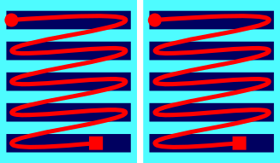 | 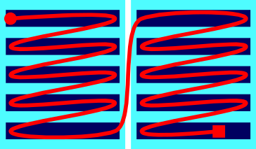 | 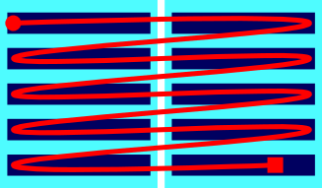
text ends | texts flows on | text runs across
boxlike partition, §4.1 | pagelike partition, §4.4 | gridlike partition, §4.6
If the text progresses through all lines of a zone and ends there (Exhibit 4.1.A/1), with the first zone comprising an integral and complete semantic unit and the text essentially starting anew in the second zone as an independent, likewise integral and complete semantic unit, then you have a boxlike partition. Boxlike partitions are thus like chapters in a book — especially short stories in an anthology or scholarly articles in a compiled volume — that together comprise a whole, and may not need to be read in a particular sequence. Another applicable book analogy is the relation of the title page, the front matter, the actual book content and the blurb. We call such a partition boxlike because each one is a functional box enclosing a discrete segment of text that is complete in itself. In terms of structural hierarchies, a boxlike partition occurs when units of extrinsic and intrinsic structure coincide, so that a physical boundary coincides with a semantic boundary. In the extrinsic hierarchy itself, a boxlike partition is the uppermost tier.
If the text progresses through all lines of a zone and then flows on to the next zone (Exhibit 4.1.A/2), without the necessary presence of a major semantic break, then you have a pagelike partition. A pagelike partition is, unsurprisingly, like that of pages within a single chapter of a book, or of columns on a newspaper page. Each zone is physically distinct, but the units of intrinsic structure do not necessarily coincide with the zones. Thus, the partition normally occurs inside a block-level element of intrinsic structure, although it may — incidentally — be at a break in intrinsic structure. In terms of structural hierarchies, a pagelike partition is purely a feature of extrinsic structure, and its position in the extrinsic hierarchy is above that of lines, so that each pagelike zone is constituted of a number of lines.
Finally, if one or more lines of the text run across from one zone into the next (Exhibit 4.1.A/3) before continuing to the next line in the first zone, then you have a gridlike partition. A gridlike partition is like the grid of a table where each row consists of a number of cells. Line after line, the text carries seamlessly on through the grid, although here too, partitions may in some cases coincide with boundaries of the intrinsic structure, for example in the case of verse laid out in a columnlike structure (§4.7.5.3). In terms of structural hierarchies, a gridlike partition is again purely a feature of extrinsic structure, but it is independent of the hierarchy constituted of lines, subfields and the campus. It does, however, affect the hierarchy of extrinsic structure because it may cut across the units of that hierarchy, including lines, and thus effectively create a subdivision below the level of lines, so that each line is constituted of a number of gridlike zones.
Because XML cannot include overlapping hierarchies (§2.2.4) and the hierarchy of XML elements in our edition is dedicated to the representation of intrinsic structure (§3.1), we cannot use block-level elements for representing units of extrinsic structure unless they are units which, by nature, always coincide with units of intrinsic structure. As evident from the above classification, this is true of boxlike partitions. These are thus encoded as textpart divisions, which are also the uppermost tier in the encoding of intrinsic structure. However, the hierarchically lower units of extrinsic structure do not consistently correspond to units of intrinsic structure, so they necessitate a different encoding approach. This employs empty elements (§2.2.2) corresponding to points of transition, rather than text-containing elements corresponding to structural units. This kind of element is called a milestone (§4.3). Whereas for intrinsic structure, the start-tag and end-tag of a container enclose a unit such as a paragraph, for extrinsic structure we encode a single milestone at the beginning of each unit such as a line. The encoding hierarchy of extrinsic structure is illustrated in Exhibit 4.1.B, where saturated colours (green, blue and yellow) represent mandatory components of an edition, and pastel colours (light green, lavender and aqua) represent non-mandatory components. The labels in the Exhibit are shown in angle brackets to indicate that they correspond to XML elements, but the actual XML elements are introduced in the sections discussing their encoding.
Exhibit 4.1.B. the encoding hierarchy of extrinsic structure
<edition> contains
 | <textpart A> contains
 |  | <page 1> “contains”
 |  |  | <line 1> “contains” | <cell A> “contains” | …text a… | <cell B> “contains” | …text b…
 |  |  | <line 2> “contains” | <cell A> “contains” | …text c… | <cell B> “contains” | …text d…
 |  |  | <line 3> “contains” | <cell A> “contains” | …text e… | <cell B> “contains” | …text f…
 |  | <page 2> “contains”
 |  |  | <line 4> “contains” | <cell C> “contains” | …text g… | <cell D> “contains” | …text h…
 |  |  | <line 5> “contains” | <cell C> “contains” | …text i… | <cell D> “contains” | …text j…
 |  |  | <line 6> “contains” | <cell C> “contains” | …text k… | <cell D> “contains” | …text l…
a
a
a
a
a
 | <textpart B> contains
 |  | <page 1> “contains”
 |  |  | <line 1> “contains” | <cell A> “contains” | …text m… | <cell B> “contains” | …text n…
 |  |  | <line 2> “contains” | <cell A> “contains” | …text o… | <cell B> “contains” | …text p…
 |  |  | <line 3> “contains” | <cell A> “contains” | …text q… | <cell B> “contains” | …text r…
 |  | <page 2> “contains”
 |  |  | <line 4> “contains” | <cell C> “contains” | …text s… | <cell D> “contains” | …text t…
 |  |  | <line 5> “contains” | <cell C> “contains” | …text u… | <cell D> “contains” | …text v…
 |  |  | <line 6> “contains” | <cell C> “contains” | …text w… | <cell D> “contains” | …text x…

As already discussed in §3.1, the edition division (§2.3.3) corresponds to the entirety of an inscription and thus contains the entire hierarchy of extrinsic structure as well as that of intrinsic structure. With respect to extrinsic structure, the edition division represents the inscribed campus. The edition may be subdivided into textparts, each comprising an integral whole and containing the entire text of a boxlike partition of the inscription. The edition and the boxlike partition are members of both the extrinsic and the intrinsic hierarchy, and are encoded as container elements. As a consequence, no XML element can begin inside one textpart division and end in the next.
Within the edition – or, as the case may be, within any textpart division – the intrinsic and extrinsic hierarchies go their separate ways, with the extrinsic structure encoded as pointlike milestones. These represent virtual containers, so that a partition may be said to “contain” everything that is located in the XML document from the point where the given partition begins to the point where another partition of the same hierarchical level begins, or a transition to a higher-level partition occurs, or a division (a textpart or the edition) ends. In the Exhibit, solid borders and colour-filled complete frames indicate actual containment by an XML element, while dashed borders without complete frames indicate virtual containment. An edition or textpart division must always contain one or more lines (blue). Within the edition or textpart division, groups of lines may be “contained” within pagelike partitions (lavender), and some or all lines may “contain” two or more gridlike partitions (aqua).
The extrinsic structure of some inscriptions can be highly complex. Were we to attempt to accurately reflect all details of structural complexity in encoding, the possible combinations of various overlapping hierarchies would soon proliferate beyond a reasonable point. On the one hand, it would be all but impossible to draw up, and then correctly observe, guidelines for all possibilities; on the other hand, doing so would serve no practical purpose while processing the digital edition by computer. Then again, many inscriptions have no partitions at all (consisting only of lines in a single zone), and the only common type of inscription that involves more than one kind of partition is the copperplate charter. Copperplate charters typically consist of a seal and a body, which are boxlike partitions, and their body in turn consists of pages (pagelike partitions), while there are no further partitions in the seal.
In DHARMA encoding practice, we make a point of keeping encoding complexity within reasonable limits. The use of textpart divisions in an edition is therefore limited to specific kinds of cases where this is deemed to be warranted (§4.7.3). A single division (the edition or a textpart) is permitted to contain only one kind of pagelike partition. When gridlike partitions are present, their encoding is recommended only when expedient (for instance to enable referring to specific “cells” of the grid). If necessary, more than one kind of gridlike partition may be used within a single division, but doing so is generally counter-recommended. In §4.7 we provide guidance for situations in which various kinds of encoded partitions are applicable, as well as for cases which are best encoded without the usual milestone elements for extrinsic structure (§4.7.1), including the encoding of forme work (i.e. pagination and foliation numbers, §4.7.2). Some complete encoding examples are provided in the Case Studies of Appendix A. As a general guideline, also keep in mind that whenever the encoded structure does not provide an accurate fit for the original structure, human-readable annotation can always be added.

Numeration for reference
All TEI elements can be supplemented with arbitrary numeration using the attribute @n, primarily to be used as reference by human end users. Another attribute, @xml:id (§14.6.6), is employed for the rigorous, machine-readable referencing of elements. For the purpose of referring to units of extrinsic structure, DHARMA editions use numeration involving @n on all milestone elements (as well as for textpart divisions). According to usual conventions, our editions’ stanzas and their lines can be referred to by the number of their container (§3.1.1), but our primary means of reference to the text of documentary editions is by line number. The projectwide conventions introduced in the applicable subsections for numbering elements with @n not only ensure consistency in our editions, but also facilitate human-readable reference and in fact actually afford a degree of machine-interpretable referencing. This is possible so long as element numbers are unique within any given level of the hierarchy, so that any structural compartment can be unambiguously identified by a combination of the numbers of the elements representing its place in the structure. For instance, in Exhibit 4.1.B above, “text o” can be referred to by pointing to textpart B, page 1, line 2, cell A.

Boxlike partitions
Recall from §4.1 that a boxlike partition is what happens when a discrete zone of the text is also semantically distinct from the rest as in Exhibit 4.1.A/1, amounting to a major subunit of a text’s extrinsic as well as intrinsic hierarchy. Intrinsically, it usually contains a number of basic prose and/or verse containers. Extrinsically, it may or may not be divided into lower-level structural parts. The semantic discontinuity between two textparts is somewhat analogous to the chapters of a book. To understand clearly how textpart divisions differ from and relate to other divisions of intrinsic and extrinsic structure, carefully read §3.1 and §4.1.
Boxlike partitions are encoded with a container element, the textpart division, as described in §4.2.1. Such a division is hierarchically subordinate to the edition division and superordinate to the basic containers for intrinsic structure. In essence, textpart divisions are complete editions except that they are gathered together in a single XML document and thus have a shared header, commentary and bibliography. Accordingly, the numbering of other elements within one textpart is independent of the numbering of similar elements in another textpart (§4.2.1.4). Conversely, the critical apparatus (§10) and translation (§11) included in a digital edition replicates the structure of the text itself, so if an edition contains textpart divisions, then corresponding textparts must also be created in the critical apparatus and the translation. In order to keep encoding complexity within limits, the use of textpart is limited in DHARMA practice to a small range of cases where this is deemed to be warranted (§4.7.3).

Encoding as textpart divisions
Exhibit 4.2.A: minimal encoding of textpart divisions
<div type="edition">
<div type="textpart" n="A">
...
</div>
<div type="textpart" n="B">
...
</div>
</div>
- each boxlike unit must be wrapped in the element <div> as in Exhibit 4.2.A, with the following attributes
  - mandatorily, @type="textpart"
  - mandatorily, @n as per §4.2.1.1
  - optionally, @subtype as per §4.2.1.2
- the encoding represents only the existence and demarcation of a textpart but says nothing about its physical aspects such as size or position on the support
  - the latter information shall be described for human readers in the annotation
  - the use cases in §4.7.3 give some illustrations of various topological arrangements and additional encoding examples
- if your <div type="edition"> includes a <div type="textpart">, then the textpart divisions must tessellate, meaning that everything within the edition must be also within one textpart or another
- textparts shall be arranged in the order you deem to be the logical reading order of the text as a whole, or its best approximation

Textpart numbering
- every textpart division must carry the mandatory attribute @n, the value of which must be unique through the XML document
- the value of @n is utilised in display for automatically generated headings (§4.2.1.3)
- uppercase Latin letters are generally recommended for numeration, but any scheme may be used depending on your preference and the conventions of your specific field, including
  - Arabic numbers
  - a combination of uppercase and lowercase Latin letters to represent major and minor faces of a three-dimensional object in the same way as for pagelike milestones (§4.4.3.1)

Textpart subtypes
- the optional attribute @subtype may be used to encode the physical nature of textparts
  - the use of this attribute is recommended as a simple means of indicating the nature of a partition that can also be displayed as a title (§4.2.1.3)
- the value of @subtype is utilised in display for automatically generated headings (§4.2.1.3)
- the value of @subtype shall normally indicate the physical nature of the corresponding partition of extrinsic structure, disregarding its visual appearance, topological position relative to other textparts, and semantic function in intrinsic structure
- the permitted values of @subtype are listed below, while specific instructions for when @subtype should be used and with what values are found in the subsections of §4.7.3
  - "column" for zones placed side by side and generally taller than they are wide
  - "face" for a physically contiguous surface of a three-dimensional object of any shape and any number of sides
  - "faces" for two or more contiguous surfaces that together comprise a box of text, such as the frontal and lateral face of a four-sided stele
  - "fragment" for physical fragments as per §4.7.3.2
  - "item" for physically separate objects such as architectural elements, e.g. when an inscription is engraved on two pillars or doorjambs
  - "trial" for trial engravings as per §4.7.3.3
  - "zone" for visually distinct zones that do not readily meet any of the specific definitions above
    - a zone is generally conceived of as being on a single contiguous surface, but in inscriptions with a complex topology, this unit may also be used for a visually distinct area occupying two or more surfaces
  - this list of values is largely identical to the values permitted for of @unit on <milestone>
    - these are discussed in §4.3.1, where you will also find pointers to illustrations
  - only the values listed above may be used, even though earlier versions of this Guide permitted using custom values

Titles for textparts
When an XML edition is rendered for display in the DHARMA environment, headings for textpart divisions will be automatically generated from the subtype (if present) and the number. When these automatic headings are deemed insufficient, an optional custom heading may be added to the encoding, which will replace the auto-generated title.
- auto-generated headings will consist of the value of @subtype (with the initial letter changed to uppercase), followed by the value of @n (unchanged), for example as follows
  - <div type="textpart" n="A"> → “A”
  - <div type="textpart" subtype="fragment" n="1"> → “Fragment 1”
  - <div type="textpart" subtype="face" n="a"> → “Face a”
- to create a custom heading for a textpart division, use the optional element <head xml:lang="eng"> immediately after the start tag of a textpart division
  - such elements in our editions will by default be regarded as editorial and therefore need not be marked up explicitly as such
    - the mandatory language attribute (§14.4.1) makes it sufficiently clear that their content is not part of the original text
  - the use of this element is recommended when the textparts of an inscription are different in nature, so they cannot be conveniently described by a combination of subtype and number
    - in this case add a <head> element and optionally omit @subtype
  - when multiple textparts are of the same nature, the use of @subtype remains recommended even if <head> elements are also added
  - the attribute @n on the <div> element remains mandatory even if a <head> is present
  - see Exhibit 4.2.B for an illustration
- it is generally recommended that you stick to concise headings in English, and in particular to the suggestions in the subsections of §4.2.1.4 for specific use cases
  - the editorial heading will be neither altered in display, nor supplemented with the value of @n, so when creating custom headings,
    - use a capital initial and feel free to include spaces, additional capitals and punctuation as necessary
    - however, to avoid complications, do not use any further markup within this element, except the element <foreign> (§14.4.2), which you may employ if you deem necessary
Exhibit 4.2.B: non-contiguous fragments with custom headings
<div type="textpart" subtype="fragment" n="1">
<head xml:lang="eng">Upper left corner</head>
...
</div>
<div type="textpart" subtype="fragment" n="2">
<head xml:lang="eng">A small piece not adjacent to any edge</head>
...
</div>
- explicitly encoded headings will show “Upper left corner” and “A small piece not adjacent to any edge”

Numbering elements within textparts
The numbering of structural elements serves for reference, implying that the number of any represented entity should be unique. However, uniqueness is only a criterion within each textpart, since a reference unique across the entire edition can still be created by combining the textpart number with the number of the entity in question. For example, even if textpart A and textpart B both have a line 1, these can still be identified unambiguously as “line 1 of textpart A” and “line 1 of textpart B”.
Because textpart divisions are essentially independent editions, for the sake of clarity and consistency we recommend restarting numeration in each textpart for any structural entities present in more than one textpart (typically: physical lines and stanzas). Doing so is especially warranted when there is no straightforward sequence of progression from one textpart to another, but restarting never does any harm. Therefore, employ consecutive numbering through textparts only when you have a strong reason to do so.

Encoding with milestones
As introduced in §4.1, we employ empty elements to indicate points of transition relevant to extrinsic structure. This kind of empty element is called a milestone in TEI parlance. The generic <milestone/> element, when used for extrinsic structure, must always carry the attribute @unit (§4.3.1) to encode what kind of transition it represents. TEI also provides several specialised milestone elements, where the unit is implicit in the element’s name and does not need to be encoded explicitly. Of these, our encoding makes use of <pb/> “Page Beginning” (§4.4.2) and <lb/> “Line Beginning” (§4.5), while the generic <milestone/> element is used with @type="pagelike" to represent pagelike partitions other than actual pages (§4.4.2.1), and without @type to represent gridlike partitions (§4.6.1). Milestone-type elements representing extrinsic structure are always numbered in our editions, with numeration schemes for each kind discussed in the relevant sections. The present section gathers instructions that apply in general to the structural milestones we use.

Milestone units
- the attribute @unit is mandatory for all <milestone> elements representing extrinsic structure
- the value of this attribute shall be a single word describing the nature of the partition analogously to the (optional) @subtype of textpart divisions (§4.2.1.2), based on the physical nature of the corresponding partition of extrinsic structure, disregarding its visual appearance, topological position relative to other textparts, and semantic function in intrinsic structure
- the permitted values of @unit, applicable to both pagelike (§4.4.2.1) and gridlike (§4.6.1) <milestone> elements, are as follows:
  - "block" for inscriptions on separable architectural blocks in a larger element such as a wall (gridlike: Exhibit 4.7.O)
  - "column" for zones placed side by side and generally taller than they are wide
    - resembling the columns of newsprint for pagelike partitions, as in Exhibit 4.7.K
    - resembling verse with metrical subunits arranged into quasi-columns for gridlike partitions, as in Exhibit 4.7.Q and the Case Study in Appendix A.6
  - "face" for a physically contiguous surface of a three-dimensional object of any shape and any number of sides (gridlike: Exhibit 4.7.R; see also the Case Study in Appendix A.6 for pagelike faces subdivided into gridlike columns)
  - "faces" in texts where each pagelike zone involves lines continuing across two or more surfaces such as the frontal and lateral face of a four-sided stele
    - this unit is not normally applicable to gridlike partitions, but a gridlike partition with @unit="face" may be used to encode the boundary of each face constituting a pagelike zone of this kind, as in the Case Study in Appendix A.5
  - "fragment" for objects with two or more extant inscribed fragments
    - fragmentation generally engenders gridlike partitions as in Exhibit 4.7.W, but may occasionally result in a pagelike partition as in Exhibit 4.7.X as well as in a boxlike one as in Exhibit 4.7.I
  - "item" for physically separate objects such as architectural elements, e.g. when an inscription is engraved on two pillars or doorjambs (pagelike Exhibit 4.4.C)
    - this unit is not normally applicable to gridlike partitions
  - "zone" for visually distinct zones that do not readily meet any of the specific definitions above
    - a zone is generally conceived of as being on a single contiguous surface, but in inscriptions with a complex topology, this unit may also be used for a visually distinct area occupying two or more surfaces
  - only the values listed above may be used, even though earlier versions of this Guide permitted using custom values

Milestones interrupting the text
When a milestone for extrinsic structure falls inside a word, this must be encoded as per §4.3.2.1 to show that the structural break is not also a word break. In situations where a structural boundary — typically a fracture, but occasionally also a transition to another surface of a three-dimensional object — splits one or more atomic akṣaras of the text, the target graphemes corresponding to the split akṣara shall be arbitrarily allocated to one side of the partition or the other. Specific guidelines for this are given in §4.7.6.1. When a theoretically atomic akṣara is deliberately separated into its constituent parts by the scribe, this can be encoded as per §5.1.4.

Milestones interrupting words
- a structural transition interrupts a word if it occurs at a point other than between two independent words, i.e. at any place where cannot add an editorial space (TG §7.3.2), including cases
  - where the words before and after the transition are compounded to one another (e.g. mahā/rāja)
  - where an initial vowel is fused in sandhi to the vowel before the transition (e.g. tathā/pi, atre/yam, tatho/ktam; but not so/yam, where the sandhi does not involve vowel fusion)
  - unlike the boundaries of intrinsic structure (§3.2.4.1), extrinsic structure can interrupt words which are separable in transliteration, when the separation of the source’s akṣaras does not coincide with the structural transition because a final vowel has been reduced in sandhi to a semivowel
    - e.g. a/sty atra, asty a/tra, asā/v api, asāv a/pi
  - a structural transition is understood to interrupt a word even if the word is also interrupted by another feature at the same spot, such as
    - connector symbols (§5.3.2.3) before the transition
    - a space imposed by physical features (§5.4.2.2) before or after the transition
    - pre-modern deletion (§5.5.1) before or after the transition
    - a lacuna (§6.5) before or after the transition, provided that the original presence of an interrupted word can be inferred with fair likelihood (see §4.3.2.2 for details)
- when a structural transition interrupts a word, then any and all milestone tags representing that transition must take the attribute @break with the value "no" to encode the fact that the structural break does not also signify a break in the text
  - if several kinds of milestone occur together at such a point, each of them must be redundantly encoded with @break="no", as in Exhibit 4.3.A
- occasionally, a partition can result in the splitting of an atomic akṣara, in which case @break="no" is of course also applicable; in addition,
  - akṣaras deliberately divided by the engraver into two parts across a physical feature such as a line break are to be handled as per §5.1.4
  - akṣaras inadvertently split by a gridlike feature such as fragmentation are to be handled as per §4.7.6.1
- when you have used @break="no" on a milestone element,
  - do not start a new line of code or add a space before the milestone tag (see also §4.3.3)
  - never add a hyphen before the milestone tag to indicate that it breaks a word (this is to be indicated only in the encoding)
    - however, if you use editorial hyphens for the segmentation of compounds (TG §7.3.5), then
      - boundaries marked by editorial hyphens must still be treated as being inside words
      - as per §7.8.2, the editorial hyphen must be placed after the milestone rather than before it, as in the last line of Exhibit 4.3.D
Exhibit 4.3.A: multiple milestones interrupting a word
... tad viditvā yathocitaṁ bhāga-bhoga<pb
n="3r" break="no"/><lb
n="19" break="no"/>m upanayantaḥ sukhaṁ prativasatha...

Judging word interruption in lacunose text
- when text before or after a milestone is lost, badly damaged, or unintelligible for some other reason, then it may not be possible to decide for certain whether the milestone interrupts a word
  - in such cases, use @break="no" when you are reasonably certain that an interruption is present
  - if you are uncertain, omit @break="no" (thus making no explicit assertion) even if there is a chance that a word may be interrupted
  - observing the following guidelines
- when there is a lacuna before the transition,
  - use @break="no" if the extant text begins with an incomplete indivisible morpheme or with the final part of what you are certain was a prefixed or compound word
  - but do not use @break="no" if the extant text is intelligible (and plausible in context) as it is, even if there is some chance that the previous line contained a prefix or a compound member attached to the first extant word
- when there is a lacuna after the transition,
  - use @break="no" if the end of the extant text is clearly not the end of an independent word
  - but do not use @break="no" if the end of the extant text may be the end of an independent word, even if there is a chance that this word continued in the current line
- when there is a lacuna both before and after the spot where a structural milestone is (expected to be) located, then in addition to uncertainty as to whether a word is interrupted, it may not be possible to determine the exact number of characters lost on either side of the transition
  - if the lacuna is not restored, do not use @break="no" (which would assert that a word has been split by the milestone) and simply encode gaps (§6.5) of unknown or uncertain length on both sides of the milestone tag
  - if you supply the lost text (as per §6.4), create the milestone tag at its most likely position vis-à-vis the text and use or omit @break="no" as dictated by the restored text
    - if you feel that the uncertainty of this positioning matters, mention it in your annotation

Good encoding practice for milestone elements
The milestones representing extrinsic structure are on the same hierarchical level as the edited text. As a result, situations where milestones coincide with breaks in intrinsic structure demand extra attention, as discussed in §4.3.3.1. When phrase-level elements wrap a chunk of text that contains a milestone, it is theoretically correct to include the milestone within the phrase-level element. However, in actual practice this is not permitted in EpiDoc for <unclear> elements (§6.3.1) and can lead to undesirable complications in other cases, so we generally prefer to split phrase-level elements into two parts, before and after the milestone. For further details on the hierarchy of encoding and its practical implications, see §16.2.
Milestone elements always mark the beginning of a unit of extrinsic structure, and must accordingly be created for the start of the first extrinsic unit of any kind in a document (Exhibit 4.3.B), not only for transitions to subsequent units. In DHARMA practice, line beginnings are mandatorily encoded, even for editions (or textpart divisions) consisting of only a single line. Other structural milestones are not mandatory: an inscription comprised of a single field is not perceived to be a page.
In a document with a hierarchical extrinsic structure, a transition point on a higher tier is always accompanied by a transition on the lower tier(s); for instance, whenever a page begins, a new line begins too. At every such point, every applicable milestone must be explicitly encoded, in an order of decreasing hierarchical level, as in Exhibit 4.3.B.

Milestones and block-level elements
Milestone elements must be inside rather than outside block-level elements representing intrinsic structure (§3.2). Achieving this sometimes requires counterintuitive encoding logic. In the hierarchy of intrinsic structure represented solely with block-level elements, lower-level units are always contained within higher-level units. Likewise, in the hierarchy of extrinsic structure represented with milestones, higher-level milestones precede lower-level ones; for example, page beginnings precede line beginnings. However, when extrinsic and intrinsic boundaries coincide, such as when a stanza begins at the beginning of a physical line, the intuitive assumption may be to encode the milestone representing the extrinsic boundary (e.g. a line beginning) before the start-tag representing the intrinsic boundary (e.g. for a stanza), because by common sense, the stanza begins “inside” the line. Often, however, the opposite is true: many extrinsic boundaries fall inside intrinsic units. In order to make our encoding consistent, DHARMA editions therefore always place milestone elements inside block-level containers, unless it is impossible to do so.
Thus, at the start of an edition or a textpart division, any applicable milestone elements must be encoded after all applicable block-level elements have been opened, as in Exhibit 4.3.B. When boundaries of extrinsic and intrinsic structure coincide, any and all applicable milestones shall be created after the start tag of any block-level elements beginning there (not before the end tag of the block-level element(s) ending there), as in Exhibit 4.3.C.
Exhibit 4.3.B: several kinds of milestones at the beginning of an edition
<div type="edition">
<lg n="1" met="anuṣṭubh">
<l n="a"><milestone type="pagelike" unit="zone" n="A"/><lb n="1"/><milestone unit="fragment" n="a"/>Āsīt...

Exhibit 4.3.C: multiple milestones coinciding with nested block-level container boundaries
<lg n="5" met="upajāti">
...
<l n="d"> ... śāntiM</l>
</lg>
<lg n="6" met="upajāti">
<l n="a"><pb n="2"/><lb n="9"/>guptānvaya ...
...
</lg>
- this stanza begins at the beginning of a page in a set of copper plates
- the milestones for the page beginning as well as the line beginning are the first items within the first <l> element of the new stanza

Milestones and white space
General instructions regarding spacing around XML elements are given in §16.1. There is no technical need to separate milestones from adjacent text or elements with spaces, so spaces must only be used around milestone elements where the text (disregarding the milestone) would contain an editorial space, i.e. at a word break. Adding more than the necessary amount of space, as well as the use of new lines in the code, is not a technical problem but it can lead to undesirable consequences in processing. We therefore prefer to avoid using spaces on both sides of a milestone. If a partition encoded with a milestone coincides with an editorial space, the space shall be placed before the milestone. However, it is completely acceptable to insert new lines (carriage returns) within milestone tags, and doing so consistently for certain kinds of milestones will make your XML document easier to scan while working, as in Exhibit 4.3.D.
Exhibit 4.3.D: carriage returns used within milestone tags
...manv-ādi-praṇīta-dharmmaśāstra-pracarita-vr̥ddhiḥ <pb
n="2r"/><lb
n="7"/>yudhiṣṭhira Iva satya-sandhaḥ br̥haspatir iva naya-jñaḥ mātā-pitr̥<lb
n="8" break="no"/>-pādānudhyātaḥ śrī-viṣṇuvarddhana-mahārājaḥ...

Pagelike partitions
Recall from §4.1 that a pagelike partition is what happens when the text continues from the end of a zone to the beginning of the next, typically without a major semantic boundary, as in Exhibit 4.1.A/2. The text of all such partitions together comprises a single virtual field that is an integral whole, while the chunks of text in the individual partitions are not complete in themselves. We call these partitions pagelike because each zone is analogous to a page in a book: the boundary is usually incidental and irrelevant to the text’s semantic structure, although it may also coincide with a semantic break. Since such a partition may occur inside a unit of intrinsic structure, the encoding equivalent of a pagelike partition must be an empty milestone element (§4.3). For the genuine pages of copperplate charters, we use <pb/> elements (§4.4.2), while for other partitions of analogous nature we employ <milestone type="pagelike"> (§4.4.2.1).
There is no technical limit to the number of different kinds of pagelike partitions that a document may contain. However, to avoid complications in markup and referencing, our project policy is always to employ a maximum of one kind of pagelike partition per division (i.e. only one kind in an undivided edition, or only one kind in each textpart of a subdivided edition). Thus, an edition or textpart may contain either <pb/> or <milestone type="pagelike"> with one particular @unit (§4.3.1), but not both, nor <milestone type="pagelike"> with two or more different values of @unit. When encoding a structurally complex inscription, instead of resorting to multiple kinds of pagelike partitions, try to make the best use of other encoding solutions. Considerations for some such situations are discussed in §4.7.

Terminology for pages and related entities
In this section and elsewhere when discussing pages and pagelike entities, we use the following terms in the following specific senses.
- a plate is one discrete plate of copper (or other substance) bearing an inscription or part thereof
- a face is the physical surface on one side of a plate
  - in other contexts, a face is one largely flat surface on any three-dimensional object
- the recto face of a plate or sheet is the obverse, the face that comes first in sequence
- the verso face of a plate or sheet is the reverse, the face that comes next in sequence
- a page is an abstract unit of text that is inscribed on one face of a plate or one side of a sheet of another substance
- a folio as an abstract unit of text comprised of two pages that belong to a single plate or sheet

Marking up genuine pages
Exhibit 4.4.A: generic encoding for page beginnings
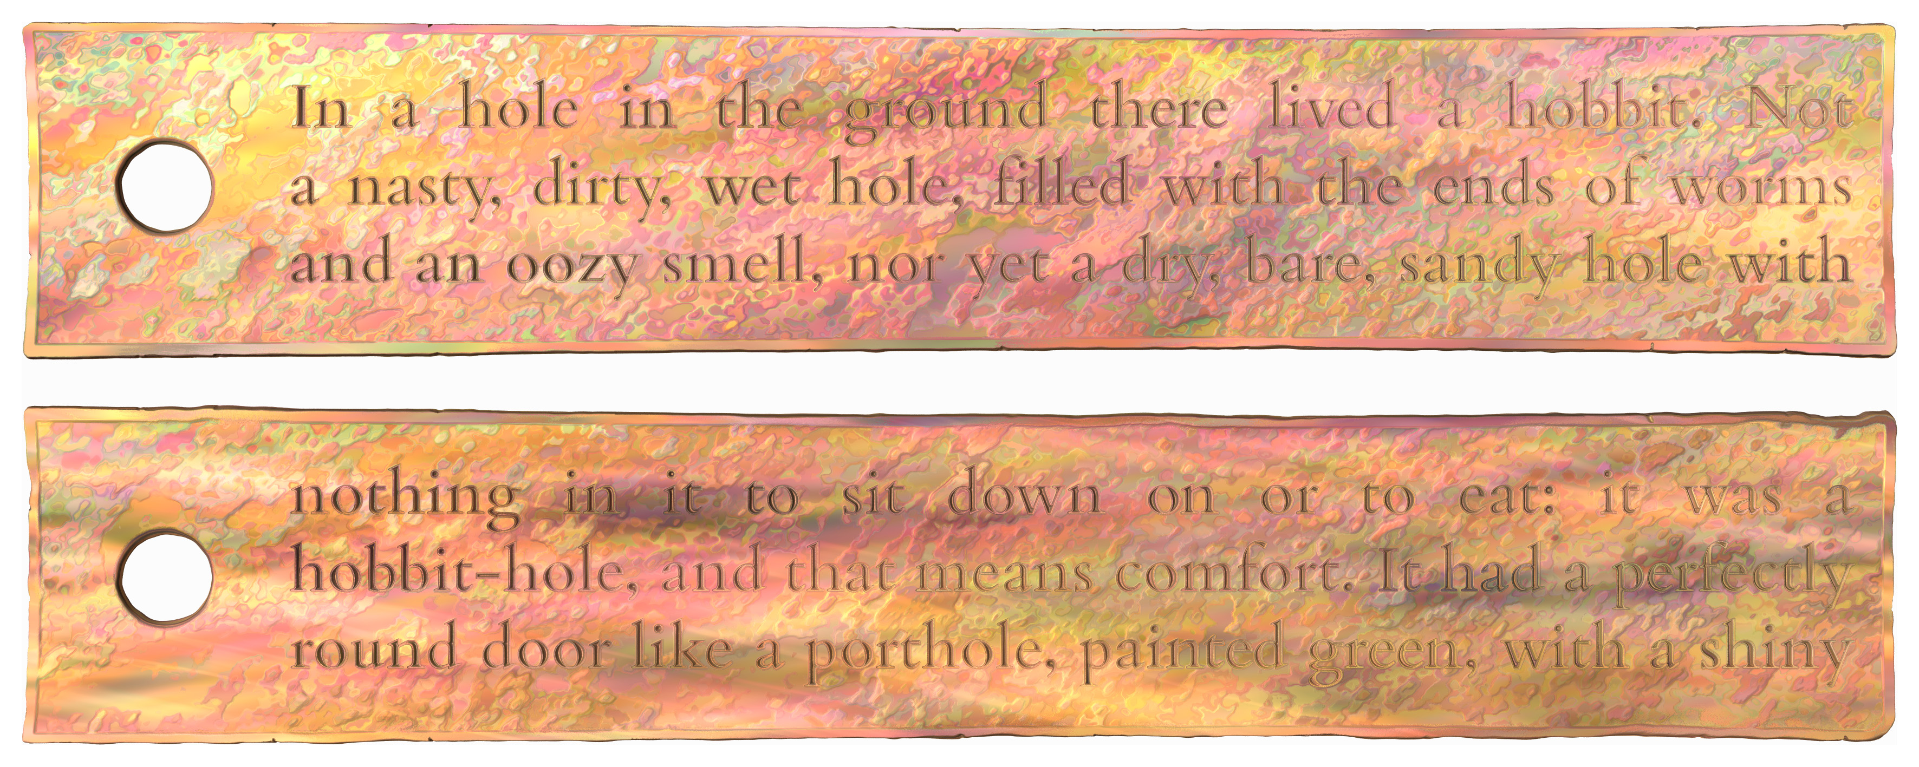
<p><pb n="1"/><lb n="1"/>...
<lb n="2"/>...
<lb n="3"/>...
<pb n="2"/><lb n="4"/>...
<lb n="5"/>...
...
</p>
- complete encoded illustration: Appendix A.2
- to encode genuine pages, as in copper plates, use the empty element <pb/> as in Exhibit 4.4.A, with the following attributes
  - mandatorily, @n as per §4.4.2.1
  - as applicable, @break for page beginnings interrupting words as per §4.3.2.1
- <pb/> marks page beginnings (rather than transitions) and thus, when pages are present in a document, the element must be created at the start of each page
  - including the first page
  - and including pages without text (§4.4.2.2)
- good practice considerations applicable to structural milestones (§4.3.3) apply equally to page beginnings

Page numbering
Pages are numbered for reference. When an XML edition is rendered for display, labels for pages will be automatically generated from the encoded number. Unlike pagelike milestones, the <label> element (§4.4.3.2) is not permitted in conjunction with page breaks.
- pages are mandatorily numbered in DHARMA editions
- the recommended values for numbering pages are 1r, 1v, 2r, 2v etc.
  - the value of @n is thus composed of
    - an Arabic numeral starting with 1 and proceeding in steps of 1 per plate (folio)
    - the abbreviation to identify the recto (obverse) and verso (reverse) face of each plate
  - e.g. <pb n="1r"/>
- if you have a good reason to do so, you may opt to use a different numbering scheme for pages with the following constraints:
  - the value of @n must not contain a space (use an underscore _ instead if a space is essential)
  - each page must have a unique number within your edition (or, if applicable, within a textpart division)
- when several textpart divisions of an edition include pages, page numbers must be reset in each textpart (§4.2.1.4) unless there is a strong reason not to do so
- see §4.7.2 about encoding any original pagination or foliation

Uninscribed copperplate faces
- plates must always be encoded as having two pages per folio, even if one of these pages is blank; this will facilitate the eventual linking of images (including images of blank faces) to individual pages of the digital edition
- blank faces shall be encoded as the corresponding <pb/> element, with the following recommendations for the sake of consistency within the project
  - for sets of copper plates where the first and/or last plate is only inscribed on one face, designate the blank faces to be the outer faces of the set, i.e. the recto of the first plate and the verso of the last plate
  - for sets or single plates inscribed on only one face (of each plate), designate the inscribed face as the recto, and the blank face as the verso
  - the <pb/> elements for first/last blank pages should be placed just inside the start/end tag of the enclosing division (i.e. the edition division or a textpart division)
    - thus, these <pb/> elements will be outside block-level containers in spite of the general rule (§16.2.4) that such empty elements must be inside block-level containers
  - see Appendix A.2 for an illustration of pages in an EpiDoc document

Marking up other pagelike zones
Exhibit 4.4.B: generic encoding for pagelike partitions
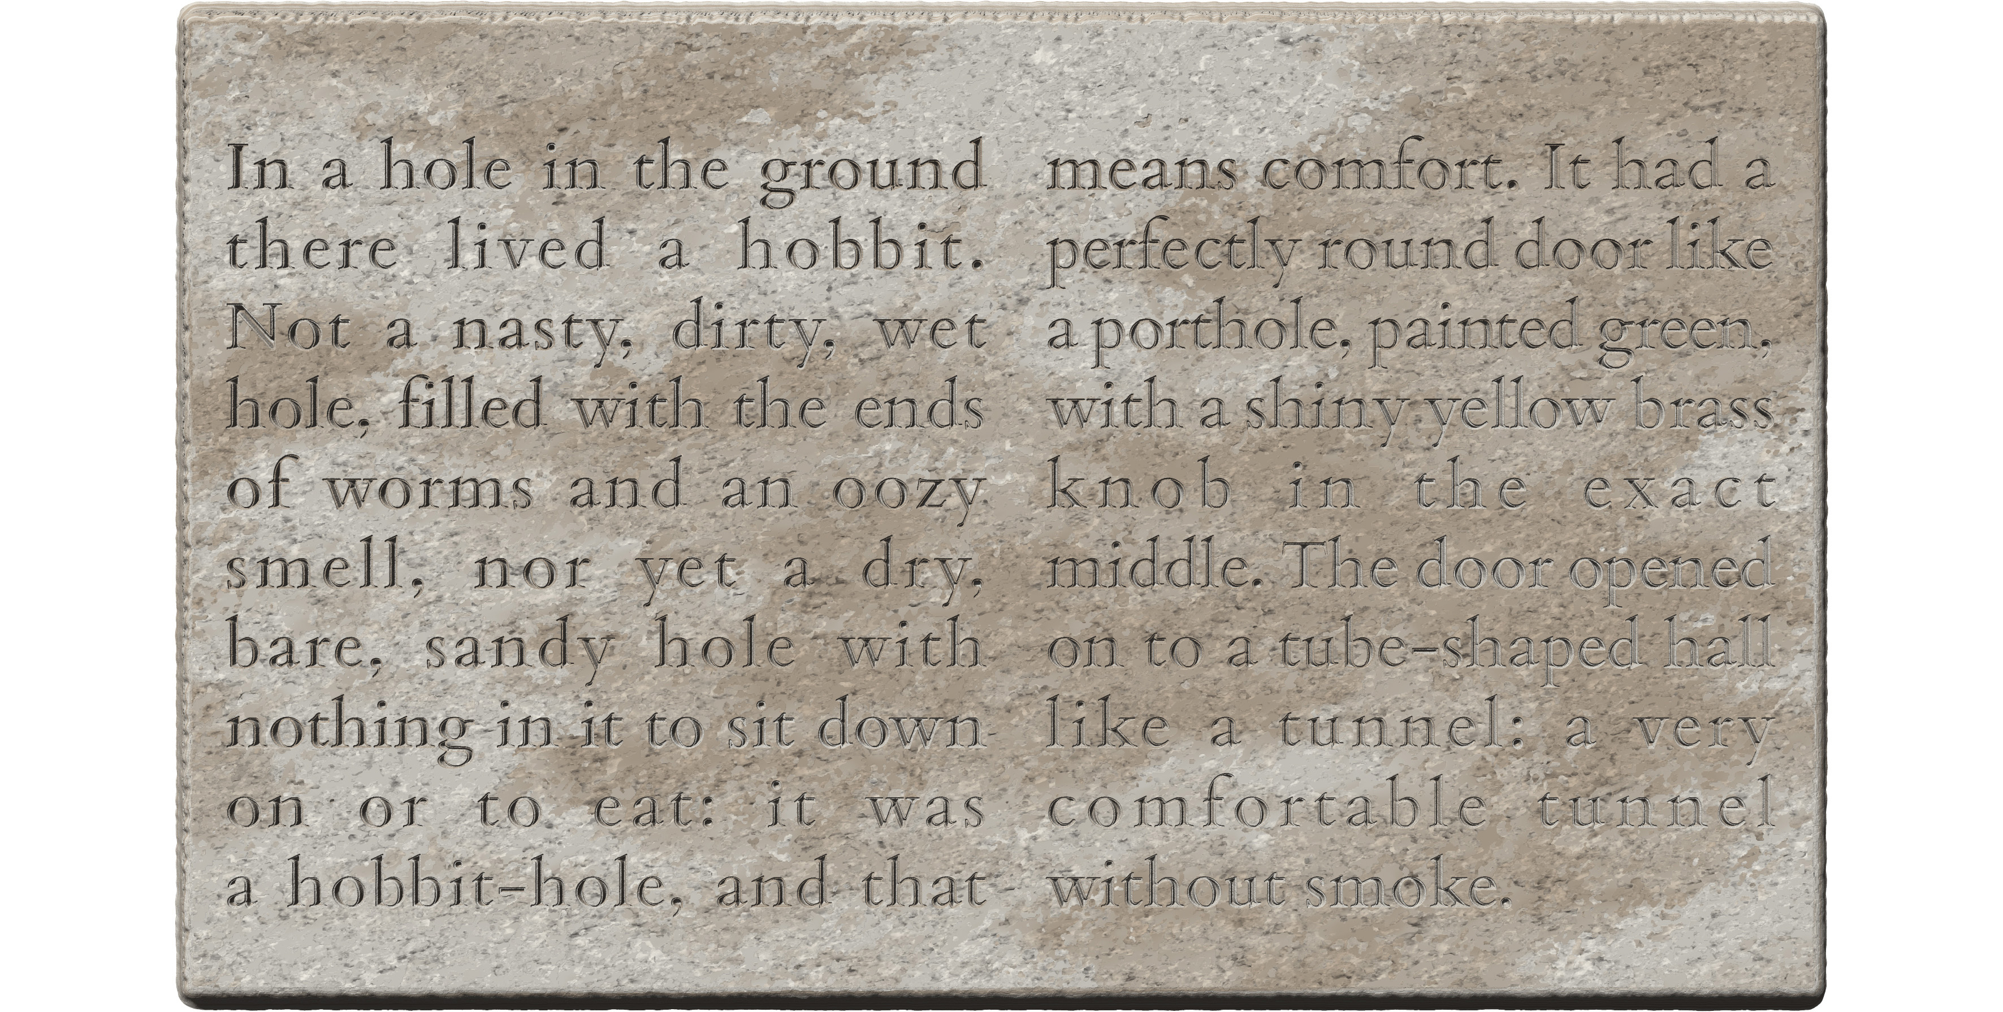
<p><pb n="1"/><lb n="1"/>...
<lb n="2"/>...
...
<pb n="2"/><lb n="11"/>...
<lb n="12"/>...
...
</p>
- compare the exhibits in §4.7.4.2
- to encode pagelike partitions other than genuine pages, use the empty element <milestone/> as in Exhibit 4.4.B, with the following attributes
  - mandatorily, @type with the value "pagelike"
    - this serves in our project to explicitly distinguish these elements from other milestones used in an edition
  - mandatorily, @unit to encode the nature of the transition explicitly as per §4.3.1
  - mandatorily, @n as per §4.4.3.1
  - as applicable, @break for partitions interrupting words as per §4.3.2.1
- <milestone/> marks zone beginnings (rather than transitions) and thus, when pagelike zones are present in a document, the element must be created at the start of each such zone including the first
- good practice considerations applicable to structural milestones (§4.3.3) apply equally to pagelike partitions
- see §4.7.4 for further discussion of when pagelike zones should be used, and the Case Studies in Appendix A.5 and Appendix A.6 for more complex scenarios

Numbering pagelike milestones
- pagelike partitions are mandatorily numbered in DHARMA editions
- the values of @n recommended for the identification of pagelike partitions other than actual pages are uppercase Latin letters beginning with “A”
  - nonetheless, any numeration scheme may be used depending on your preference and the conventions of your specific field; in particular, feel free to use
    - the uppercase letters N, S, E, W to indicate cardinal directions (Exhibit 4.4.C)
    - lowercase letters alternating with uppercase ones to denote major/frontal and minor/lateral faces of a three-dimensional object such as a Southeast Asian stele, e.g. A, b, C and d (for faces inscribed as separate zones)
      - or pairs of such letters, Ab and Cd (where pairs of faces constitute single virtual zones)
- when several textpart divisions of an edition include pagelike milestones, then
  - if the pagelike partitions are of the same kind (i.e. have the same @unit), then their numbering must be reset in each textpart (§4.2.1.4) unless there is a strong reason not to do so
  - if the pagelike partitions are of different kinds, it is recommended that you employ different numeration schemes for them in addition to distinguishing them by @unit (§4.3.1)
  - recall from §4.1 that only one kind of pagelike partition is allowed within any single division (i.e. in the edition or in each textpart, as the case may be)

Labels for pagelike milestones
Milestones are numbered for reference. When an XML edition is rendered for display, labels for pagelike partitions will be automatically generated from the unit and the number, as noted in the examples in this section. When these automatic headings are deemed insufficient, an optional custom label may be added to the encoding, which will replace the auto-generated label.
- auto-generated labels will consist of the value of @unit (with the initial letter changed to uppercase), followed by the value of @n (unchanged), for example as follows
  - <milestone type="pagelike" unit="face" n="A"/> → “Face A”
  - <milestone type="pagelike" unit="zone" n="1"/> → “Zone 1”
- to add flexibility to the titling displayed for pagelike partitions, use the optional element <label xml:lang="eng"> immediately after the <milestone/> element
  - such elements in our editions will by default be regarded as editorial and therefore need not be marked up explicitly as such; the mandatory language attribute (§14.4.1) makes it sufficiently clear that their content is not part of the original text
  - only add labels to zones if you find that the combination of @unit and @n cannot produce a sufficiently meaningful title; complex details such as the size and relative position of zones should be annotated, not encoded within the edition
  - for the sake of consistency it is recommended that you stick to concise labels in English
  - see Exhibit 4.4.C for an illustration
- although the content of editorial labels will replace the title auto-generated from @unit and @n in display, the use of the attributes @unit and @n on the <milestone/> element remains mandatory even if a <label> is present
- the contents of the label will not be altered in display, so
  - use a capital initial and feel free to include spaces, additional capitals and punctuation as necessary
  - however, to avoid complications, do not use any further markup within this element, except the element <foreign> (§14.4.2), which you may employ if you deem necessary
Exhibit 4.4.C: two doorjambs as a pagelike partition with custom headings
<milestone type="pagelike" unit="item" n="N"/><label xml:lang="eng">Northern Doorjamb</label>...
<milestone type="pagelike" unit="item" n="S"/><label xml:lang="eng">Southern Doorjamb</label>...
- explicitly encoded headings will show “Northern Doorjamb” and “Southern Doorjamb”

Numbered elements in pagelike partitions
- as set out under §4.5.2, physical line numbering may be either
  - consecutive throughout successive pagelike partitions, or
  - restarted in each pagelike partition, provided that complex line numbers are used, which incorporate the number of the page or zone
- the numeration of any other numbered elements must ignore pagelike partitions, i.e. continue consecutively through each such partition
  - this explicitly includes stanzas, whose numbering is normally reset in boxlike partitions, but never after a pagelike partition

Physical lines
To make the distinction from verse lines (§3.2.2) explicit, inscribed lines are referred to in this guide as epigraphic lines or physical lines where ambiguity is possible. The beginning of each epigraphic line must always be marked up within the edition. For the purpose of encoding in our project, we define a physical line as a stretch of text whose glyphs comprise a spatially and textually contiguous sequence while being spatially distinct from glyphs belonging to other lines.
Exhibit 4.5.A. A tidy inscription
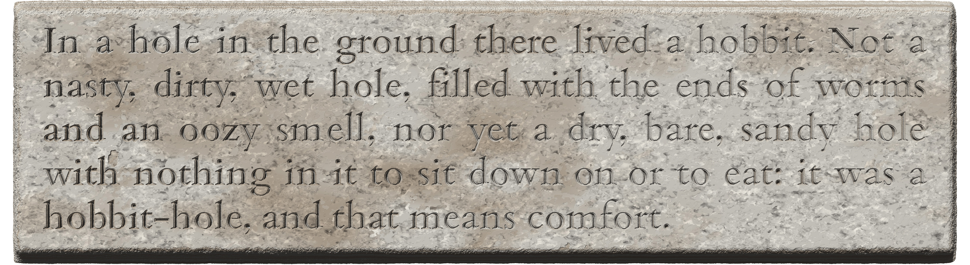
This definition includes no presumptions concerning a line’s
- position (some lines of a text may be set off from other lines; see §4.7.1.1 and §4.7.1.2 for specific cases)
- directionality (e.g. some lines run right to left while others run left to right; see §8.5.2)
- orientation (e.g. some lines may be vertical while others are horizontal; see §8.5.2)
- shape (lines may bend in various ways to follow an uneven surface, or the ends of certain lines may bend upward or downward to accommodate extra glyphs before the margin or the edge of the support)

The concrete topology of the inscription is, however, irrelevant, so the tidy slab in Exhibit 4.5.A and the untidy boulder in Exhibit 4.5.B are encoded in the same manner, differing only in the number of lines. The arrangement of lines can be annotated as needed, but not encoded in the edition except for some basic layout features, which will be discussed in §8.2.2.
Exhibit 4.5.B. An untidy inscription
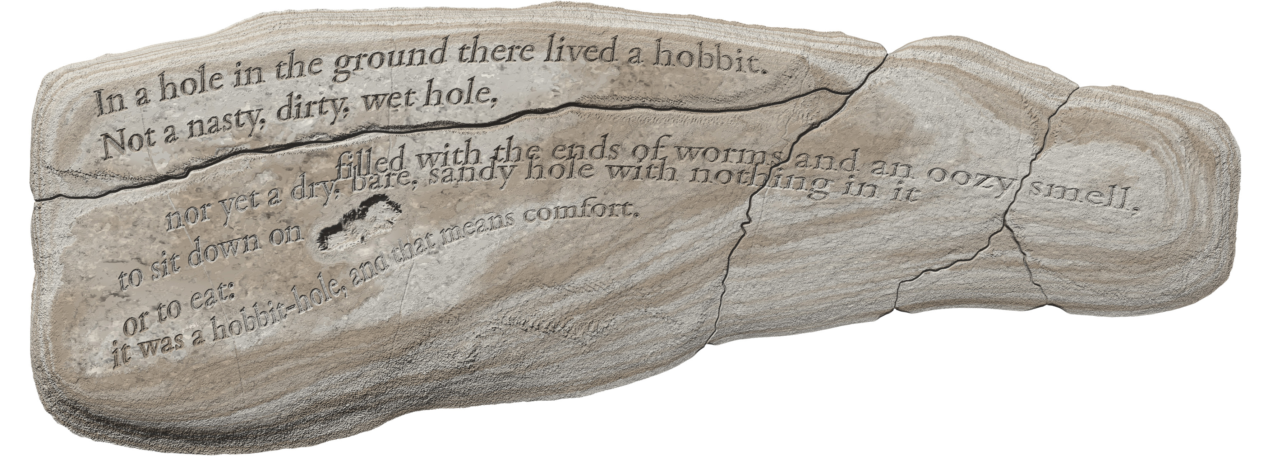

Marking up line beginnings
Exhibit 4.5.C: generic encoding for line beginnings
<p><lb n="1"/>In a hole in the ground...
<lb n="2"/>nasty, dirty, wet...
<lb n="3"/>and an oozy smell...
<lb n="4"/>with nothing in it...
<lb n="5"/>hobbit-hole, and...
</p>
- marking up line beginnings is mandatory for all lines of all our editions, using the empty element <lb/> as in Exhibit 4.5.C, with the following attributes
  - mandatorily, @n as per §4.5.2
  - as applicable, @break for line beginnings interrupting words as per §4.3.2.1
  - when applicable, additional attributes representing the visual features of a line (§8.2.2)
- <lb/> marks line beginnings (rather than transitions) and must thus be present at the start of each line including the first
- since the use of this element is mandatory, it must be present even in inscriptions (or textparts) consisting of a single line

Numbering lines
- every physical line of text in your edition must have a number encoded in the @n attribute of the corresponding <lb/> element
  - line numbering is mandatory even if an inscription (or textpart) contains only one line
- in order to eliminate ambiguity in referencing, every line number in an XML edition must be unique
  - except that if your document has textpart divisions, then the requirement of uniqueness only applies within such a division (§4.2.1.4)
- line numbering in DHARMA editions normally follows a consecutive scheme (§4.5.2.1) but can alternatively follow a repetitive scheme (§4.5.2.2)
  - the repetitive scheme is preferred for certain subcorpora in order to accommodate the line numbering conventions of the subfield
  - the choice between the consecutive or repetitive system shall be determined on the level of subcorpora, but may be overridden on a case-by-case basis
  - in rare cases (namely, copperplate grants with a lost medial plate encoded without the use of textparts as per §6.5.5.3), you will have to resort to complex line numbering even if related editions normally use the consecutive system

Consecutive line numbering
By default, our editions use consecutive line numbering with simple numbers.
- the value of the @n attribute shall be an Arabic numeral starting with 1 for the first line and increasing with a step of 1 for each subsequent line
- line numbers for visually separate incipits may deviate from this numeration scheme as per §4.7.1.1
- line numeration must be restarted in each textpart (this is not a technical requirement but an arbitrary rule for consistency across the corpus, §4.2.1.4)
- line numeration must not be restarted with pagelike partitions, so lines of copperplate inscriptions must be numbered consecutively through the pages (see the Case Study in Appendix A.2 for an illustration)

Repetitive line numbering with complex numbers
When pagelike partitions (§4.4) are present in an inscription, repetitive numeration may be used as an alternative. In the repetitive scheme of line numbering, the numbers are reset for each successive pagelike partition.
- to ensure the uniqueness of line numbers throughout the edition, complex line numbers must be used in this system
  - complex numbers consist of a simple line number as per §4.5.2.1, preceded by a prefix that is the identifier of the current partition, i.e. the value of the @n attribute of the “parent” <pb/> or <milestone/> element; for example,
    - for a stele inscribed on faces A and B, the lines must be numbered "A1", "A2", etc., and "B1", "B2", etc. on these faces (see Appendix A.5 and Appendix A.6 for illustrations)
    - for a set of copper plates with pages 1v and 2r, lines must be numbered "1v1", "1v2", etc., and "2r1", "2r2", etc. on these pages (see Appendix A.3 for an illustration)
  - should the number of your partitions be a numeral or end with a numeral (including Roman numerals), add a . (period, full stop) as a separator between the partition number and the simple line number
    - e.g. if your partitions are numbered A1, b1, etc., then your line numbers should be "A1.1", "A1.2", etc., and "b1.1", "b1.2", etc.
- if your subcorpus follows the repetitive scheme, then it is recommended that for consistency’s sake you use complex line numbers even on copper plates with just a single inscribed page
- also for consistency’s sake, if your subcorpus follows the repetitive scheme, then complex numbers should be preferred for numbering lines across boxlike partitions, even though the uniqueness of line numbers is only a requirement within each such partition

Gridlike partitions
Recall from §4.1 that a gridlike partition is what happens when each line of the text, having reached the end (normally the right edge) of a zone, continues at the beginning (normally the left edge) of the next zone, and returns to the first zone with the next line, as in Exhibit 4.1.A/3. A patchwork of adjacent but physically distinct zones thus together comprise a single virtual text field. We call these partitions gridlike because each zone is analogous to a cell in the grid of a table. The extrinsic boundary is usually incidental and irrelevant to the text’s semantic structure, although it may coincide with a semantic break either inadvertently or by design. Since such a partition often occurs inside a unit of intrinsic structure, the encoding equivalent of a gridlike partition is a milestone element (4.3), namely <milestone/> without @type (§4.6.1).
The encoding of gridlike partitions is optional in DHARMA practice, with §4.7.5 describing when it is desirable. There is no technical limit to the number of different kinds of gridlike partitions that a document may contain, and it may in certain rare cases be expedient to encode more than one gridlike structure in a text, for example when the text is laid out by design in quasi-columns and a secondary grid has been superimposed on the inscription by fragmentation. It is therefore permitted to use gridlike milestones with two (or even more) different units within a single document (or textpart). It will not, however, be possible to create a machine-actionable reference to a section of text involving a combination of gridlike partitions, and keeping track of the grids will be difficult for the encoder and thus error-prone. Therefore, given that encoding gridlike partitions is optional to begin with, consider carefully whether encoding more than one grid in an edition is worth the complication.

Marking up gridlike partitions
Exhibit 4.6.A: generic encoding for gridlike partitions
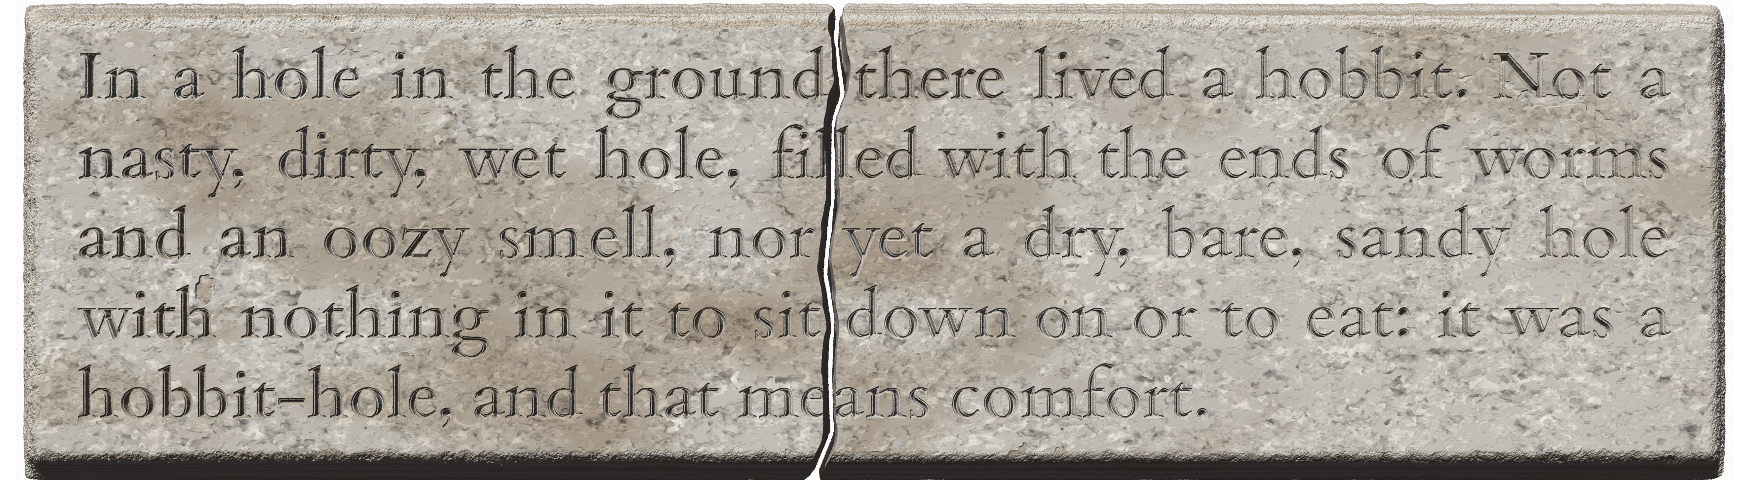
<p>
<lb n="1"/><milestone unit="fragment" n="a"/>In a hole in the ground <milestone unit="fragment" n="b"/>there lived a hobbit. Not a
<lb n="2"/><milestone unit="fragment" n="a"/>nasty, dirty, wet hole, fil<milestone unit="fragment" n="b" break="no"/>led with the ends of worms
...
</p>
- complete encoded illustration: Exhibit 4.7.O
- gridlike partitions may be encoded with the element <milestone/> as in Exhibit 4.6.A, with the following attributes
  - @type="gridlike" is understood by default in the DHARMA scheme, so @type need not be explicitly present
  - mandatorily, @unit to encode the nature of the transition explicitly as per §4.3.1
  - mandatorily, @n as per §4.6.1.1
  - as applicable, @break for partitions interrupting words as per §4.3.2.1
- <milestone/> marks zone beginnings (rather than transitions) and thus, when gridlike zones are present in a document, the element must be created at the start of each such zone including the first
- since gridlike zones cut across lines, the milestones for each zone must be iterated in every line of the text that is affected by the gridlike partition
- gridlike features may occasionally split an akṣara into parts that cannot be represented separately in transliteration; see §4.7.6.1 about encoding such cases
- see §4.7.5 for further discussion of when gridlike partitions should be used

Numbering gridlike milestones
Milestones are numbered for reference. When an XML edition is rendered for display, labels for gridlike milestones will be automatically generated from the encoded number. Unlike pagelike milestones, the <label> element (§4.4.3.2) is not permitted in conjunction with these milestones.
- gridlike milestones are mandatorily numbered in DHARMA editions
- the values of @n recommended for the identification of gridlike partitions are lowercase Latin letters beginning with “a”
  - nonetheless, any numeration scheme may be used depending on your preference, the conventions of your specific field, and the idiosyncratic nature of the grid you are encoding
    - in particular, feel free to use lowercase letters alternating with uppercase ones to denote major/frontal and minor/lateral faces of a three-dimensional object such as a Southeast Asian stele, e.g. A, b, C and d
- the number referring to every zone of the grid must be unique
  - since gridlike milestones with a given combination of @unit and @n will normally be iterated several times in a document (namely once in every line that crosses the zone to which that combination pertains), in complicated cases feel free, at your discretion, to assign a unique number to each cell of the grid
  - should you need to encode gridlike milestones with two or more different units within a single document (e.g. "column" alternating with "fragment" to encode an inscription on whose original gridlike layout a secondary gridlike layout was superimposed by fragmentation), it is recommended that you use a different numeration scheme for the two

Dealing with the realities of extrinsic structure
As already noted (§4.1), in DHARMA editions we deliberately keep the complexity of encoding within reasonable limits. In this section we discuss cases where the primary field of an inscription (or, as the case may be, a partition of a multipage inscription) is accompanied by one or more supplementary zones (§4.7.1) or by page or folio numeration marks (§4.7.2). We also examine situations that are best encoded with boxlike (§4.7.3), pagelike (§4.7.4) and gridlike (§4.7.5) partitions, and discuss some realistic cases with a less-than-neat extrinsic structure, resulting most commonly from fragmentation (§4.7.6).

Peripheral inscribed zones
Smaller inscribed zones supplementing a primary inscribed field and containing, for instance, an auspicious invocation, word or symbol, are generally handled simply through the encoding of lines as explained in §4.7.1.1 and §4.7.1.2.
In the Western epigraphic and codicological tradition, opening symbols, words, phrases or stanzas in a document are called incipit. Concluding passages and symbols are called explicit or, when recording details about the creation of the document, colophon. The last lines of inscriptions can also be visually separated from the rest of the principal inscribed field for physical rather than semantic considerations, such as when the engraver had simply run out of space and wrote the last line(s) in a margin or interpolated it between the regular lines.
In DHARMA editions, neither incipits nor explicits (including colophons) are distinguished in the encoding. If they are semantically autonomous, then they are wrapped, like any other portion of the text, in one or more <ab>, <p> or <lg> elements as applicable (§3). If they are visually offset from the main text, we still prefer not to encode them as partitions in extrinsic structure. Recall that epigraphic lines may appear in any visual arrangement (§4.5), so if one line or a small number of lines is visually offset, it or they do not necessarily have to be conceptualised as a separate zone. Therefore, opening and closing lines are encoded just like any other line, as in Exhibit 4.7.A. The fact that they are spatially offset from the principal body can be annotated, while specially aligned lines may be optionally encoded as per §8.5.1. That said, we do recommend a special numbering scheme for incipits, which shall conventionally indicate to the reader that such lines are spatially offset from the principal field.
Exhibit 4.7.A: incipit and colophon
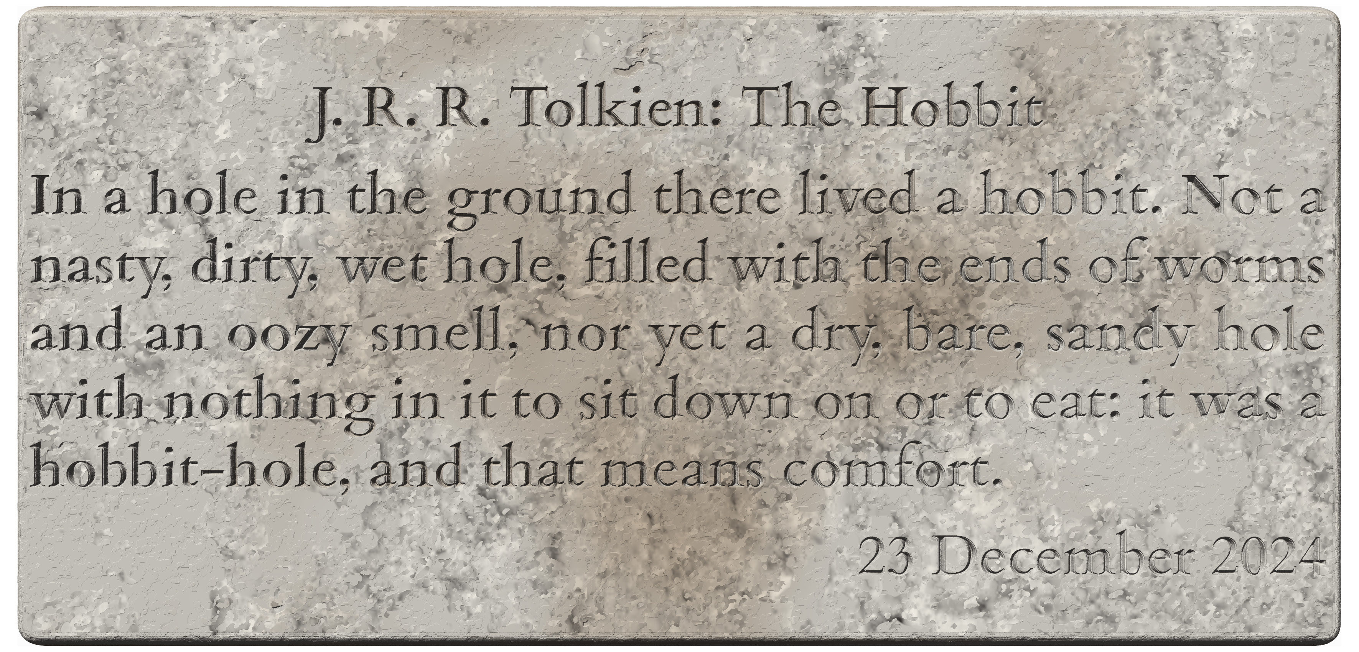
<ab>
<lb n="1"/>J. R. R. Tolkien: The Hobbit
</ab>
<p>
<lb n="2"/>In a hole in the ground...
...
<lb n="6"/>hobbit-hole, and that means comfort.
</p>
<ab>
<lb n="7"/>23 December 2024
</ab>
- the alignment of the first and last line may be encoded as in Exhibit 8.5.A
- the first line could be optionally encoded with special numeration (§4.7.1.1)

Spatially offset opening sections (incipits)
- incipits are usually semantically separate from the principal inscription, and will therefore be normally enclosed in one or more separate <ab>, <p> or <lg> element as applicable (§3)
- the line(s) containing an incipit may be numbered from 1, with the numeration continuing seamlessly into the main field, as in Exhibit 4.7.A
  - this is recommended for incipits whose spatial location fits into the regular sequence of lines in the main field
- optionally, the incipit’s line(s) may be given a different numeration scheme, which by DHARMA convention indicates a visually offset incipit
  - this is recommended when the incipit is outside the regular sequence of lines, such as
    - above the principal field and conspicuously separate from it (as in Appendix A.6)
    - inset into the principal campus at a corner, edge, or floating inside (as in Exhibit 4.7.B)
    - in a margin (as in Exhibit 4.7.C)
  - the recommended numeration scheme is to add a leading 0 (zero) to the numbers of offset lines, then starting the numeration of the main field’s lines normally from 1
    - for simple line numbers, use 01, 02, etc. for visually offset incipit lines, as in Exhibit 4.7.B
    - if the lines of your edition are numbered using the repetitive scheme (§4.5.2.2), use A01, A02, B01, etc. on any pagelike partition where an offset incipit is present
      - see the Case Study in Appendix A.6 for a Cambodian stele as an illustration
  - if desired, you may opt for a different numeration scheme for incipit lines, so long as all line numbers remain unique through an edition (or textpart division)
- if applicable (i.e. if different from the body text), optionally encode the alignment (§8.5.1) and/or orientation (§8.5.2) of the incipit lines using attributes on the <lb/> element, as in Exhibit 4.7.C
  - all other details of presentation (e.g. line length, relative location, interference with the regular lines) shall be recorded for human readers in your annotation, but not encoded explicitly
Exhibit 4.7.B: incipit of two lines inset in the top left corner
<ab>  <lb n="01"/><ab>dr̥ṣṭaM</ab>  <lb n="02"/><ab>siddhaM</ab>  </ab>  <p>  <lb n="1"/><p>agniṣṭomāpto...  <lb n="2"/>sādyaskra-catur-aśvamedha...  <lb n="3"/>m mahārāja-śrī...  ...  </p> | 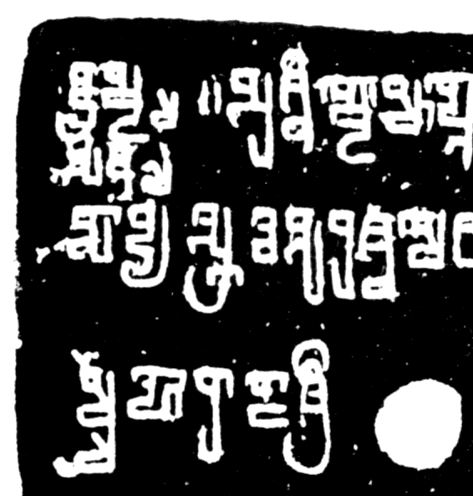
- the two lines of the incipit are outside the regular sequence of the lines of the principal field, so they have been encoded with special numbering

Exhibit 4.7.C: incipit written vertically, with upright glyphs, in the left margin
<ab>  <lb n="01" rend="tb-upright"/>siddhaM  </ab>  <lg n="1" met="sragdharā">  <l n="a"/><lb n="1"/>yasyopasthāna...</l>  <l n="b"/><lb n="2"/>guptānāṁ...</l>  <l n="c"/><lb n="3"/>rājye...</l>  <l n="d"/><lb n="4"/>varṣe...</l>  </lg> | 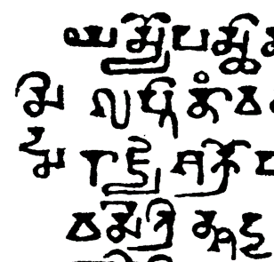
- the incipit is outside the regular sequence of the lines, so it has been encoded with special numbering
- in the edition, the line with the incipit is placed before the lines of the body
- the directionality of this line has been encoded as per §8.5.2

Spatially offset closing lines (colophons)
- colophons are usually semantically separate from the principal inscription, and will therefore be normally enclosed in one or more separate <ab>, <p> or <lg> element as applicable (§3)
- colophons in our texts often begin midline, contiguously with the end of the preceding text
- even when a colophon occupies a line or lines on its own, such lines shall usually not be distinguished in the encoding from regular lines
  - passages interpreted as colophons but physically integrated with the partition and line structure of the main field shall not be marked up in any special manner
    - number their lines consecutively after the last regular line
  - when one or a few last lines are aligned or oriented differently than the lines of the main field, as in Exhibit 4.7.D
    - then regardless of whether these lines comprise a colophon, these visual layout features can be optionally encoded as per §8.5.1 and §8.5.2
- however, when a smaller piece of text that is deemed to belong rather to the end than to the beginning of the text (i.e. to be an explicit rather than an incipit) is inset into the principal campus at a corner, edge, or floating inside (as in Exhibit 4.7.E), this may be represented by a different numeration scheme, which by DHARMA convention indicates a visually offset explicit
  - the recommended numeration scheme is to add a leading 0 (zero) to the numbers of offset lines
    - for simple line numbers, use 01, 02, etc. for visually offset explicit lines, as in Exhibit 4.7.B
    - if the lines of your edition are numbered using the repetitive scheme (§4.5.2.2), use A01, A02, B01, etc. on any pagelike partition where an offset explicit is present
  - if desired, you may opt for a different numeration scheme for explicit lines, so long as all line numbers remain unique through an edition (or textpart division)
- all other details of presentation (e.g. line length, relative location, interference with the regular lines) shall be recorded for human readers in your annotation, but not encoded expressly
Exhibit 4.7.D: last line inscribed vertically in the right margin
<p>  <lb n="1"/>In a hole in the ground  <lb n="1"/>there lived a hobbit. Not  <lb n="1"/>a nasty, dirty, wet hole,  <lb n="1"/>filled with the ends of  <lb n="1"/>worms and an oozy  <lb n="1"/>smell, nor yet a dry, bare,  <lb n="1"/>sandy hole with nothing  <lb n="8"/>in it to sit down on or to  <lb n="9"/>eat: it was a hobbit-hole  <lb n="10" rend="bt-rotated"/>and that means comfort.  </p> | 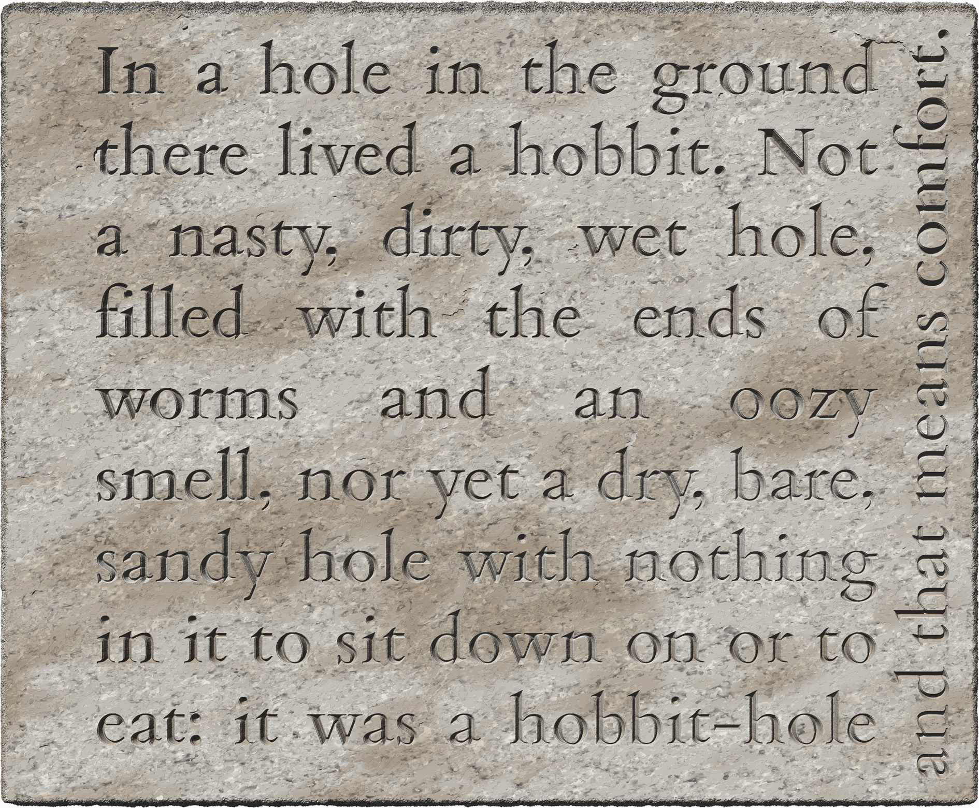
- the last line was presumably written in the margin because the engraver had run out of space
- no encoding indicates this quirk of layout
- but the directionality of the last line is encoded as per §8.5.2

Exhibit 4.7.E: explicit floating within the principal inscribed field
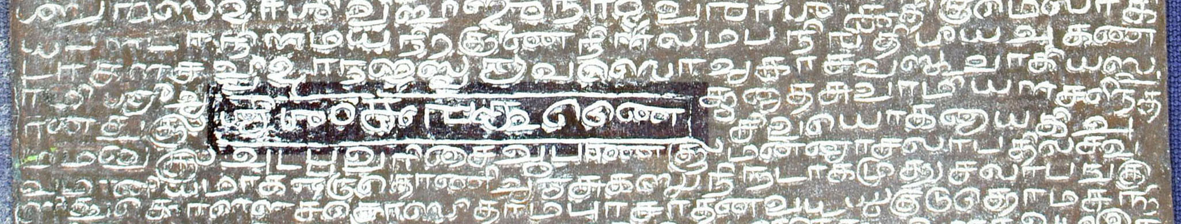
<p>
...
<lb n="60" break="no"/>āṉat=tuk=ku=M</p>
<p>civayōka-ṉāyaki A
<lb n="61" break="no"/>mmaṉuk=ku=M Aṭap=pa-varicai Āparaṇat=tu=k=ku=M
...
</p>
<ab>
<lb n="01"/><seg rendition="class:36768 maturity:83213">śrī-śaṁkaran·</seg> tuṇai
</ab>
- the text in the frame is a blessing that is not connected to the adjacent text
- the frame is located in the lower third of the verso of a copper plate
- the contents of the frame have been represented as a specially numbered explicit
- in the edition, it is placed in logical sequence after the lines of the body
- at the physical location of the inset, only the regular body lines are represented in the edition
- the Grantha script used in part of the blessing is encoded as per §8.2.3.4

Pagination or foliation: “forme work”
Copperplate sets sometimes bear numbers to indicate the reading order of folios. In principle, other inscriptions involving pagelike partitions (§4.4) might also include labels or numeration outside the principal field of one or more pages. The generic term for such items is forme work, borrowed from printing jargon, where forme means the frame constructed to hold the blocks of movable type that constitute a page. In our encoding practice, the use of forme work shall be restricted to cases where very short, identical or similar pieces of text (typically for numeration) appear in conjunction with one or more pages of a document involving pagelike partitions. In other cases, consider whether the text item you are dealing with is rather an incipit (§4.7.1.1) or a colophon (§4.7.1.2). The encoding of forme work is illustrated in Exhibit 4.7.G.

Encoding forme work
Exhibit 4.7.F. Location of forme work with respect to the principal field
top-left | top | top-right
left | principal  inscribed  field | right
bot-left | bottom | bot-right

- forme work items shall be wrapped in the element <fw>, with the following attributes
  - mandatorily, @n (even if there is only one forme work item in your document)
    - the value of @n shall be the same as the @n of the <pb> (or <milestone/>) element marking the beginning of the page on which the forme work item appears, e.g. “1v”, “2v”, etc.
  - mandatorily, @place relative to the principal inscribed field, with values as shown in Exhibit 4.7.F
    - should forme work be partly or wholly inside the principal field, use the value that best describes its location relative to the centre of the inscribed field
- details of presentation (e.g. precise location, interference with the regular lines) shall be recorded for human readers in your metadata (layout description), but not encoded explicitly
Exhibit 4.7.G: foliation in the right margin
<p>  <pb n="1r"/>  <fw n="1r" place="right">  <num value="1">1</num>  </fw>  <lb n="1"/>In a hole in the ground...  <lb n="2"/>nasty, dirty...  ...  </p> | 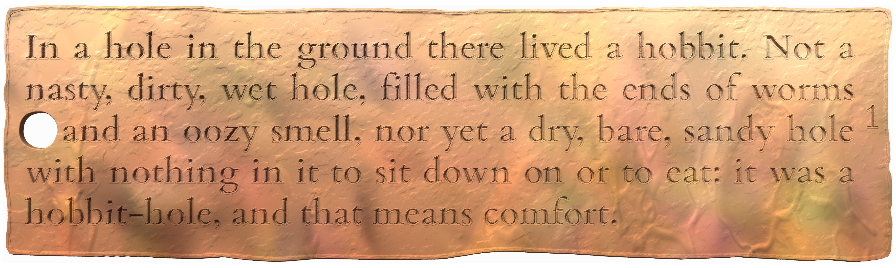
- for a complete encoded example see the Case Study in Appendix A.2

The position of forme work in the encoded edition
- as in the case of boxlike partitions (§4.2), the content of forme work is a complete and meaningful unit in itself, but unlike a textpart division, forme work is a supplement to (rather than a subunit of) the principal text of an inscription and is associated with a specific page
  - the <fw> element shall be placed immediately after the <pb/> (or <milestone/>) element marking the start of the page on which the forme work item is found, therefore
    - it must come before the first <lb/> element on that page
    - it will normally appear inside block-level containers for intrinsic structure (§3), often interrupting the course of the text within such containers
      - the occurrence of such an interruption is encoded on the page and line beginnings and does not affect the markup for forme work
    - the <fw> element may be outside block-level containers when forme work is present on a page whose <pb/> element is outside block-level containers, i.e. in the rare but potentially possible cases where a page bears forme work, but the rest of the page is blank (§4.4.2.2) or lacunose (§6.5.4)
- should your inscription have two (or more) foliation marks on a single page, encode two (or more) <fw> elements one after the other, in an order that seems most logical
  - in this case, add trailing numbers to the number generated from the page number, e.g. <fw n="2v1">, <fw n="2v2">, etc.

The content of forme work
- the <fw> element shall by default be the direct parent of the text of the forme work, without an additional text container such as <ab>
- as a rule, line beginnings shall not be marked up within forme work, with the following exceptions
  - should you encounter forme work written in two or more distinct lines, use an <lb/> element (§4.5) to encode each line beginning
    - in this case we recommend using line numbers prefixed with the number of the <fw> element, e.g. “1r-1”, “1r-2”, etc.
  - if the orientation of the forme work is different from that of the principal field, then this can be encoded optionally, but only on <lb/> elements, therefore if you wish to avail of the option, create a line beginning within the forme work and encode orientation on this <lb/> element as per §8.5.2
- numeral signs used in foliation/pagination must be marked up as usual
  - for numeric glyphs other than decimal digits (§5.2.1)
  - for the number denoted by the signs (§9.1)

When to use textpart divisions
Since most of the texts for which we create documentary editions are not long enough to warrant division into chapters on a purely semantic basis, in DHARMA encoding practice we strive to keep complexity down by restricting the use of textpart divisions to well-warranted situations where a major semantic division coincides with a conspicuous break in extrinsic structure. To continue our book analogy for structural elements, we prefer to create textpart divisions for units whose semantic independence is not merely like that of chapters in any book, but more like that of short stories in an anthology or scholarly articles in a compiled volume. This section identifies the specific situations for which we consider textpart divisions ideal or acceptable.
In any other case where you feel that textpart partitions may be relevant for a text partitioned into physical and semantic sections, consider carefully whether this encoding method is ideal, or if alternatives would be feasible (on which see also §4.7.4.2).

Copperplate sets with an inscribed seal
Since the seal text is not an integral part of the text of a copperplate charter, we always encode copperplate sets with inscribed seals as textpart divisions, as shown in Exhibit 4.7.H.
Exhibit 4.7.H: copper plates with inscribed seal
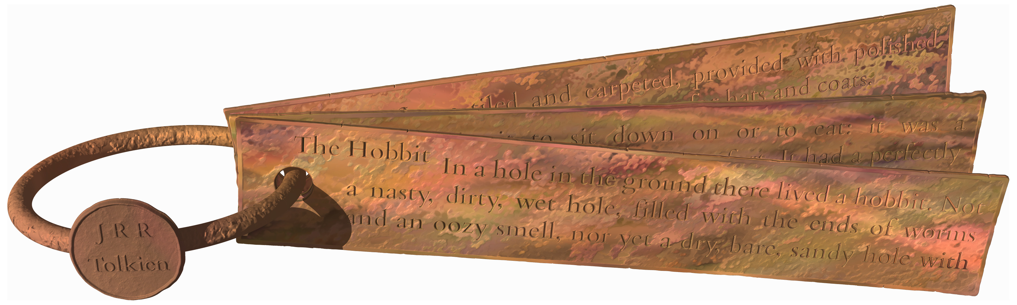
<div type="edition">
<div type="textpart" n="A">
<head xml:lang="eng">Seal</head>
...
</div>
<div type="textpart" n="B">
<head xml:lang="eng">Plates</head>
...
</div>
</div>
- complete encoded illustration: Appendix A.2
- this applies to single or multiple plates provided with a seal inscription that is represented in the edition, regardless of whether the seal is soldered to a plate, attached with a ring to a set of plates, or currently detached
  - including seal inscriptions which are completely illegible and represented only as a lacuna
  - but excluding cases where no seal inscription is represented in the edition for any reason, such as
    - when the seal never bore an inscription
    - when the seal as a whole is lost
- for the sake of consistency throughout the corpus, the textpart for the seal text shall precede the textpart for the plates
  - unless the seal’s point of attachment is at the bottom of a single plate
- should more than one inscribed seal be present, create separate textparts for each, in the sequence you deem most appropriate
- the textparts shall be numbered normally, without @subtype, but with custom headings “Seal” and “Plates” as shown in Exhibit 4.7.H
  - for more than one inscribed seal, use “First seal,” “Second seal,” etc. in the headings

Non-contiguous fragments
When an inscription survives in two or more fragments which were not physically contiguous on the unbroken support, it is usually not possible to reconstruct how many lines of text were lost between the two fragments. Sometimes, even the order in which the extant fragments were meant to be read may be doubtful. In such cases it is best to encode each fragment as a standalone textpart as in Exhibit 4.7.I, with the lines numbered separately in each.
Exhibit 4.7.I: non-contiguous fragments
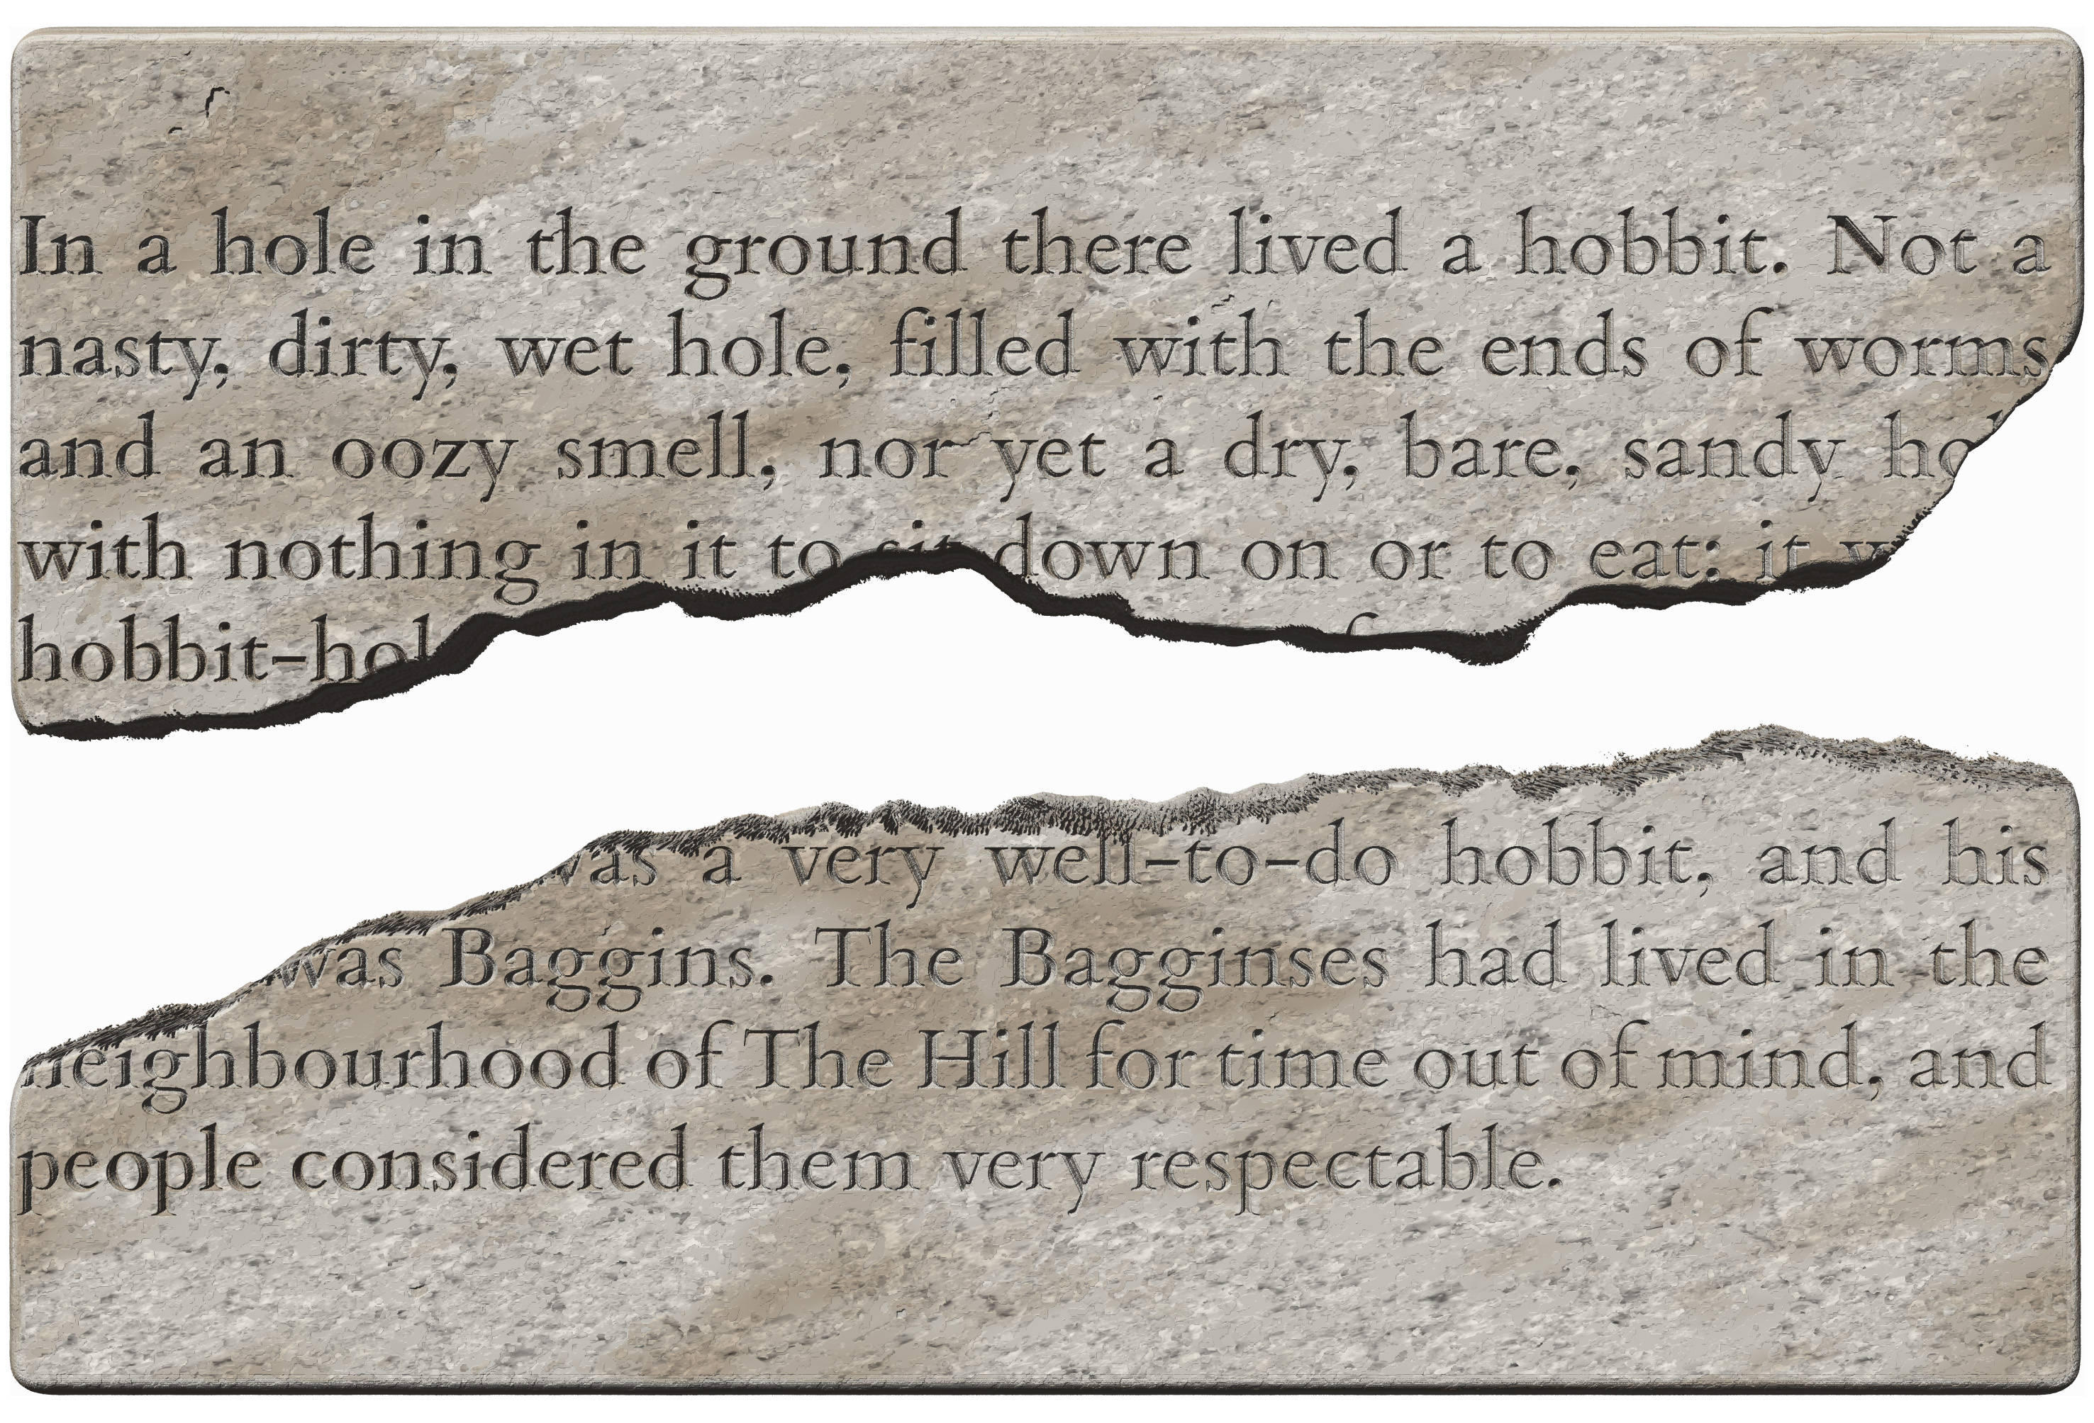
<div type="edition">
<div type="textpart" subtype="fragment" n="A">
...
</div>
<div type="textpart" subtype="fragment" n="B">
...
</div>
</div>
- complete encoded illustration: Appendix A.1
- this applies whenever the text connecting the extant parts of the text is not represented at all in the edition
  - such a situation might also come about in an inscription that is not fragmented, but so thoroughly worn in the middle that its lines cannot even be counted, much less read
  - however, if the connecting text is represented, even if only so far as its basic structure (e.g. lines, copperplate pages), then the fragments need not and should not be encoded as textparts
  - see also §6.5.4 about encoding massive lacunae without resorting to textparts
- the textparts shall be created in the sequence you deem most appropriate
- the textparts shall be numbered normally, with @subtype="fragment" as shown in Exhibit 4.7.I
  - resulting in auto-generated headings such as “Fragment A”
  - alternatively, you may choose to use descriptive custom headings, for example as shown in Exhibit 4.2.B
- incomplete block-level containers on any fragment shall be encoded as per §3.2.3.1

Trial engravings
Trial engravings are short, often unintelligible, pieces of text outside the campus of the main inscription, which were presumably created for testing purposes before engraving the actual inscriptions and were probably not visible when the finished inscription was displayed in its original setting. We always encode trial engravings as textpart divisions.
- textparts for trial engravings may be created before or after the textpart for the main inscription as you deem fit
- the textparts shall be numbered normally, with @subtype="trial" for the trial engravings and no @subtype for the main inscription (unless one is warranted for some reason beyond the fact that it is accompanied by trial engravings)
  - this value of @subtype is an exception to the general preference for classifying textparts purely on the basis of physical nature, in order to facilitate searching the corpus for trial engravings
- a custom heading may be created at your discretion, but @subtype="trial" must always be present on the trial textparts

Same message in different languages
When two inscriptions on the same support or on associated supports carry an identical (or closely related) message in two (or more) separate languages, these can be encoded as textpart divisions.
- this applies whenever the two inscriptions are connected closely enough to be recognised as parts of a single epigraphic installation, but nonetheless separate in layout
  - language change within a single integral inscription must not be encoded with textpart divisions
  - for further guidance on multilingual inscriptions, including the encoding of language, see §8.1.2
- create the textparts in the order you deem most appropriate
- the textparts shall be numbered normally, with @subtype or custom headings at your discretion

No obvious reading order
When, for whatever reason, there is no obvious order in which physically and semantically distinct zones of text ought to be read, but there is nevertheless good reason for treating them as a single document rather than as separate inscriptions, you may choose to encode them as textpart divisions.
- this applies in particular to multiple short inscriptions engraved on various parts of a support such as a rock face, a monument or a sculpture
  - if there is reason to believe that the inscriptions do not constitute a semantic whole and/or that they were engraved on separate occasions (as for instance various graffiti on a monument), then it is preferable to encode each as a separate edition
- create the textparts in the order you deem most appropriate
- the textparts shall be numbered normally, with @subtype or custom headings at your discretion
  - custom headers such as “Head”, “Halo”, “Back” and “Pedestal” (etc.) are recommended for inscriptions on various parts of a statue

Complex, hierarchical extrinsic structure
If an inscription is written in several distinct zones and one or more of these zones are further subdivided, this cannot be represented in our encoding because for practical reasons we have chosen not to employ more than one kind of pagelike partition in a division (§4.1). If you are certain that the hierarchical structure must be reflected in your encoded edition, you may choose to employ textpart divisions for the top level of such a hierarchical structure, and pagelike partitions within one or more of the divisions as applicable. Keep in mind, however, that there is no solid advantage to attempting to faithfully represent every detail of a structurally complex document in your encoding. Creating separate editions (in separate XML documents) is also a viable alternative to creating textparts in a single edition, especially if the parts concerned are integral in themselves, if they have little semantic connection, and especially if they were engraved on separate occasions or on separate objects.

When to use pagelike partitions
The use of the <pb/> element is restricted in DHARMA practice to genuine pages, i.e. the sides of effectively two-dimensional sheets of a thin material. Other pagelike partitions, encoded with <milestone type="pagelike">, can also occur on stone and other supports. When deciding whether to encode a pagelike partition, the questions to ask yourself is whether the visual separation of the zones is strong enough to warrant a partition at all, and if yes, whether the semantic distinctness of the zones is strong enough to warrant a boxlike (rather than a pagelike) partition.

A pagelike partition is not always necessary
Sections of a reasonably coherent text are sometimes separated by vertical (interlinear) space in what is otherwise a fairly well-defined single zone. If the first or last line (or few lines) of an inscription are set apart visually from the rest, see §4.7.1 for the relevant encoding. Otherwise, choose one of the following options depending on your judgement of the degree to which the sections are semantically and physically distinct.
- if there is little to no semantic discontinuity between the sections, and the physical separation is not very emphatic, as in Exhibit 4.7.J, then encode the text as a single unit, ignoring the interlinear space in your edition and only describing it in your annotation
  - since epigraphic lines may appear in any visual arrangement (§4.5), encoding one line after another does not assert that the lines are equidistant
- if the sections are semantically separate and/or the physical separation is emphasized (for instance by a large space or by a carved feature), then encode pagelike partitions as per §4.4
- if the sections are completely independent, then boxlike partitions may be applicable, but before encoding such a partition, consider the guidelines in §4.7.4.2
Exhibit 4.7.J: a quasi-partition with interlinear space
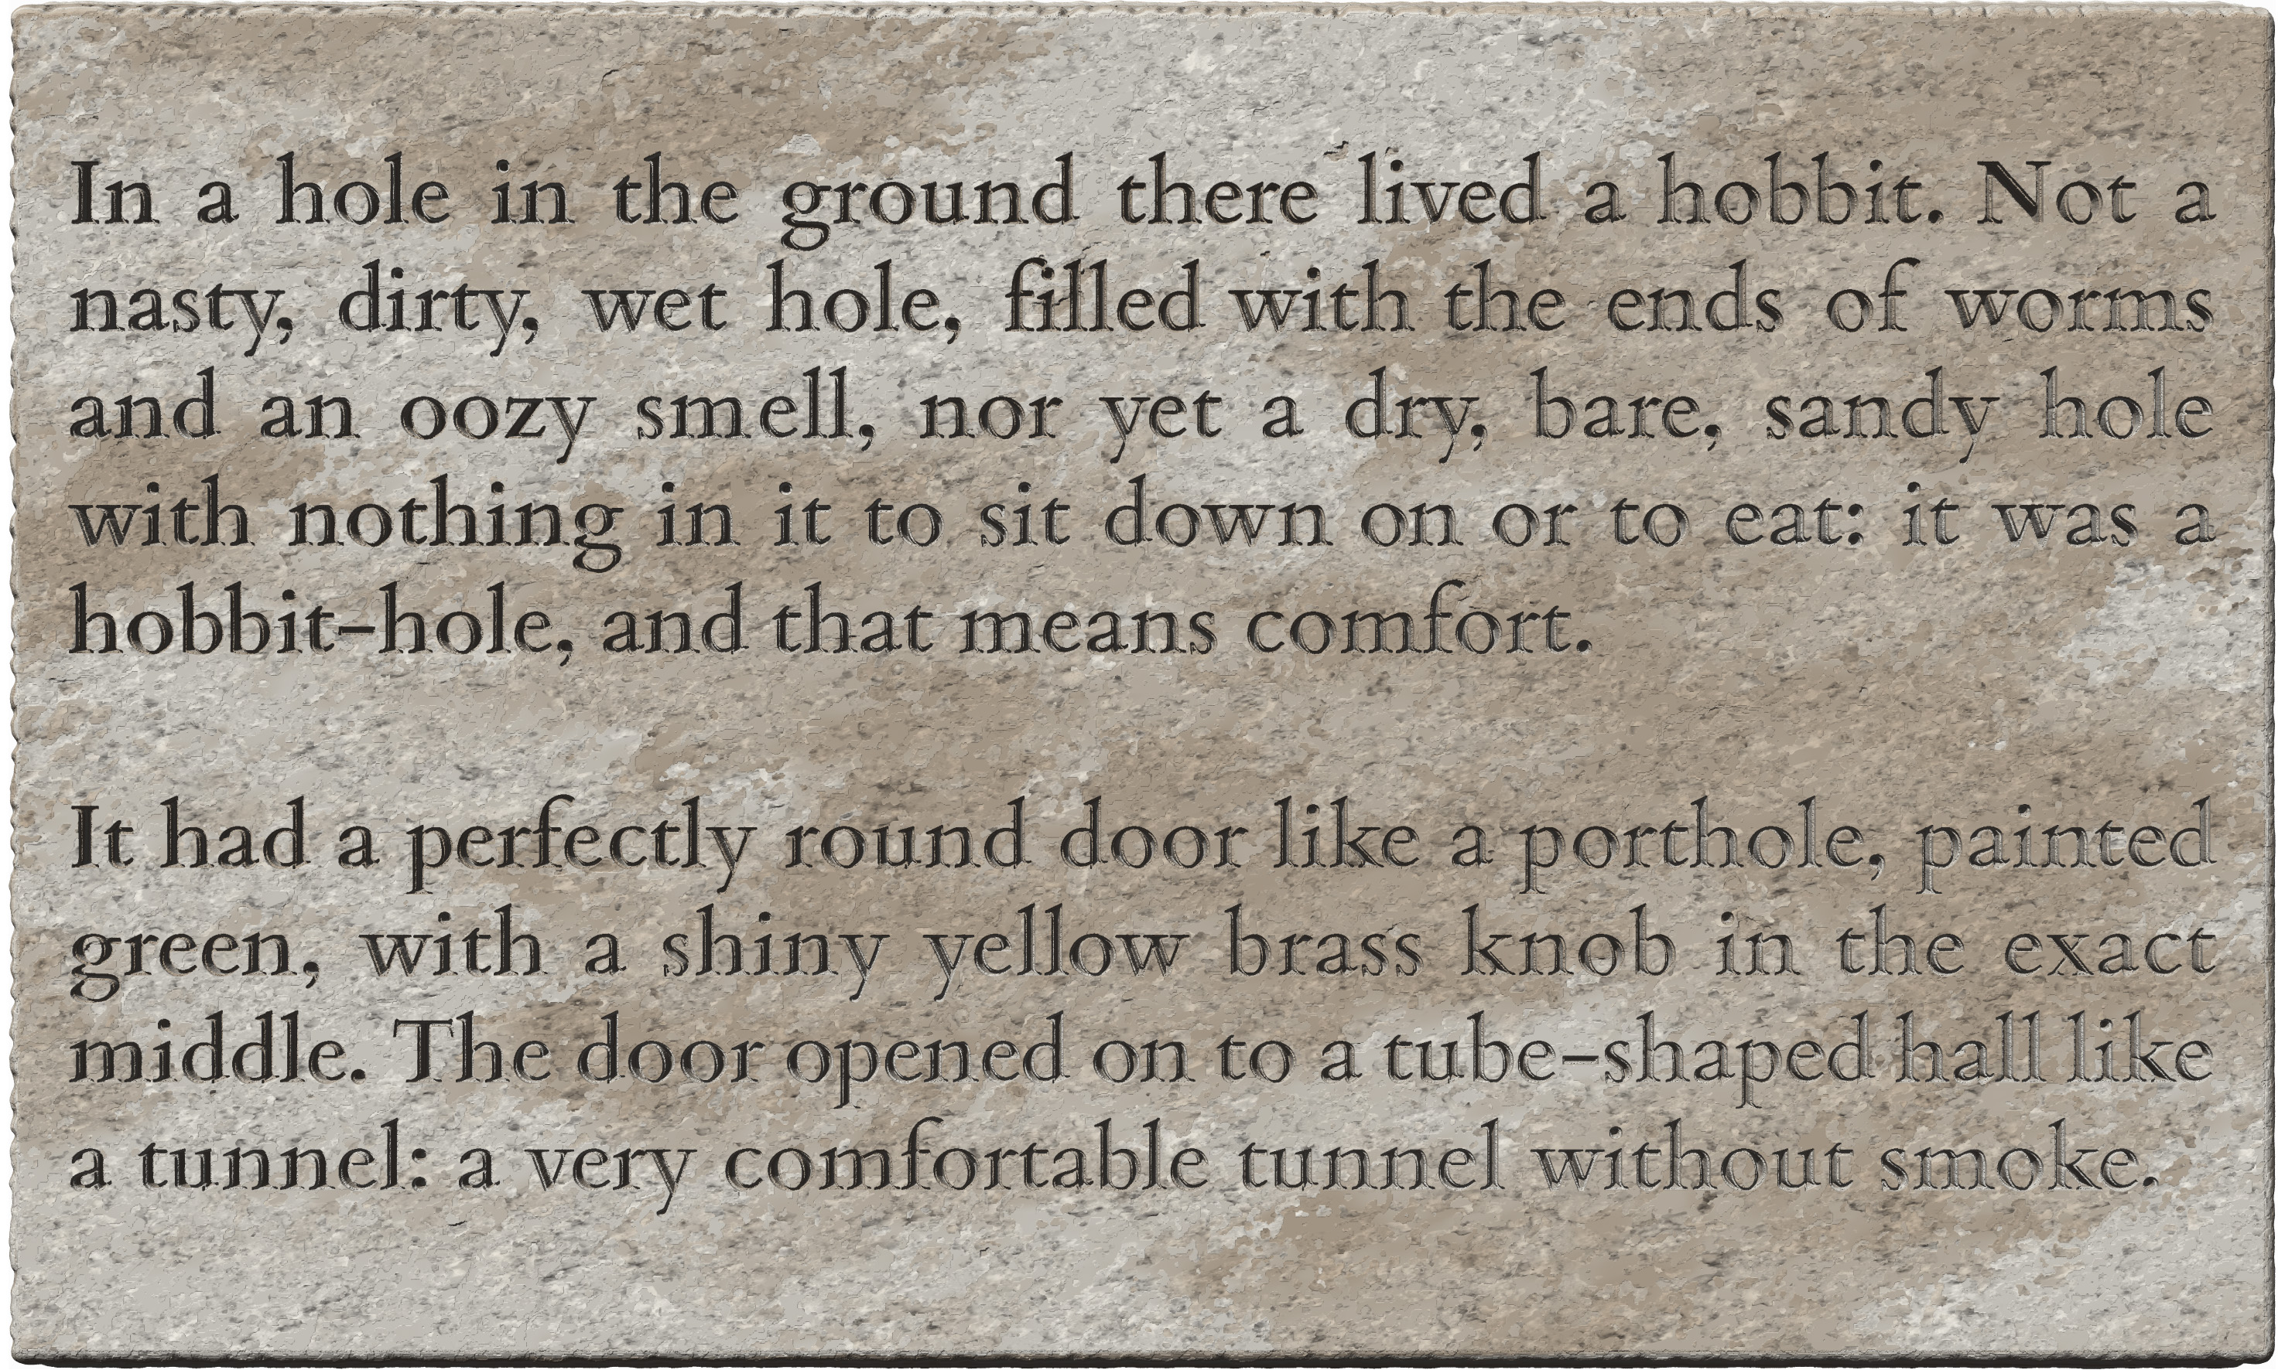
<p>
<lb n="1"/> In a hole in the ground there lived a hobbit. Not a
...
<lb n="5"/><p>hobbit-hole, and that means comfort.
</p>
<p>
<lb n="6"/>It had a perfectly round door like a porthole, painted
...
</p>
- this inscription can be perceived as a single inscribed field
- the two blocks of writing are semantically cohesive and their visual separation is moderate
- therefore the text has been encoded simply as a sequence of lines

Pagelike partitions are preferable to boxlike partitions
- pagelike partitions are normally applicable when the text of an inscription is laid out in two or more zones which are to be read consecutively and are not genuine pages on a thin, effectively two-dimensional support
- pagelike zones may be presented in any arrangement on one or more surfaces, e.g.
  - one below the other on a single surface, as in Exhibit 4.7.J
  - one beside the other on a single surface, as in Exhibit 4.7.K
  - on adjacent faces (or face-pairs) of a three-dimensional object (e.g. stele or pillar), as in Appendix A.5 and Appendix A.6)
  - on multiple linked objects (e.g. two jambs of a doorway, as in Exhibit 4.7.L)
- if you deem the zones to be visually distinct enough to warrant encoding a partition (cf. §4.7.4.1), then, regardless of their topology, the appropriate encoding must be selected on the basis of the zones’ semantic distinctness:
  - if a unit of intrinsic structure begins at the end of one zone and continues in the next as in Exhibit 4.7.K,
    - a boxlike partition cannot be created, because its boundaries would overlap the boundaries of the intrinsic unit
    - the only suitable encoding for such a case is thus a pagelike partition
    - this applies regardless of how conspicuously the zones are separated in space, so the two doorjambs in Exhibit 4.7.L must be encoded along the same lines
  - if the extrinsic partition coincides with a semantic boundary as in Exhibit 4.7.M,
    - it is technically possible to encode a boxlike partition
    - but we nonetheless prefer to treat such a partition as pagelike and encode boxlike partitions only in well-warranted cases (§4.7.3)
  - however, if the text of the two zones is semantically independent, so the two are basically two separate (though related) texts, as in Exhibit 4.7.N,
    - then the encoding of a boxlike partition is technically possible and permitted under §4.7.3
    - encoding as a pagelike partition does, however, remain a viable alternative
    - a case-by-case judgement must be made at your discretion, based on the degree of semantic connection perceived between the zones
      - in a structurally complex inscription, the presence of subdivisions within one or more zones may also warrant the use of boxlike partitions (§4.7.3.6)
Exhibit 4.7.K: two pagelike zones on a slab
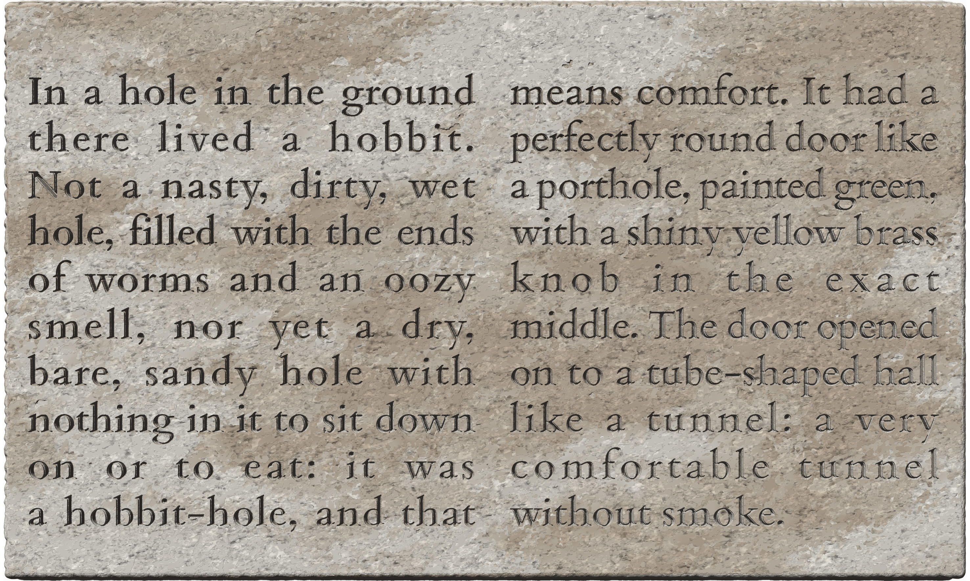
<p>
<milestone type="pagelike" unit="column" n="A"/>
<lb n="1"/>In a hole in the ground
<lb n="2"/>there lived a hobbit.
...
<lb n="10"/>a hobbit-hole, and that
<milestone type="pagelike" unit="column" n="B"/>
<lb n="11"/>means comfort. It had a
<lb n="12"/>perfectly round door like
...
<lb n="20"/>without smoke.
</p>
- the partition occurs within a sentence, and it is therefore technically impossible to encode a boxlike partition
- therefore, pagelike milestones are used
- line numbers continue in the second column; alternatively, complex line numbers (§4.5.2.2) could be used, as illustrated in the Case Study in Appendix A.5

Exhibit 4.7.L: doorjambs as pagelike zones
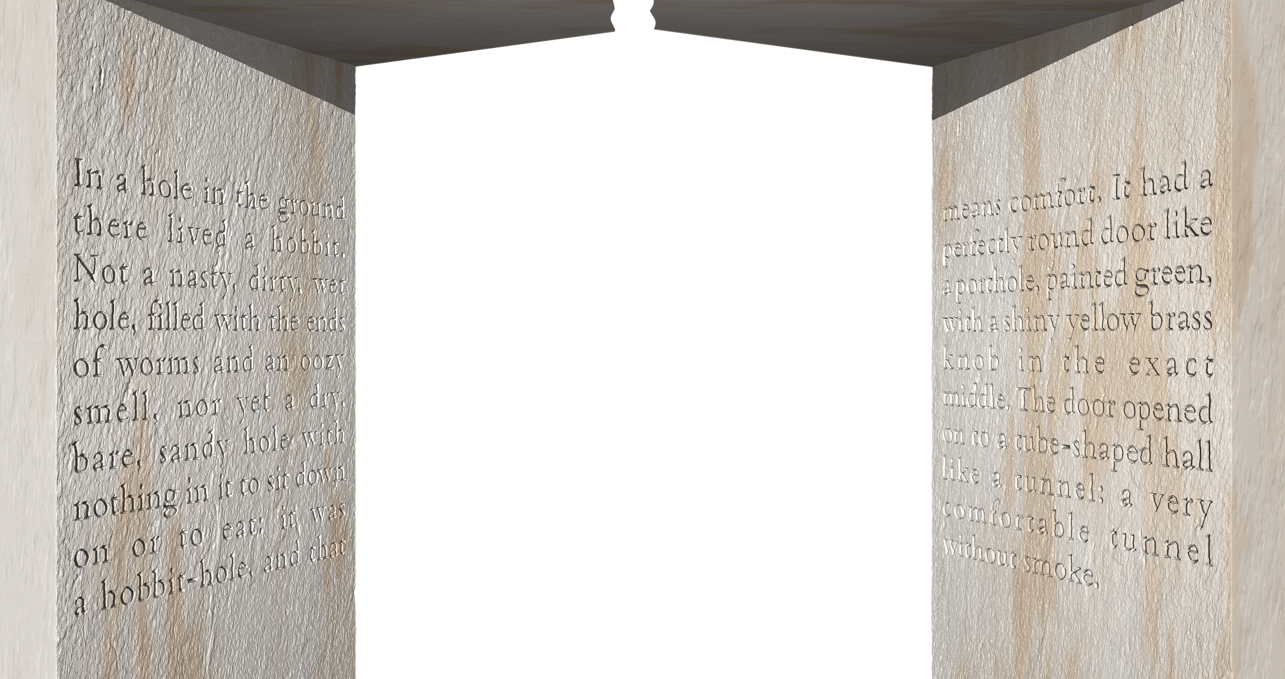
<p>
<milestone type="pagelike" unit="item" n="A"/>
<lb n="1"/>In a hole in the ground
<lb n="2"/>there lived a hobbit.
...
<lb n="10"/>a hobbit-hole, and that
<milestone type="pagelike" unit="item" n="B"/>
<lb n="11"/>means comfort. It had a
<lb n="12"/>perfectly round door like
...
<lb n="20"/>without smoke.
</p>
- the structure of this inscription is identical to that in Exhibit 4.7.K, differing only in topology
- the partition occurs within a sentence, and it is therefore technically impossible to encode a boxlike partition
- therefore, pagelike milestones are used
- line numbers continue in the second column; alternatively, complex line numbers (§4.5.2.2) could be used, as illustrated in the Case Study in Appendix A.5

Exhibit 4.7.M: pagelike partition at semantic boundary
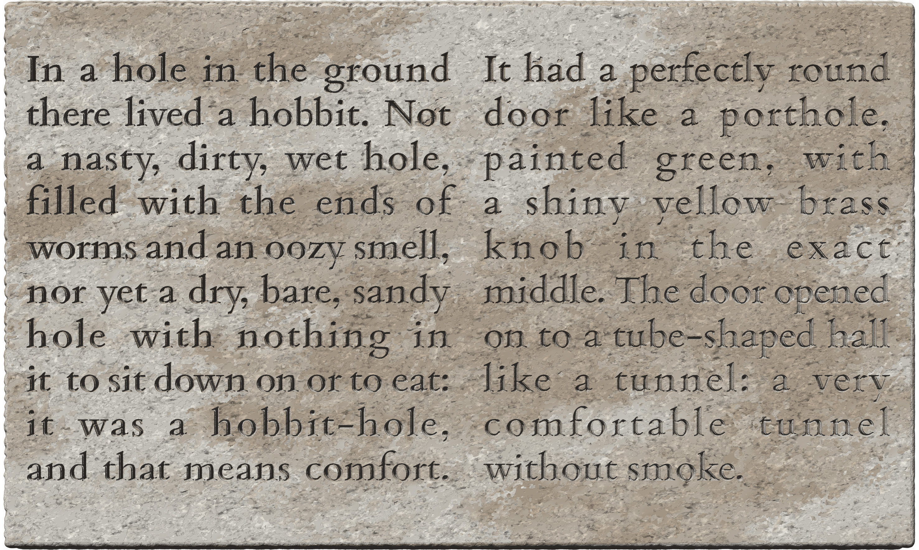
- the partition occurs between sentences, where a new unit of intrinsic structure can be started
- encoding as a boxlike partition is technically possible, but not warranted
- this inscription must be encoded with a pagelike partition

Exhibit 4.7.N: pagelike or boxlike partition at major semantic discontinuity
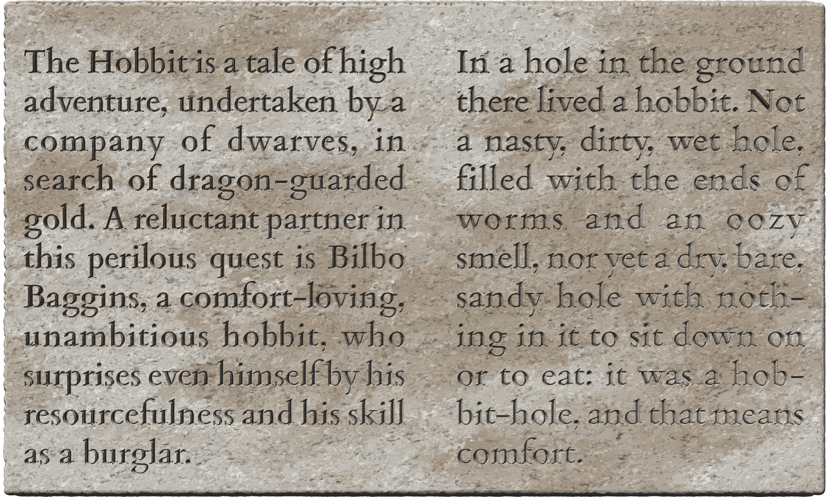
- the partition coincides with a major semantic discontinuity
- encoding as a boxlike partition is technically possible and may be warranted, at your discretion

When to use gridlike partitions
The encoding of gridlike partitions with milestones is, as already noted in §4.1, not mandatory and should be applied on a case-by-case basis, judging the feasibility of encoding versus the anticipated usefulness of having the partitions represented in the edition. Representing such partitions in the encoding can be especially advantageous if some elements of description apply only to specific partitions (e.g. certain fragments are kept in a different place, or certain facets of the support are in a different state of preservation), because each partition can then be referred to unambiguously, and the edition will show which parts of the text correspond to which partition. If you opt not to encode gridlike milestones, treat the text straightforwardly as if it occupied a simple surface, and describe the layout in as much detail as you wish in your annotation.
This section discusses neat gridlike structures that involve vertical or near-vertical grid lines. Guidance is provided separately in §4.7.6 for untidy structures, most often (but not always) generated by fragmentation, and also usually amenable to encoding as gridlike partitions.

Grids of architectural blocks
A gridlike extrinsic structure may be the result of physically separate (or at least separable) objects constituting a complex support. This most commonly happens with blocks of masonry constituting part of a wall which bears an inscription, as in Exhibit 4.7.O.
- encoding gridlike partitions is recommended for building blocks, especially if they are not currently integrated into a structure
  - the milestones shall be encoded with @unit="block" (§4.3.1)
Exhibit 4.7.O: gridlike partitions for text inscribed across architectural blocks
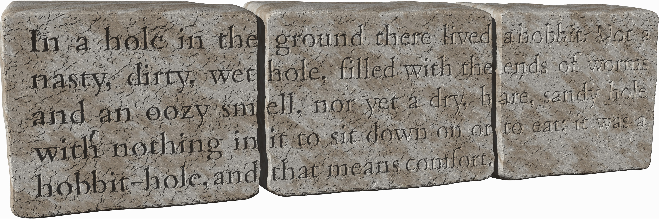
<p>
<lb n="1"/><milestone unit="block" n="a"/>In a hole in the <milestone unit="block" n="b"/> ground there lived <milestone unit="block" n="c"/>a hobbit. Not a
<lb n="2"/><milestone unit="block" n="a"/>nasty, dirty, wet <milestone unit="block" n="b"/>hole, filled with the <milestone unit="block" n="c"/>ends of worms
<lb n="3"/><milestone unit="block" n="a"/>and an oozy sm<milestone unit="block" n="b" break="no"/>ell, nor yet a dry, b<milestone unit="block" n="c" break="no"/>are, sandy hole
<lb n="4"/><milestone unit="block" n="a"/>with nothing in <milestone unit="block" n="b"/>it to sit down on or <milestone unit="block" n="c"/>to eat: it was a
<lb n="5"/><milestone unit="block" n="a"/>hobbit-hole, and <milestone unit="block" n="b"/>that means comfort.
</p>
- notice the use of @break="no" for the two milestones in line 3, which interrupt a word (§4.3.2.1)

Grids of fragments
The breakage of an inscription’s support can result in a gridlike partition, as in Exhibit 4.7.P. Situations where fragmentation produces a more disorderly structure are discussed separately in §4.7.6 below.
- encoding gridlike partitions is recommended for fragments, especially if the pieces have different proveniences, custodial histories or are preserved at different locations
  - the milestones shall be encoded with @unit="fragment" (§4.3.1)
Exhibit 4.7.P: gridlike partitions for text inscribed across contiguous fragments
<p>
<lb n="1"/><milestone unit="fragment" n="a"/>In a hole in the ground <milestone unit="fragment" n="b"/>there lived a hobbit. Not a
<lb n="2"/><milestone unit="fragment" n="a"/>nasty, dirty, wet hole, fil<milestone unit="fragment" n="b" break="no"/>led with the ends of worms
<lb n="3"/><milestone unit="fragment" n="a"/>and an oozy sm<milestone unit="fragment" n="b" break="no"/>ell, nor <milestone unit="fragment" n="b"/>yet a dry, b<milestone unit="fragment" n="c" break="no"/>are, sandy hole
<lb n="4"/><milestone unit="fragment" n="a"/>with nothing in it to sit <milestone unit="fragment" n="b"/>down on or to eat: it was a
<lb n="5"/><milestone unit="fragment" n="a"/>hobbit-hole, and that me<milestone unit="fragment" n="b" break="no"/>ans comfort.
</p>
- notice the use of @break="no" for milestones in lines 2 and 5, which interrupt a word (§4.3.2.1)

Grids of quasi-columns
When an inscription on a single surface is divided into several zones, this usually produces a pagelike or, occasionally, a boxlike partition (§4.7.4.2). However, especially when an inscription consists of many stanzas of verse following an identical or similar metre, the text may be arranged in the form of quasi-columns with a horizontal space between them, as in Exhibit 4.7.Q. We call these ‘quasi-columns’ because in true columns the reading sequence is from the top to the bottom of one column, then proceeding to the next (which is a pagelike partition, §4.7.4.2), while here each line crosses over into the next column before continuing with the next line of the first column.
The boundaries of stanzas and their subunits are often emphasised with spaces in inscriptions, but if the layout is not deliberately designed with quasi-columns, these spaces will be staggered throughout the lines instead of constituting a grid (illustrated in Exhibit 5.4.A). In such a case, a gridlike partition is not present.
- encoding gridlike partitions is recommended for quasi-columns only if the columns are a neat and salient feature of the inscription’s layout
  - in this case, the milestones shall be encoded with @unit="column" (§4.3.1)
  - if quasi-columns are present only in a part of the inscribed field, then encode gridlike milestones only for the lines affected by the quasi-columns (cf. §4.7.6.1)
- if quasi-columns are encoded with milestones, then the space between them shall not be represented as space (§5.4.1) in your edition
- if you choose not to encode a gridlike partition for spaced verse (whether because you consider it unnecessary or because the spacing is irregular), the spaces shall be encoded as per §5.4.1
Exhibit 4.7.Q: gridlike partitions for verse inscribed in quasi-columns
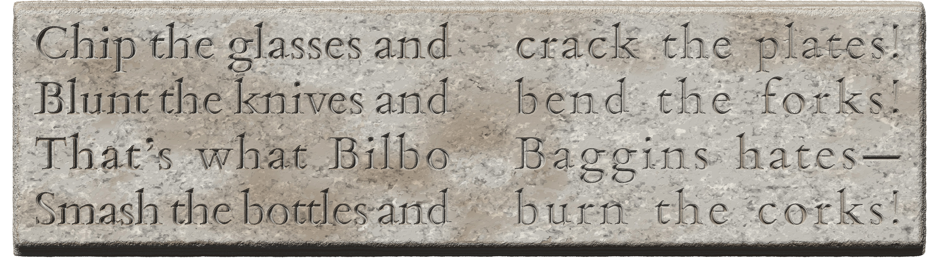
<lg n="1">
<l n="a"><lb n="1"/><milestone unit="column" n="a"/> Chip the glasses and <milestone unit="column" n="b"/>crack the plates!</l>
<l n="b"><lb n="2"/><milestone unit="column" n="a"/>Blunt the knives and <milestone unit="column" n="b"/>bend the forks!</l>
<l n="c"><lb n="3"/><milestone unit="column" n="a"/>That’s what Bilbo <milestone unit="column" n="b"/> Baggins hates—</l>
<l n="d"><lb n="4"/><milestone unit="column" n="a"/>Smash the bottles and <milestone unit="column" n="b"/>burn the corks!</l>
</lg>
- in this inscription, spacing at the caesura in each line arranges the text into neat columns
- the start of each column has been marked up with a gridlike milestone
- if some or all subsequent column beginnings coincide with the beginning of a verse line (rather than just a caesura within a line), then the milestone for the applicable column must be within the container for the new line
- compare Exhibit 5.4.A where the same stanza’s spacing does not result in the text laid out in columns, so encoding with gridlike milestones is not applicable
- alternative encoding without milestones:
<lg n="1">
<l n="a"><lb n="1"/> Chip the glasses and <space/>crack the plates!</l>
<l n="b"><lb n="2"/>Blunt the knives and <space/>bend the forks!</l>
<l n="c"><lb n="3"/>That’s what Bilbo <space/>Baggins hates—</l>
<l n="d"><lb n="4"/>Smash the bottles and <space/>burn the corks!</l>
</lg>

Grids of subsurfaces
Complex three-dimensional surfaces such as those of a polygonal pillar or a stele may be inscribed in such a way that each line runs across two or more subsurfaces, as in Exhibit 4.7.R and Appendix A.5. The edges separating the faces constituting the surface produce a gridlike partition.
- encoding gridlike partitions is generally not recommended for complex surfaces, but may be applied if such encoding is deemed useful
  - the milestones shall be encoded with @unit="face" (§4.3.1)
- if you choose not to encode a gridlike partition for a complex surface, and the lines contain conspicuous spaces around the transitions from one subsurface to another, these spaces shall be encoded as per §5.4.1
Exhibit 4.7.R: gridlike partitions for adjacent faces of a polygonal pillar
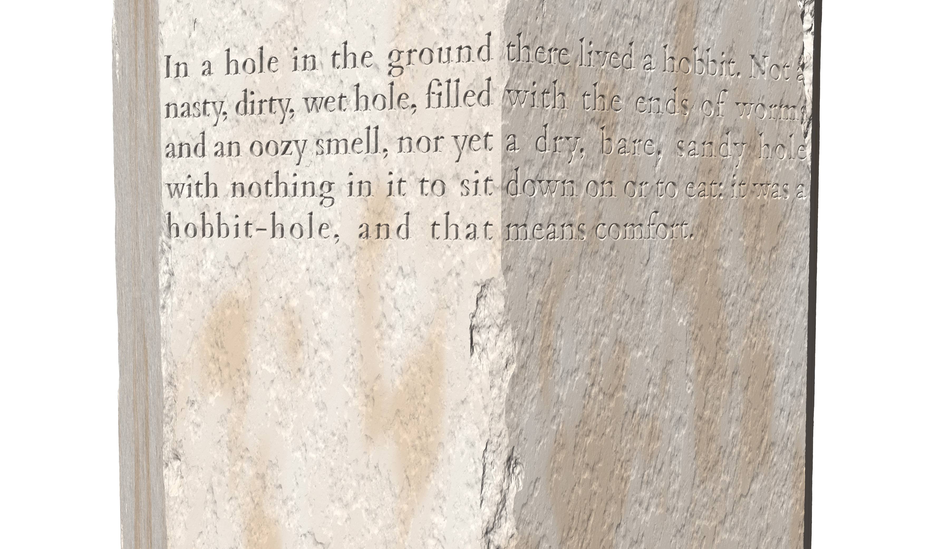
<p>
<lb n="1"/><milestone unit="face" n="a"/>In a hole in the ground <milestone unit="face" n="b"/>there lived a hobbit. Not a
<lb n="2"/><milestone unit="face" n="a"/>nasty, dirty, wet hole, filled <milestone unit="face" n="b"/>with the ends of worms
<lb n="3"/><milestone unit="face" n="a"/>and an oozy smell, nor yet <milestone unit="face" n="b"/>a dry, bare, sandy hole
<lb n="4"/><milestone unit="face" n="a"/>with nothing in it to sit <milestone unit="face" n="b"/>down on or to eat: it was a
<lb n="5"/><milestone unit="face" n="a"/>hobbit-hole, and that <milestone unit="face" n="b"/>means comfort.
</p>

Untidy extrinsic structure
Certain aspects of extrinsic structure – typically fragmentation, but occasionally also the surfaces of complex three-dimensional objects – result in partitions that do not constitute a neat grid covering the entire campus of an inscription. This section describes good practice for such untidy situations. In addition to the specific guidelines below, keep in mind that when some extant pieces of a fragmented inscription cannot be fitted together, then boxlike partitions are called for (§4.7.3.2). Also keep in mind that in cases where fragments (or surfaces) do join up, as in the situations covered in this section, the encoding normally involves gridlike partitions, and the encoding of such partitions is always optional (§4.7.5). Thus, before complicating your encoding in an attempt to represent an untidy original document’s structure, consider whether doing so serves a useful purpose.

Features inadvertently splitting akṣaras
Three-dimensional features of the support, such as a crack, may split a glyph inadvertently. When the feature is encoded as a partition (usually a gridlike one, possibly a pagelike one), then the graphemes of the text need to be assigned to one side of the partition or another. Such a situation must be handled differently from cases where a theoretically atomic glyph was deliberately split into parts by the engraver in order to accommodate a feature, for which see §5.1.4. For inadvertently split glyphs, make a case-by-case decision based on the following guidelines.
- by default, treat the partition as if it did not split any glyphs, and thus
  - if all or most of a line is split in a largely horizontal direction by a pagelike partition, arbitrarily assign the entire line to the side on which there is more of it and encode the partition before or after that line as applicable (see also §4.7.6.4)
  - if an akṣara is split in a largely vertical direction by a gridlike partition as in Exhibit 4.7.S, arbitrarily assign the entire akṣara to the side on which there is more of it and encode the partition before or after that akṣara as applicable
    - if the split is more or less equal, make your choice based on the diagnostically more useful part of the akṣara and/or the location of morpheme boundaries
- however, if the feature is sufficiently fine and great accuracy is desirable, individual graphs (which correspond to individual graphemes and are thus separable in transliteration) may be allocated to one side as in or another even if they belong to a single glyph of the original, as in Exhibit 4.7.T
  - the conditions for allocating a grapheme to a particular side of a feature are
    - that the original graph is, or can be reconstructed as being, wholly or mostly on that side
    - that the graphic sequence of the graphs corresponds to the reading sequence
      - thus, a superscript preconsonantal r or a prescript e cannot be allocated to a side other than that of the primary consonant of an akṣara
  - graphs which are split into more or less equal parts by the feature should still be allocated arbitrarily to one side of the milestone or the other, on the basis of considerations such as the location of the larger or diagnostically more useful part of the akṣara and the location of morpheme boundaries
- whichever way you allocate the transliterated graphemes vis-à-vis the feature, word interruption (§4.3.2.1) shall be encoded on the basis your allocation; thus,
  - @break="no" is not required just because the feature splits a glyph
  - @break="no" is required when the encoded milestone interrupts a word
Exhibit 4.7.S: glyph split by a gridlike feature and allocated to one side
... piṅul· <milestone unit="fragment" n="2"/> <unclear>hu</unclear>ler· ... | 
- the glyph hu is split in roughly equal parts by a vertical crack
- most of this glyph is to the right of the crack, and this glyph is the beginning of a word, so the entire transliteration has been placed to the right of the milestone, which does not take @break="no"

Exhibit 4.7.T: glyph split by a gridlike feature, graphemes individually allocated to sides
... Ika<unclear>na</unclear><milestone unit="fragment" n="2" break="no"/><unclear>ṁ</unclear> patiḥ ... | 
- the glyph naṁ is split and partly obliterated by a vertical crack
- the anusvāra is (or would have been) definitely to the right of the crack, while the body na has been arbitrarily allocated to the left of the milestone, which needs @break="no"

Features splitting only some lines of an inscription
Recall from §4.1 that gridlike partitions represent the lowest tier of the hierarchy of extrinsic structure, and that the scope of a milestone is understood to be up to the point where a partition of the same, or a higher, tier occurs. The logical consequence of this is that when a grid covers the entirety of an inscription, the milestones for each cell of the grid must be present in each epigraphic line of the edition (or the textpart division). Sometimes, however, a grid applies only to part of the inscribed campus, as in Exhibit 4.7.U. In order to reduce code clutter and encoding burden, in this latter case we use milestone elements only in the specific lines which are directly affected by the feature represented by the milestone. It will be understood in such a case that the partition applies only to the lines where it is encoded. If the inscription is fragmented, then lines without an encoded partition will be assumed to be on the largest adjacent fragment. Multiple irregular fragments shall be encoded in the same manner: lines not affected by the fragmentation need no gridlike milestones, while affected lines need as many milestones as the number of separate fragments across which the line in question continues.
Exhibit 4.7.U: gridlike milestones in only some of the lines
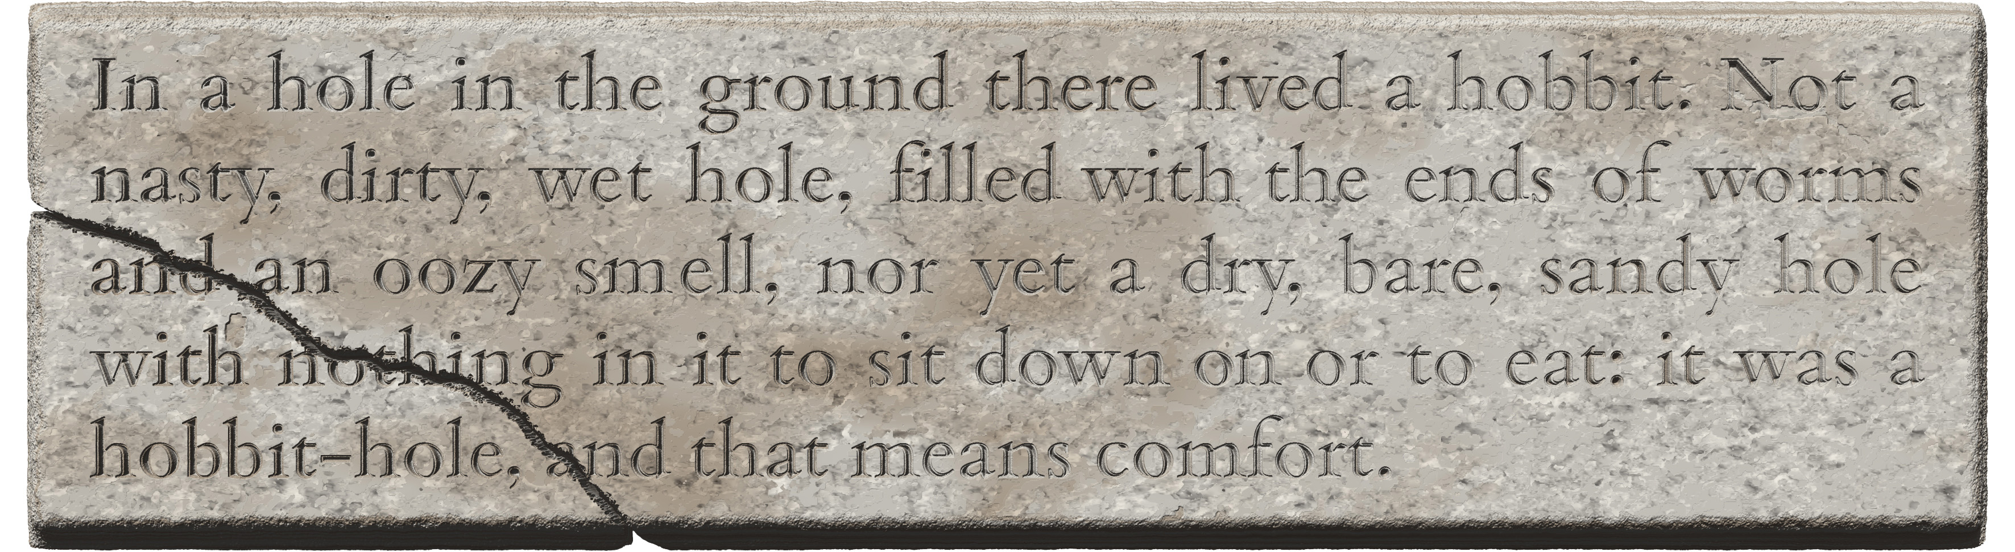
<p>
<lb n="1"/>In a hole in the ground there lived a hobbit. Not a
<lb n="2"/>nasty, dirty, wet hole, filled with the ends of worms
<lb n="3"/><milestone unit="fragment" n="a">and <milestone unit="fragment" n="b">an oozy smell, nor yet a dry, bare, sandy hole
<lb n="4"/><milestone unit="fragment" n="a">with not<milestone unit="fragment" n="b" break="no"><unclear>h</unclear>ing in it to sit down on or to eat: it was a
<lb n="5"/><milestone unit="fragment" n="a">hobbit-hole, <unclear>a</unclear><milestone unit="fragment" n="b" break="no">nd that means comfort.
</p>
- the first two lines are not affected by fragmentation, so no gridlike milestones are encoded there
- split glyphs are arbitrarily assigned to one side of the crack as per §4.7.6.1

Missing pieces
Just because a piece of an inscription has been lost, as in Exhibit 4.7.V, there is no need to encode any kind of partition. As far as encoding is concerned, this is just another kind of lacuna, to be encoded according to §6.5 (with special considerations for massive lacunae in §6.5.4). If the lost piece is subsequently recovered and the digital inscription is updated accordingly, then partitions can (optionally) be encoded for the fragments, as in Exhibit 4.7.U above.
As a logical extension of this approach, if an inscription consists of two or more extant fragments while one or more further fragments are lost, as in Exhibit 4.7.W, then partitions (if they are encoded) should be created only for the extant fragments. Thus:
- the lacunae representing the text belonging to a lost fragment, whether restored or not, shall be encoded as belonging to the adjacent extant fragment
  - if two sides of a lost fragment are adjacent to different extant fragments, arbitrarily pick one of the extant fragments (typically the earlier one) and encode the lacunae as belonging to that fragment
- when the edges of lacunae are partially restored on the basis of the adjacent preserved text, feel free to allocate the restorations to the fragment which serves as the basis for restoration, even if the rest of the lacuna is allocated to another fragment
  - in this case, word interruption (§4.3.2.1) shall be encoded on the basis your allocation of the milestone, not on that of the actual location of the fracture; thus,
  - @break="no" is not required when a full word is restored on one side of the milestone
Exhibit 4.7.V: inscription with a missing piece
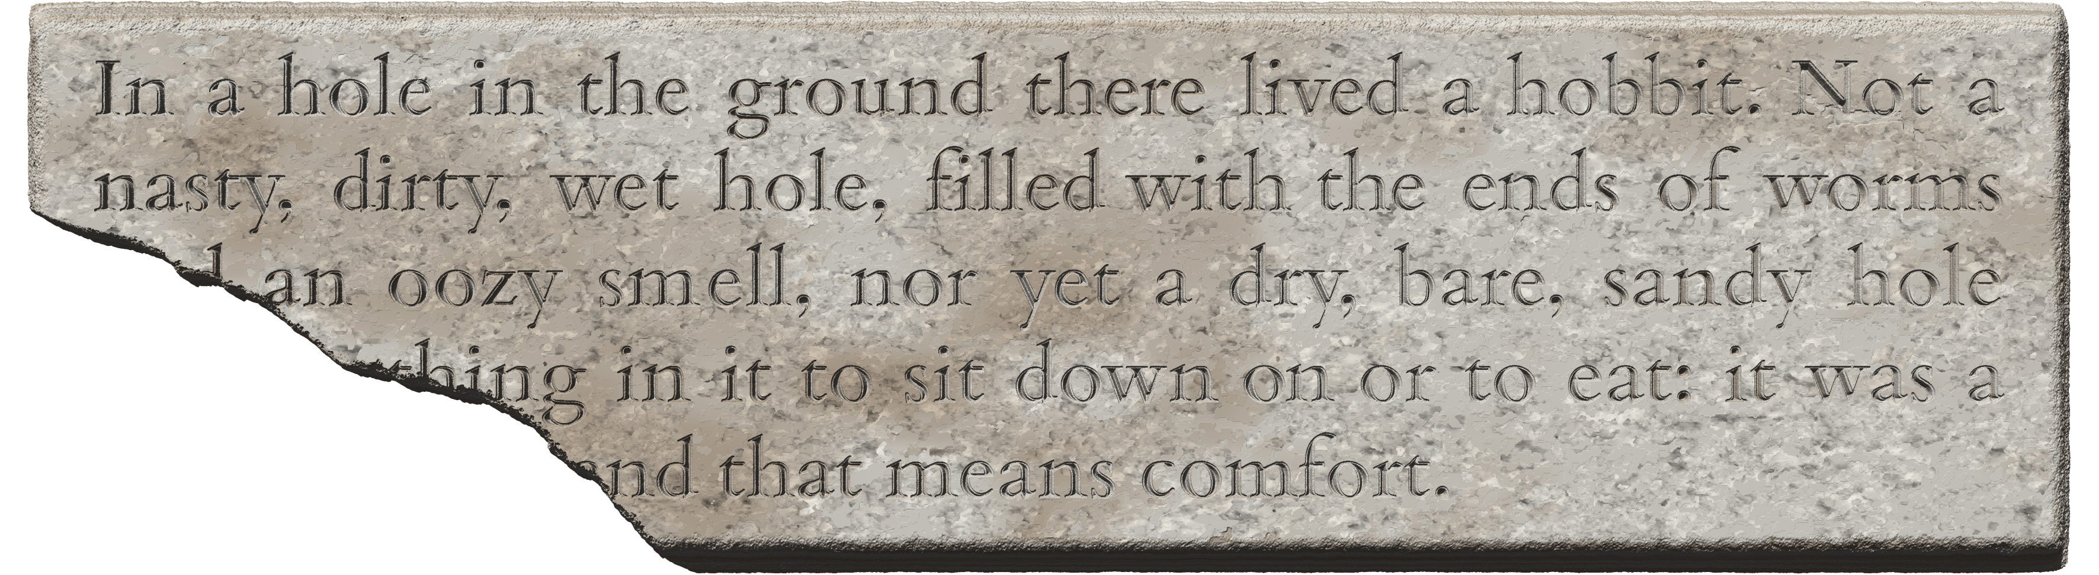
<p>
<lb n="1"/>In a hole in the ground there lived a hobbit. Not a
<lb n="2"/>nasty, dirty, wet hole, filled with the ends of worms
<lb n="3"/><gap reason="lost" quantity="3" unit="character"/>an oozy smell, nor yet a dry, bare, sandy hole
<lb n="4"/><gap reason="lost" quantity="8" unit="character"/><unclear>h</unclear>ing in it to sit down on or to eat: it was a
<lb n="5"/><gap reason="lost" quantity="14" unit="character"/>nd that means comfort.
</p>

Exhibit 4.7.W: gridlike partitions for contiguous fragments with a missing piece
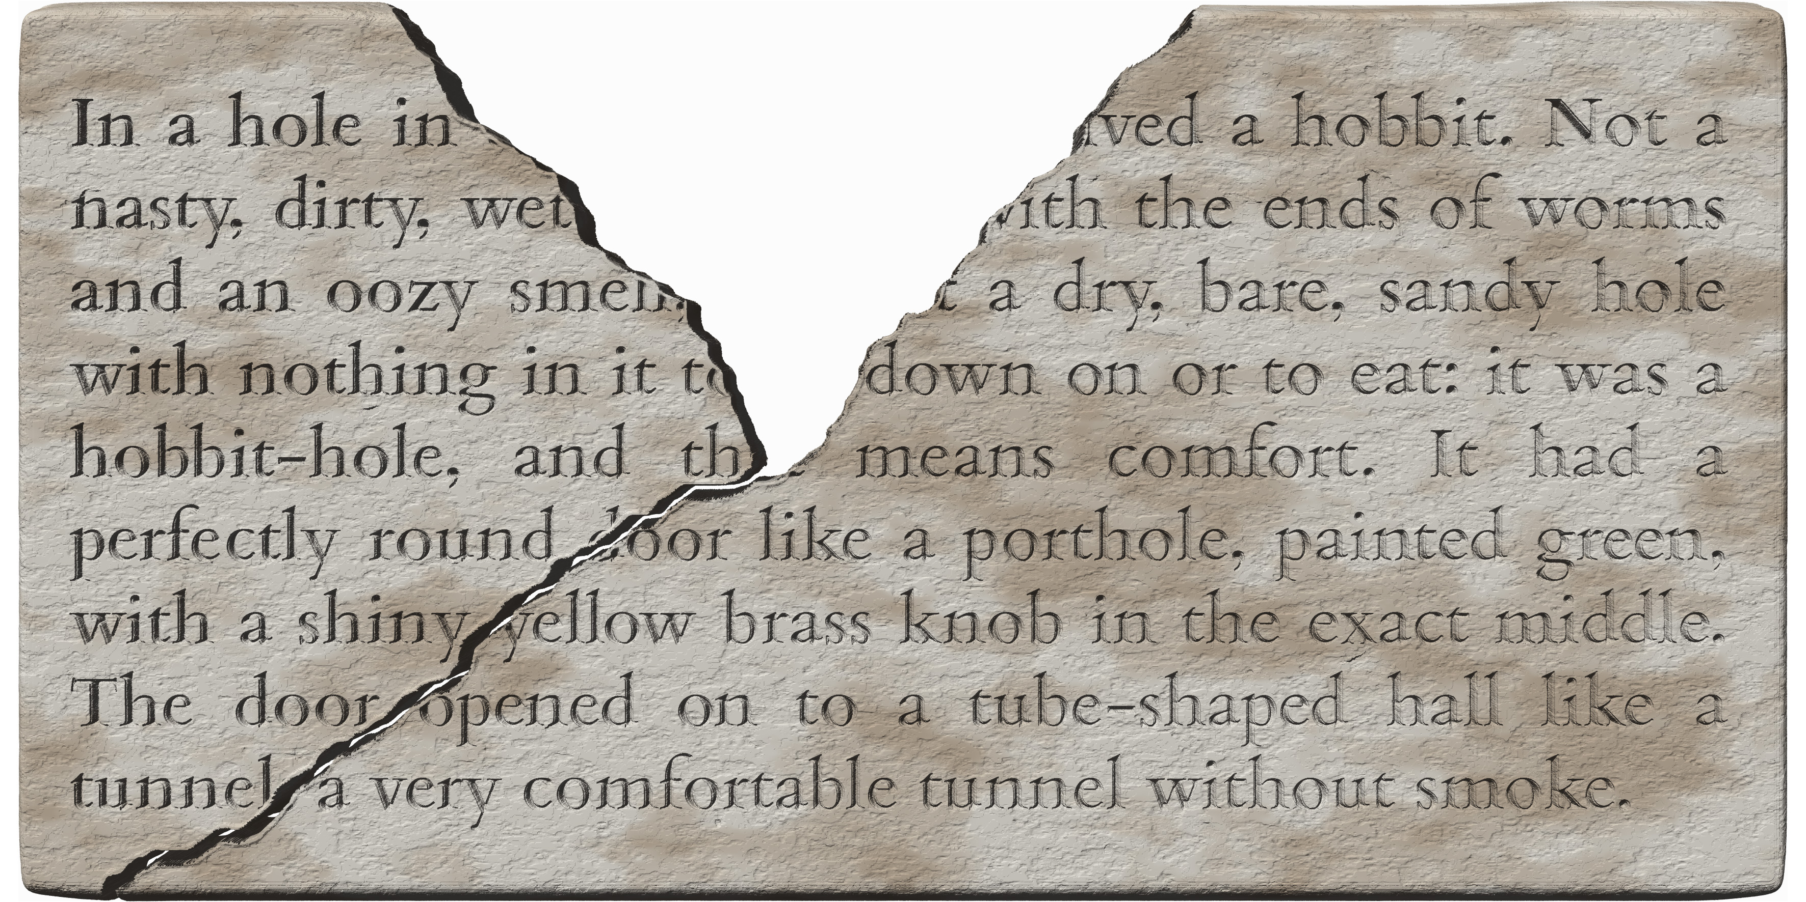
- two extant fragments of a slab can be joined, but a smaller fragment is missing
- the fragments are optionally encoded as gridlike milestones
- the lacunae in the first five lines are arbitrarily allocated to fragment a
- restorations of partially lost words are always allocated to the fragment bearing their extant segments
<p>
<lb n="1"/><milestone unit="fragment" n="a"/>In a hole in <gap reason="lost" quantity="17" unit="character"/> <milestone unit="fragment" n="b"/><supplied reason="lost">li</supplied>ved a hobbit. Not a
<lb n="2"/><milestone unit="fragment" n="a"/>nasty, dirty, wet <gap reason="lost" quantity="14" unit="character"/> <milestone unit="fragment" n="b"/><supplied reason="lost">w</supplied><unclear>i</unclear>th the ends of worms
<lb n="3"/><milestone unit="fragment" n="a"/>and an oozy sme<unclear>ll</unclear> <gap reason="lost" quantity="10" unit="character"/> <milestone unit="fragment" n="b"/>a dry, bare, sandy hole
<lb n="4"/><milestone unit="fragment" n="a"/>with nothing in it <unclear>t</unclear><gap reason="lost" quantity="6" unit="character"/> <milestone unit="fragment" n="b"/>down on or to eat: it was a
<lb n="5"/><milestone unit="fragment" n="a"/>hobbit-hole, and th<supplied reason="lost">at</supplied> <milestone unit="fragment" n="b"/>means comfort. It had a
<lb n="6"/><milestone unit="fragment" n="a"/>perfectly round <milestone unit="fragment" n="b"/><unclear>d</unclear>oor like a porthole, painted green,
<lb n="7"/><milestone unit="fragment" n="a"/>with a shiny <milestone unit="fragment" n="b"/>yellow brass knob in the exact middle.
<lb n="8"/><milestone unit="fragment" n="a"/>The door <milestone unit="fragment" n="b"/>opened on to a tube-shaped hall like a
<lb n="9"/><milestone unit="fragment" n="a"/>tunne<unclear>l</unclear><supplied reason="lost" cert="low">:</supplied> <milestone unit="fragment" n="b"/>a very comfortable tunnel without smoke.
</p>

Features splitting an inscription horizontally
A fracture or other three-dimensional feature of the support may split an inscription horizontally, i.e. along the lines of the text, as in Exhibit 4.7.X. Encoding such a feature is optional, and the considerations in §4.7.5 continue to apply. However, encoding it as a gridlike partition would not be practicable, since each cell of a grid is understood to be part of a line (§4.1), while here the partition is on a higher level of the extrinsic hierarchy, with full lines belonging to each fragment. Therefore, if encoding is desired, such a feature is to be treated as a pagelike partition.
- if a fracture or other feature splits an epigraphic line horizontally or nearly horizontally, so that there are parts of that line’s text on both sides of the feature, then assign the entire line arbitrarily to one side of the feature or the other (see also §4.7.6.1)
- even if a small number of characters in the affected line are wholly on one side of the feature, you are free to choose this encoding in preference to using numerous gridlike milestones in that line
Exhibit 4.7.X: pagelike partition for a horizontal fracture
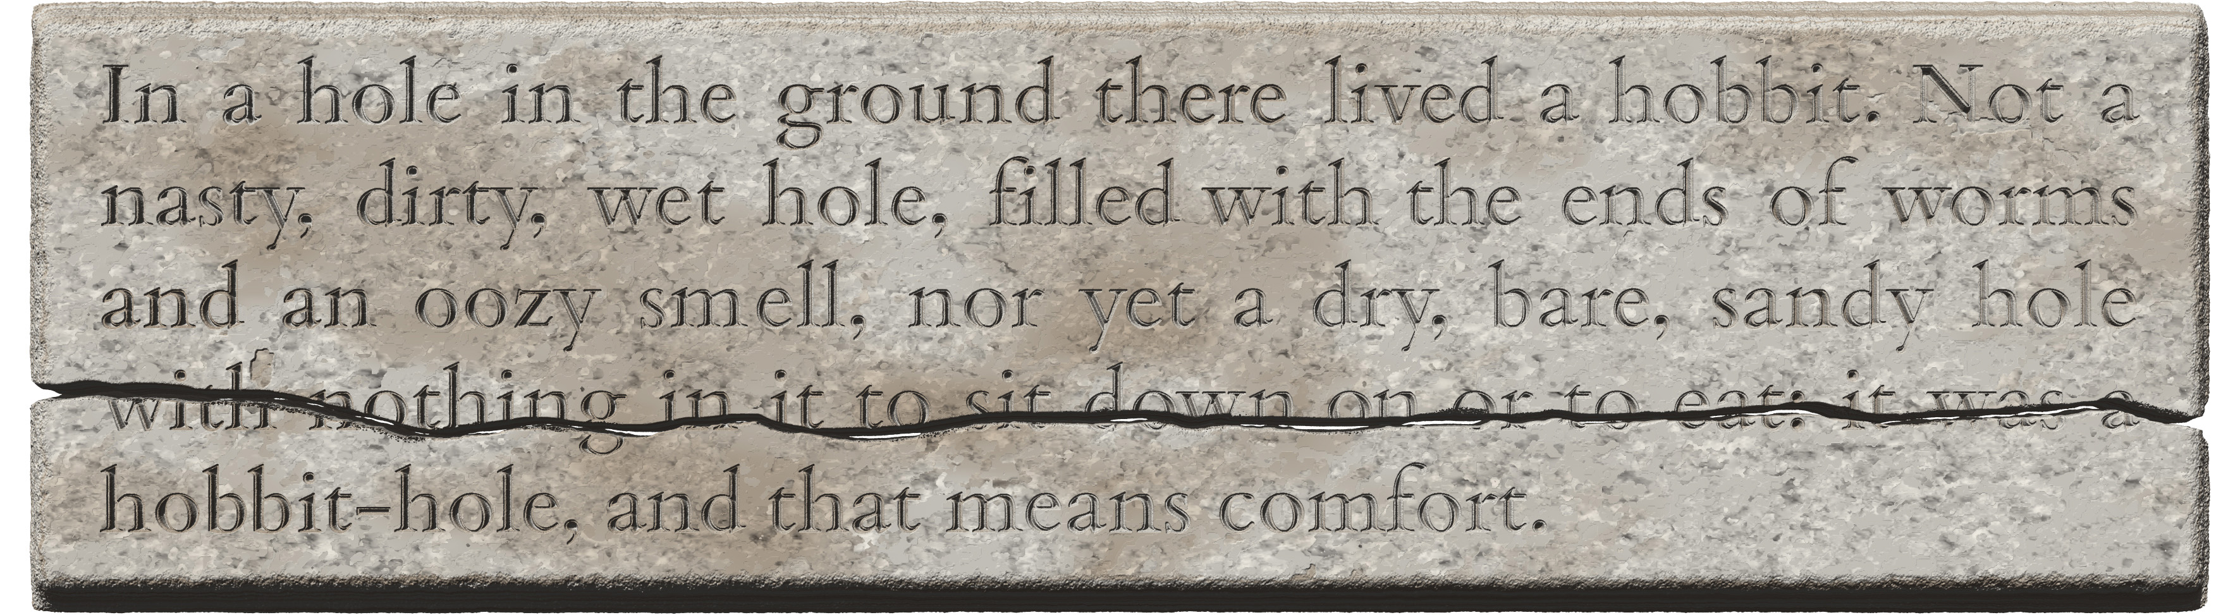
<p>
<milestone type="pagelike" unit="fragment" n="A"/>
<lb n="1"/>In a hole in the ground there lived a hobbit. Not a
<lb n="2"/>nasty, dirty, wet hole, filled with the ends of worms
<lb n="3"/>and an oozy smell, nor yet a dry, bare, sandy hole
<milestone type="pagelike" unit="fragment" n="B"/>
<lb n="4"/>with nothing in it to sit down on or to eat: it was a
<lb n="5"/>hobbit-hole, a<nd that means comfort.
</p>

The received text

Phonographic graphemes
Phonographic graphemes do not, as a rule, need markup on their own: they, including several special glyph forms, are handled through transliteration alone as per TG §4. Occasionally, a phonographic glyph is employed in a different function, which is to be handled according to §5.1.5. This section concerns additional encoding methods that may in some circumstances be applicable to phonographic graphemes or their parts.

Tagging target graphemes as one akṣara
As per TG §3.3.2.1, in transliteration we employ the = (equals) sign as optional shorthand in the role of a character joiner, for use between two target graphemes that are manifested in the source as parts of a single complex glyph (TG §2.4.3), when these would normally manifest as (components of) separate glyphs according to the general rules of the Indic writing system. In any situation where you use the = sign according to the TG’s recommendations, as well as in any other situations where you feel it is useful to demarcate a string of target graphemes as belonging to a single glyph in the source, the following XML markup may be used. This encoding is optional, and it may be used either in addition to or instead of the shorthand involving the = sign.
- to tag any string of transliterated graphemes as belonging to a single glyph in the source writing system, wrap these graphemes in the element <seg type="aksara">, for example as in Exhibit 5.1.A
      - 1: an akṣara with two vowel markers, du=ā
      - 2: a ligature in Tamil (k=ka), as distinct from both kka (with an implicit vowel killer) and k·ka (with an explicit vowel killer)
      - 3: a combining upadhmānīya (in ḫ=pu), to distinguish it from an inline upadhmānīya
- editorial spaces and hyphens may freely appear within this element wherever necessary
  - thus, if a word or compound boundary occurs within such an akṣara, encode respectively e.g.
    - <seg type="aksara">k ka</seg> or <seg type="aksara">k= ka</seg>
    - <seg type="aksara">k-ka</seg> instead of <seg type="aksara">k=-ka</seg>
Exhibit 5.1.A: character with two vowel marks tagged as a single akṣara
 | glyph | shorthand | encoding + shorthand | encoding only
1 |  | du=ā | <seg type="aksara">du=ā</seg> | <seg type="aksara">duā</seg>
2 |  | k=ka | <seg type="aksara">k=ka</seg> | <seg type="aksara">kka</seg>
3 |  | ḫ=pu | <seg type="aksara">ḫ=pu</seg> | <seg type="aksara">ḫpu</seg>

Tagging parts of phonographic glyphs
As discussed in the TG (§3.1.4.2), our transliteration scheme ignores the variation of graphotactic allographs, i.e. different graphs normally employed in different positions for the same grapheme, such as the regular, superscript and subscript forms of <r> in most Indic writing systems. In XML encoding, we suggest a system of “sub-akṣara markup” for tagging individual target graphemes with the purpose of indicating which part of a source glyph manifests that grapheme.
Keep in mind that DHARMA transliteration does distinguish graphemic allographs, i.e. the independent and dependent forms of vowels and consonants, so in all but a few cases a reader familiar with the source writing system will be able to reconstruct the graphetic composition of the source on the basis of the transliterated text. Sub-akṣara markup is optional, and is generally counter-recommended on account of the encoding complexity involved. You may, however, need this kind of encoding for representing extraordinary spatial arrangement in the source when this is deemed desirable (§5.1.3), and for the encoding of micro-level lacunae (§6.5.2.4) for textual loci that are both highly problematic as regards legibility and pivotal as regards interpretation.
- see §5.1.4 about handling glyph components separated from others by an intervening physical feature, a situation for which sub-akṣara markup is not applicable
- see §6.3.3 about handling legibility issues concerning glyph components, a situation for which sub-akṣara markup is not normally warranted
- if you choose to tag a specific sub-akṣara component, wrap it in <seg type="component"> and add a @subtype attribute with one of the following values:
  - "body" for the principal component of a complex glyph, which may be a single consonant or a conjunct
  - "consonant" for exactly one consonant component whose graphic location cannot be determined or is irrelevant
  - "conjunct" for two or more consonant components belonging to a single akṣara (when you know the consonant was not single because prosody eliminates that possibility, or because vestiges definitely indicate a conjunct even though it is illegible)
  - "vowel" for the vocalisation of an akṣara, when the location of the vowel marker cannot be determined or is irrelevant
  - "superscript" for any components above the body, such as a superscript r or a superscript vowel marker
  - "subscript" for any components below the body, such as the subscript consonant of a conjunct or a subscript vowel marker
  - "prescript" for any components to the left of the body, generally a vowel marker but also applicable to part of a horizontally composed ligature
  - "postscript" for any components to the right of the body, generally a vowel marker but also applicable to part of a horizontally composed ligature
- when dealing with sub-akṣara lacunae in relatively simple cases, your primary concern is to encode what kind of grapheme was lost, without regard to exactly what kind of glyph component represented it; in this case,
  - either use "vowel" for a lost vowel component, and "consonant", "conjunct" or "body" respectively for a lost consonant component that is known to be single, known to be a conjunct, or may be either of these
  - or forego sub-akṣara encoding and use the placeholders V for ‘any vowel’ and C for ‘any consonant’ (TG §3.3.2.2) instead of encoding illegible or lost graphemes as component-level lacunae
- when dealing with unusually composed glyphs or with partial lacunae in complex cases that can benefit from a very high level of detail in the encoding (e.g. because the text is unintelligible and you wish to be fully objective in encoding what you see, without projecting any interpretation onto it), your primary concern is to describe the nature of the original glyph as accurately as possible; in this case,
  - give preference to the values "body", "superscript", "subscript", "prescript" and "postscript" to encode the graphic location of the lacuna within the complex glyph, and use "vowel", "consonant" and "conjunct" only when it is impossible to determine the graphic location of a component that must have been present

Unusual spatial arrangement in conjuncts
As our primary objective is to encode texts, the place to record information about unusual glyph composition is your annotation. However, in order to facilitate future palaeographic research, you may optionally use sub-akṣara markup (§5.1.2) for tagging parts of phonographic glyphs in order to specify what part of a complex original glyph corresponds to any given target grapheme, as illustrated in Exhibit 5.1.B. When doing so, aim to minimise the complexity of your encoding and add tags only to the components that most conspicuously deviate from the expected composition. However, if you deem that there is any ambiguity regarding akṣara boundaries, feel free to wrap target graphemes and lacunae belonging to a single original character in the element <seg type="aksara"> as per §5.1.1
Exhibit 5.1.B: conjunct with regular r instead of superscript
<seg type="component" subtype="body">r</seg>ya | 
- rya is here written with a regular (body) r and a subscript y instead of a superscript r and a regular y
- the fact that the r is tagged as a body component dispenses with the need to explicitly tag the y as a subscript component
r<seg type="component" subtype="prescript">g</seg><seg type="component" subtype="body">gh</seg>a | 
- rggha is here written in a horizontal composition, with g to the left of a regularly positioned gh
- in this example the second and third consonant components have both been tagged explicitly for their position, though it may be sufficient to tag the prescript g in this way

Complex glyphs deliberately split over an intervening feature
Parts of akṣaras may be split off from the rest of the glyph by a physical feature, most commonly a line break, sometimes a physical defect in the support or the binding hole in a copper plate. In this section we discuss situations where the scribe deliberately decomposed theoretically atomic glyphs into constituent parts in order to accommodate such an intervening feature. Inadvertent splits, typically caused by fracture, are discussed in §4.7.6.1.
Exhibit 5.1.C: anusvāra separated from glyph
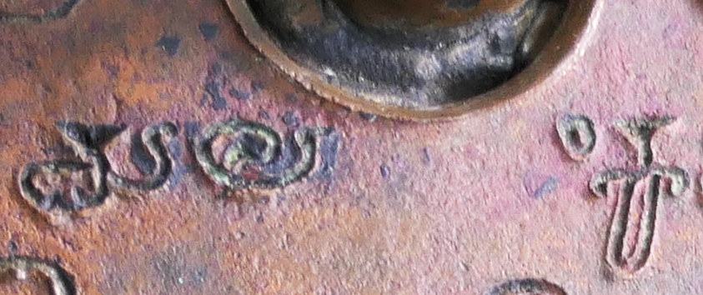
mala<space type="binding-hole"/>ṁka
- the intervening features may be line beginnings (§4.5.1) or space imposed by physical features (§5.4.2.2) and must be encoded as applicable
- if the split can be represented accurately in transliteration because the physical order of the graphs corresponds to the logical sequence of the graphemes (typically involving anusvāra, visarga or a postscript vowel marker) as in Exhibit 5.1.C:
  - apply no special markup
  - encode the intervening feature in its physical and logical place
Exhibit 5.1.D: vowel marker separated from glyph

A⌈<space type="descender"/>horātri
- the vowel marker for o consists of a stroke on the left and another stroke on the right
- the stroke on the left has been split off from the consonant by a descender from the line above
- if the split cannot be represented accurately in transliteration because the physical order of the graphs differs from the logical sequence of the graphemes (typically involving prescript vowel markers or a split consonant body) as in Exhibit 5.1.D:
  - this is handled in transliteration by means of the placeholder characters ⌈ (left ceiling, U+2308) and ⌉ (right ceiling, U+2309), as per TG §4.4.7
    - the placeholder characters are essential shorthand (TG §3.3.1), meaning that they do not have an encoding alternative in DHARMA practice and will be used in XML editions in the same way as in non-XML contexts
  - follow the TG’s instructions as regards the placement of the ceiling and the transliterated graphemes vis-à-vis the encoded interruption
  - all the target graphemes pertaining to an original akṣara must be placed on that side of the interruption where the consonant body is located, while the applicable placeholder character must be placed on the other side of the interruption

Split glyphs combined with legibility issues
- in all examples in this subsection
  - <> represents an interrupting element of any nature
  - grey text represents unclear graphs or elements
  - the dotted circle ◌ is to be ignored
- if some of the components involved are unclear (§6.3)
  - apply this tag to whichever target graphemes are affected, but not to unaffected ones
  - if and only if the split-off component is itself affected, apply the tag to the placeholder and to the corresponding target grapheme separately, without including the encoded interruption
  - for example:
    - கெ<> ா → k<unclear>o</unclear><><unclear>⌉</unclear>
    - கெ<> ா → <unclear>ko</unclear><>⌉
    - ெ<>கா → <unclear>⌈</unclear><>k<unclear>o</unclear>
  - if the reading of some components is ambivalent (§6.3.2)
    - consider alternatives in the interest of minimising complexity
      - encoding the akṣara as unclear may be sufficient for a reader familiar with the script to deduce the possible alternatives
      - annotation may be added to explain the nature of the problem to the human end user
    - if you deem that encoding ambivalence is essential
      - do so for the target graphemes concerned
      - add an unclear tag to the placeholder if the split-off component is affected
      - do not include the placeholder in the markup for ambivalence, and do not include the interruption itself in any markup
    - for example:
      - கெ<> ா (where the unclear element after the interruption may be the glyph ர ra instead of the vowel marker ா) →
        - k<choice><unclear>o</unclear><unclear>era</unclear></choice>
<><unclear>⌉</unclear>
        - note that in this case the second option of the <choice> element produces the text “kera<>⌉”, where the placeholder sign must be understood to mean that the entire preceding akṣara (i.e. ra), rather than just one component of it, is located after the interruption
  - if an adjacent lacuna has obliterated a split-off component which you supply (§6.4)
    - mark up the affected vowel
      - as supplied if it consists only of the supplied split-off component
      - as unclear if it consists of an extant component and a supplied split-off component
    - mark up the placeholder as supplied
    - do not include the interruption itself in any markup
    - for example
      - கெ<> ா (with grey text for the restored lacuna) →
        - k<unclear>o</unclear>
<><supplied reason="lost">⌉</supplied>
      - ெ<>க →
        - <supplied reason="lost">⌈</supplied>
<>k<supplied reason="lost">e</supplied>
  - if an adjacent lacuna may have obliterated a split-off component but you do not supply this even tentatively
    - simply mark up the extant vowel component as unclear and leave it to the proficient reader to deduce the fact that an additional component may have been destroyed in the lacuna

Phonographic glyphs in a different function
The glyphs that normally manifest phonographic graphemes or akṣaras may occasionally be used in other graphemic functions. For example, the glyphs for |ka|, |kha| etc. may be used for numeration, while those for |tha|, |cha| or |chaḥ| may be employed as closing symbols at the end of texts. In such cases, transliterate the glyph with the appropriate phonographic target graphemes. However, as per TG §6.2, symbol glyphs whose shape is similar to a phonographic glyph but not identical to that glyph as attested or expected in the given writing system shall be treated as peripheral graphemes and encoded accordingly (§5.3).

Numeral signs
As core graphemes of our transliteration system, numerals are rendered with Arabic numerals in transliteration, and this transliteration identifies the applicable source grapheme with sufficient accuracy. However, source numeral graphemes which are represented by something other than a single Arabic numeral require encoding as per §5.2.1 when used in an XML context, in order to make it clear that a cluster of target graphemes represents a single numeral in the source.
- in addition to the glyph encoding presented in this section, in DHARMA practice all numbers are also encoded for their semantic value
  - because value encoding can also apply to numbers represented in words, it is described in §9.1 under the generic section on encoding semantic information
- occasionally, a glyph that normally represents a numeral is employed in a different function, which is to be handled according to §5.2.3

Glyph encoding for numerals
We use the TEI element <g> (for “glyph” or “gaiji”) in the encoding of all glyphs other than phonographic ones and decimal digits. The use of this element indicates that our set of target graphemes provides no direct equivalent to the original glyph, and that the contents of this element represent a single source grapheme.
- when a single source numeral glyph is represented in transliteration with anything other than a single Arabic numeral, wrap the transliterated grapheme(s) in <g type="numeral">

No glyph encoding for digital numerals
Exhibit 5.2.A: a digital numeral

<num value="1218">1218</num>
- decimal digits need no glyph markup
- semantic markup added as per §9.1
Encoding with <g> is not needed (and must not be added) to decimal digits, i.e. the integers 0 to 9 represented in the source by an individual grapheme.
- do not use glyph markup for
  - standalone digits, as the second 8 in Exhibit 9.1.A
  - digits conjoined additively to non-digital numeral signs, as the first 8 and the 5 in Exhibit 9.1.A
  - multiple digits used in place-value notation for a larger number, as in Exhibit 5.2.A

Encoding non-digital numerals
All non-digital numerals must be individually wrapped in <g type="numeral">. This glyph markup disambiguates the transliteration from other meanings in which the same target graphemes might be used and, for clusters of target graphemes, clarifies the demarcation of the source grapheme. The semantic markup for number values (§9.1) clarifies the denoted number even when this is not self-evident from a series of glyphs. Non-digital numerals encountered in our practice are of the following kinds.
- numeral glyphs denoting powers of 10 and their multiples, transliterated with multi-digit Arabic numerals as per TG §4.2.2
  - standing alone, e.g.
    - 𑁤𑁿𑁓 = |200| → <g type="numeral">200</g>
  - combined additively with other numeral glyphs, e.g.
    - 𑁤𑁜𑁔 = |100| + |20| + |3| → <g type="numeral">100</g> <g type="numeral">20</g> 3
      - note that the transliterated 3 is not wrapped in <g>, because it is a single Arabic digit
Exhibit 5.2.B: multiplicative combination
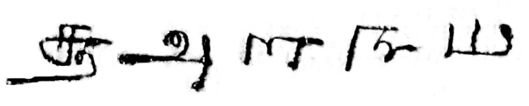
  - combined multiplicatively (as well as additively) with other numeral glyphs, e.g. Exhibit 5.2.B
    - |1000| × |8| + |100| × |3| + |10| → <g type="numeral">1000</g> 8 <g type="numeral">100</g> 3 <g type="numeral">10</g>
      - 8 and 3 are not wrapped in <g>, because they are single Arabic digits
  - vertical bars denoting |1| in Cambodian inscriptions, transliterated with I (uppercase i) as per TG §4.2.3
    - used singly, e.g. <g type="numeral">I</g>
    - or in groups, e.g. <g type="numeral">III</g>
  - glyphs denoting fractions, transliterated as per TG §4.2.3 with common fractions (involving a slash)
    - e.g. a source glyph meaning “one eighth” → <g type="numeral">1/8</g>

Numeral signs and their context
- use spaces around transliterated numerals as instructed in TG §7.3.4.2, i.e. essentially:
  - add spaces to separate the transliterated (and, if applicable, encoded) representation of any and all numerals from any and all adjacent graphemes except:
    - use no spaces between numerals used together in place-value notation
    - use no spaces around a numeral sign that interrupts a word

Numeral glyphs in a non-numeral function
The glyphs that normally manifest numeral graphemes may occasionally be used in other graphemic functions, which shall be treated as follows. The semantic tags for numbers introduced in §9.1 are not applicable in any of these cases.
- as per TG §6.2, symbol glyphs whose shape is similar to (and/or derived from) a numeral glyph but not identical to the regular numeral attested or expected in the given writing system shall be treated as peripheral graphemes and encoded accordingly (§5.3)
- regular numeral glyphs used for functions other than to represent numbers shall be transliterated as numbers, including the following
  - symbolic use: if a regular numeral sign (rather than a shape derived from one) is used as a symbol
    - such as the glyph |1| used as an auspicious opening symbol
  - phonographic use: if a numeral sign represents a phonographic value
    - such as the glyph |2| used in Old Sundanese to represent the phonemes /ro/)
  - “metalinguistic” use: numeral signs signifying vowel length, accent type or word repetition
- when in doubt, rely on the following rules of thumb
  - transliterate numeral signs as numbers unless both of the following conditions are met:
    - their graphetic shape is clearly different from the regular sign for the same number found or expected in the document
    - and you are confident that they do not represent a number in their semantic context
  - add the semantic encoding for numbers (§9.1) only for signs that represent a number which is part of the document’s content
    - imagine the document being read out loud by a contemporary reader: if they would read a number, then number encoding is applicable

Peripheral graphemes

Representing peripheral graphemes in a digital edition
Peripheral graphemes, informally also called symbols, are graphemes which we represent in transliteration by means of a placeholder grapheme dedicated to one of the basic functional classes, namely ideograms, punctuation marks, connectors and abstract symbols as defined in TG §5 and §5.3.2 below.
Since the glyph shapes of peripheral graphemes only rarely show a consistent correlation with their graphemic functions across the corpora of texts we deal with, our encoding conveys information separately about the physical appearance of the glyph where applicable, and about the editor’s interpretation of its function where applicable. Specifically, at the level of transliteration we use a narrow range of default placeholders (§5.3.3.1), with one placeholder dedicated to each functional class of peripheral grapheme; in addition, we optionally allow arbitrary placeholders (§5.3.3.2) for greater variety and more accurate human-friendly representation. The placeholders may be combined with glyph encoding (§5.3.4), which can represent the same basic functional classification as the default placeholders and, in addition, allow a fairly precise differentiation based either on the glyph’s visual appearance or on its name in a source writing tradition. The synergy of transliteration and encoding is illustrated in Exhibit 5.3.A (identical to the figure in TG §5.1). Strategies for combining the available transliteration and encoding options are outlined in TG §5.1.3.
Exhibit 5.3.A: representation of peripheral graphemes through transliteration and encoding
method | solution | demarcation | individuation
method | solution | demarcation | by form | by function
transliteration | default placeholders | clear | — | basic
transliteration | arbitrary placeholders | unclear when multi-character | vague | vague, implied
encoding | <g> | clear | — | —
encoding | @type | — | — | basic
encoding | @ref | — | specific | (implied for ideograms)

What counts as a symbol?
The symbols discussed in this section are graphemes, with the implication that they signify information that pertains, however vaguely, to language. Any other graphic content in an original document may be described in annotation, but shall not be represented in transliteration and through symbol encoding, as discussed in TG §3.1.4.3. In particular, the following features are not symbols:
- decorative or illustrative imagery, which is to be annotated
- scribal (premodern editorial) marks, which are represented in the encoding but not in the text (see §5.4.2.1 about marks used in lieu of text not inscribed; §5.4.4 about marks for scribal correction)
- as per §5.1.5 and §5.2.3, core glyphs (i.e. phonographic and numeral glyphs) are not symbols in this sense even when they are employed in a symbolic function, and shall therefore be transliterated according to their primary signification and not wrapped in glyph encoding for symbols
  - however, as per TG §6.2, symbol glyphs whose shape is similar to a core glyph but not identical to that glyph as attested or expected in the given writing system (e.g. the glyph oṁ written in a conspicuously archaic or stylised form) shall be treated as peripheral graphemes

Classifying symbols by function
For the purposes of transliteration as well as encoding, we categorise peripheral graphemes into four broad functional classes: ideograms, punctuation marks, connectors and abstract symbols. These classes are discussed in TG §5 and only briefly summarised here. We find that because of the vague nature of many symbols a more precise differentiation by function would entail difficulty in defining functions and inconsistency in applying the classification. Moreover, across the writing systems in our scope — and even within a single writing tradition or a single document — any particular glyph may be used in any of these basic functions (or without a clear function). Therefore, even though particular shapes are often associated with particular functions, functional classification must be judged on a case-by-case basis, and the assignment of a grapheme to a particular function never implies any particular shape.

Ideograms
- ideograms (TG §5.2) are graphemes that signify words, morphemes or abstract concepts
- modern international examples include |+| |%| |$| |€|
- examples in Indic writing systems include |ॐ| (Devanagari oṁ), |௳| (Tamil piḷḷaiyār cuḻi)
- numerals are technically also ideograms, but from a practical point of view we treat them as core graphemes (§5.2)

Punctuation marks
- punctuation marks (TG §5.3) are graphic signs employed for segmentation into syntactic or metrical units such as such as sentences, clauses, list items and stanzas or their subdivisions
  - throughout this Guide, the term ‘punctuation mark’ is always used in this specific and restricted sense
  - thus, figural and ornamental signs, as well as “typographic” signs used to mark the end or beginning of an entire text or a major section of text, are generally excluded from this class
- modern international examples include |.| |,| |!|
- examples in Indic writing systems include vertical bars, horizontal dashes and their variations

Connectors
- connectors (TG §5.4) are a special set of marks which signify that a spatial interruption in the script is not to be understood as a break in linguistic structure
  - connectors include the marks called ‘space fillers’ in previous versions of this Guide, used where a part of the writing surface could not accommodate the text to be written, filling it up with one or more marks in order to preserve the continuity of the writing
  - as well as marks used singly at line ends to signify that a word break is not present (like a modern hyphen)
- conversely, signs used by the scribe as placeholders for characters of text he was unable to provide (for example because they were illegible in the manuscript being copied) are not connectors and shall be encoded as per §5.4.2.1

Abstract symbols
- abstract symbols (TG §5.5) are all peripheral graphemes that cannot be confidently assigned to either of the above three classes
  - abstract symbols are also called simply ‘symbols’, but we also use the term ‘symbol’ in a generic sense to refer to all peripheral graphemes
- classifying a grapheme as an abstract symbol means choosing not to assert any particular linguistic function for it, but is not an assertion that it has no function at all
  - thus, all graphemes whose function is ambiguous or uncertain shall be classified as abstract symbols, even if there is a chance that they might qualify for one of the specific classes
  - encoding an abstract symbol instead of a specific function is not an error and will have little ultimate impact on the quality of our corpus

Transliterating peripheral graphemes
The placeholders used for peripheral graphemes are a device of transliteration, and are accordingly discussed in TG §5. Here, we summarise only the essentials. We dedicate a default placeholder to each of the broad functional classes introduced in §5.3.2 above. When an arbitrary placeholder (§5.3.3.2) is not desired, every peripheral grapheme in the source must be transliterated with the default placeholder appropriate to its class.

Default placeholders
- the default placeholders for the classes are as follows
  - for ideograms: @ (at sign)
  - for punctuation marks: . (dot, period or full stop)
  - for connectors: § (section sign)
  - for abstract symbols: * (asterisk)
- in XML editions, the default placeholders will usually be combined with glyph encoding (§5.3.4)
- default placeholders may be used without being wrapped in a <g> element in the following circumstances:
  - when supplying editorial punctuation for the purpose of semantic segmentation, as per §7.8.3
  - when encoding a text from a previous edition, without access to the original or a surrogate, if that edition records the presence of a symbol without describing its appearance

Arbitrary placeholders
At the editor’s discretion, arbitrary target graphemes (or strings of target graphemes) may be used for representing any peripheral grapheme in the source. Arbitrary placeholders can be Unicode characters chosen to resemble the source grapheme’s graphetic appearance or to imitate its perceived graphemic function, as well as strings alluding to an emic name of the source grapheme or describing it in etic terms (TG §5.1.2).
- in XML editions, it is generally preferable to use only the default placeholders and combine them with glyph encoding (§5.3.4)
- nonetheless, because they can help reduce code clutter, arbitrary placeholders are permitted in XML contexts if they are deemed to be satisfactory representations of the source grapheme
  - arbitrary placeholders may be used without glyph encoding provided that they consist of a single character
  - multi-character arbitrary placeholders must, however, always be combined with glyph encoding (§5.3.4) to make it clear that a particular string of target characters corresponds to a single source grapheme
- strategies for combining the available transliteration and encoding options are outlined in TG §5.1.3
- in XML editions, arbitrary placeholders are most likely to be used for basic forms of punctuation marks, as follows
    - | (U+007C Vertical Line) for signs comprised of a single plain vertical bar
    - / (slash) for signs comprised of a single vertical bar with a hook, crossbar or ornamental addition
    - , (comma) for short, predominantly vertical and often curved strokes at any height
  - additional recommendations for arbitrary placeholders are available in the TG sections (under §5) discussing the functional classes

Glyph encoding for peripheral graphemes
We use the TEI element <g> (for “glyph” or “gaiji”) in the encoding of all glyphs other than phonographic ones and decimal digits. The use of this element indicates that our set of target graphemes provides no direct equivalent to the original glyph, and that the contents of this element represent a single source grapheme.
- the (default or arbitrary) placeholders that correspond in transliteration to a peripheral grapheme in the source may be wrapped in the element <g>
  - this encoding is mandatory for arbitrary placeholders that consist of more than one character and optional but recommended for all other placeholders
  - the <g> element for peripheral graphemes can be supplemented with the following attributes
    - optionally or as required, @type to assign the grapheme to a functional class as per §5.3.4.1
    - optionally, @ref to associate the grapheme with an item in our authority file for symbols as per §5.3.4.2
- in DHARMA practice, <g> for symbol encoding shall always contain text (a transliteration placeholder)
  - unlike the earlier versions of this Guide, which endorsed empty <g/> elements for certain kinds of symbols

Encoding symbol function
The attribute @type on the <g> element for peripheral graphemes formally associates the glyph with one of the basic functional classes introduced in §5.3.2. It thus redundantly represents the same information as the choice of default placeholder, but does so in a rigorous machine-readable manner.
- the available values of @type for symbol encoding are as follows
  - "ideogram" for ideograms (other than numerals)
  - "punctuation" for punctuation marks
  - "connector" for connectors
  - "symbol" for abstract symbols, i.e. anything not explicitly assigned to any of the above classes
    - this is the default value of @type, meaning that if the attribute is not present in the code, the <g> element will automatically be understood to have this type
    - for this reason, @type should always be explicitly encoded in conjunction with default placeholders other than * (i.e. the default placeholders for any of the other three classes), because omitting @type would then result in a contradictory classification

Encoding symbol identification through the authority file
The attribute @ref on the <g> element for peripheral graphemes formally associates the glyph with an entry in our authority file for Glyph Taxonomy. The contents and use of the of the Taxonomy are explained in the authority file itself and are only briefly summarised here.
The authority file is a classified list of symbol tokens, which are short descriptive labels identifying various kinds of symbols. Within the authority file, tokens are divided at the top level into an etic and an emic class. The etic class consists of tokens that describe the graphic appearance of symbols in simple and objective terms. This class is structured hierarchically in the manner of a taxonomy, with a small number of “genus” tokens for basic classes such as vertical bars, horizontal dashes, bullets, etc., and a larger number of “species” and “subspecies” tokens for more or less specific varieties of these classes. The emic class includes tokens that identify a language and specify a source-language term for a particular symbol that has a name in a given writing tradition. The language tags in the emic tokens correspond to the genus names of the etic class, while the symbol terms correspond to species names.
For each token, the authority file includes a “name” and a “description.” Names are either very concise indications of the symbol’s appearance, or terms designating the symbol’s meaning. Descriptions contain more detailed, but still concise, information about the symbol. Entries also optionally include a “mapping,” which is a Unicode character that is in some way similar to and representative of the original symbol. These details are involved in the generation of display in a DHARMA environment (§5.3.4.3).
- the value of @ref on the <g> element representing a symbol must begin with the abbreviation "sym:", indicating that it refers to our Glyph Taxonomy authority file, followed by a symbol token, e.g.
  - with emic tokens, "sym:tam-kalancu" to refer to the sign called kaḻañcu in the Tamil writing tradition
  - with etic tokens, "sym:bullet-double" to refer to a sign in the shape of a double bullet (an entity of the “bullet” genus and within that to the “double” species)
- when @ref is not present on a symbol encoded with <g>¸ the symbol will by default be understood to be unclassified, meaning that the encoder has chosen not to associate this peripheral grapheme with the Taxonomy, for example
  - because the symbol is too unclear to assert any shape for it
  - because no visual documentation is available and a previous editor did not describe the symbol
  - because the shape of the symbol is not deemed relevant

Rendering symbols for display
When rendered for display in the DHARMA ecosystem, encoded symbols will appear as described below. Arbitrary placeholders used without a <g> wrapper will of course be shown as plain text. The examples in §5.3.4.4 also show the display rendition of encoded symbols.
- the actual text representing the symbol will be as follows:
  - by default, the mapping assigned to the token in the authority file (§5.3.4.2) will be displayed
    - this is possible whenever the symbol is encoded with a <g> element, which has the attribute @ref, which points to a valid token in the authority file, which has a “mapping”
    - by design, mapping is included in the authority file only for a limited range of symbols that can be satisfactorily mapped to reasonably similar-looking digital characters with reasonably broad font support
  - if no mapping is available for a symbol, then the name assigned to the token in the authority file (§5.3.4.2) will be displayed
    - this is possible whenever the symbol is encoded with a <g> element, which has the attribute @ref, which points to a valid token in the authority file
    - all tokens in the authority file have a name
    - the objective of this display is to indicate the precise type of the symbol to the end user when no mapping has been assigned to a token
  - if neither a mapping nor a name are available, then the content of the <g> element will be displayed
    - this is possible whenever the symbol is encoded with a <g> element
    - the objective of this display is primarily to show an arbitrary placeholder (§5.3.3.2) used in transliteration, but it is also a fallback display option for default placeholders encoded with <g> but not associated with a valid token (because @ref was not added or its value is not a valid token)
- the above text will be highlighted with a different font colour (purple)
  - when the text displayed is the name assigned to a token, then this will also be surrounded with angle brackets and a cartouche, to disambiguate the name from text present in the source and to allow retaining this disambiguation when the rendered text is copied and pasted into another working environment
- when the user moves their mouse over the display rendition of an encoded symbol, the following additional information will be shown
  - the functional class of the symbol (§5.3.2) if encoded with @type
  - the name of the symbol if a valid token is encoded with @ref
  - the description of the symbol if a valid token is encoded with @ref

Examples of symbol encoding
The Exhibits in this section provide examples of symbols transliterated with default placeholders and encoded for function and identification.
Exhibit 5.3.B: encoding ideograms
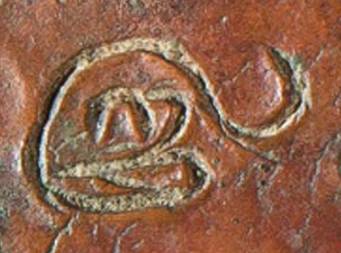
<g type="ideogram" ref="sym:tam-varusam">@</g>
- this will appear in display as ௵ (based on the mapping in the authority file)

Exhibit 5.3.C: encoding punctuation marks

deśam apālayaT<g type="punctuation" ref="sym:doubleBar-serifed">.</g> tat-putro jayasiṁhas trayastriṁśataṁ<g type="punctuation" ref="sym:bar-serifed">.</g>
- these will appear in display as apālayaT∥ and trayastriṁśataṁ| (based on the mapping in the authority file)
- if a rough representation of the shape is sufficient, the arbitrary placeholders || and | may be used
- encoding is not required for |, but mandatory for ||, which consists of two characters
- <g type="punctuation" ref="sym:doubleBar-serifed">||</g> for full identification (displayed as ∥, not as ||, as the mapping in the authority file overrides the content)
- <g type="punctuation">||</g> to clarify only the function (displayed as ||, the content of the <g> element, because there is no reference to the authority file)
- <g>||</g> as a minimal representation (displayed as || because there is no reference to the authority file)
- alternatively, ‖ (U+2016 Double Vertical Line), a single Unicode character, may be used without encoding

Exhibit 5.3.D: encoding connectors
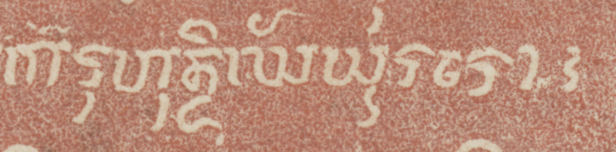
karuhun di:rghăyūrăro<g type="connector" ref="sym:bar-curly">§</g>
alternatives:
- § as a minimal representation without encoding
- ¦ (U+00A6 Broken Bar) as an arbitrary placeholder without encoding
- <g type="connector">§</g> to make no assertion regarding shape (displayed as the content § because there is no @ref)
- <g ref="sym:bar-curly">¦</g> or <g ref="sym:bar-curly">*</g> to make no assertion regarding function
- both of these will be displayed as | (the mapping assigned to the token in the authority file overriding the content)
- if the default placeholder § is wrapped in <g>, then @type must also be present (§5.3.4.1), while arbitrary placeholders may be wrapped in <g> without @type

Exhibit 5.3.E: encoding abstract symbols

<g ref="sym:floret-complex">*</g> svasti
- type="symbol" could be added, but is not necessary because this is the default value
- the display will be ⁜ (the mapping assigned to the token in the authority file)
- alternatively, an arbitrary placeholder such as ✤ might be used, with or without a <g> wrapper and with or without @ref
- if @ref is not present, then the arbitrary placeholder will be displayed

Multiple peripheral graphemes
- groups of peripheral graphemes appearing together, whether identical or different, shall normally be encoded with separate <g> wrappers
  - clusters of symbols that are frequently used together in a given writing tradition can, however, be treated as single glyphs and, accordingly, wrapped in just one <g> element
    - this applies in particular to the double vertical bars which are quite ubiquitous in the Indic writing system
    - but can also apply to more elaborate combinations when these belong to an established convention, such as the Balinese punctuation marks in TG §5.3.1
- series of more than two identical glyphs (e.g. three vertical bars) are best treated as combinations of singles, unless some of them are clearly doubles (as indicated by spacing or by additional strokes joining the pairs)
- the requirement of individual wrapping applies likewise to connectors (for which earlier versions of this Guide prescribed a single wrapper)
  - this increases code clutter for iterated connectors, as illustrated in Exhibit 5.3.F, but is desirable in order to ensure consistency in the encoding
Exhibit 5.3.F: encoding multiple connectors
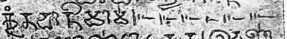
kr̥tavān imām· <g type="connector" ref="sym:flourish-taperOut-bars">§</g><g type="connector" ref="sym:flourish-taperOut-bars">§</g><g type="connector" ref="sym:flourish-taperOut-bars">§</g><g type="connector" ref="sym:flourish-taperOut-bars">§</g><g type="connector" ref="sym:flourish-taperOut-bars">§</g><g type="connector" ref="sym:flourish-taperOut-bars">§</g>

Peripheral graphemes and their context
- use spaces around transliterated symbols as instructed in TG §7.3.4.4, i.e. essentially:
  - add spaces to separate the transliterated (and, if applicable, encoded) representation of any and all peripheral graphemes from any and all adjacent graphemes, except:
    - punctuation marks shall not be separated with a space from preceding text
    - groups of symbols appearing together may be spaced or not, at your discretion
    - use no spaces around a peripheral grapheme that interrupts a word, as in Exhibit 5.3.D
- if a peripheral grapheme appears at the boundary of two block-level containers for intrinsic structure (§3), allocate it to one of the containers depending on your judgement of its semantic function
  - when in doubt, e.g. because a generic symbol marks the transition from one passage to another without being semantically associated with either, allocate it to the end of the earlier containing block
- as a special case, peripheral graphemes, especially punctuation marks, may be written at an akṣara boundary next to, but not coincident with, a word boundary (which would fall within the akṣara)
  - such symbols must always be represented in the transliterated text at their actual location (and thus without editorial spacing)
  - however, it is recommended that you flag this as non-standard usage and optionally also normalise the text (§7) by restoring the symbol at the word boundary and changing the sandhi and editorial spacing as applicable, as in Exhibit 5.3.G
  - when this happens at the end of a container element such as a verse line, encode the container boundary at its logical place (§3.2.4.1), disregarding the akṣara boundary and the symbol
Exhibit 5.3.G: punctuation placed at akṣara boundary rather than word boundary
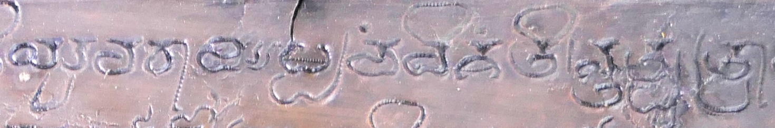
- flagged: ...yuvarājaḫ paṁcaviṁśati<orig>|n</orig>tat-putro...
- normalised: ...yuvarājaḫ paṁcaviṁśati<choice><orig>|n</orig><reg>M| </reg></choice>tat-putro...
- the punctuation mark belonging at the end of the word paṁcaviṁśatim is written after ti, because the end of this word has been inscribed as a homorganic nasal forming a conjunct with the beginning of the next word
- the arbitrary placeholder | used in the illustration could of course be supplemented with encoding or replaced with a default placeholder plus encoding

Space left blank in the original
As discussed in TG §5.6, all spaces in our transliterated texts will be considered editorial. Consequently, spaces present in the source and deemed significant must always be represented in transliterated texts. The _ (underscore) character is a dedicated placeholder for significant space in DHARMA transliteration. In XML editions, this must normally be replaced by (not wrapped in) the empty element <space/>. This encoding, unlike the transliteration placeholder, allows us to record the nature (§5.4.2) and size (§5.4.2.4) of each space in attributes of that element. Small spaces used for semantic segmentation (§5.4.1) do not require these details and may be represented either by means of <space/> without attributes or by means of the underscore, but the former is preferable in an XML context.

Space for semantic segmentation
This subsection is about spaces employed within lines with the presumed purpose of separating semantic units. Regular TEI practice is not to use <space/> for interword spaces, but since our texts normally use scriptio continua (i.e. they do not space words), we generally consider them to be significant spaces when they do occur and encode them accordingly. Guidelines for when interword spaces are, or are not, to be recognised as significant are given in §5.4.1.1 below, while the special case of spacing metrical units is discussed in §5.4.1.2.
- for our purposes, spaces are deemed to serve semantic segmentation when they appear
  - between words
  - after stanzas or verse lines
    - spaces at the same horizontal position in multiple lines, dividing the text into visually separate columns, may instead be encoded as gridlike partitions as per §4.6
  - at a transition from verse to prose or vice versa
  - at points where the topic changes markedly, for instance
    - after an initial salutation or auspicious phrase
    - before a colophon
- space employed for semantic segmentation shall normally be encoded using the <space/> element
  - without @type, i.e. semantic spacing is understood in our convention to be the default type of space
  - without size encoding, because semantic spacing is usually normal-sized
  - however, for conspicuously large semantic spaces (exceeding two average character widths), size must be encoded as per §5.4.2.4

When is interword spacing significant?
- spaces smaller than the width of one average character may be ignored at your discretion
- it is generally preferable not to encode semantic spaces in the following cases:
  - when small spaces appear without an obvious semantic function, such as
    - space between adjacent glyphs within a word
    - interword spaces that are no larger than spaces occurring between glyphs within a word
    - however, segments written in conspicuously widely spaced glyphs may be marked up as per §8.3
  - when small spaces appear between phonographic and other graphemes, such as
    - before and/or after numeral signs
    - before and/or after punctuation marks and other symbols
  - when interword spaces appear consistently throughout an inscription
    - this feature of an inscription (i.e. the fact that it does not use scriptio continua) may be mentioned in the metadata or commentary rather than being encoded at every instance
  - it is generally preferable to encode semantic spaces in the following cases, even if they are smaller than one typical character width:
    - when interword spaces are used inconsistently in an inscription
    - when a particular space appears in lieu of punctuation at the end of a semantic unit (e.g. stanza, verse line or a topic in prose)

Spacing on a metrical basis
The boundaries of metrical units (stanzas, verse lines, cola) are sometimes indicated in inscriptions with spaces, regardless of whether they coincide with a semantic boundary or not. Metrically based spaces, for instance between stanza quarters, may appear consistently one below the other, in effect dividing the text into two or more quasi-columns. In this special case, illustrated in Exhibit 4.7.Q, you can choose at your discretion to encode gridlike partitions for the quasi-columns as per §4.6, or simply to encode each space in its place. Both encodings are shown in Exhibit 4.7.Q.
In other cases, typically when the inscribed lines do not coincide with metrical units, the spacing of metrical units does not give rise a layout feature. Instead, the metrical spaces will be staggered line after line as illustrated in Exhibit 5.4.A, rather than lining up vertically. In this case, the metrical spaces can only be encoded as <space/> elements; or, when they coincide with the boundaries of encoded containers (as the ends of verse lines in Exhibit 5.4.A), they may be left unencoded at your discretion.
Exhibit 5.4.A: spacing between prosodic units
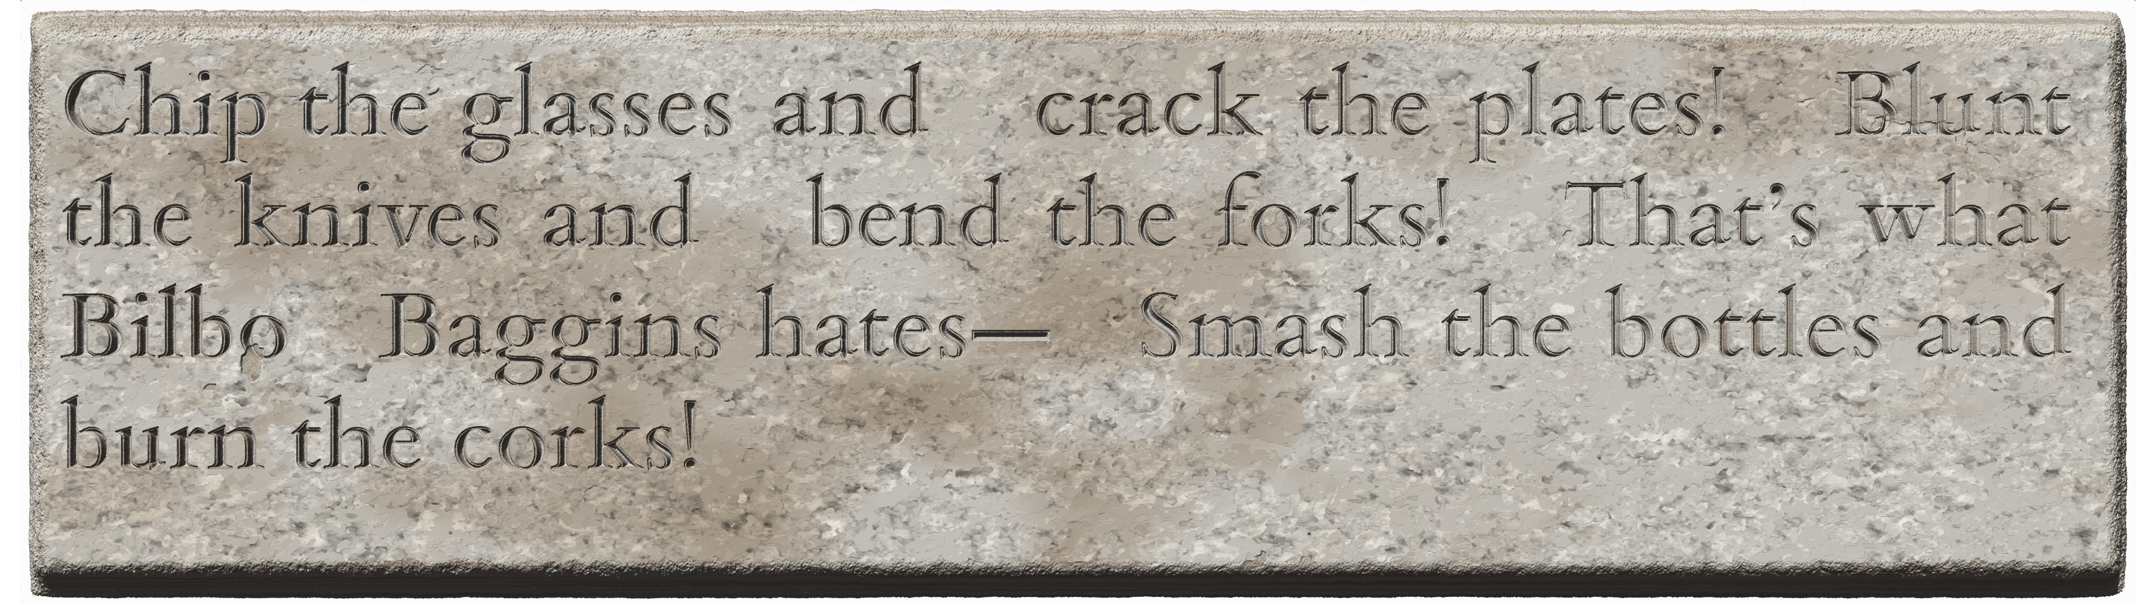
- in this inscription, spaces have been left blank in the text at caesuras and line ends
- however, the spaces do not line up one below the other (as they do in Exhibit 4.7.Q)
- therefore, they are to be encoded as semantic spaces (if at all), not as gridlike milestones
<lg n="1">
<l n="a"><lb n="1"/> Chip the glasses and <space/>crack the plates!<space/></l>
<l n="b">Blunt <lb n="2"/>the knives and <space/>bend the forks!<space/></l>
<l n="c">That’s what <lb n="3"/>Bilbo <space/> Baggins hates—<space/></l>
<l n="d">Smash the bottles and <lb n="4"/>burn the corks!</l>
</lg>

Other kinds of space
Spaces left blank in the original document may be considered significant even when they do not serve to indicate semantic or metrical boundaries. This subsection describes the encoding of other kinds of significant space, and discusses the use of space for layout (§5.4.2.4), which is not to be encoded as space.

Space left blank for missing content
This subsection is about areas that were deliberately left blank when the rest of the inscription was engraved, because the content to be written was not available to the engraver. This usually happens either because certain particulars, such as a name or a date, were to be added later, or because the engraver was unable to interpret a glyph in the archetype he was working from. Such spaces are called vacat in the western scholarly tradition.
- to encode spaces left blank for missing content, use <space/> with @type="vacat"
  - encoding the size of such spaces (§5.4.2.4) is recommended even if they are normal-sized
  - e.g. <space type="vacat" quantity="3" unit="character"/>
Exhibit 5.4.B. space marked for missing content
<space type="vacat" rend="mark" quantity="9" unit="character"/>
- if unwritten space is filled with some kind of scribal mark such as dotting, horizontal lines, etc., as in Exhibit 5.4.B
  - add the attribute @rend="mark" to the space element encoded as above
  - the appearance of the mark may be described in your annotation
  - such scribal marks are to be distinguished from connectors (§5.3.2.3), which are used when there is no missing content
- if space was left blank and later partially or completely filled with text, it may be difficult to determine whether, and exactly where, this has happened, as well as to distinguish this from deletion followed by rewriting, which is to be treated as per §5.5.3
  - if any uncertainty is involved, proceed as follows
    - edit the text normally, without any special encoding for vacat
    - if any space remains, encode it normally
      - as vacat if you are certain of this identification
      - as unclassified (§5.4.2.3) if you are not certain
    - describe the situation in your annotation
  - if you are quite certain that space had been left blank and later filled, and are able to determine its beginning and endpoint precisely,
    - encode vacat for the entire length of the space originally left blank
    - immediately after the <space/> element, encode a premodern inline addition (§5.5.2)
    - if any blank space remains, include an unclassified space (§5.4.2.3) within the encoded premodern addition

Space imposed by physical necessity
This subsection is about spaces left blank because a physical feature of the support prevented the engraver from writing on a certain area. Encoding such interruptions as significant space is helpful because their presence may be the cause of non-standard sandhi and scribal errors.
- the encoding of spaces imposed by physical necessity is optional, and may not be possible when working from a printed edition without access to the original or a surrogate
- if you do choose to encode any such space in an edition, then do so consistently throughout that particular edition
  - consistency does not necessarily mean encoding each and every imposed space; instead, you may opt for one of the following strategies:
    - encoding all imposed spaces of a particular class (of those listed below), but not other classes
    - encoding imposed spaces when they disrupt the text by falling inside a word, but not encoding them when they fall between words
  - consistency should be complete within an edition, but cannot be realistically expected across our entire corpus or even across the body of texts encoded by a single person
    - aiming for consistency across your subcorpus is a good idea, but feel free to adopt a different strategy for any text where this seems desirable
- when encoding spaces imposed by physical necessity, distinguish these from other spaces by adding the attribute @type to <space/>, with a value depending on the nature of the interruption as follows
  - "binding-hole" for the binding hole in a copper plate or manuscript page
    - see also below for additional instructions concerning the encoding of such holes
  - "descender" for part of a glyph encroaching from the previous line
  - "ascender" for part of a glyph encroaching from the following line
Exhibit 5.4.C. space skipped due to feature
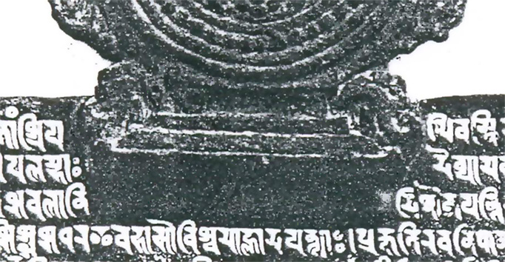
<space type="feature"/>
  - "feature" for a deliberately created feature on the surface (such as engraved artwork, high relief, or a seal attached directly to a copper plate, excluding binding holes, ascenders and descenders covered above), as in Exhibit 5.4.C
  - "defect" for a blemish of the surface that was not deliberately created (such as a natural crack or pit, or a fault in the creation of the writing surface)
- imposed spaces shall always be encoded without further attributes, i.e. never use @quantity and @unit to encode their size, because the size of such spaces is determined by factors extraneous to the text
  - the location and size of large surface irregularities, whether or not you have encoded them as space elements, may be described in your layout description (briefly), your commentary (when you wish to discuss them at some length), or an apparatus note (to discuss a specific imposed space)
- unlike other encoded spaces, imposed space will frequently occur within a word, in which case you should not surround the element with editorial spaces (§5.4.4)
- when a single surface irregularity affects more than one line in this way, separately encode an imposed space for every affected line
  - we use no explicit encoding for the fact that these interruptions are due to a single irregularity (but this may be mentioned in your annotation)
- when encoding binding holes, keep in mind that the occasion for encoding is not the presence of a binding hole, but the fact that such a hole has obliged the engraver to skip horizontally, therefore
  - do not encode a space for a hole that is fully outside a margin line (in the area surrounding the text field), as in Exhibit 5.4.D/1
  - do not encode a space for a hole that lies within the text field, but between lines, as in Exhibit 5.4.D/2
    - this applies even if lines above/below the hole bend, or if glyphs in those lines are distorted in order to accommodate the hole
  - optionally encode a space for a hole that is on or within the margin line, causing one or more text lines to begin with an indent, as in Exhibit 5.4.D/3
  - preferably encode a space for a hole that is fully within the text field, interrupting one or more text lines, as in Exhibit 5.4.D/4
    - this applies to all lines that skip some space around the hole, even if the hole itself does not penetrate into the area where a line’s text could have been inscribed, as in Exhibit 5.4.D/5
Exhibit 5.4.D: positions of a binding hole relative to text
1 | 2 | 3 | 4 | 5
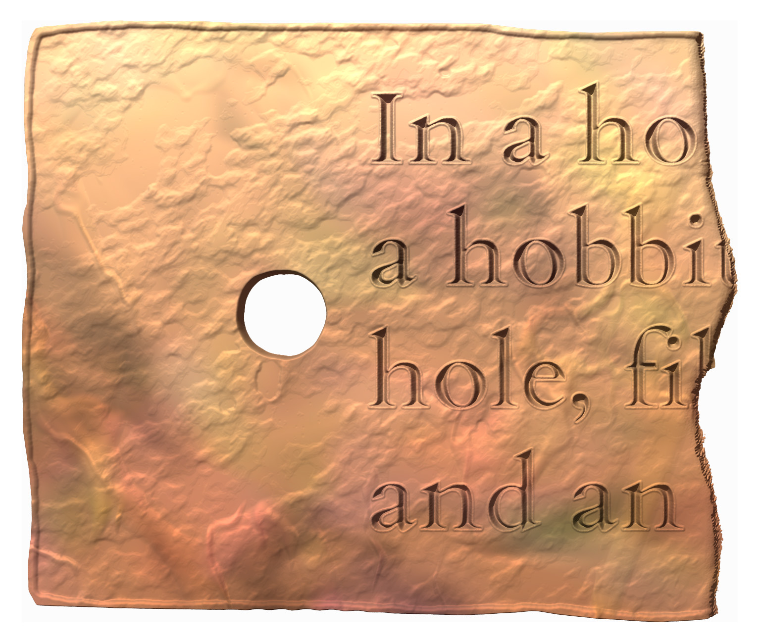 | 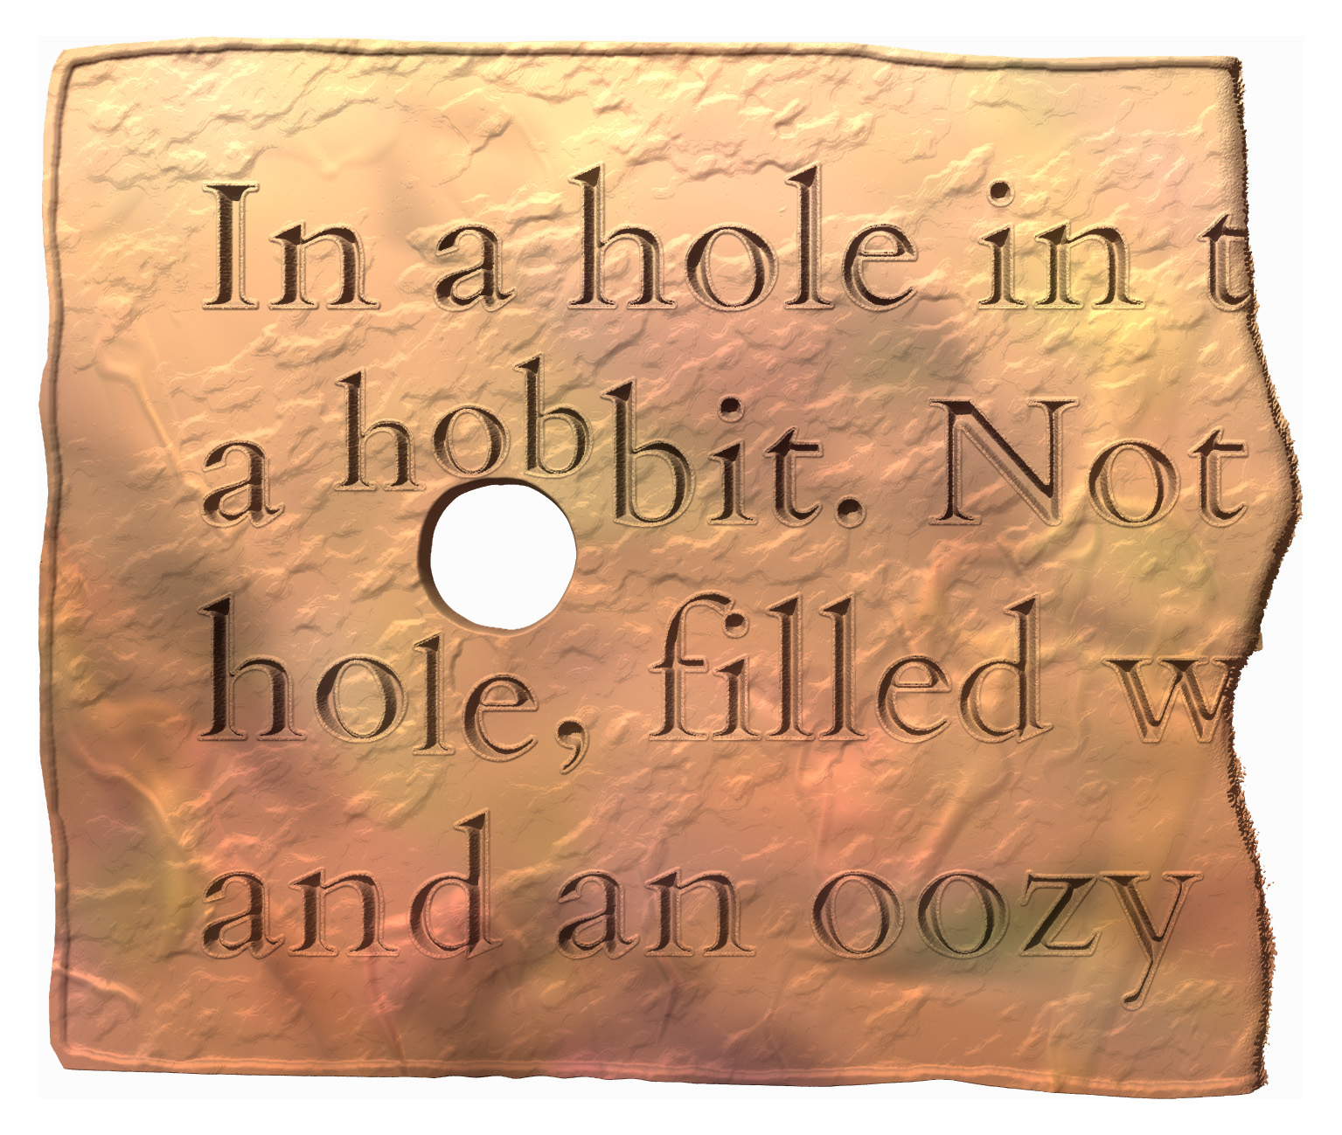 | 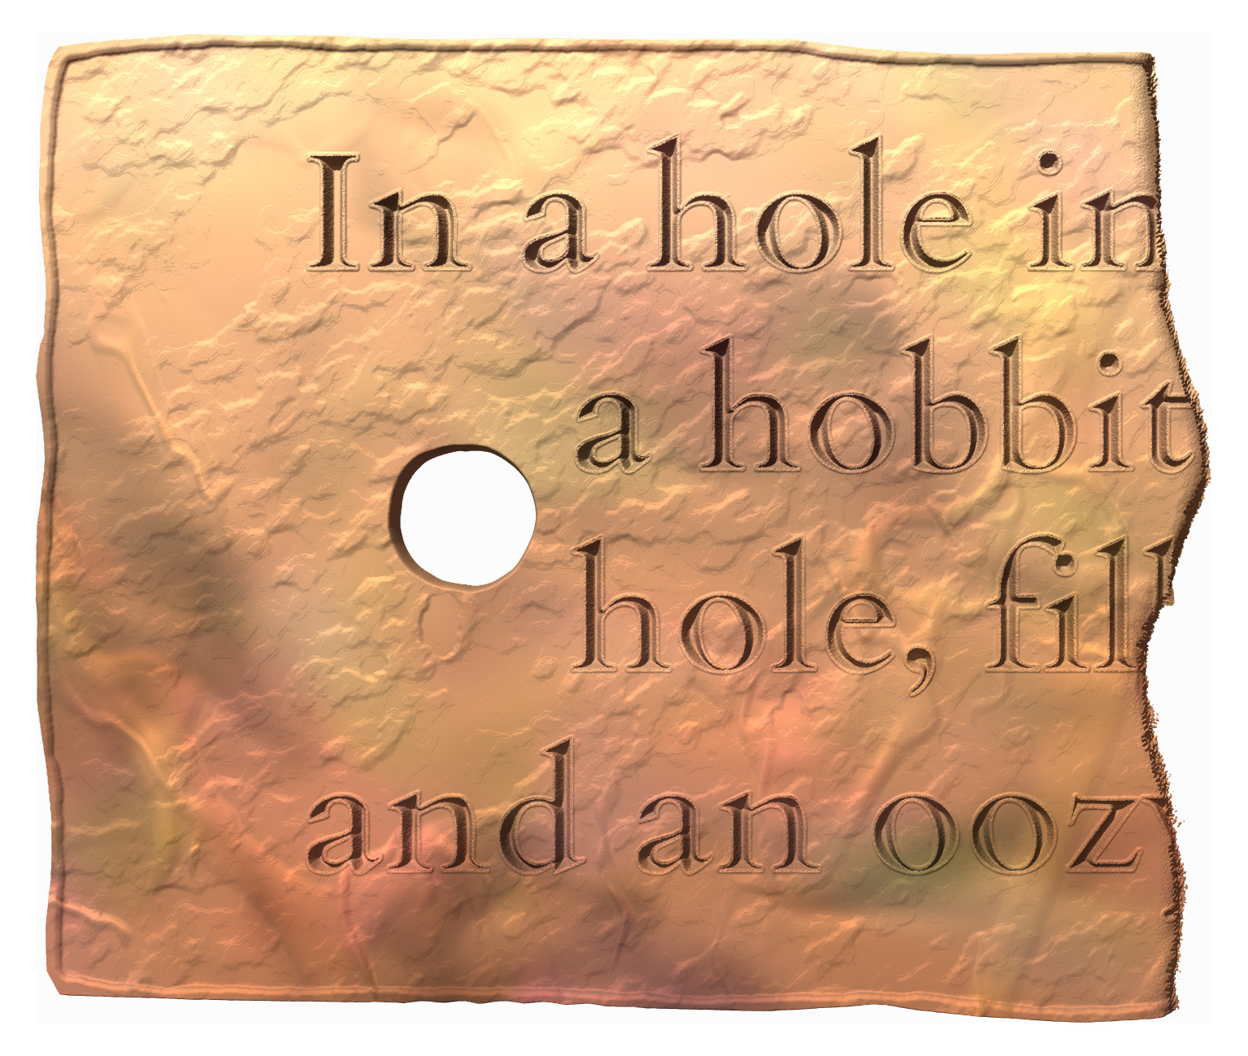 | 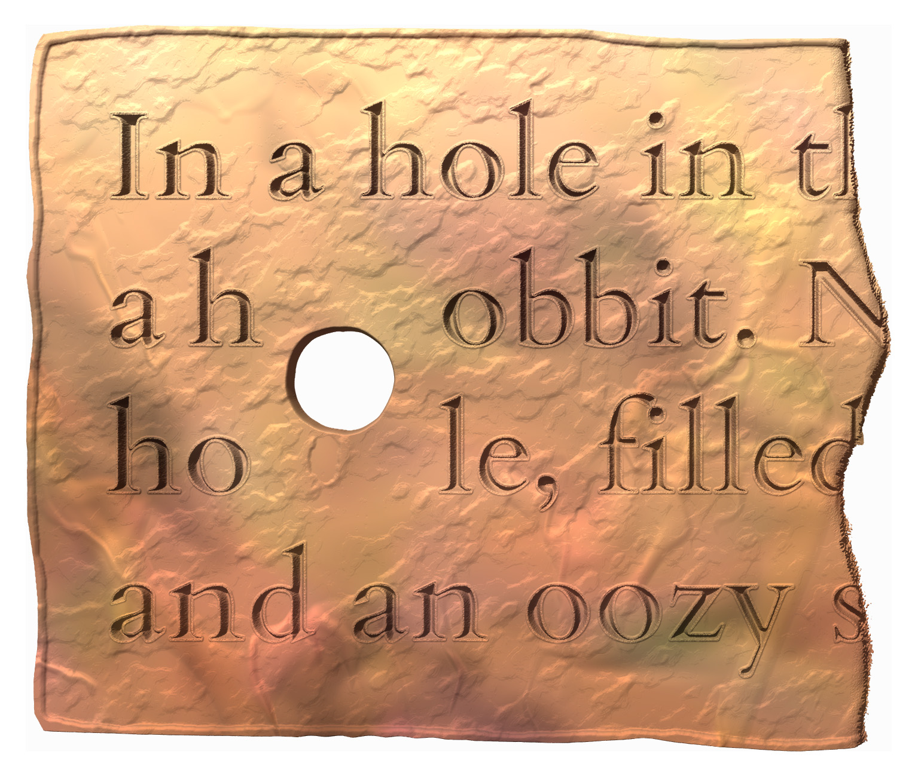 | 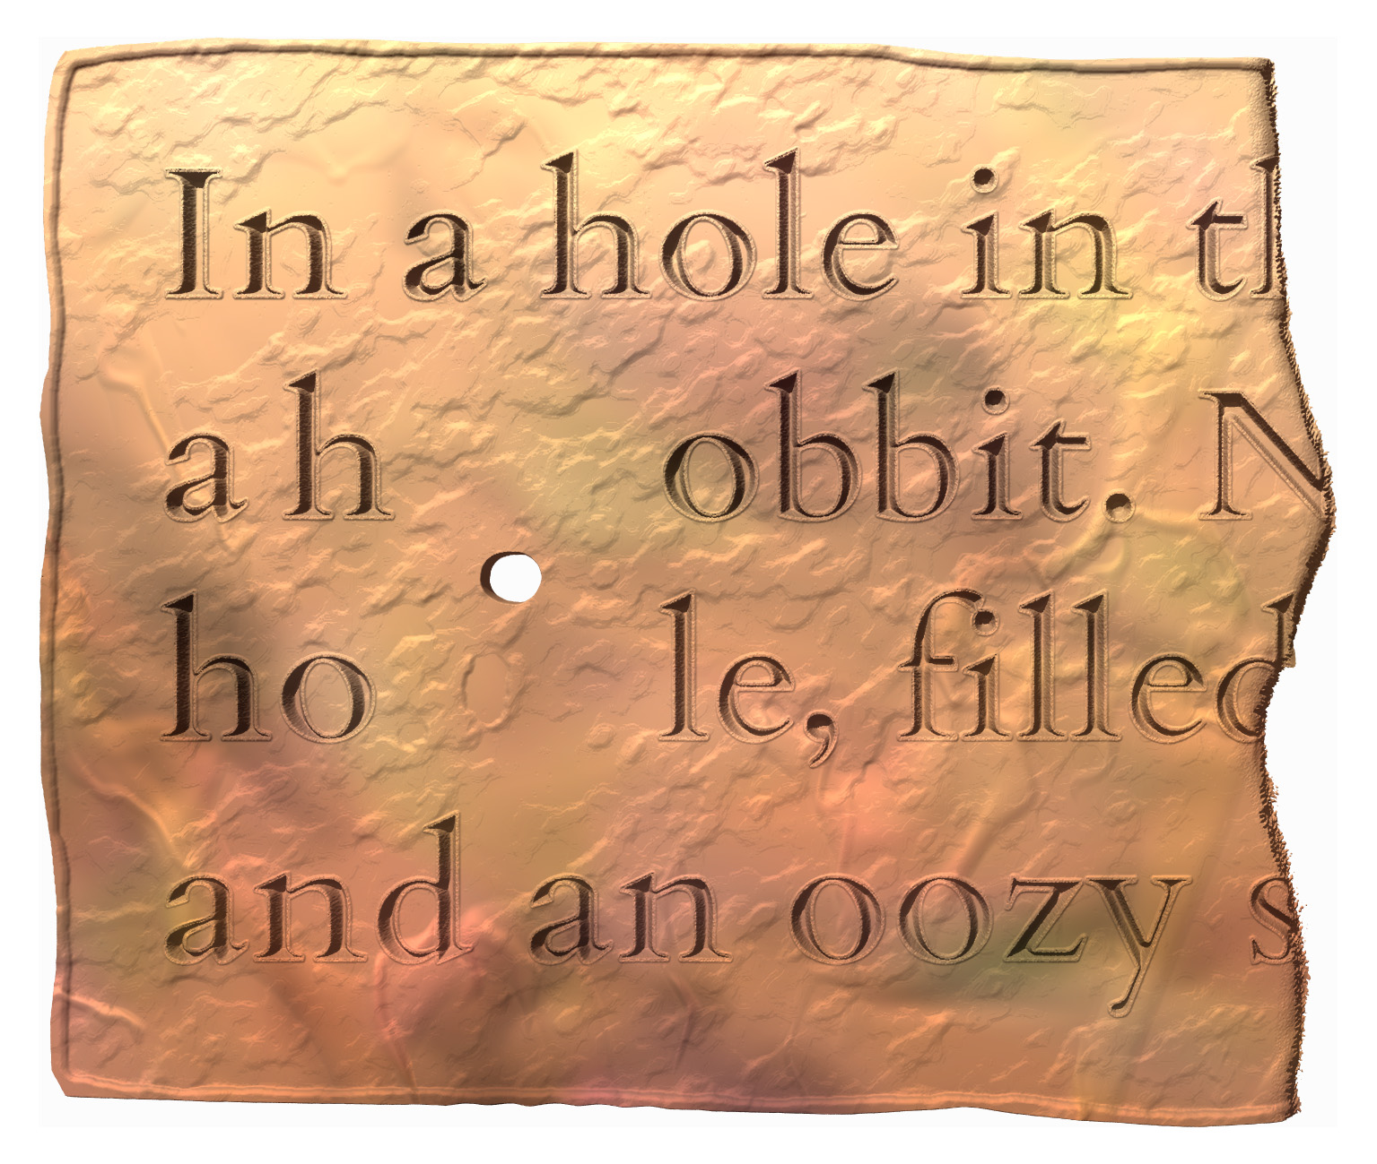

Unclassified space
This subsection concerns spaces which may be deemed significant even though they cannot be assigned to any of the types dealt with above.
- spaces may, for instance, be unclassified because
  - working without access to a good surrogate, you cannot decide if any of the classes apply, or
  - none of these types correspond closely enough to your hypothesis of why the space is present
- unclassified spaces shall be encoded using <space/> with @type="unclassified"
  - add no further attributes for normal-sized spaces
  - for larger spaces, encode size as per §5.4.2.4

Layout spacing
Space left blank in a document for the sake of visual layout should not, as a rule, be marked up as space. Such features should be mentioned in the annotation, and may be represented through encoding as follows:
- for inline layout blanks: optionally encode specially aligned lines as per §8.5.1 when spaces appear
  - at the end of a line that begins flush with the left margin
  - at the beginning of a line that ends flush with the right margin
  - at the beginning and end of a line that is centred between the two margins
  - between words or glyphs throughout a line that is justified to both margins
- for blank areas between lines: by default encode nothing
  - create no <lb/> elements for empty lines and insert no <space/> elements to represent them
  - the regular line spacing and any deviations from it should be described for human readers in the layout description
  - opening passages (incipits) separated by space from the body of an inscription may be given special line numbers as per §4.7.1.1
- for blank pages in copper plates: encode <pb/> elements for each page as per §4.4.2.2, but insert no <space/> elements to represent their content

The size of spaces
- to encode the size of a space, add both of the following attributes to the <space/> element
  - @quantity, whose value shall be the width of the space given as the number of characters that could fit into it (i.e., the number of widths of an average akṣara)
    - this quantity is always understood to be approximate
  - @unit, with the value "character"
    - our encoding does not use any other units for the size of spaces
- when these attributes are not present, <space/> is by default understood to represent a “normal” space such as that found between two words, which usually has a breadth no larger than two average characters
  - it is therefore not necessary to explicitly encode the size of normal spaces

Spaces and their context
- the element <space/> should normally be separated from surrounding text by editorial spaces in your file, except:
  - if a <space/> occurs within a word of the text, no spaces must be added around the element; see §7.8.1 for more details.
    - there is no explicit encoding for the fact that a space interrupts a word
  - if a <space/> occurs at the boundary (beginning or end) of a structural container, do not add a space between the containing element’s tag and the <space/> element
- if a space appears in lieu of punctuation at the boundary of two block-level containers for intrinsic structure (§3), allocate it to the end of the earlier container unless you strongly feel that it belongs to the beginning of the latter container
- as a special case, spaces may appear at an akṣara boundary next to, but not coincident with, a word boundary (which would fall within the akṣara)
  - such spaces must always be represented in the transliterated text at their actual location (and thus without editorial spacing)
  - however, it is recommended that you flag this as non-standard usage and optionally also normalise the text (§7) by restoring the symbol at the word boundary and changing the sandhi and editorial spacing as applicable, as in Exhibit 5.4.E
  - when this happens at the end of a container element such as a verse line, encode the container boundary at its logical place (§3.2.4.1), disregarding the akṣara boundary and the symbol
Exhibit 5.4.E: space at akṣara boundary rather than word boundary
- original: <l n="a">jayatīndrādidevāsya<space/>ś</l><l n="b">śrīmān yajñapatīśvaraḥ</l>
- flagged: <l n="a">jayatīndrādidevāsya<orig><space/>ś</orig></l><l n="b">śrīmān yajñapatīśvaraḥ</l>
- normalised: <l n="a">jayatīndrādidevāsya<choice><orig><space/>ś</orig><reg>ḥ<space/></reg></choice></l><l n="b">śrīmān yajñapatīśvaraḥ</l>
- the space belonging at the end of the word °āsyaḥ is placed after sya, because the end of this word has been merged in sandhi into conjunct (śśrī) with the beginning of the next word

Premodern scribal intervention
The word ‘scribe’ refers in this Guide to any person who has made a purposeful and meaningful contribution to a written document before it became an object of modern study. Scribal intervention thus means a purposeful and meaningful change effected in an already written text, often by the original scribe and at or near the time of the original engraving, but in some cases by a different person and/or at a much later time. Scribal intervention is usually constructive (as in addition, discussed in §5.5.2 and correction, §5.5.3), but it may also be destructive in a deliberate and targeted manner (deletion, §5.5.1). Scribal intervention does not include the purposeful or accidental effacement of an entire inscription or random parts thereof, nor the engraving of a palimpsest over a pre-existing inscription.

Scribal deletion
Scribal deletion is the deliberate cancellation of one or more graphemes in a pre-written text by a scribe. Deletion is usually of an editorial nature, affecting parts of the text that were incorrectly or needlessly written. Deletion also includes the targeted removal of circumscribed sections of an inscription (e.g. of names). Deletion accompanied by a corrective or restitutive addition is correction, treated in §5.5.3. Damage to the support is to be handled according to §6, while space left blank in an inscription is discussed in §5.3.5. When it is doubtful whether purposeful deletion has taken place, choose the encoding for the phenomenon you deem most likely, and discuss the matter in your annotation.
- graphemes that were deleted in premodern time are to be wrapped in the element <del>, with the following attribute
  - as applicable, @rend for the manner of deletion as per §5.5.1.1
- this element must always contain text or markup equivalent to text
  - if the vestiges of the deleted text cannot be read with confidence, use the applicable markup (§6.3.1.3) within the <del> element
    - text that has been rendered illegible by deletion must be marked up as a lacuna (§6.5) within the deletion, e.g. <del><gap reason="illegible" quantity="1" unit="character"/></del>

Encoding the manner of deletion
In DHARMA usage, the <del> element will by default be understood to represent text rendered illegible through erasure by means such as chiselling the stone, hammering the copper flat, or rubbing the surface smooth. Deletion by erasure needs no additional encoding. In some inscriptions, scribal cancellation marks are employed instead of, or in addition to, erasure. In both of these cases, encode the presence of such marks by adding the attribute @rend to the <del> element, as in Exhibit 5.5.A.
- the following values are permitted for @rend with <del>:
  - "strikeout" for text struck through or cross-hatched
  - "ui" for the combined application of vowel markers u and i to glyphs to be deleted
  - "other" for any deletion marker other than those listed above
  - "corrected" when neither erasure nor a cancellation mark is present, and deletion is implied by the presence of a correction written over the earlier text (to be encoded as per §5.5.3)
- further details about the form and placement of deletion marks used in your inscription may be annotated
Exhibit 5.5.A: premodern deletion with editorial marks
- the inscribed text naiḥ mas· su has been marked for cancellation | 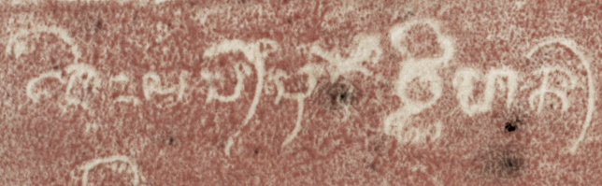
<del rend="other">naiḥ mas· su</del> vḍihan·

Scribal addition
Scribal addition is the insertion of one or more graphemes into a pre-written text by a scribe. Addition is usually of an editorial nature, restoring parts of the text that were erroneously omitted. Addition for the correction of deleted text is correction, treated in §5.5.3. Additions supplementing a previously written text with content that was presumably not originally intended at the time of its writing, such as an additional clause appended to an inscription, are generally to be treated as organic parts of the document and not as scribal additions. However, small supplementary items written in interlinear or marginal space may be treated as additions at your discretion. Additions written in space originally left blank with the purpose of filling later (§5.4.2.1) can and should be encoded as scribal addition if you are certain that this is what happened.
- in the digital edition, text added by the scribe must be placed at its logical location (where it was meant to be read), regardless of its physical location in the original
  - in this subsection, we refer to an addition’s logical location as its locus, and its physical location as its place
  - if you cannot confidently determine the intended locus of a piece of interpolated or marginal text, choose one of the following options at your discretion:
    - put the added text at its most likely locus and describe the situation in your annotation
    - put the added text at a plausible structural point near to its place, such as the beginning or end of a line, page, semantic unit or the entire inscription and describe the situation in your annotation
    - encode the added text at or near its place as an additional line of the principal text (§4.7.1.2)
    - for longer additions that do not obviously integrate into the semantic structure of the principal text, especially when consisting of multiple lines, you may opt to create a separate textpart division (§4.2)
- graphemes that were added in premodern time are to be wrapped in the element <add>, with the following attributes
  - mandatorily, @place for the physical location of the added text as per §5.5.2.1
  - as applicable, @rend with the value "mark" to encode the involvement of a premodern scribal mark (Sanskrit kākapada), as illustrated in Exhibit 5.5.C and Exhibit 5.5.D
    - this encoding distinguishes neither the shape of such a mark, nor its location (e.g. at the locus of insertion, next to the inserted text, or at both places)
    - the shape and location of the marks shall be described in an apparatus note (§10.7)
- the inserted text may include additional markup when necessary
  - for any text-containing elements whose scope begins or ends outside the addition, take care to avoid overlap and split elements according to their hierarchy (§16.2)
  - empty structural elements (line beginnings, §4.5; and gridlike milestones, §4.6) should normally be placed outside the <add> tags, but if an addition takes up the entirety of one or more physical lines (or stretches of text indicated by a gridlike milestone), then you may encode line beginnings and milestones within an addition at your discretion and number them as you deem appropriate; see Exhibit 3.2.D for an illustration

Encoding the place of the addition
- the physical location of text added by the scribe is to be encoded with the attribute @place on the <add> element
  - in DHARMA encoding practice, this attribute must always be explicitly present on <add>
- the attribute may take the following values:
  - "unspecified" for cases where your only source is a previous edition that does not specify the place of the inserted text
  - "inline" for an addition inscribed within the same line in the immediate vicinity of the locus, including
    - one or more glyphs inserted between two pre-engraved glyphs
    - one or more glyphs inserted into a space previously left blank (§5.4.2.1)
    - one or more graphs (e.g. a vowel marker or a subscript consonant) inserted into a pre-engraved glyph
  - "above" for an interlinear addition above the locus (in any horizontal position)
  - "below" for an interlinear addition below the locus (in any horizontal position), as in Exhibit 5.5.B
  - "top" for an addition in the top margin (in any horizontal position)
  - "bottom" for an addition in the bottom margin (in any horizontal position)
  - "left" for an addition in the left margin (in any vertical position)
  - "right" for an addition in the right margin (in any vertical position)
  - "overstrike" for an addition written over pre-existing text with the intent to replace (correct) it, discussed further in §5.5.3
Exhibit 5.5.B: premodern interlinear addition
- an originally inscribed dīnāram was corrected to dīnāra-dvayam by adding dvaya between lines below this word
dīnāra<add place="below">-dvaya</add>m

Exhibit 5.5.C: premodern addition with a scribal mark next to the added text
- an originally inscribed maphalā was corrected into makaphalā by adding ka between lines below this word (see the illustration)  - the scribal marks on the left and right of the added ka look like punctuation marks, but the scribe’s intention was not to write ma,ka,phalā so we should not interpret these marks as punctuation marks | 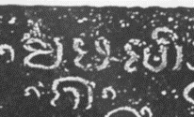
ma<add place="below" rend="mark">ka</add>phalā

Exhibit 5.5.D: premodern addition with a scribal mark next to the place of addition
- the glyph va was omitted from the text °r avadhāraṇayā  - subsequently inserted below the line  - with kākapada marking the spot of addition | 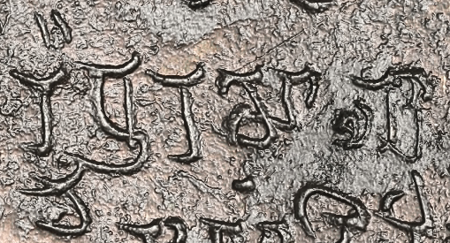
r a<add place="below" rend="mark">va</add></subst>dhāraṇayā

Scribal correction
Scribal correction is the deliberate cancellation of one or more graphemes in a pre-written text by a scribe, accompanied by the restitution of (not necessarily the same number of) other graphemes. Scribal correction is usually of editorial nature, replacing text deemed erroneous with text deemed correct, but may also be an amendment of the content.
- when a correction is inscribed over previously engraved text which was rendered altogether illegible in the process and cannot be restored with any confidence, encode the correction as an addition with @place="overstrike", as in Exhibit 5.5.E
  - in this case, the presence of cancelled pre-correction text is merely implied by the special value of this attribute
- whenever any of the pre-correction text can be read or restored, with high or low confidence, scribal correction must be encoded as a combination of scribal deletion and scribal addition, wrapped in the element <subst> to show that one is meant to be substituted by the other
  - within this element, use <del> (§5.5.1) and <add> (§5.5.2) as instructed above and with any applicable attributes, with the following additional considerations
    - use the attribute @rend="corrected" on <add> if the text to be replaced was neither erased nor marked for cancellation
      - either because it was overwritten with the post-correction text, as in Exhibit 5.5.E
      - or because it was left in place without any apparent alteration and the post-correction text was inscribed nearby, as in Exhibit 5.5.F
    - use the attribute the attribute @place="overstrike" on <add> if the replacement text is inscribed right over the pre-correction text (rather than at some other position), as in Exhibit 5.5.E
- occasionally, scribal correction may take place without explicit addition, when the correction consists in changing the order of the already inscribed glyphs, and this is indicated by a mark rather than by re-inscribing the glyphs in the correct order, as in Exhibit 5.5.H
  - if you are confident in your interpretation of such a situation, encode scribal correction normally, putting the presumably intended corrected reading in <add>
Exhibit 5.5.E: scribal correction by overwriting
- the glyphs tuṣṭa were overwritten with catu because the scribe had omitted the first akṣara of the word catuṣṭayaṁ, but noticed and corrected the mistake immediately  - the pre-correction glyphs are not deleted (@rend="corrected" on <del>)  - the post-correction glyphs are written over the pre-correction text (@place="overstrike" on <add>) | 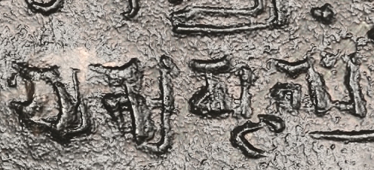
<subst><del rend="corrected">tuṣṭa</del><add place="overstrike">catu</add></subst>ṣṭayaṁ

Exhibit 5.5.F: scribal correction written inline
- an originally inscribed dvau was corrected to dve immediately  - the correction is placed after the pre-correction glyph (@place="inline" on <add>)  - the incorrect dvau was not explicitly cancelled (@rend="corrected" on <del>) | 
devakule <subst><del rend="corrected">dvau</del><add place="inline">dve</add></subst>

Exhibit 5.5.G: scribal correction by striking out a component
- an originally inscribed prisaṅgi was corrected to prasaṅgi by striking out the superfluous i marker  - @rend is not used on <del>, since the i was erased, which is the default method of deletion  - although no explicit a was engraved, the deletion of i entails the replacement of that grapheme by a, so this must be encoded as correction rather than deletion (§5.5.4)  - the addition is encoded with @place="overstrike" because the post-correction reading is in the same place as the pre-correction reading | 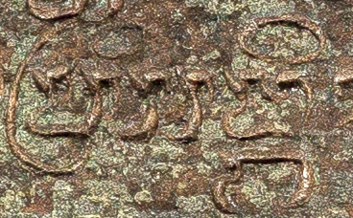
pr<subst><del>i</del><add place="overstrike">a</add></subst>saṅgi

Exhibit 5.5.H: implied scribal transposition
- an originally inscribed ri lata was corrected to ri tala in a manuscript by adding a scribal mark | 
ri<subst><del rend="corrected">lata</del><add place="overstrike" rend="mark">tala</add></subst>
- although the intended correction is not explicitly written anywhere, the intent was clear to the editor, so the encoding records implied correction with the details that can be represented in our encoding scheme:
- that the pre-correction text is not explicitly deleted, but overruled by the correction (@rend="corrected" on <del>)
- that the post-correction text is right there and not somewhere else on the support (@place="overstrike" on <add>)
- that a scribal mark is present (@rend="mark" on <add>)

Good practice in encoding scribal intervention
Since the units to which all our encoding applies are the source graphemes (for which see also §16.3), scribal intervention can only be, and must always be, represented in our editions in terms of graphemes, and not in terms of akṣaras, graphs, elements or any other unit. This has the following important implications.
- scribal intervention can apply to a unit smaller than the akṣara, so if one or more component graphs of a complex glyph have been changed by the scribe, this is to be encoded as a specific change of the corresponding graphemes, and not as a correction of the entire akṣara (as it would usually be shown in an edition printed in an Indic script), for example
    - in deletion, ś<del>r</del>āpa
      - not <subst><del>śrā</del><add>śā</add></subst>pa
    - in addition, tārkṣ<add>y</add>a
      - not tā<subst><del>rkṣa</del><add>rkṣya</add></subst>
    - in correction, pa<subst><del>t</del><add>d</add></subst>ma
      - not pa<subst><del>tma</del><add>dma</add></subst>
  - note that these examples show no attributes on <del> and <add>, because they illustrate hypothetical scenarios that may be implemented differently in the source, but the encoding of actual instances of scribal intervention may require the use of attributes as per §5.5.1.1 and §5.5.2.1
- scribal intervention cannot apply to a unit smaller than the grapheme, so the deletion (or, when this can be discerned, the addition) of a graphic element cannot be encoded as such; instead,
  - the scribal alteration of a non-distinctive element (such as an ornamental curlicue or a superfluous stroke) can be annotated if desired, but not represented in markup
  - the deletion (or addition) of a distinctive element must be encoded as correction of one grapheme to another, for example
    - in a script where śa differs from ga only in that the former has a cross-stroke, and the scribe erroneously engraved śuṇa instead of guṇa, then corrected this by erasing the cross-stroke, this is a correction of ś to g: <subst><del rend="corrected">ś</del><add place="overstrike">g</add></choice>uṇa
      - although the scribe actually erased the cross-stroke, on the level of graphemes the ś itself was not physically deleted (hence @rend="corrected" on the <del> element, §5.5.1.1), while the g was created in the same place (hence @place="overstrike" on the <add> element, §5.5.2.1)
- due to the nature of aksharic writing, the deletion or addition of certain graphs (namely of a vowel marker or virāma) may result in the substitution of one grapheme by another (viz. of the marked vowel or virāma by the default vowel, or vice versa), which must be encoded as scribal correction rather than scribal deletion or addition, for example
  - if the vowel marker u is erased from the word jñātum, this changes the reading to jñātam
    - which must be encoded as jñāt<subst><del>u</del><add place="overstrike">a</add></subst>m
      - not jñāt<del>u</del>m (which would mean that the post-correction reading is jñātm)
      - even though the scribe did not actually add anything, on the level of graphemes the u was physically deleted (hence no @rend on the <del> element, §5.5.1.1), while the grapheme a was created in the same place (hence @place="overstrike" on the <add> element, §5.5.2.1)
    - see Exhibit 5.5.G for a fully encoded example of such deletion
  - if the vowel marker ā is added to the second akṣara of the word putraḥ, this changes the reading to putrāḥ
    - which must be encoded as putr<subst><del rend="corrected">a</del><add place="overstrike">ā</add></subst>ḥ
      - not putr<add>ā</add>ḥ (which would mean that the pre-correction reading is putrḥ)
      - even though the scribe did not actually delete anything, on the level of graphemes the a was cancelled without physical deletion (hence @rend="corrected" on the <del> element, §5.5.1.1), while the ā was created in the same place (hence @place="overstrike" on the <add> element, §5.5.2.1)

Legibility issues

Representing legibility issues in TEI/EpiDoc
This section is concerned with the encoding of text which is present in the source document, or was presumably present when the source was in a pristine state, but which cannot be read with complete confidence today. Encoding what should have been there but is (and was) not, i.e. editorial intervention, is the subject of §7. The textual loci affected by a legibility issue are tagged with phrase-level elements (§2.2.2), which are hierarchically subordinate to the block-level containers for prose and verse, therefore any continuous stretch of problematic reading that extends across a block-level boundary must be encoded with two separate phrase-level elements, one in each of the containers. Encoding hierarchy is discussed further in §16.2.
The TEI elements relevant to the source’s legibility are <damage>, <unclear>, <gap> and <supplied>. Which of these applies to any given locus, and what attributes should be used on them, depends on the degree to which the source text is objectively legible and your confidence in the reading selected for your edition, as illustrated in Exhibit 6.1.A, with the table’s labels explained below in more detail.
Exhibit 6.1.A: encoding of legibility issues
Confidence in edition text | Status of source text
Confidence in edition text | lost | illegible | problematic
high | <supplied>  with @reason="lost" | <unclear> | optional <unclear> optional <damage>
reasonable | <supplied>  with @reason="lost" | <unclear> | <unclear>
tentative | <supplied>  with @reason="lost"  and @cert="low" | <unclear>  with @cert="low" | <unclear>  with @cert="low"
nil | <gap>  with @reason="lost" | <gap>  with @reason="illegible" | NA
- the status of the text in the source document as an objective, physical entity
  - lost: the support is gone or at least its surface layer is completely destroyed so that all vestiges of writing are obliterated
  - illegible: the support is extant, but the glyphs cannot be made out with any degree of confidence
  - problematic: the glyphs can be made out at least tentatively, but if taken out of context, their reading would be equivocal
- confidence in the accuracy of your edition’s text (reading or restoration informed by context and expertise)
  - high: your reading or restoration is quite certainly identical to what was actually written, or if not 100% accurate then differing only in trivial details (for instance, there may have been orthographic variation or a scribal error in the source)
  - reasonable: your reading/restoration is likely to be correct, but there is a chance of a non-trivial alternative reading being possible
  - tentative: your reading/restoration is a best guess or a diagnostic conjecture, with a fair chance that the actually engraved text differed from it in a non-trivial way
  - nil: the text cannot be read or restored with any confidence, so you prefer not to venture a guess

The element <unclear> (§6.3) in principle stands for text that has been read at least tentatively from the source but which might not be readable with full confidence when removed from its context. Unclarity is usually a result of damage to the support, but it may also be a consequence of the eccentric or poor execution of the original writing. The latter can be distinguished from the former by the addition of an attribute (§6.3.1.2), but the overall method of the encoding is indifferent to the reason why a locus is not perfectly legible. In DHARMA practice, <unclear> is not required when the text in context has been read with complete confidence even if some ambiguity might apply to the glyphs taken out of context. Loci affected by damage that does not impede reading may be tagged with <damage> (§6.2), although this is not usually done in DHARMA practice.
When you have no reading or restoration whatsoever for a particular locus, the edition obviously cannot contain text for that locus, but the presence and extent of a lacuna must be indicated in some way. This is done with the element <gap>, which stands as a placeholder for text that is not available. The use of this element for various kinds of lacunae is discussed in detail in §6.5. Our practice, in accordance with EpiDoc, distinguishes two kinds of lacuna based on the condition of the support: if the source text is altogether gone, then the gap is classified as “lost”, while if writing is present at least vestigially, it is classified as “illegible”.
When the text is altogether lost from the source but can be at least tentatively restored by the editor (on the basis of expertise, context and related texts), the element <gap> is not applicable because the edition does contain text for the locus. Instead, the element <supplied> (§6.4) is added to tag text as an editorial restoration. Importantly, EpiDoc does not allow the use of <supplied> when text, however effaced, is still present in the source. While a lacuna may be either “lost” or “illegible,” a stretch of restored text must always be “lost.” The rationale behind this is that if any vestiges remain, and these can be reconstructed on the basis of context, then they meet the definition of <unclear> and ought to be marked up as such. Although we feel that a meaningful and potentially helpful distinction can be made between “conjecturally restored text not explicitly ruled out by vestiges” and “text restored on the basis of vestiges,” our encoding practice shall follow established EpiDoc convention. Therefore, as shown in the middle column of Exhibit 6.1.A, when editorial text is present at a locus that is illegible rather than lost, this text mut be marked up as <unclear> rather than as <supplied reason="lost".
Whenever text (either read or restored) is present at a locus, low editorial confidence in the accuracy of that text is to be indicated by adding the attribute @cert="low" to the phrase-level container.

Damage not impeding legibility
When the source text is to some extent effaced by damage but this does not affect its legibility, the element <damage> may be used to wrap any contiguous stretch of text affected by damage. We find that this complicates the encoding (especially when in interaction with other tags) without providing any noticeable advantage, and therefore recommend that conspicuous patches of weathering or loss be described for human readers in your annotation, but not encoded in the edition. If you do wish to use <damage>, keep in mind that it does not replace the encoding of legibility issues discussed in the other parts of this section, only augments them.

Unclear readings

Encoding unclear text
Unclear text is text that can be read in the source with some confidence, but not with complete certainty on account of damage or unusual glyph formation.
- use the element <unclear> for unclear readings with the following attributes
  - as applicable, @reason to indicate that the reading issue is due to unusual execution rather than to damage, as per §6.3.1.2
  - as applicable, @cert to indicate that the editorial reading is tentative, as per §6.3.1.3
- when marking up text as unclear, you must keep in mind that the EpiDoc schema permits only text and the XML element <g> within <unclear>
  - therefore, if a stretch of text you wish to mark up as unclear incorporates or overlaps with another stretch that needs different markup (for instance editorial intervention), you will need to split the stretches of text tagged with <unclear> accordingly
  - see §16.2.7 for further discussion and examples

When to use <unclear>
- as defined in EpiDoc, the element <unclear> stands for any grapheme “of which at least traces survive, but not adequately to identify the letter unambiguously outside of its context”
- therefore, this encoding is applicable to all of the following situations
  - “I’m not quite sure this bit of text is correct”
    - this is the basic situation where most of us would intuitively want to tag a locus as unclear
  - “this bit of text is entirely illegible in the source, but I can restore it”
    - as discussed in §6.1, such a restoration cannot be encoded as <supplied> and must instead be encoded as <unclear>
  - “this bit of text could conceivably be something else if the context was not there to help”
    - although <unclear> would in principle be required in all such situations, in DHARMA practice we prefer leaving its use to the editor’s discretion and recommend not adding this tag to trivial cases of potential out-of-context ambiguity
    - the rationale for this is that individual graphs lifted out of their context would often be somewhat ambiguous in the source documents we work with (due to full or partial homography in the particular writing system, to careless execution by the scribe, or to damage to the support), but cluttering the edition with <unclear> markup would distract attention from spots where damage (or form) casts genuine doubt on a reading

The reason of unclarity
The reason why a locus is deemed unclear is understood by default to be damage to the support, which may or may not be aggravated by the careless execution of the writing. In situations where the support is quite pristine but the reading is nonetheless unclear because the glyphs are unfinished, clumsily executed, or take an unusual or idiosyncratic shape, add the attribute @reason with the value "eccentric_ductus" to the <unclear> element.
- e.g. <unclear reason="eccentric_ductus">jñ</unclear>āna
- when damage and eccentric ductus are (or may be) simultaneously present, use <unclear> with or without this attribute depending on what you consider to be the primary reason for the lack of clarity
  - when in doubt, prefer <unclear> without this attribute

Tentative readings
By default, the element <unclear> only expresses potential ambiguity when taken out of context, without saying anything about the degree of confidence in a reading. As discussed in §6.1 and shown in Exhibit 6.1.A, the default assumption is that the locus has been read with high or reasonable confidence. When the reading of a locus is tentative, add the attribute @cert with the value "low" to the <unclear> element.
- e.g. mahā<unclear cert="low">puruṣa</unclear>
- no additional degrees of confidence shall be represented in markup, so "low" here may stand for anything between “not quite confident” to “desperate conjecture”
  - however, it is preferable to save desperate conjectures for your commentary or apparatus, and within the edition, only encode readings in which you have some confidence
- note that while a low certainty expressed by this attribute is often a consequence of extensive damage, the degree of legibility is not in direct correlation to the necessity of adding this attribute, thus:
  - even very badly damaged text may be marked up with plain <unclear> if it can be confidently supplied in the context; whereas
  - even text that is only slightly affected by damage or awkward execution may need to be marked up as <unclear cert="low"> if the context permits a variety of plausible alternative readings, as may easily be the case in unintelligible or only partly understood contexts (e.g. names, words foreign to the language of the inscription, or in case of extensive damage to the context)

Encoding ambivalent text
If a damaged or malformed glyph affords a limited number of alternative interpretations and the context does not allow you to select the most likely candidate, each alternative may be listed in individual <unclear> tags, wrapping the list in the <choice> element to show that only one of these is actually present at the given locus.
- e.g. s<choice><unclear>th</unclear><unclear>v</unclear></choice>a for an akṣara that might be read as stha or sva
- in this usage, <unclear> shall be used without @cert (§6.3.2.2), but @reason may be added if applicable (§6.3.1.2)
- since the encoding of alternative readings for an ambivalent locus impedes the readability and (especially) the searchability of the edition, this encoding should be used considerately and may in many circumstances be replaced by simply encoding the most likely alternative as unclear (§6.3.2.1)
- the text outside this encoding and the text within each of the alternative <unclear> elements must be entered with care, making sure that all of the possible alternative readings are accurately reproduced even when the ambivalence gives rise to complications such as
  - a different number of graphemes in the alternatives, e.g. g<choice><unclear>r̥</unclear><unclear>ra</unclear></choice>ha for a locus that could be read as gr̥ha or graha
  - different editorial spacing or hyphenation applicable to the alternatives, e.g. tath<choice><unclear>āp</unclear><unclear>ā h</unclear></choice>i for a locus that could be read as tathāpi (tathā*api in inseparable sandhi) or tathā hi (two separable words)
    - see §7.8.1.1 about avoiding spaces at the beginning or end of a text-containing element
  - see also §6.3.3 on good practice
- ambivalence involving more than two alternatives may be marked up by adding further <unclear> elements within <choice>
  - it is, however, recommended that you limit the number of alternatives to no more than two, and in the rare case where a higher number of genuinely plausible alternatives are possible, instead record the single most likely one as <unclear> and mention the others in your commentary or apparatus

Trivial ambivalence
As for unclear markup in general, feel free to ignore trivial ambivalence that can be resolved confidently on the basis of the context.
- in particular, when some pairs of glyphs look very similar (or wholly identical) in the script of your inscription, it is recommended that you record the expected reading without any markup or with a single <unclear> element, e.g.
  - if a word might be read as ṣahārāja in an inscription where ṣa and ma are very similar, simply record mahārāja or <unclear>m</unclear>ahārāja
  - if a word might be read as sambatsara in an inscription where ba and va are very similar, simply record samvatsara or sam<unclear>v</unclear>atsara
- however, if a possible alternative reading alters the meaning in a non-trivial way, then the ambivalence should normally be marked up (unless you are absolutely confident that it is ruled out e.g. by sandhi or by the wider context)
  - e.g. if Adharma or sudharma are both possible because the akṣaras A and su are very similar in the document
- even non-trivial alternatives may be left unencoded if you consider one to be much more likely than others, or if the locus is poorly understood and several alternatives are equally feasible
  - in such cases, simply encode the most likely reading as unclear
  - also keep in mind that those readers of your edition who are interested in possible alternatives can be expected to be familiar enough with the script in question to be able to work out those possible alternatives once they have received indication that a certain reading is unclear

The probability of alternative readings
By DHARMA convention, alternative readings for ambivalent loci shall be listed in order of decreasing probability (as judged by the editor). Although it is technically possible to assign specific probabilities to each alternative, we see no advantage to complicating our encoding with such information. The attribute @cert shall be likewise avoided in ambivalent readings, because using it on both alternatives would be pointless, while using it only on the less likely alternative would not add more information than what is already implied by the order of alternatives.

Good practice in encoding unclear readings
Since our editions are in Romanised transliteration, <unclear> encoding can and must precisely target the graphemes affected by a reading issue.
- if only a certain glyph component of the original script is unclear or ambiguous, then do not use tags around the transliteration of the entire akṣara, e.g.
  - e.g. sph<unclear>u</unclear>rad and NOT <unclear>sphu</unclear>rad (unless s, ph and u are all unclear)
- when unclarity applies to several graphemes which are contiguous in the reading order represented in transliteration, use a single <unclear> element around them even if they belong to different akṣaras in the source and even if they are not physically adjacent
  - e.g. mitr<unclear>eṇ</unclear>a and NOT mitr</unclear>e<unclear><unclear>ṇ</unclear>a (even if e is to the left of the clear tr while ṇ is to its right), nor mi<unclear>treṇa</unclear> (unless t, r, e, ṇ and a are all unclear)
- sub-akṣara markup for identifying specific glyph components (§5.1.2) is normally not necessary and should be avoided in such cases, since the graphetic position of the individual graphs can be inferred from the context
- in general, rather than using complicated encoding involving multiple alternative readings, rely on the expertise of the readers of your edition to figure out the exact locus of doubt within a complex original glyph and its possible implications, even in cases such as
  - doubt concerning the presence of a graph
    - encoding the default vowel of an akṣara as unclear (with low certainty if relevant) will tell the reader that a vowel marker might be present, e.g.
      - k<unclear>a</unclear> can signify a k with plenty of damage around it, which may obscure a vowel mark
    - encoding a component as unclear (with low certainty if relevant) will tell the reader that the component may be absent or may be a similar-looking component that represents a different grapheme, e.g.
      - sa<unclear>ṁ</unclear> can signify a probable saṁ where the anusvāra may be absent (in which case the reading is sa) or may be something else (such as a visarga or a punctuation mark)
      - g<unclear>r̥</unclear> can signify a probable gr̥ where the r̥ marker may be absent (in which case the reading is ga) or may be something else (such as a consonantal subscript r, in which case the reading is gra)
- the informed reader can also be expected to work out that unclarity affecting a specific graph may
  - affect the position of the corresponding grapheme in the reading order, e.g.
    - <unclear cert="low">r</unclear>ddha can signify a probable rddha where there is a fair chance that the superscript r is absent (in which case the reading is ddha) or is something else (such as a vowel marker for ā, in which case the reading is ddhā)
    - affect the way in which the akṣaras of the source are constituted, e.g.
      - k<unclear>ā</unclear> representing the sequence கா in Tamil, where what has been interpreted as an ā marker may instead be a separate akṣara ர ra
      - p<unclear>ā</unclear>ta representing the sequence पात in premodern Nagari that employs a pr̥ṣṭhamātrā form of e, so that what has been interpreted as pāta may instead be pate
- however, when you deem it desirable to encode such ambivalences explicitly, include the complete sequences affected by the ambivalence in spite of the blanket instruction to tag only the specific graphs affected by a reading issue, e.g.
    - <choice><unclear>rddha</unclear><unclear>ddhā</unclear></choice>
    - k<choice><unclear>ā</unclear><unclear>ara</unclear></choice>
    - p<choice><unclear>āta</unclear><unclear>ate</unclear></choice>

Editorial restoration
An editorial restoration is a stretch of text which the editor believes was probably present in the source document, but which could not be read at all in the source. Although conceptually a restored lacuna is a particular kind of lacuna, the two require different encoding approaches because a restoration contains text while an unrestored lacuna does not. Unrestored lacunae will be addressed in §6.5.
- where you as editor restore parts of the text that can no longer be made out in the original, the restored segments must be wrapped in the element <supplied>, with the following attributes
  - mandatorily, @reason to indicate why a restoration was necessary, as per §6.4.1
  - as applicable, @cert to indicate that the editorial restoration is tentative, as per §6.4.2
  - as applicable, @evidence to record the basis of the restoration, as per §6.4.3
- bear in mind that, as discussed in §6.1, restoration with <supplied> is for cases where a restoration is not based on what can be made out of the original writing
  - if vestiges of text can be made out to a degree sufficient to corroborate a restoration, then (regardless of how scant these vestiges are) the text should be treated as an unclear reading rather than a restoration
    - e.g. <supplied reason="lost">pitr̥</supplied><unclear>bhiḥ</unclear> saha pacyate (where vestiges give some confirmation for bhiḥ, whereas pitr̥ is wholly gone)

The reason for a restoration
The mandatory attribute @reason, indicating why a the editor has supplied text, normally takes the value "lost" in restored lacunae, meaning that text was supplied because the writing is entirely obliterated.
- e.g. <supplied reason="lost">sodra</supplied>ṅgaḥ soparikaro
- instead of "lost", you may use the value "undefined" if and only if
  - you are encoding your digital edition (or an apparatus reading) from a printed edition without access to the original inscription or a visual representation of it
  - and the previous editor gives no clear indication whether the supplied text was omitted (for which see §7.5.3) or lost
  - and you cannot make a reasonable guess as to which of these is actually the case
- other possible values of @reason on <supplied> are not applicable to the restoration of lacunae (but to the correction of scribal omission, §7.5.3; to supplying editorial punctuation, §7.8.3; and to adding clarifications to a translation, §11.4)

Tentative restoration
Text supplied by the editor is conventionally understood to be reasonably confident, but it can always involve a degree of uncertainty, especially as regards trivial details such as orthographic variation.
- when a restoration is particularly tentative, add the attribute @cert with the value "low" to the <supplied> element
  - e.g. mahā<supplied reason="lost" cert="low">puruṣa</supplied>
- no additional degrees of confidence shall be represented in markup, so "low" here may stand for anything between “not quite confident” to “desperate conjecture”
  - however, it is preferable to save desperate conjectures for your commentary or apparatus, and within the edition, only encode restorations in which you have some confidence

The basis of restoration
By default, editorial restoration will be assumed to be based on conjecture. Conjectural restoration thus needs no explicit encoding beyond that outlined above.
- the attribute @evidence may be added to <supplied> to indicate a restoration based on something other than conjecture, with the following permitted values:
- "parallel" for restoration on the basis of one or more specific parallel texts
  - if your edition includes a restoration of this type, the parallel text(s) used as evidence shall be identified in the commentary to your edition
    - such identification shall be in a human-readable form, but if the parallel text has been encoded for DHARMA, then the edition should be referred to (§14.6.4.1)
  - parallel texts are not necessarily complete and identical copies of the text being edited, but include partial parallels, where passages such as a genealogical list or a stanza occur in more than one text
  - however, partial parallelisms that occur widely in a given corpus, especially if they are short and/or they occur with some variation, are better understood as contextual knowledge supporting conjecture, and restorations based on such convergence should be encoded without @evidence
- "previouseditor" for restoration based on the testimony of a previous editor, when the text can no longer be made out at present
  - note that there is no facility to distinguish between multiple previous editors within this tag; if such a distinction is necessary, it shall be made in the apparatus attached to your edition (§10)
  - likewise, alternative conjectural restorations should be recorded in the apparatus (if at all); @evidence="previouseditor" is only for cases where an earlier editor reports an actual reading for text now lost
  - if you are working from a previous edition and have no visual documentation of an entire inscription or a sizeable part of one, then the text should not be marked up as supplied at all; instead, treat it as a regular part of the edition and clarify the situation in your commentary

Lacunae

Encoding lacunae
To encode a lacuna, i.e. a stretch where your edition contains no text because the source could not be read at all and could not be restored even tentatively, use the element <gap>.
- use <gap> for lacunae with the following attributes
  - mandatorily, @reason as per §6.5.1.1
  - mandatorily, @unit combined with either @extent or @quantity as per §6.5.1.2
  - as applicable, @precision as per §6.5.1.2
- since a gap is, by definition, a point where text is not available, this element can never contain text
  - restored lacunae must be encoded with <supplied> rather than with <gap>, as per §6.4
  - partially restored lacunae must be encoded as independent <gap> and <supplied> elements
    - e.g. gudrahāra-vi<supplied reason="lost">ṣaye</supplied> <gap reason="lost" quantity="2" unit="character" precision="low"/>
  - the <gap> element is thus usually empty (<gap/>), but it may contain another empty element when the existence of a lacuna is uncertain, as per §6.5.3.3
- <gap> elements, where they are adjacent to extant or restored text, should normally be separated from text by a space unless you are reasonably confident that the lacuna included part of a word whose other part is preserved or restored outside the lacuna, in which case the text should precede or follow the <gap> element without an intervening space
  - by convention we shall take a lacuna encoded without an intervening space as a definite indicator of an editorial hypothesis that the word preserved adjacent to the lacuna is not complete
  - whereas a lacuna encoded with an intervening space will not be regarded to imply any hypothesis about the completeness or incompleteness of the preserved word

The reason for lacunae: illegible or lost
In alignment with EpiDoc convention, we make a distinction between lacunae resulting from the total loss of the original writing and those where the writing is present at least in a vestigial form but cannot be read even tentatively. This distinction is encoded in the attribute @reason, which can take the following values for lacunae.
- "lost" where parts of the support are altogether gone, or where the support itself is extant, but its surface has peeled off so that not even the faintest traces of writing remain
- "illegible" where the inscribed text cannot be read at all, but the support is extant and vestiges of writing remain (i.e. there is a chance, however narrow, that with new insights, technological advances or sheer luck, some of the text can be recovered)
- "undefined" where it is impossible to make the above distinction for a certain lacuna, to be used if and only if
  - you are encoding your digital edition (or an apparatus reading) from a printed edition without access to the original inscription or a visual representation of it
  - and the previous editor gives no indication whether a lacuna is illegible or wholly lost
  - and you cannot make a reasonable guess as to which of these was the case when the previous editor did their work
- in addition to the above three, the values "omitted" and "ellipsis" are permitted in contexts other than lacunae (§7.7, §10.3, §11.4.3)

The size of lacunae
The size of a lacuna must be encoded through a combination of attributes. The relevant attributes and their permitted values are introduced here, while the following subsections on managing various kinds of lacunae will give specific instructions for their use in different situations.
- @unit is mandatory for all lacunae in DHARMA practice and indicates the unit in which the size of a lacuna is recorded, with the following possible values
  - "character" for lacunae measured by the number of lost akṣaras, which may be
    - calculated fairly precisely, when
      - the text is in syllabic verse which lets you determine the number of akṣaras lost (give or take a few potential final consonants and/or punctuation marks)
      - although the glyphs are damaged beyond recognition, their headmarks or outlines can nonetheless be counted with a very small margin for error
    - estimated approximately (adding @precision, see below), for example when
      - you can count the number of characters in an adjacent line for a span of the same width as that of the lacuna
      - the text is in quantitative verse, and you estimate the number of syllables lost on the basis of the number of morae missing from the verse
  - "component" for lacunae measured by the number of lost character components
    - this unit is for use in lacunae affecting only a specific part of a glyph (§6.5.2.4)
  - "line" for lacunae measured by the number of lost inscribed lines (§4.5)
    - lost lines may be counted accurately or estimated
- in addition to @unit, another mandatory attribute specifies the size of the lacuna in the recorded units
  - in all cases where the number of lost units can be counted or estimated, this attribute is @quantity, whose value must be an integer number
  - when the size of the lacuna cannot be quantified, it must be encoded with the attribute @extent and the value "unknown"
- when the size of a lacuna is recorded in terms of quantity, but the number encoded in that attribute is approximate, add the attribute @precision with the value "low"
  - as a rule of thumb, low precision should be indicated when the estimated quantity of a lacuna is likely to have an error margin below 20%
    - if even this level of accuracy is unattainable, then encoding an unknown extent is preferable
  - although TEI affords the facility to do so, in DHARMA practice we do not encode any other degrees of precision, nor use minimum and maximum possible values for the length of a lacuna

Managing inline lacunae
Most lacunae are inline, meaning that they can be encoded as gap elements on the same level as the text, while the encoding for the extrinsic structure of the text, including line beginnings (§4.5.1), can be established without regard for the lacuna. Whenever feasible, lacunae should be encoded as inline features.
- inline lacunae shall be encoded with a <gap/> element at the same level of the encoding hierarchy as the text, with the following attributes
  - mandatorily, @reason as per §6.5.1.1
  - mandatorily, a size measurement in units of characters and a quantity or extent, with precision encoded if applicable, as per §6.5.1.2
  - e.g. <gap reason="illegible" quantity="7" unit="character" precision="low"/>
- while encoding inline lacunae, the boundaries of extrinsic and intrinsic structural units must be respected, as discussed in §6.5.2.1 and §6.5.2.2
- when the metrical structure of lost text is known, this must be encoded as per §6.5.2.3

Inline lacunae and extrinsic structure
Since inline lacunae are at the same hierarchical level as the text, they are subordinate to physical lines (as well as to all higher levels of the extrinsic hierarchy, §4.1), with the following implications.
- a physical line will usually contain text on one or both sides of the lacuna
  - there is no explicit encoding method for lacunae from the beginning of a line to a certain point, or from a certain point to the end of a line, since this is clearly implied by the encoding of the lacuna and the line beginnings
    - e.g. <lb n="1"/>śrīmad-asanapura-nivāsa <gap reason="lost" quantity="15" unit="character" precision="low"/><lb n="2"/>
- each encoded lacuna is an independent entity: if a single area of damage or loss causes lacunae in more than one line, the encoding does not reflect that these lacunae are connected
- when an entire line is lost or illegible, but it is certain that the line did once exist, the line beginning must be encoded normally, followed by an inline lacuna and no text
- even when a small and precisely known number of lines are lost, it is preferable to encode line beginnings and inline lacunae for each (§6.5.3.1)

Inline lacunae and intrinsic structure
Since inline lacunae are at the same hierarchical level as the text, they are subordinate to the block-level containers for intrinsic structure (§3.1), with the following implications.
- when a lacuna affects both sides of a (presumable) boundary between units of intrinsic structure, then
  - the boundary must be reconstructed and encoded at its estimated position
  - separate inline lacunae must be encoded on both sides of the boundary
- especially in verse, a physically single lacuna may affect multiple phrase-level containers one after the other
  - the structural framework of stanzas (i.e. the <lg> element and the applicable number of <l> elements) must as a rule be fully encoded even if a significant part of a stanza is lost
  - separate inline lacunae must then be distributed accordingly into each container, as in Exhibit 6.5.A
Exhibit 6.5.A: structural markup in lacunose verse
<lg n="25" met="anuṣṭubh">
<l n="a"><gap reason="illegible" quantity="8" unit="character"/></l>
<l n="b"><gap reason="illegible" quantity="8" unit="character"/></l>
<l n="c"><gap reason="illegible" quantity="8" unit="character"/></l>
<l n="d"><gap reason="illegible" quantity="4" unit="character"/><lb n="72" break="no"/>yate kr̥miḥ</l>
</lg>
- only the last line on this copper plate is legible, starting with the end of a known stanza
- the rest of this stanza would have been engraved in the now illegible penultimate line
- the editor chose not to restore the text because any one of several known variants of the stanza may have been used here
- verse markup has been created for all four lines of the stanza, each containing a lacuna of eight characters
- the prosody of the missing text (§6.5.2.3) has not been encoded because doing so would not help in reconstructing the missing text

Lacunae with known prosody
When the prosodic pattern of a lacuna can be established from the context, a representation of this pattern can be added to the encoding of the lacuna. Doing so is strongly recommended for all short lacunae in syllabo-quantitative verse, where explicitly representing the pattern may help the reader perceive the extant text as verse and may be an aid to conjectural restoration of the lost text. Because the overall prosodic pattern for a stanza is already encoded on its block-level container, encoding the prosody of longer gaps, especially complete verse lines, is not essential, but nonetheless desirable. When prosody is encoded for lacunae stretching across verse line boundaries, separate <gap/> elements must of course be created within each line container as per §6.5.2.2.
- to add a prosodic pattern to an encoded inline lacuna, wrap the <gap/> element in a <seg> element with the attribute @met
  - the value of this attribute shall be the prosodic pattern of the missing text, in ASCII prosodic code (VG §1.4)
  - example in a syllabo-quantitative metre (vasantatilakā, ––⏑–⏑⏑⏑–⏑⏑–⏑–⏓): <seg met="++-+---+-"><gap reason="lost" quantity="9" unit="character"/></seg> suvarṇṇa-dāne
- when encoding the prosody of lost text, disregard:
  - caesurae (which may or may not have been observed by the composer)
  - complex nuanced constraints, such as those applicable to the first half of an anuṣṭubh line
    - instead, any syllable that is not fully determined by the template should be denoted as anceps, e.g. <l n="c"><seg met="====-+"><gap reason="lost" quantity="6" unit="character"/></seg>vyāpi</l><l n="d">candraguptākhyam adbhutaM</l>
  - legitimate metrical variations, as in vipulā anuṣṭubh (instead, treat all lost anuṣṭubh verse as pathyā)
  - and optional constraints such as vipulā and capalā āryā (instead, treat all lost gāthā-type verse as pathyā)
- encoding the prosody of a lacuna in moraic verse is a more complicated affair and less potentially helpful for reconstruction
  - lacunae in moraic verse may therefore be encoded simply as <gap/> elements at your discretion
    - since the number of lost syllables cannot be determined on the basis of the metre, the length of such a lacuna must usually be estimated and accordingly encoded with @precision="low" on the <gap/> element
  - if you choose to encode the prosody of such a lacuna, use an appropriate combination of numerical notation for mora counts with the notation of syllable length for syllables whose length can be determined on the basis of the metre and the adjacent extant text, remembering to use the foot separator | between moraic feet and adjacent feet or cola, but not at the end of a segment whose metre is encoded
    - example in a moraic metre (āryā, first hemistich, 4|4|4|4|4|4|4|2): yo vīkṣya <seg met="3|4|4|4|-"><gap reason="lost" quantity="12" unit="character" precision="low"/></seg> bandhana-niruddhaM
      - the first foot is yo vīkṣ
      - in the second foot, ya would have been followed by 3 morae, which may have been comprised of either 2 or 3 syllables, so only numerical notation can be used for the lost part
      - the third to fifth feet, each of 4 morae, are fully lost, and each may have been comprised of 2 to 4 syllables, so only numerical notation can be used for them
      - the sixth foot ends in bandha (3 morae), so one short syllable must have been lost at the beginning of this foot
      - the seventh and eighth feet, na-niruddhaM, are extant
    - moraic feet may be constrained (e.g. the pattern ⏑–⏑ is prohibited in many tetramoraic feet), but this depth of prosodic analysis is not desirable in our encoding of the prosody of lacunae: simply encode lost tetramoraic feet as 4 regardless of whether or not they exclude certain patterns

Micro-level lacunae
As a special case of inline lacunae, the loss or illegibility of specific components of a complex glyph can be represented explicitly in our digital editions. When this level of precision is deemed worth the while, lacunae affecting parts of a complex glyph may be encoded by using "component" as the value of @unit on the <gap> element and combining this with sub-akṣara encoding (§5.1.2) in the following manner. A less sophisticated but much simpler alternative, permitted under §5.1.2 and TG§3.3.2.2, is to use the placeholders V and C instead of encoding illegible or lost graphemes as component-level lacunae.
- mark up available parts of the same akṣara normally as unclear or supplied if applicable
- at the lost component’s logical position in the transliterated text, create a <gap/> element with the following attributes
  - mandatorily, @reason as per §6.5.1.1
  - mandatorily, @unit with the value "component"
  - mandatorily, @quantity, normally with the value of 1 (see below)
- wrap the <gap/> element in <seg type="component"> with an applicable value of @subtype as per §5.1.2
  - if the lost component is a vowel whose prosodic length is known, then add the attribute @met (as per §6.5.2.3) to the <seg type="component"> wrapper (instead of adding an extra <seg> element to be qualified by @met)
    - such markup should reflect the positional value of the vowel and not its length by nature: if a vowel is followed by more than one consonant, then it is positionally long even if it is a short vowel by nature
- because it is the <seg> wrapper that identifies the kind of component affected by the lacuna,
  - the @quantity of such a gap will normally be 1
    - except in rare cases where you are confident that two (or even more) components of the same kind (e.g. subscript) have been lost
  - several components lost within a single akṣara must normally be encoded with a separate <gap/> enclosed in a separate <seg>
  - however, a component as understood in sub-akṣara markup (§5.1.2) is not necessarily a single glyph component (i.e. a single graph representing a single grapheme): some values of @subtype (e.g. "body", "conjunct") permit or require more than one grapheme
- if you deem that the resulting complicated markup leads to potential ambiguity regarding akṣara boundaries, feel free to wrap target graphemes and lacunae belonging to a single original glyph in the element <seg type="aksara"> as per §5.1.1
Exhibit 6.5.B: lost consonants
- a vowel marker for ā and an anusvāra are visible in the last partial line of a fragment | 
<seg type="aksara"><seg type="component" subtype="body"><gap reason="lost" quantity="1" unit="component"/></seg>ā</seg>
<seg type="aksara"><seg type="component" subtype="body"><gap reason="lost" quantity="1" unit="component"/></seg><unclear cert="low">a</unclear>ṁ</seg>

Exhibit 6.5.C: lost vowel marker
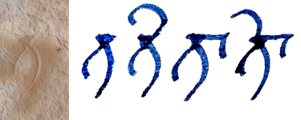
- the consonant t has so much damage around it that it may have had any of several vowel marks or none, as in the hypothetical image here
- some candidates are shown on the right
- the same might be represented through transliteration without markup using the optional shorthand tV (TG §3.3.2.2)
t<seg type="component" subtype="vowel"><gap reason="illegible" quantity="1" unit="component"/></seg>

Exhibit 6.5.D: lost body with subscript component
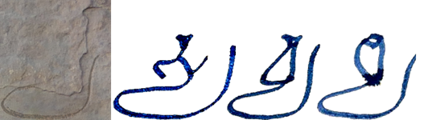
- a clear subscript y survives but the principal consonant(s) are obliterated along with any vowel marker, as in the hypothetical image above
- some candidates are shown on the right
<seg type="component" subtype="body"><gap reason="illegible" quantity="1" unit="component"/></seg>y<seg type="component" subtype="vowel"><gap reason="illegible" quantity="1" unit="component"/></seg>

Exhibit 6.5.E: a complex sequence of partially lost glyphs
- a sequence comprised of the following elements, which are known to follow the prosodic pattern −−⏑
- the legible glyph ku, which is simply transliterated
- one wholly illegible akṣara, which we prefer not to encode simply as a lacuna of one character which is prosodically long, as this would obscure the fact that since the preceding (clear) ku is prosodically long, the present lost akṣara must be a conjunct
- a clear regular y that may or may not have had a vowel marker attached
ku<seg type="aksara"><seg type="component" subtype="conjunct"><gap reason="illegible" quantity="1" unit="component"/></seg><seg type="component" subtype="vowel" met="+"><gap reason="illegible" quantity="1" unit="component"/></seg></seg>y<seg type="component" subtype="vowel" met="+"><gap reason="illegible" quantity="1" unit="component"/></seg>
- in the above example, the tag <seg type="aksara"> around the second (wholly lost) character is not strictly necessary, but it has been added to make it explicit that the illegible conjunct consonant and the illegible vowel comprise one akṣara

Managing line-level lacunae
As noted in §6.5.2, the preferred method for encoding lacunae is to treat them as inline. Consequently, when
a lacuna extends over one or more entire physical lines, the preferred encoding method is to mark up the beginning of each line, with an inline lacuna occupying the entire line. Doing so allows the edition to reflect the source’s extrinsic structure accurately and to number physical lines consecutively without complications. This, of course, is only feasible when the number of lost or illegible lines is small and can be precisely determined.

Inline lacunae for full lines
When the number of lost or illegible lines is small (as a rule of thumb, up to five) and can be determined precisely, reconstruct the extrinsic structure in your edition and encode inline lacunae as follows.
- encode each line beginning (§4.5.1), numbering them consecutively
- populate each line with separate inline <gap/> elements (§6.5.2), encoded as lost or illegible (§6.5.1.1) as the case may be, with estimated quantity or unknown extent (§6.5.1.2)
- e.g. for a gap of two full lines, <lb n="3"/><gap reason="lost" quantity="30" unit="character" precision="low"/><lb n="4"/><gap reason="lost" quantity="30" unit="character" precision="low"/>

Multiline lacunae
When a large number of lines (as a rule of thumb, more than five) lines are lost or illegible, or the number of lines affected by a lacuna cannot be determined exactly, encode line-level lacunae as follows.
- do not encode line beginnings for the lost lines
- use the <gap/> element, encoded as lost or illegible (§6.5.1.1) as the case may be, with "line" as the value of @unit (§6.5.1.2)
- for a precisely known number of lost or illegible lines, record the number in @quantity
  - e.g. <gap reason="lost" quantity="6" unit="line"/>
- for an estimated number of lost or illegible lines, record the number in @quantity and add @precision="low"
  - e.g. <gap reason="lost" quantity="6" unit="line" precision="low"/>
- for an unknown number of lost (or illegible) lines, use @extent with the value "unknown" (but retain @unit with the value "line" to distinguish such lacunae from inline lacunae of unknown length)
  - e.g. <gap reason="lost" extent="unknown" unit="line"/>
- if a multiline lacuna occurs at any place other than the end of an inscription, the editorial numbering of the extant lines will need special consideration, with the following general recommendations
  - if the number of lines in the lacuna is known precisely, it is best if you mentally assign numbers to these lines and start or continue numbering after the lacuna accordingly
    - for example, if an inscription has three extant lines, followed by a six-line lacuna and three more extant lines, then number the extant lines 1 to 3 and 10 to 12
  - if the number of lines in the lacuna is unknown, disregard the lacuna and start or continue numbering extant lines consecutively
    - for example, if an inscription has three extant lines, followed by an indeterminate lacuna and three more extant lines, then number the extant lines 1 to 3 and 4 to 6
  - if the number of lines in the lacuna is estimated, then choose one of the above methods at your discretion
- additional considerations for the interaction of multiline lacunae with intrinsic and extrinsic structure are discussed in the section on massive lacunae (§6.5.4)

Possibly lost lines
In some cases it is impossible to tell whether there were more lines to an inscription than are now extant. Such situations are best described in the annotation of an edition, but if you wish to represent it in encoding, proceed as follows.
- create a <gap> element for a multiline lacuna (§6.5.3.2) even if you estimate or know the number of possibly lost lines to be small
  - the value of @reason shall always be "lost" in such a case
    - just conceivably, the support might be extant but so effaced that it may or may not bear vestiges of writing, but this is for all practical purposes equivalent to saying that the writing (if it ever existed) is now lost
- within this element, add <certainty match=".." locus="name"/>, where
  - @match=".." indicates that we are making a statement regarding certainty applicable to the parent element (i.e. <gap>)
  - @locus="name" indicates that the uncertainty concerns the name of the parent element (viz. “gap”, and thus the fact that what we have there is a lacuna)
  - note that in this single case, the <gap> element is not empty but comprised of separate opening and closing tags wrapping the <certainty> element
- for example,
  - one line possibly lost: <gap reason="lost" quantity="1" unit="line"><certainty match=".." locus="name"/></gap>
  - approximately two lines possibly lost: <gap reason="lost" quantity="2" unit="line" precision="low"><certainty match=".." locus="name"/></gap>
  - any number of lines possibly lost: <gap reason="lost" extent="unknown" unit="line"><certainty match=".." locus="name"/></gap>

Managing massive lacunae
The preferred method for dealing with lacunae extending over more than one line of text is to reconstruct the lost line beginnings and populate each reconstructed line with an inline lacuna as per §6.5.3.1. However, extensive lacunae can make it impossible or at least unfeasible to fully reconstruct the extrinsic and/or intrinsic structure of a text. When this happens, we speak of a massive lacuna.
Around massive lacunae (i.e. at the points where a massive lacuna meets the extant text), we must still create the essential minimum of structural elements for any text that is present in the edition, but the lacuna itself will in this case be encoded outside the usual text containers and does not need to be divided into parts corresponding to lost lines or other units of extrinsic structure. Importantly, however, some text can often be restored (§6.4) at the edge of a massive lacuna, such as the end of a word at the start of the lacuna, or the beginning of a word at the end of the lacuna. Restored text is no less available in the edition than extant text read from the source, so any applicable structural elements must also be present for restored text. The basic framework for encoding a massive lacuna is illustrated in Exhibit 6.5.F, which shows a massive medial lacuna (i.e. one in the middle of a text). The part of the table up to the lacuna is applicable to all situations where text is available before a lacuna, and the part of the table from the lacuna onward is applicable to all situations where text is available after a lacuna.
Throughout this section, ‘available text’ includes both extant text (readings) and supplied text (restorations), while ‘unavailable text’ refers to text that is lost and not restored.
Exhibit 6.5.F: structure around a massive lacuna
 | intrinsic structure | extrinsic structure
structure start | <p part="I"> | <lb n="x"/>
extant text | abc
restored text | <supplied>def</supplied>
structure end | </p>
unavailable text | <gap .../>
structure start | <p part="F"> | <lb n="y"/>
restored text | <supplied>uvw</supplied>
extant text | xyz
structure end | </p>

Encoding a massive lacuna
- the massive lacuna itself must usually be encoded with a single <gap/> element for a multiline lacuna as per §6.5.3.2, with a known, estimated or unknown number of lines
- this <gap/> element is to be placed, exceptionally, outside block-level text containers, so it will be a direct child of the edition division or (if present), a textpart division
- the subsections below provide additional considerations for encoding an edition involving a massive lacuna, of which the following are indispensable:
  - for a massive final lacuna (i.e. where the end of an inscription is lost): §6.5.4.3
  - for a massive initial lacuna (i.e. where the beginning of an inscription is lost): §6.5.4.4
  - for a massive medial lacuna (i.e. where the middle of an inscription is lost): §6.5.4.3 and §6.5.4.4
  - for a massive bilateral lacuna (i.e. where the beginning and end of an inscription are both lost): §6.5.4.4 and §6.5.4.3

Alternatives to encoding a massive lacuna
- when the extrinsic structure of the unavailable text (including line beginnings by default and the beginnings of pages or other larger structural units when applicable) can be reconstructed with fair confidence, then it is preferable to create the applicable structural milestones and encode inline lacunae as per §6.5.3.1
  - however, if this would result in a large number of empty lines (as a rule of thumb: more than half of the edition), then feel free to forego this and encode a massive lacuna instead
  - the structural milestones must be contained within the usual block-level containers for text (§4.3.3.1)
    - occasionally, it may be possible to reconstruct the intrinsic structure of the unavailable text (especially when physical lines correspond to verse lines), in which case feel free to do so and create separate <gap/> elements within each container as per §6.5.2.2
    - but if this is impossible or impracticable, simply create a single <ab> element (§3.2.1.2) as a container for the reconstructed lines without available text
- when an inscription is interrupted by a massive medial lacuna in such a way that the number of lost lines cannot be counted or estimated reliably, then creating textpart divisions for the extant parts is a viable alternative to encoding a massive lacuna
  - this, in effect, treats the inscription as consisting of unconnected fragments (§4.7.3.2), even if the massive lacuna is merely due to surface damage
  - putting the final extant chunk in a new textpart division allows (and compels) you to restart line and stanza numbering from 1, thus avoiding complications arising from being unable to count the number of unavailable lines and stanzas
  - since textpart divisions encoded as fragments necessarily imply the presence of lacunae between the textparts, lines lost between the fragments shall not be encoded explicitly
    - the use of @part on incomplete block-level containers before and after the lacuna applies as described below
    - any partially available lines (i.e. those that contain extant or restored text at the end or beginning) must be completed by encoding an inline lacuna for the part of the line where text is not available

Structure before a massive lacuna
The encoding of a massive final lacuna is illustrated in Exhibit 6.5.G.
- intrinsic structure
  - because all available text must be within a container for intrinsic structure (§3.1) but intrinsic structure is not reconstructed within a massive lacuna, any open block-level containers must be closed after all text ends and before the lacuna is encoded
  - if the end of the available text does not coincide with the natural (semantic or metrical) end of the container, so the container ends prematurely, then the interrupted container must be encoded with @part="I" (or @part="M" if the beginning of the same container is lost to another lacuna) as per §3.2.3.1
  - if the available text is in more than one nested container (verse lines in a stanza or a list in a paragraph), then care must be taken
    - to add the end tag for all containers
    - and to add @part to all containers which end prematurely
      - if the end of the available text coincides with the end of a verse line, then @part is not applicable to that <l> element, but may still be applicable to the enclosing <lg> element if the stanza had subsequent lines lost to the lacuna
  - because structure is not reconstructed within a massive lacuna and interrupted containers are tagged with @part to show that they are incomplete, additional containers for unavailable verse lines need not and must not be created (unlike the case in §6.5.2.2)
- extrinsic structure
  - the elements representing extrinsic structure are milestones that mark transition points (§4.1), so units of extrinsic structure do not have endpoints represented in the encoding and therefore cannot be “closed” before a lacuna
  - line numbering is mandatory in all our editions (§4.5.2), so all available text must belong to a numbered line
    - thus, if any text is restored after the last extant line, a line beginning must be created for the line containing that restored text
    - however, see §6.5.4.5 for an alternative
  - if any line has available text (whether extant or restored) at the beginning but no available text later on, then an inline lacuna (§6.5.2) must be encoded for the remainder of that line
    - the inline lacuna is an entity separate from the massive lacuna and must, as usual, be within and not outside the block level text containers
      - if this happens in a verse context, attempt to reconstruct verse structure as per §6.5.2.2 for the duration of the inline lacuna, even though structure is not reconstructed for the massive lacuna itself
      - however, if this proves problematic, you may alternatively choose to encode the incomplete stanza as above, then create an <ab> element after it (and before the massive lacuna) to contain only the inline lacuna
  - if an inscription with a massive lacuna contains pages or pagelike milestones, handle it according to the considerations offered for incomplete copperplate sets (§6.5.5)
  - if an inscription with a massive lacuna contains lower-level structural boundaries (gridlike milestones), these must be ignored for the extent of the massive lacuna itself, but
    - must be reconstructed as applicable to any restored text
    - may be optionally reconstructed for the segmentation of inline lacunae adjacent to the massive lacuna, when this is feasible
Exhibit 6.5.G: massive final lacuna
<p part="I">...
<lb n="5"/>tāpasāśrama-va<supplied>ne</supplied>
<gap reason="lost" extent="unknown" unit="character">
</p>
<gap reason="lost" extent="unknown" unit="line"/>
- line 5 is the last extant line, containing some text followed by a partial restoration and an inline lacuna
- after the end-tag for the block-level container, a massive lacuna of unknown size is encoded

Structure after a massive lacuna
The encoding of a massive initial lacuna is illustrated in Exhibit 6.5.H.
- intrinsic structure
  - because all available text must be within a container for intrinsic structure (§3.1) but intrinsic structure is not reconstructed within a massive lacuna, block-level containers must be opened right after the lacuna, before any text begins
  - if the beginning of the available text does not coincide with the natural (semantic or metrical) end of the container, so the container begins late, then the interrupted container must be encoded with @part="F" (or @part="M" if the end of the same container is lost to another lacuna) as per §3.2.3.1
  - if the available text needs more than one nested container (verse lines in a stanza or a list in a paragraph), then care must be taken
    - to create the start tag for all containers
    - and to add @part to all containers which begin late
      - if the beginning of the available text coincides with the beginning of a line, then @part is not applicable to that <l> element, but may still be applicable to the enclosing <lg> element if the stanza had previous lines lost to the lacuna
  - because structure is not reconstructed within a massive lacuna and interrupted containers are tagged with @part to show that they are incomplete, additional containers for unavailable verse lines need not and must not be created (unlike the case in §6.5.2.2)
- extrinsic structure
  - the elements representing extrinsic structure are milestones that mark transition points (§4.1), so units of extrinsic structure are represented in the encoding at their start and must be created after a lacuna
  - line numbering is mandatory in all our editions (§4.5.2), so all available text must belong to a numbered line
  - all applicable milestones must be present for all available text, even if a structural unit contains only a (partial) restoration
    - thus, if any text is restored before the first extant line, a line beginning must be created for the line containing that restored text
    - however, see §6.5.4.5 for an alternative
  - line beginnings (as well as all structural milestones) after the lacuna must, as usual, be contained within block-level containers
  - if the available text begins within a word, then @break="no" must be used normally (§4.3.2.1) on the line beginning (as well as any higher-level structural milestone) preceding it
  - if any line has available text (whether extant or restored) at the end but no available text earlier, then an inline lacuna (§6.5.2) must be encoded for the beginning of that line
    - the inline lacuna is an entity separate from the massive lacuna and must, as usual, be within and not outside the block level text containers
      - if this happens in a verse context, attempt to reconstruct verse structure as per §6.5.2.2 for the duration of the inline lacuna, even though structure is not reconstructed for the massive lacuna itself
      - however, if this proves problematic, you may alternatively choose to encode the incomplete stanza as above, then create an <ab> element after it (and before the massive lacuna) to contain only the inline lacuna
  - if an inscription with a massive lacuna contains pages or pagelike milestones, handle it according to the considerations offered for incomplete copperplate sets (§6.5.5)
  - if an inscription with a massive lacuna contains lower-level structural boundaries (gridlike milestones), these must be ignored for the extent of the massive lacuna itself, but
    - must be reconstructed as applicable to any restored text
    - may be optionally reconstructed for the segmentation of inline lacunae adjacent to the massive lacuna, when this is feasible
Exhibit 6.5.H: massive initial lacuna
<gap reason="lost" extent="unknown" unit="line"/>
<p part="F">
<lb n="1"/><gap reason="illegible" precision="low" quantity="7" unit="character"/>
bhagavat-paśupati-bhaṭṭāraka-pādānugr̥hīto bappa-pādānu
<lb n="12" break="no"/>dhyātaḥ parama-bhaṭṭāraka-mahārājādhirāja-śrī-narendradevaḥ kuśali ...
</p>
- an unknown number of lines have been lost before the first extant line
- the initial part of the fist extant line is also illegible, encoded as an inline lacuna
- a block-level container is opened after the massive lacuna

Avoiding the need to reconstruct structure for restored text
The procedure for encoding a massive lacuna allows you not to reconstruct the document’s intrinsic and extrinsic structure within the stretch lost to the lacuna, but requires you to reconstruct both structures for all available text. A consequence of this is that when a lacuna’s physical beginning or end coincides with a structural boundary, then a separate structural unit must be created for any restored text, even if that text is just the beginning or end of a partially extant word. In order to avoid this complication, we suggest the following workaround.
- instead of including the restoration in the text of your edition, mention it in an apparatus note (§10.7)
- this method is recommended especially in the following cases:
  - for very short restorations (smaller than one word)
  - for the restoration of widely occurring text such as standardised genealogies or stock admonitory verses in land grants
  - for restorations where several alternatives are deemed possible, so including them in the text of the edition would be difficult anyway

Massive lacunae affecting the numbering of structural elements
DHARMA editions mandatorily include editorial numbering for units of extrinsic structure and for stanzas of verse. A massive final lacuna has no relevance to such numeration, but if a large chunk of text is unavailable at the beginning or middle of the document, then the numbers assigned to these units require an editorial decision. This subsection presents rules of thumb for that decision.
- after an initial lacuna
  - if it is possible to calculate or estimate how many units are unavailable, then feel free to number the extant units from the next greater number onward
  - if such an estimate is not possible, or for any reason you prefer not to rely on it, then treat the lacuna as a black box and start numbering the extant units from 1
  - any mix of these numeration schemes may be used
    - for example you may choose to number lines from the next greater number because the unavailable lines can be counted with fair confidence, but number stanzas from 1 because there is no way to tell how many, if any, stanzas were present in the unavailable text
- after a medial lacuna
  - if it is possible to calculate or estimate how many units are unavailable, then preferably add their number to the number of extant units before the lacuna, and number the extant units after the lacuna from the next greater number onward
  - if such an estimate is not possible, or you strongly prefer not to rely on it, then treat the lacuna as a black box and start numbering the extant units after the lacuna from the next higher number following the extant units before the lacuna
  - any mix of the above numeration schemes may be used
  - if neither seems satisfactory, you may opt to create complex numbers (analogous to repetitive line numbering, §4.5.2.2) for all units that require numeration
  - keep in mind that if you choose to create textparts instead of encoding a massive lacuna (§6.5.4.1), then numeration of all units must be restarted in every textpart division

Managing incomplete copperplate sets
Essentially, sets of copper plates of which one or more plates are missing are no different from any other document with a massive lacuna. However, the existence of discrete and separable plates complicates the encoding of structure. It would be theoretically permissible to use "plate" or a related concept as the value of @unit in a <gap/> element for encoding plate-level lacunae, but we see no practical advantage to doing so. Instead, proceed as instructed in this section.

Lost final plates
Lost final plates shall normally be ignored in the encoding. However it is, at least in some corpora, possible to confidently estimate the number of lost pages, and even that of lines on each lost page. In such a case you may choose at your discretion to reconstruct the structure for all lost pages as per §6.5.5.4.
- as a rule, simply end your edition at the end of the extant text
  - closing the currently open block-level container
  - and adding @part="I" if it is incomplete, as per §3.2.3.1
- mention in your annotation that the subsequent plate(s) are lost
- if you are able to restore any text following the last extant plate
  - preferably record it outside the edition as suggested in §6.5.4.5
  - alternatively, reconstruct the structure for the following page as per §6.5.5.4

Lost initial plates
Lost initial plates shall preferably be ignored in the encoding, but may affect the editorial numbering of extrinsic and intrinsic structural units in the extant text. At least in some corpora, it may be possible to confidently estimate the number of lost pages, and even that of lines on each lost page. In such a case you may choose at your discretion to reconstruct the structure for all lost pages as per §6.5.5.4.
- as a rule, simply start your edition at the beginning of the extant text
  - creating the applicable block-level container(s)
    - and adding @part="F" if they are incomplete, as per §3.2.3.1
  - and creating page and line beginnings normally
    - adding @break="no" to both if applicable (§4.3.2.1)
- if you are able to restore any text preceding the first extant plate
  - preferably record it outside the edition as suggested in §6.5.4.5
  - alternatively, reconstruct the structure for the preceding page as per §6.5.5.4
- depending on your corpus, it may be possible to confidently estimate the number of lost pages, and even that of lines on each lost page
  - if this is the case, you may choose at your discretion to reconstruct all lost pages as per §6.5.5.4
- number pages as follows
  - preferably: calculate or estimate the number of lost initial plates and start the numbering of the extant plates with the next higher number
    - thus, if you estimate that two plates were lost at the beginning of a set, then
      - the extant text will be encoded as beginning on page 3r
      - any restoration preceding the extant text (when not recorded outside the edition as per §6.5.4.5) will be encoded as being at the bottom of page 2v
  - if no reliable estimate can be made, start the numbering of the plates with available text from 1, thus
    - if no restoration precedes the extant text, then extant text will be encoded as beginning on page 1r
    - any restoration preceding the extant text (when not recorded outside the edition as per §6.5.4.5) will be encoded as beginning at the bottom of page 1v, while the extant text will be encoded as beginning on page 2r
- number lines as follows
  - if the number of lost lines can be calculated or at least estimated confidently, then start the numbering of the extant lines with the next higher number
    - thus, if you estimate that twenty lines were lost at the beginning of a set, then
      - the extant text will be encoded as beginning in line 21
      - any restoration preceding the extant text (when not recorded outside the edition as per §6.5.4.5) will be encoded as being at the end of line 20
  - if no reliable estimate can be made, start the numbering of the lines with available text from 1, thus
    - if no restoration precedes the extant text, then the extant text will be encoded as beginning in line 1
    - any restoration (covering less than a full line) preceding the extant text (when not recorded outside the edition as per §6.5.4.5) will be encoded as beginning at the end of line 1, while the extant text will be encoded as beginning in line 2
  - alternatively, especially if the number of lost plates can be estimated but that of lost lines cannot, use complex line numbering (§4.5.2.2) even if the rest of your corpus uses consecutive line numbers
- number stanzas as follows
  - if on the basis of related texts you can estimate the number of lost stanzas with great confidence, start numbering extant stanzas with the next higher number
  - in all other cases, number extant stanzas from 1

Lost medial plates
Unlike incomplete copperplate sets with only the end and/or only the beginning missing, we prefer not to ignore lost medial plates in our encoding.
- if the number of lost plates is known or can be estimated with at least some confidence, then
  - reconstruct the structure for the lost plates as per §6.5.5.4
    - the Case Study in Appendix A.3 shows a fully encoded illustration of a reconstructed medial plate
  - before the first lost plate, encode the text as you would for lost final plates (§6.5.5.1)
  - after the last lost plate, encode the text as you would for lost initial plates (§6.5.5.2)
  - since the structure of the lost plates is reconstructed, any restored text on a lost plate can be integrated into that structure, so do not resort to recording restorations outside the edition
  - in the section after the last lost plate, number units as follows
    - continue page numbering after the reconstructed numbering for the lost plates
    - continue line numbering after the reconstructed numbering for the lost plates
      - or use complex line numbering (§4.5.2.2) if the number of lost pages could be estimated but that of lost lines could not
    - continue stanza numbering with the next greater number after that of the last extant stanza
      - unless you can estimate the number of stanzas in the lost plates with great confidence, in which case skip their numbers and continue numeration with the next higher number
- if the total number of lost medial pages cannot be estimated with any confidence, encode the extant sections as textpart divisions (§4.2, §6.5.4.2) to eliminate difficulties with page and line numbering
  - the Case Study in Appendix A.4 shows a fully encoded illustration of a missing medial plate encoded with textpart divisions
  - within each textpart, encode only the pages pertaining to that part of the edition and do not reconstruct any page or line beginnings believed or known to be lost unless you find it essential to show a restoration in the edition
  - if you are able to restore any text preceding the first extant plate
    - preferably record it outside the edition as suggested in §6.5.4.5
    - alternatively, reconstruct the structure for the preceding page as per §6.5.5.4

Reconstructing structure for lost copper plates
Reconstruction of the page and line beginnings for lost copper plates is the less preferred option for missing final and initial plates and the preferred option for missing medial plates unless it is impossible to estimate their number.
- to reconstruct the page structure for one or more missing plates, estimate the number of missing plates and create <pb/> elements for both the recto and the verso face of each
- to reconstruct a single page in order to accommodate a restoration (when not using the option to record such a restoration outside the edition, §6.5.4.5), create only the single (recto or verso) page beginning for the page on which the restored text would have been located
- handle the line structure on reconstructed pages as follows
  - the default option is to create no <lb/> elements and instead encode a multiline lacuna (§6.5.3.2) on each lost page, with an extent of a known, estimated or unknown number of lines
  - if the page has been reconstructed in order to accommodate a restoration, then a line beginning must be reconstructed for the line(s) in which the restored text would have been located
    - for the remaining lines on the same page, encode a multiline lacuna (§6.5.3.2) on each lost page, with an extent of a known, estimated or unknown number of lines
    - the part of the line outside the restored reading must be encoded as an inline lacuna (§6.5.2)
  - alternatively, if it is feasible to do so, you may choose to reconstruct line beginnings for all lines on every lost page, encoding an inline lacuna for each line

Editorial intervention
The editor intervenes in the text of a document because she perceives that there is something anomalous in the language of the text as received. The kind of editorial intervention, and thus the manner of its encoding, differs depending on the nature of the perceived anomaly (§7.1): does the text contain an inadvertent scribal mistake, or is its unusualness likely to be deliberate on the part of its composer? Once an anomaly and its nature have been identified, you as editor must decide what to do about it and encode the intervention accordingly (§7.2). Additional guidelines for good practice applicable to all editorial intervention are collected in §7.7, while §7.8 discusses “curatorial” modifications the editor can make in the text without encoding them as editorial.

Distinguishing correction from normalisation
While classical editions of Indic epigraphic texts rarely make such a distinction, TEI allows us to differentiate text written in error from non-standard usage. To set the two apart, you as editor must, informed by your expertise, establish the text as intended by the persons(s) who composed it. Doing so may be problematic and will often involve a subjective decision, which may be supported by the guidelines presented below.

Erroneous readings
A received reading that deviates from the presumed intent of its composer is an erroneous reading, which may or may not be linguistically correct. An erroneous reading is of the nature of a typographic mistake: it is created inadvertently as a result of a mistake on the part of a scribe. Correction is the editorial rectification of an erroneous reading by restoring the text to the form that you believe the composer of the text had intended.
- the correction of scribal mistakes is on the whole strongly recommended in our editions, because doing so may be necessary in order to make the text intelligible and, when the text is intelligible as received, can clarify the editor’s notion of what the text had been intended to be
- when judging whether an unexpected reading is erroneous or non-standard, it may be helpful to keep in mind that scribal errors often (though not necessarily) have one or more of the following features
  - they occur inconsistently through a document and deviate from the expected form randomly, producing readings which are meaningless or inappropriate to the context
    - the expected (correct) form of the same word may thus also occur in the same document
  - they involve a graphically similar glyph or graph instead of the expected one
    - e.g. ka instead of ra in a script where these look similar
  - they involve the omission of glyphs or sequences that ought to be repeated (haplography)
    - e.g. varṣa instead of vavarṣa; mandaṁ instead of mandaṁ mandaṁ
  - they involve the repetition of glyphs or sequences that ought to appear only once (dittography)
    - e.g. sasarveṣāṁ or sarvesarveṣāṁ instead of sarveṣāṁ
  - they involve the omission of a chunk that is elsewhere preceded and followed by the same (or a very similar) glyph or sequence (eyeskip)
    - e.g. mañjarī-puñjarita instead of mañjarī-puñja-piñjarita

Non-standard readings
A received reading that matches the presumed intent of its composer is not erroneous, but may be non-standard if it does not conform to generally established linguistic conventions. A non-standard reading is created deliberately, although not necessarily with awareness of its non-standard nature. That is to say, non-standard language is written usually when a composer’s individual concept of a language differs from the general conventions governing that language, or occasionally when a composer chooses to transgress such conventions. Normalisation is the editorial rectification of non-standard usage by alteration into something that fits the standard more closely.
- normalisation is always optional in our editions, but is recommended whenever you deem it helpful to the reader for understanding difficult non-standard language or for clarifying your editorial interpretation of it
- when judging whether an unexpected reading is erroneous or non-standard, it may be helpful to keep in mind that non-standard variations often (though not necessarily) have one or more of the following features
  - they occur consistently through a document and deviate from the expected form systematically, producing readings which are meaningful and appropriate to the context once their systematic deviation has been taken into account
  - they involve a plausible phonological alternative to the standard pronunciation of a word or sequence
    - e.g. vacchara instead of vatsara; kuṭiṁbin instead of kuṭuṁbin; krita (or kruta or krata) instead of kr̥ta
  - they involve a plausible graphemic alternative to the standard orthography of a word or sequence
    - e.g. satva instead of sattva; sattya instead of satya
  - they involve the application of a generic grammatical rule where a specific rule (exception) is expected
    - e.g. rājasya instead of rājñaḥ
  - they involve the application of a specific grammatical rule where it is not expected to apply
    - e.g. mahārājñaḥ instead of mahārājasya

Encoding editorial intervention
In DHARMA digital editions, the literal reading of the source must always be present (i.e. never discarded in favour of a correction or normalisation), and any editorial alteration must be explicitly tagged as such (i.e. never silent), except for the small number of specific cases listed in §7.8 below. This requirement leaves us with the following practical scenarios for the treatment of an anomalous reading: ignore it (§7.3), flag it as anomalous (§7.4) or rectify it by providing the corrected or normalised reading as an alternative to the received reading (§7.5). All of the encoding introduced in this section must comply with the guidance on good practice in §7.7.
The action you take with regard to any linguistic anomaly must be selected at your discretion, depending on your perception of the relative commonness or uncommonness of the anomaly in your corpus and of its transparency to the scholarly target audience. No objective and universal criteria can be established for such a decision, but the following subsections provide some rules of thumb for the kinds of cases where each level of intervention is appropriate. The general aim is not to clutter the edition with code (and its display rendition with character-based markup) unless it serves a useful purpose. A lower level of intervention may be applied to phenomena that you perceive to be common in your particular text or subcorpus. Erring on the side of caution is always allowed, so in any individual case where you deem a higher level of intervention to be warranted, feel free to encode it.

Encoding tools for anomalous readings
TEI and EpiDoc provide the following elements for encoding the editorial treatment of incorrect or non-standard text.
- for encoding anomalous readings in the received text,
  - the element <orig> (for “original form”) serves as a wrapper for text that is literally present in the source, but is deemed by the editor to be non-standard
  - the element <sic> (Latin for “thus”) serves as a wrapper for text that is literally present in the source, but is deemed by the editor to be incorrect
  - on their own, these elements may be used for flagging a reading as anomalous (§7.4)
- for indicating readings altered by the editor,
  - the element <reg> (for “regularisation,” which is a synonym of normalisation in TEI usage) serves as a wrapper for text that has been normalised by the editor because the received reading was deemed non-standard
  - the element <corr> (for “correction”) serves as a wrapper for text that has been corrected by the editor because the received reading was deemed erroneous
  - these elements are never used on their own in DHARMA editions, since the received (i.e. unaltered) reading must always be present
    - instead, they are employed in rectification by substitution (§7.5.1), where the element <choice> wraps both the received reading (tagged as above) and the editorial reading, indicating that only one of the two is actually present at the given locus
- TEI also caters for marking up parts of the text which are deemed superfluous and parts of the text which have been added by the editor:
  - the element <surplus> serves as a wrapper for text that is present in the source but should not be there according to the editor
  - the element <supplied> serves as a wrapper for text that is no present in the source but should be there according to the editor
    - the attribute @reason with the value "omitted" on this element indicates that the supplied text ought to have been written by the scribe but was omitted
  - these elements do not, by general TEI convention, assert anything about the nature or reason of redundance or omission, but in DHARMA editions, they are dedicated solely to the rectification of erroneous readings
    - therefore, even when non-standard orthography could be normalised simply by adding or suppressing specific graphemes, this must not be done with these elements but rather by the substitution method outlined above
    - this leaves us with the following possible editorial actions:
      - correction by suppression of superfluous graphemes written by mistake (§7.5.2)
      - correction by restitution of erroneously omitted graphemes (§7.5.3)

Ignoring anomalous readings
Trivial linguistic anomalies may be left without any editorial encoding.
- this applies in particular to (near-)universal features of inscriptional orthography prevalent throughout South and Southeast Asia, or throughout a particular region, including but not limited to:
  - the doubling of plosives, nasals and glides after an r (e.g. dharmma for dharma)
  - the use of an anusvāra instead of the class nasal or vice versa (e.g. maṁtra for mantra)
    - including final positions (e.g. kin tu for kiṁ tu as well as tathoktaṁ| for tathoktaM|)
  - the use of hiatus (often deliberately to imply a pause) where sandhi would be expected by modern standards
- in Old Javanese, it is recommended that you ignore the following kinds of anomalies unless they create ambiguity:
  - spelling of long pepet with ə plus length mark (to be transliterated as ə: as per TG §4.1.7
  - use of R̥ or L̥ (and R̥̄ or L̥̄) in words whose dictionary spelling has rə or lə (or rə̄ or lə̄)
- in Old Khmer, it is recommended that you ignore the following kinds of anomalies unless they create ambiguity:
  - absence of virāma
  - representation of final consonant C by the spelling CCa, including final /h/ represented as ḥha
- grammatical laxity may in general be ignored, especially in complex constructions such as subordinate clauses, long compounds or compound-like structures, and very long “sentences” encompassing multiple topics and/or stanzas
  - we see no advantage in attempting to force a source document into conforming to canons which, even if they exist for the language in question, may not have been known or perceived as binding by the document’s composer
  - in particular, normalisation to high standards should be avoided if doing so requires altering or reorganising a stretch of text longer than a word or two
- scribal mistakes you deem to be completely insignificant and entirely transparent may be ignored at your discretion

Flagging anomalous readings
Flagging reading as linguistically anomalous without rectifying it serves two purposes: it highlights unexpected text for the reader’s attention, and it makes it clear to the reader that the unexpected text is not your editorial mistake.
- flagging without rectification is recommended for scribal errors and unintelligible text only if you cannot propose a single confident correction (tentative or alternative corrections may be discussed in an apparatus note, §10.7), or if a mistake is entirely transparent
- flagging without rectification is recommended for non-standard orthography that is common but not quite universal, such as
  - the doubling of consonants in certain conjuncts that do not begin with r (e.g. puttra for putra; sattya for satya)
  - the exchange of a consonant for a phonetically similar one (e.g. muṇi for muni)
  - infidelity to the correct length of vowels in words borrowed from Sanskrit, in languages where inconsistency in spelling of vowel-length is rampant (e.g. bhima for bhīma)
- flagging without rectification is recommended for non-standard language use that is common in a given subcorpus or text, such as
  - non-standard or substandard grammar (e.g. rājasya for rājñaḥ; kr̥tedam for kr̥tam idam; sā gataḥ for sā gatā)
  - non-standard sandhi (e.g. anugrahāya-m udaka-pūrvveṇa; paṁca-s-triṁśottaratame)
  - hyper-Sanskritisation (e.g. prārk instead of prāk, śrāpa instead of śāpa)

Flagging erroneous and uninterpretable readings
- to flag a reading deemed erroneous or unintelligible, wrap it in the element <sic>
  - this markup on its own is primarily for use on text that is legible but does not seem intelligible (i.e. for which no straightforward correction can be offered)
    - stretches of text which are uninterpretable on account of poor legibility do not require <sic>, but <sic> may of course include markup for unclear readings and lacunae
- for example,
  - a trivial scribal error flagged as such: mahār<sic>a</sic>ja (ā would be correct)
  - an unintelligible phrase flagged as such: <sic>marnta kali-kulanām</sic>

Flagging non-standard readings
- to flag a reading deemed non-standard but intelligible, wrap it in the element <orig>
- for example,
  - a non-standard (tadbhava) word form in Sanskrit text: dine <orig>Āśvoja</orig>-śuklasya (Āśvayuja or ’śvayuja is expected)
  - a non-standard or substandard spelling: sahasrā<orig>n</orig>i (sahasrāṇi is expected)

Rectifying anomalous readings
Rectifying a linguistically anomalous reading means providing an editorial alternative for the anomalous reading, i.e. correcting or normalising it. Rectifying a reading rather than merely flagging it serves useful purposes. On the one hand, it helps readers understand the text and makes your interpretation of it explicit. On the other hand, it facilitates searching texts by ensuring that the expected form is present in the XML file and can thus be returned as a match for queries even if the received text differs from the expected.
Anomalous language can be restituted by any combination of three actions, as illustrated in Exhibit 7.5.A — where the received reading surddha is rectified into śuddhaḥ — and detailed in the following subsections. Substitution (§7.5.1) is when the received reading is replaced by the editor with a rectified reading. Suppression (§7.5.2) is when part of the received reading is deemed superfluous and deleted by the editor. Restitution (§7.5.3), also called suppletion, is when the editor adds something to the received reading.
Exhibit 7.5.A: editorial rectification of anomalous language
received text: | s | u | r | d | dh | a
intervention: | substitution |  | suppression |  |  |  | restitution
rectified text: | ś | u |  | d | dh | a | ḥ
- rectification is strongly recommended for all erroneous readings unless
  - they are absolutely trivial (in which case they may be ignored or flagged)
  - you are unable to propose a confident correction (in which case they should be flagged)
- non-standard orthography and language use (such as the phenomena listed in §7.1.2 and §7.4 above) should be preferably rectified if the phenomenon is rare in a given subcorpus or if it leads to ambiguity or hinders understanding in a given case (e.g. dattvā instead of dattā; rakṣya instead of rakṣa)
- the degree to which you rectify an anomalous reading need not be absolute: the aim is not to copy-edit the source text to some hypothetical standard of language but to render it more comprehensible and indexable with a minimum of invasiveness
  - when a document contains trivial linguistic anomalies that you ignore (§7.3), your rectified readings should preferably also contain similar anomalies where applicable; for example if the document normally doubles nasals after r, then
    - correct karppa to karmma (rather than karma)
    - normalise varnna to varṇṇa (rather than varṇa)
  - if a text consistently uses upadhmānīya or jihvāmūlīya, and your correction involves the restitution of an omitted visarga in a phonemic context that would call for one of these forms, then supply upadhmānīya or jihvāmūlīya instead of a regular visarga,
    - e.g. sarvva-rājocchettu<supplied reason="omitted">ḫ</supplied> pr̥thivyām apratirathasya
  - as far as possible, presuppose a plausible minimum of scribal error, and thus impose a plausible minimum of editorial rectification to obtain reasonably correct text; for example,
    - correct karpa to karma (even if the karmma would be expected in the document), assuming the simple mistake of inscribing p in place of m rather than the complex mistake of inscribing p for mm
    - correct viṅgati to viṅśati (rather than fully standard viṁśati), assuming the simple mistake of inscribing ṅga in place of ṅśa rather than the complex mistake of inscribing ṅga in place of śa and simultaneously omitting an anusvāra
    - correct viśati to viṁśati (even if viṅśati would be expected in the document), assuming the simple mistake of omitting an anusvāra rather than the complex mistake of inscribing śa instead of ṅśa
    - should you feel the need, feel free to add normalisation on top of a correction (§7.7.5)

Substitution

Correction by substitution
- to correct a reading deemed erroneous,
  - flag the original text with <sic>
  - add the corrected alternative directly after this, wrapped in the element <corr>
  - and wrap both these elements together in the element <choice>, indicating that either, but not both, of the two is to be read at the given locus
  - for the sake of consistency, the received reading shall always precede the editorial reading in DHARMA editions
- for example: mahār<choice><sic>a</sic><corr>ā</corr></choice>ja (a corrected to ā)

Normalisation by substitution
- to normalise a reading deemed non-standard,
  - flag the original text with <orig>
  - add the normalised alternative directly after this, wrapped in the element <reg>
  - and wrap both these elements together in the element <choice>, indicating that either, but not both, of the two is to be read at the given locus
  - for the sake of consistency, the received reading shall always precede the editorial reading in DHARMA editions
- for example: e<choice><orig>ś</orig><reg>ṣ</reg></choice>a (eśa normalised to eṣa)

Textual integrity in substitution
When rectifying an anomalous reading by substitution, keep in mind that it must always be possible to produce the pristine received text by ignoring the segment tagged with <corr> or <reg> and, vice versa, to produce the pure rectified text by ignoring the segment tagged with <sic> or <orig>. In other words, the tag for the received text must contain a segment exactly corresponding to that contained in the tag for the rectified text. Word boundaries, indicated by editorial spacing or hyphenation in our editions, may be separable in only one of the textual alternatives, in which case care must be taken to include the space or hyphen only in the applicable tag, but not in the other tag or outside the encoded intervention.
- if you choose to include any context in your intervention (§7.7.2), then the context must be identically present in both of the tags, while if you exclude context, then care must be taken to exclude context from both tags; for example,
  - in encoding a correction of pautrāḥ to pautraḥ, each of the following are correct:
    - pautr<choice><sic>ā</sic><corr>a</corr></choice>ḥ (targeting a single grapheme)
    - pautr<choice><sic>āḥ</sic><corr>aḥ</corr></choice> (including relevant context)
    - but each of the following are incorrect:
      - pautr<choice><sic>āḥ</sic><corr>a</corr></choice>ḥ (this would mean a correction of pautrāḥḥ to pautraḥ)
      - pautr<choice><sic>ā</sic><corr>ra</corr></choice>ḥ (this would mean a correction of pautrāḥ to pautrraḥ)
      - paut<choice><sic>rāḥ</sic><corr>aḥ</corr></choice> (this encodes a correction of pautrāḥ to pautaḥ)
  - in encoding a normalisation of yathāruha to yathārhaṁ, each of the following are correct:
    - <choice><orig>yathāruhaṁ</orig><reg>yathārhaṁ</reg></choice> (targeting a whole word)
    - yathā<choice><orig>ruha</orig><reg>rhaṁ</reg></choice> (including only minimal context)
    - but each of the following are incorrect:
    - <choice><orig>yathāruha</orig><reg>yathārha</reg></choice>ṁ (this encodes a normalisation of yathāruhaṁ to yathārhaṁ)
    - <choice><orig>yathāruha</orig><reg>rhaṁ</reg></choice> (this encodes a normalisation of yathāruha to rhaṁ)
    - yathār<choice><orig>uha</orig><reg>rhaṁ</reg></choice> (this encodes a normalisation of yathāruha to yathārrhaṁ)
- when substitution involves a separable word boundary, take care to maintain the separation (space or hyphen) where, and only where, it is technically possible
  - if both alternatives are separable, make sure that both are separated
    - e.g. dān<choice><orig>ā ś</orig><reg>āc ch</reg></choice>reyo
  - if only the received alternative is separable, make sure the rectified alternative is not separated
    - e.g. <choice><orig>puṇya-vividuye</orig><reg>puṇyābhivr̥ddhaye</reg></choice>
  - if only the rectified alternative is separable, make sure the received alternative is not separated
    - e.g. umula<choice><orig>t</orig><reg>t t</reg></choice>a
  - see also §7.8.1.1 about the need to avoid spaces at the beginning and end of text-containing elements

Suppression: editorial deletion of superfluous text
As noted in §7.2.1, editorial suppression is only used in DHARMA practice for superfluous graphemes written by mistake. When non-standard language can be normalised by removing one or more specific graphemes, use the generic encoding for normalisation by substitution (§7.5.1.2), with additional guidance on good practice in §7.7.2.1.
- to suppress superfluous graphemes deemed to be written by mistake, enclose the superfluous text in the element <surplus>
  - before encoding editorial deletion, be sure that you have read and understood §7.7.1
- suppression is normally applicable to instances of dittography (repetition) involving graphically separable chunks of writing, including
  - erroneous repetition of words, e.g. veda-vyāsena vyāsena <surplus>vyāsena</surplus> (three iterations of vyāsena where two iterations are correct)
  - erroneous repetition of akṣaras, e.g. naika-samara-śata<surplus>ta</surplus>vijayinā (śatata was inscribed instead of śata)
- when individual and graphically inseparable superfluous graphemes appear for a reason other than erroneous repetition, choose at your discretion whether to treat them as mistakes and suppress them, or to treat them as non-standard usage and flag them (§7.4.2) without suppression or rectify them by substitution (§7.5.1.2), including cases such as
  - hypercorrection, e.g. dattaḥs tataḥ
    - suppressed as error: datta<surplus>ḥ</surplus>s tataḥ
    - flagged as non-standard: datta<orig>ḥ</orig>s tataḥ
    - normalised: datta<choice><orig>ḥs</orig><reg>s</reg></choice> tataḥ
  - pre-nasalisation, e.g. putrāṇāṁm api
    - suppressed as error: putrāṇā<surplus>ṁ</surplus>m api
    - flagged as non-standard: putrāṇā<orig>ṁ</orig>m api
    - normalised: putrāṇā<choice><orig>ṁm</orig><reg>m</reg></choice> api

Restitution: editorial addition of omitted text
As noted in §7.2.1, editorial restitution is only used in DHARMA practice for supplying text omitted by mistake. When non-standard text can be normalised by adding one or more specific graphemes, use the generic encoding for normalisation by substitution (§7.5.1.2), with additional guidance on good practice in §7.7.2.1.
Scribal omissions that you do not correct are to be encoded as per §7.6, while omissions corrected by a premodern editor on the original support are covered under §5.5.2.
Neither punctuation nor numbering must be supplied at the ends of stanzas or verse lines in DHARMA editions, because the encoding of verse containers (§3.2.2) takes care of the segmentation and numeration of metrical units. Guidance for adding editorial punctuation in other situations is given in §7.8.3, and editorial avagraha is addressed in §7.8.3.
- to restitute graphemes deemed to be omitted by mistake, enclose the added text in the element <supplied> using the mandatory attribute @reason with the value "omitted" to distinguish this from a restoration of a lacuna (§6.4)
  - before encoding editorial addition, be sure that you have read and understood §7.7.1
- restitution is normally applicable to the omission of graphically separable chunks of writing, including
  - omitted akṣaras, e.g. dhanada-varuṇendrānta<supplied reason="omitted">ka</supplied>-samasya
  - omitted words, e.g. tasya <supplied reason="omitted">tasya</supplied> tadā phalaM
  - longer omitted strings of glyphs, when they can be supplied on the basis of sound conjecture or parallel texts
- when individual and graphically inseparable graphemes are missing, choose at your discretion whether to treat their absence as a mistake and supply them, or to treat this as non-standard usage and flag their context (§7.4.2) without supplying the missing graphemes or rectify them by substitution (§7.5.1.2), including cases such as
  - potential non-standard language, e.g. dhamma
    - restituted: dha<supplied reason="omitted">r</supplied>mma
    - flagged as non-standard: dha<orig>mma</orig>
    - normalised: dha<choice><orig>mma</orig><reg>rmma</reg></choice>
  - probable accidental omission, e.g. datā
    - restituted: dat<supplied reason="omitted">t</supplied>ā
    - flagged as non-standard: da<orig>t</surplus>ā
    - normalised: da<choice><orig>t</orig><reg>tt</reg></choice>ā
  - when an expected small component (such as a superscript r or an anusvāra) cannot be made out in the original or the facsimile you are working from, consider the state of the support and preferably encode as lost and restored (as per §6.4) unless you are certain that the cause is scribal omission, not damage to the support

Encoding scribal omission without editorial restoration
Occasionally, you may feel certain that something has been omitted from the source (for example because a metrical segment or part of a word is missing), but are unable to restore the omission with any confidence.
- the encoding of such omissions, like that of lacunae (§6.5.1), involves the <gap/> element, with the following attributes
  - mandatorily @reason="omitted"
  - mandatorily @unit="character"
  - mandatorily, either @extent or @quantity, as explained under §6.5.1.2
- if such an omission occurs in metrical verse, then encode the prosody of the omitted text by wrapping the <gap/> element in <seg> and adding @met to the latter, with values as per §6.5.2.3
  - e.g. in a śārdūlavikrīḍita stanza: vr̥ttaḥ stutya-ya<seg met="+-+--"><gap reason="omitted" quantity="5" unit="character"/></seg>-matir nnityodayas satyavāK
- tentative or alternative restorations for an unrestored lacuna may be discussed in an apparatus note (§10.7)

Good practice in editorial intervention

Manipulating graphemes
Since the units to which all our encoding applies are the source graphemes (for which see also §16.3), editorial intervention can only be, and must always be, represented in our editions in terms of source graphemes, and not in terms of akṣaras, target graphemes, phonemes or any other unit. This has the following important implications.
- editorial intervention can apply to a unit smaller than the akṣara, so if not all components of a complex akṣara require intervention, then only the specific intervention is to be encoded, and not a substitution of the entire akṣara (as it would usually be shown in an edition printed in an Indic script), for example
    - in suppression, ś<surplus>r</surplus>āpa
      - not <choice><sic>śrā</sic><corr>śā</corr></subst>pa
    - in restitution, tārkṣ<supplied reason="omitted">y</supplied>a
      - not tā<choice><sic>rkṣa</sic><corr>rkṣya</corr></subst>
    - in substitution, pa<choice><sic>t</sic><corr>d</corr></subst>ma
      - not pa<choice><sic>tma</sic><corr>dma</corr></subst>
- editorial intervention cannot apply to a unit smaller than the grapheme, so even if the engraver had merely omitted an element or added a superfluous stroke, editorial correction cannot be encoded at this level; instead
  - the absence or superfluous presence of a non-distinctive element can be annotated if desired, but not represented in markup except by encoding eccentric ductus (§6.3.1.2)
  - the absence or superfluous presence of a distinctive element must be encoded as a correction of one grapheme to another, for example
    - in a script where ka differs from ra only in the presence of a cross-stroke in the former, and the scribe erroneously engraved lora instead of loka, your rectification of that error is a correction of r to k: lo<choice><sic>r</sic><corr>k</corr></choice>a
      - and not an editorial restitution (of the cross-stroke), even though the scribe’s physical error was the omission of a graphic element
    - in a script where śa differs from ga only in that the former has a cross-stroke, and the scribe erroneously engraved śuṇa instead of guṇa, your rectification of that error is a correction of ś to g: <choice><sic>ś</sic><corr>g</corr></choice>uṇa
      - and not an editorial suppression (of the cross-stroke), even though the scribe’s physical error was the engraving of a superfluous glyph component
- due to the nature of aksharic writing, the suppression or restitution of certain graphs (namely of a vowel marker or virāma) may result in the substitution of one grapheme by another (viz. of the marked vowel or virāma by the default vowel, or vice versa), which must be encoded as substitution rather than suppression or restitution; for example
  - if the scribe engraved mahāraja and you correct this to mahārāja, your rectification of that error is a correction of a to ā: mahār<choice><sic>a</sic><corr>ā</corr></choice>ja
    - and not an editorial restitution (of the vowel marker), even though the scribe’s physical error was the omission of a glyph component
    - while mahār<supplied reason="omitted">ā</supplied>ja would mean that the received reading is mahārja, which you correct to mahārāja
  - if the scribe engraved viditim and you correct this to viditam, your rectification of that error is a correction of i to a: vidit<choice><sic>i</sic><corr>a</corr></choice>m
    - and not an editorial suppression (of the vowel marker), even though the scribe’s physical error was the engraving of a superfluous glyph component
    - while vidit<surplus>i</surplus>m would mean that your intended correction is viditm
  - if the scribe engraved śrīmāna and you correct this to śrīmān·, your rectification of that error is a correction of a to virāma: śrīmān<choice><sic>a</sic><corr>·</corr></choice>
    - instead of restituting a virāma, you may choose simply to suppress the inherent vowel
      - this will assert that your correct text, had it been present in the original, would have been written with a ligature (conjoining the final n to the next akṣara) rather than in hiatus
      - e.g. śrīmān<surplus>a</surplus> mahārājaḥ, where the text corrected by you and written in the original writing system would have involved the ligature nma
    - if the original document employs special final forms of consonants, then the editorial correction is different again, as illustrated in the next point
- also due to the nature of aksharic writing, the suppression or restitution of certain graphemes may entail the changing of an adjacent grapheme; for example
  - supplying a consonant before an initial vowel form requires the transformation of that initial vowel into a dependent vowel
    - e.g. correcting Adharma to sadharma is not simply a restitution of s, but a correction of A to sa: <choice><sic>A</sic><corr>sa</corr></choice>dharma
  - suppressing a vowel in a final position may require the transformation of the preceding consonant into a final form (if the writing system in question employs final consonant forms and one is applicable in the context)
    - e.g. correcting śrīmāna to śrīmāN is not simply the suppression of a, but a correction of na to N: śrīmā<choice><sic>na</sic><corr>N</corr></choice>
- due to the nature of our transliteration scheme, some source graphemes are represented by digraphs in our editions, but an editorial change that apparently affects only part of a digraph (a single target grapheme) in fact affects a complete source grapheme (represented by two target graphemes); for example
  - if the scribe engraved sukhya and you correct this to saukhya, your rectification of that error is a correction of u to au: s<choice><sic>u</sic><corr>au</corr></choice>khya
    - not restitution of a, even though in transliteration you are only adding a single target grapheme
  - if the scribe engraved utphannasya and you correct this to utpannasya, your rectification of that error is a correction of ph to p: ut<choice><sic>ph</sic><corr>p</corr></choice>annasya
    - not suppression of h, even though in transliteration you are only removing a single target grapheme
  - if the scribe engraved nikhāya and you correct this to nidhāya, your rectification of that error is a correction of kh to dh: ni<choice><sic>kh</sic><corr>dh</corr></choice>āya
    - not correction of k to d, even though in transliteration you are only changing that target grapheme

The scope of editorial intervention
When you flag or rectify anomalous language, the size of segments included in your tags should generally be whatever you deem to be a reasonable minimum to which the anomaly can be localised. Instead of placing only the absolute minimum within your tags, you may choose to include relevant context. In this connection, relevant context means any adjacent graphemes (or, for higher-level intervention, adjacent morphemes) which in your opinion may have played a role in generating the anomaly (as phonetic context engendering the use of an unexpected phoneme; as graphetic context engendering the use of an unexpected graph; or as grammatical or semantic context engendering the use of an unexpected word or morpheme), or are useful for highlighting the nature of the anomaly by suggesting what the expected reading should have been. Whether or not to include context is not a wholly subjective decision, and the choice has very little ultimate effect on our corpus so long as the received text is faithfully reproduced and any editorial intervention accurately reflects the rectified text. See also §7.7.3 on the option to encode several editorial changes as a single intervention. Additional considerations are provided for the normalisation and flagging of non-standard readings (§7.7.2.1).
- the rectification of orthography should target only the specific graphemes involved
  - when anomalous orthography is flagged but not corrected, you may choose to include relevant context
    - e.g. sahas<orig>rān</orig>i (sahasrāṇi is expected, and it is the vicinity of r that drives the retroflexion of n)
- the rectification of grammar may target
  - a specific grapheme or a small cluster of adjacent graphemes, when this is sufficient to clarify the correction
    - e.g. yuṣmābh<choice><sic>ya</sic><corr>i</corr></choice>ḥ
  - the whole of a morpheme (word, stem, prefix, suffix, ending) when you feel that this improves clarity or when several non-adjacent graphemes would otherwise need to be modified
    - e.g. mahārāj<choice><sic>asya</sic><corr>ena</corr></choice>
  - when anomalous grammar is flagged but not corrected, you may choose to include context beyond the affected word
    - e.g. <orig>tasmai viprasya</orig> (where either tasya viprasya or tasmai viprāya would be expected)
- the rectification (in particular, normalisation) of non-standard lexicon should normally target whole words
  - but you may choose to target smaller units if this seems more expedient, for instance in a word that mixes Sanskritic and Middle Indic characteristics
- editorial intervention at a larger scale, involving entire phrases or the transposition of words, should preferably not be made in the edition but only suggested in an apparatus note (§10.7)
  - but exceptions may be made for well-understood text with numerous anomalies
  - in particular, feel free to include the contents of an entire <l> element in a single substitution in the stock admonitory stanzas cited in land grants, whose error-rate is often much higher than in the remainder of an inscription
    - e.g. <l><choice><orig>sva-datnā para-datnā vvā</orig><reg>sva-dattāṁ para-dattāṁ vā</reg></choice></l>

The minimum scope of intervention for non-standard readings
As indicated in §7.2.1 above, there is no encoding method dedicated to the suppression or restitution of individual graphemes in the framework of normalisation, so normalisation must always be encoded as substitution, even if the normalised reading can be obtained simply by adding or removing specific graphemes to or from the received text. Although it is theoretically permissible to leave empty either of the children of <choice> (i.e. <orig> or <reg>), and thus simulate suppletion or suppression, we avoid doing this in DHARMA practice because it is conceptually complicated and may be difficult to interpret when rendered for display. Moreover, doing so would still leave us without a method for merely flagging a locus that could be normalised by adding a specific grapheme. Therefore, when flagging or normalising non-standard usage, at least one adjacent grapheme must be included in your markup in the following situations.
- when non-standard orthography manifests as the absence of an expected grapheme, then relevant context must be included in the markup
  - in flagging (because nothing else is there to flag), e.g.
    - sa<orig>t</orig>va
    - qə<orig>c</orig>u
    - sakuli<orig>li</orig> ḍayəḥ
  - as well as in normalisation (to avoid using an empty <orig> element), e.g.
    - sa<choice><orig>t</orig><reg>tt</reg></choice>va
    - qə<choice><orig>c</orig><reg>ñc</reg></choice>u
    - sakuli<choice><orig>li</orig><reg>liṁ</reg></choice> ḍayəḥ
- when non-standard orthography manifests as the presence of a superfluous grapheme, then
    - choose at your discretion whether to flag only the superfluous grapheme or include relevant context, e.g.
      - e<orig>ṉ</orig>ṉ eḻuttu or e<orig>ṉṉ</orig> eḻuttu
      - sa<orig>ṁ</orig>mvat or sa<orig>ṁm</orig>vat
    - while relevant context must be included in normalisation (to avoid the creation of an empty <reg> element), e.g.
      - e<choice><orig>ṉṉ</orig><reg>ṉ</reg></choice> eḻuttu
      - sa<choice><orig>ṁm</orig><reg>m</reg></choice>vat

The precision of editorial intervention
The tools at our disposal allow us to encode editorial intervention at the level of individual graphemes (§7.7.1). This level of precision is, in an ideal situation, applicable to and desirable in all editorial intervention. However, many source documents call for a large number of editorial corrections and, as the case may be, normalisations. Encoding several separate editorial interventions in a small space creates clutter which makes it difficult to work with (and easy to make mistakes in) our encoded files and can also hinder the legibility of the edition as displayed to the end user. The purpose of editorial intervention is to reveal to the scholarly reader where the editor sees a problem with the received text, how the editor identifies that problem, and how she rectifies it. This can be likewise achieved by bundling several alterations into a single act of intervention. So long as the received text is faithfully reproduced (and if an editorial rectification is present, then that too is accurate and fits the context), the tagging of a short segment and the tagging of a longer segment that includes graphemes not directly involved in the anomaly are functionally equivalent. Therefore, at your discretion, feel free to encode a single editorial substitution on a string of graphemes that would, in principle, call for several separate interventions on smaller units.
- for example
  - a single correction mahārāj<choice><sic>adhijājā</sic><corr>ādhirāja</corr></choice>
  - may replace meticulous detail: mahārāj<choice><sic>a</sic><corr>ā</corr></choice>dhi<choice><sic>j</sic><corr>r</corr></choice>āj<choice><sic>ā</sic><corr>a</corr></choice>

Editorial intervention in metrical verse
Scribal mistakes, non-standard language, and the correction or normalisation thereof, can interfere with prosody, therefore editorial intervention in metrical verse must be executed with extra care. The leading principles are the following:
- if a correction or normalisation is encoded in verse, then the prosody of the locus is to be understood as the prosody of the rectified (and not the received) reading; therefore
  - if the prosody is deviant in the received text but appropriate in the rectified text, then the line containing the anomaly does not need encoding for a metrical deviation
  - if the prosody is deviant in the rectified text, then the line containing the anomaly must be encoded as metrically deviant (with the attribute @real, as per §3.3.4.1)
- in rectifying anomalies in verse, correct prosody should be prioritised over linguistic neatness; therefore
  - always correct scribal mistakes and standardise non-standard usage where such an intervention can restore faulty prosody to the expected
  - abstain from encoding either a correction or a normalisation (and instead, merely flag the spot) if doing so would disrupt otherwise correct metre
  - but keep in mind that non-standard prosody has a right to exist, and do not “correct” non-standard prosody in reasonably correct language just to put the metre right
- “correct prosody” in this context means the prosody expected on the basis of the applicable template
  - in order to facilitate research on prosody, all deviations from the standard rules shall preferably be encoded with @real including
    - vipulā anuṣṭubh (§3.3.4.1)
    - the presumed use of poetic licence
- detailed instructions for possible scenarios are given in the subsections below

If the prosody is incorrect, but the language is not anomalous
If the received text has deviant metre, but is otherwise linguistically standard, correct and meaningful, then editorial intervention is usually not warranted. Incorrect or non-standard metre does not in itself constitute grounds for correction or normalisation. Instead, encode the metrical deviation as per §3.3.4.2. Editorial intervention is, however, permitted if you can thereby restore the expected metre and believe that your intervention is in line with the composer’s intent, i.e. that the metrical deviation is a result of scribal mistake. In this case proceed as in §7.7.4.2.
As a special case, a prosodic deviation in linguistically standard text can sometimes be corrected by the application of a straightforward “de-normalisation” where the composer presumably had a metrically appropriate non-standard form in mind, but the scribe has replaced this with the metrically inappropriate standard form.
- de-normalisation should not be encoded in your edition: instead, add @real to the <l> element affected (§3.3.4.1), and explain the situation in an apparatus note (§10.7)
- for example, in an even pāda of an anuṣṭubh stanza:
  - <l n="a" real="-+-+-+-+">kṣitīśa-siṅhavarmmaṇas</l>
  - accompanied by a note explaining that the non-standard form siṅhavarmmasya, for which parallels are known to occur in related texts, would be metrically correct

If rectifying an anomaly can achieve correct prosody
If the prosody is deviant, but the correction of an error or the normalisation of non-standard orthography or morphology can restore the prosody to the expected pattern, proceed as follows.
- rectify the anomaly even if you would ignore or merely flag the same anomaly in other circumstances
  - unless you feel that doing so would be contrary to the composer’s intent, in which case proceed as in §7.7.4.3
- encode this intervention as a correction, even if in other circumstances you would encode the same intervention as normalisation
  - the underlying assumption in this case is that the composer had the correct or standard form in mind, but that form has been replaced by an incorrect or non-standard form in the process of the creation of the document
- do not add @real to the <l> element affected, since the prosody has been restored
- for example, in an odd pāda of an anuṣṭubh stanza:
  - <l n="c">ṣaṣṭi <choice><sic>varuṣa</sic><corr>varṣa</corr></choice>-sahasrāṇi</l>
  - where varuṣa is a vernacularised spelling of varṣa that is hypermetrical here
  - the alteration to varṣa is encoded as a correction
  - since the intervention restores the expected metre, @real is not encoded on the line

If correct prosody cannot be achieved
If the received text has both anomalous language and deviant prosody, but you see no straightforward way to restore the prosody to the expected pattern by correcting or normalising the language, or feel that doing so would change the intended meaning or be otherwise incompatible with the composer’s intent, proceed as follows.
- preferably, merely flag the anomaly and add @real to the <l> element affected (§3.3.4.1)
  - the proposed rectification of the anomaly may be mentioned in an apparatus note (§10.7)
  - for example, in an even pāda of an anuṣṭubh stanza:
    - <l n="a" real="-++--+++-">sva-dattāṁ para<lb break="no" n="20"/>-dattām <orig>vāpi</orig></l>
    - instead of vāpi, the standard version of this common stanza has vā, which is metrically appropriate
    - but since vāpi is morphologically and orthographically correct, fully standard, and meaningful in the context, it is assumed to be deliberate and only flagged as original and not corrected to vā
- however, if you feel confident that a particular correction or normalisation is warranted, you may choose to implement it at your discretion even if doing so still leaves the prosody deviant
  - the pattern encoded in @real must in this case correspond to the prosody of the rectified text, not that of the received text

If rectification would disrupt correct prosody
If the received text is anomalous in language but metrically appropriate, and rectifying the anomaly would render the prosody inappropriate, proceed as follows.
- preferably, abstain from implementing the correction or normalisation
  - instead, simply flag the spot as erroneous or non-standard
    - the correct or standard form may be mentioned in an apparatus note (§10.7)
  - for example, in a vasantatilakā stanza, <l n="a">saḥ sarvva-satva-satat<orig>ārtthibhi</orig> nitya-dātā</l>
    - the metre is correct, but the form °ārtthibhi is a solecism for expected °ārtthibhyo, which in turn would be metrically incorrect, so the locus has been merely flagged as non-standard
- however, if you deem that correction or normalisation within the edition is essential, then you may encode it
  - in this case, @real must be added to the <l> element affected (§3.3.4.1), with a value corresponding to the prosody of the rectified text
  - for example, normalising the above excerpt: <l n="a" real="++-+---++++-++">saḥ sarvva-satva-satat<choice><orig>ārtthibhi</orig><reg>ārtthibhyo</reg></choice> nitya-dātā</l>

Nesting correction and normalisation
Should you find it necessary to do so, it is technically possible acceptable to use error encoding (including flagging, correction, suppression and suppletion) within the markup for non-standard usage (including flagging and normalisation). This corresponds to the editorial opinion that a non-standard reading (corresponding to the composer’s intent) was written erroneously by the scribe. In such a case, the recommendation is to include an entire word as relevant context in the markup for non-standard usage, to separate it more clearly for the specific locus of the error. Because of the complexity involved, it is recommended that you use this method (especially its most complex variant, correction within normalisation) sparingly and instead try encoding the two interventions on separate chunks of text or, when this is not possible, resort to annotation.
- for example, the word mahārajñaḥ is non-standard (the standard genitive being mahārājasya) and also contains a likely scribal mistake (as the correct non-standard form would be mahārājñaḥ)
  - flagged for both anomalies: <orig>mahār<sic>a</sic>jñaḥ</orig>
  - corrected and flagged for non-standard usage: <orig>mahār<choice><sic>a</sic><corr>ā</corr></choice>jñaḥ</orig>
    - as in the above example, but the scribal mistake is corrected rather than only flagged
  - corrected and normalised: <choice><orig>mahār <choice><sic>a</sic><corr>ā</corr></choice>jñaḥ</orig><reg>mahārājasya</reg></choice>
  - corrected and normalised as separate interventions without nesting: mahār<choice><sic>a</sic><corr>ā</corr></choice>j<choice><orig>ñaḥ</orig><reg>asya</reg></choice>
- nesting editorial intervention in any other combination must be avoided; thus
  - do not nest a normalisation within a correction
  - do not nest a correction within another correction
  - do not nest a normalisation within another normalisation
- in situations where you feel that a received non-standard form is the result of two successive stages of non-standard alteration (e.g. non-standard morphology written with non-standard orthography), we recommend one of the following strategies
  - encode only the received reading (as <orig>) and the ultimate normalisation (as <reg>), and record your ideas about an intermediate stage in an apparatus note (§10.7)
  - or encode the intermediate stage as the correction of a scribal mistake in the received text and, as permitted above, encode a normalisation with that correction nested inside it, e.g.
    - for example, the word pāñcavarṣaIkā is assumed to be a non-standard spelling of *pāñcavarṣayikā, which itself is a non-standard derivation whose expected form would be pāñcavarṣikā
    - encoded with the received reading and the fully rectified reading: pāñcavarṣ<choice><orig>aI</orig><reg>i</reg></choice>kā
    - encoded as correction nested in normalisation: pāñcavarṣ<choice><orig>a<choice><sic>I</sic><corr>yi</corr></choice></orig><reg>i</reg></choice>kā

Editorial curation
As discussed in TG §3.3, our editions can include some basic text-based markup that we call shorthand, which we employ in order to reduce clutter in our encoding. Essential shorthand (TG §3.3.1) is notation that could in principle be replaced by XML encoding, but we choose never to do so. When shorthand is present in a DHARMA digital edition, it will always be implicitly understood as editorial, even though it is not explicitly encoded as such.
Essential shorthand includes the disambiguation colon (TG §3.3.1.1), the placeholders for orphaned graphic elements (§5.1.4 and TG§3.3.1.2), the spaces and hyphens for editorial segmentation (TG §7.3) and the hyphens used for sandhi analysis (TG §7.2).
Optional shorthand is notation for which an equivalent or functionally similar encoding alternative exists in DHARMA practice, but which is nonetheless permitted (with different degrees of endorsement) in our XML editions when their simplicity is preferred to the potentially complex encoding alternative. Optional shorthand includes the character joiner sign = (§5.1.1 and TG§3.3.2.1) and the wildcards V and C for generic vowels and consonants (§5.1.2 and TG §3.3.2.2) as well as some forms of notation which are essentially a kind of editorial normalisation. The following subsections discuss editorial punctuation (which is not shorthand and must always be accompanied by encoding), along with these latter optional shorthand solutions and their encoding alternatives.

Editorial spacing
See TG §7.3.4 for general guidance about where and how editorial spaces (for word separation) should be employed, and §16.1 about how spaces in your XML document will be processed. That summary of white space in the processing of XML documents will not necessarily apply to the processing of our encoded files, chiefly because not all processing algorithms behave identically in complex situations while treating white space and the attribute @xml:space="preserve" on the <text> element of our documents. Therefore, do not bother memorising the subtleties of whitespace handling theory; instead, adhere to the following rules of thumb.
- avoid adding spaces to your text except where an editorial space is required
- make sure to add all required editorial spaces even if an XML element is also present at the same point
  - as far as possible, avoid editorial spaces at the beginning and end of the content of a container element, especially in the situations addressed in §7.8.1.1 below
- with block-level containers, feel free to enter their contents in a new line after the start tag and/or to put the end tag in a new line if that makes your work easier for you

Spacing phrase-level elements
Phrase-level elements enclosing text (e.g. those representing legibility issues, editorial intervention and restoration) are text containers, therefore
- spaces outside such elements should be used wherever necessary, i.e. wherever the text within a phrase-level container belongs to a word separate from its neighbour outside the container, e.g.
  - evam <unclear>etaT</unclear> must have a space before the container
  - evam e<unclear>taT</unclear> must not have a space before the container
- white space at the inner edges of such containers may be trimmed from their content in processing
  - therefore any necessary spaces must be placed outside these containers, e.g.
    - evam<unclear> etaT</unclear> is incorrectly spaced
    - while evam <unclear> etaT</unclear> is technically correct, though it contains a superfluous space within the <unclear> tag
- in elements that encode two (or more) alternative readings for a stretch of text, it may be necessary to add a space at the beginning or end of only one of these alternatives
  - to avoid anomalies in processing, in such cases you should increase the scope of the elements so that the space is not at the edge of the content, e.g.
    - in an ambivalent reading that may be read as tathāpi (tathā*api in inseparable sandhi) or tathā hi (two separable words)
      - tathā<choice><unclear>p</unclear><unclear> h</unclear></choice>i is incorrectly spaced (since the space before h may be trimmed)
      - to eliminate the problem, use
        - either <choice><unclear>tathāpi</unclear><unclear>tathā hi</unclear></choice>
        - or tath<choice><unclear>āp</unclear><unclear>ā h</unclear></choice>i
    - in an editorial correction of gata-kāle to gate kāle
      - gat<choice><sic>a-</sic><corr>e </corr></choice>kāle is incorrectly spaced (since the space after e may be trimmed)
      - to eliminate the problem, use
        - either <choice><sic>gata-kāle</sic><corr>gate kāle</corr></choice>
        - or gat<choice><sic>a-k</sic><corr>e k</corr></choice>āle

Editorial hyphenation
See TG §7.3.5 for general guidance about where and how editorial hyphens (for compound segmentation and some cases of sandhi analysis) should be employed.
- hyphens must never be added at the ends of epigraphic lines
  - if a line beginning interrupts a word, the element encoding the new line must take the attribute @break="no"
  - the same applies to <pb/> and <milestone/> elements
  - this encoding replaces the word-breaking hyphen used at the ends of printed lines
- when an editorial hyphen (marking an in-compound word boundary) coincides with one of the above elements or with an encoded <space/>, the hyphen shall be placed at the beginning of the text after the intervening element(s)
  - e.g. nr̥pati<lb n="12" break="no"/>-makuṭa
- unlike space, hyphens may be used without technical worries at the beginning or end of text-containing elements
- as far as feasible, avoid including editorial hyphens within markup describing the received text, e.g.
    - sarva-<unclear>lokā</unclear>nām is preferable to sarva<unclear>-lokā</unclear>nām, since the hyphen is not actually present in the text and thus not unclear
    - viṣaya-<abbr>saṁ</abbr> (where saṁ is understood to stand for saṁbaddha) is preferable to viṣaya<abbr>-saṁ</abbr>, since the hyphen, not being actually present, is not part of the abbreviation
  - however, there is no need to split phrase-level elements around an editorial hyphen even if, strictly speaking, the editorial hyphen is not qualified by the element, e.g.
    - sar<unclear>va-lokā</unclear>nām is the preferred encoding, though the hyphen, not being present in the text, is not unclear, so a more accurate but less practicable encoding would be sar<unclear>va</unclear>-<unclear>lokā</unclear>nām

Supplied punctuation
Original punctuation marks present in the text must always be transliterated and encoded as per §5.3. Editorial punctuation marks must never be added silently to an XML edition, but editorial punctuation can, and by our recommendation should, be used to render the semantic structure of a text clearer, so long as it is clearly marked up as editorial.

Encoding editorial punctuation
- editorial punctuation is recommended in the following circumstances:
  - for semantic segmentation of long paragraphs into sentences or other semantic units, when no original punctuation is present, as in Exhibit 7.8.A
  - in lists (e.g. lists of donees), to mark the end of each list item when list encoding is not used, as in Exhibit 7.8.B
  - especially if in either of the above cases the original does use punctuation marks, but does so inconsistently (i.e. only after some sentences or list items), because in this case the most logical assumption is that the lack of punctuation marks after certain items is a scribal omission
- editorial punctuation need not and must not be added at the end of any encoded block-level container (§3.2), because the encoding already takes care of segmentation in these cases
  - including
    - paragraphs and anonymous blocks containing prose (§3.2.1)
    - stanzas and verse lines (§3.2.2)
    - lists and list items (§3.2.1.3)
- to encode supplied punctuation,
  - use the default transliteration placeholder . (period, full stop) as per §5.3.3.1 and TG §5.3
  - do not add a <g> tag around this placeholder as you would for original punctuation (§5.3.4)
    - this is to express the fact that this punctuation character is an abstract one, without any assertion of its physical appearance
  - wrap the placeholder in <supplied reason="subaudible"> to mark it up as editorial
    - the rationale behind the choice of this attribute value is that punctuation is implied by the semantic context, so in a way, a punctuation mark is “subaudible” to the native or informed reader, whereas alternative encoding as editorial intervention would imply that the scribe made an error or used non-standard language, which is not the case
- when you supply punctuation within or adjacent to text that you have supplied because it had been omitted (§7.5.3) or lost (§6.4) in the original, a separate <supplied> element must be created to wrap the editorial punctuation
  - e.g. ājñāpaya<supplied reason="omitted">ti</supplied><supplied reason="subaudible">.</supplied>
- editorial punctuation in DHARMA editions will be of this single kind, without differentiation on any basis
  - although many earlier editors supply two levels of punctuation (daṇḍa and double daṇḍa), the higher punctuation level is only useful at the end of stanzas and paragraphs, where we demarcate block-level containers instead of supplying punctuations
Exhibit 7.8.A: supplied punctuation at the end of a sentence
<p> ... anumantavyo varddhanīyaś ca<supplied reason="subaudible">.</supplied> yo vājñānād ... </p>

Exhibit 7.8.B: supplied punctuation in a list with sporadic original punctuation
<p> ... Āruvaśarmmaṇa Ekkaṁśaḥ<supplied reason="subaudible">.</supplied> puna vedaśarmmaṇa Ekkaṁśaḥ<supplied reason="subaudible">.</supplied> ... jakkiśarmmaṇa Ekkaṁśaḥ<supplied reason="subaudible">.</supplied> ... vebaśarmmaṇa Ekkaṁśaḥ<g type="punctuation" ref="sym:bar">.</g> ... sarvvaśarmmaṇa ... </p>
- the original punctuation mark in the excerpt is tagged with <g>

Supplying omitted punctuation
If you are fully confident that the absence of a punctuation mark at a certain point is the result of actual scribal omission (rather than of the fact that the creator of the document did not feel the need for a punctuation mark there), then you may at your discretion choose to restitute it like any other omission instead of encoding it as subaudible.
- use the same placeholder and <g> encoding (§5.3.4) as for other comparable punctuation marks in the same document
- wrap the <g> element in <supplied reason="omitted"> as per §7.5.3
  - in this case, there is no need for a separate <supplied> tag when the restored punctuation is within or adjacent to other restored text

Supplied avagraha
As per TG §4.3.1.1, editors may supply avagraha without explicitly marking it up as editorial, because the texts in our scope hardly ever contain an original avagraha. Nonetheless, adding encoding to editorial avagrahas is strongly recommended in all XML editions and mandatory in editions which contain original avagraha.
- to mark up avagraha as editorial, wrap the avagraha (transliterated as ’ [right single quote]) in <supplied reason="subaudible">
  - this is the same encoding as that used for editorial punctuation (§7.8.3), employed for the present purpose with the same rationale
- when you supply avagraha within or adjacent to text that you have supplied because it had been omitted (§7.5.3) or lost (§6.4) in the original, a separate <supplied> element must be created to wrap the editorial avagraha
  - e.g. <supplied reason="lost">yo </supplied><supplied reason="subaudible">’</supplied><supplied reason="lost">paharttā sa</supplied> pañca-mahāpātaka-saṁyukto bhavati
- in corpora where original avagrahas are unusual, it is recommended that you wrap any original avagraha in <orig> to make it very clear that they are not editorial additions

Distinction of short and long e/o in Dravidian languages
Dravidian-language inscriptions in our purview usually do not make a graphic distinction between the short and long versions of e and o, even though this is a phonemic distinction in the languages concerned. As per TG §7.1.1, the transliteration e and o stands for the generic grapheme where a graphic distinction is not present, and for the short grapheme where a graphic distinction is present. Conversely, the transliteration ē and ō stand for the long grapheme where a graphic distinction is present, while if a graphic distinction is not present in the original, then the editor may use these as shorthand for the generic grapheme representing the long phoneme. This shorthand is permitted in XML editions, but it may also be replaced by encoding at your discretion, in order to wholly eliminate ambiguity. The cost of allowing this shorthand is that the distinction must be made explicit in documents which do make a graphic distinction between these pairs.
- when editing a document which does not make a graphic distinction between short and long e and o,
  - the generic grapheme representing the short phoneme shall be transliterated normally as e or o
  - the generic grapheme representing the long phoneme shall be
    - either transliterated with shorthand as ē or ō
    - or encoded as an editorial normalisation
      - e.g. <choice><orig>e</orig><reg>ē</reg></choice>
- when editing a document which, unusually for the DHARMA corpus, makes a graphic distinction between short and long e and o,
  - this fact must always be recorded in your palaeographic description
  - the short grapheme used properly for the short phoneme shall be transliterated normally as e or o and may be complemented with <orig> encoding for extra clarity
  - the long grapheme used properly for the long phoneme shall be transliterated as ē or ō and must be complemented with <orig> encoding to disambiguate it from the shorthand
  - if the short grapheme is used (anomalously) for the long phoneme, this may be
    - either transliterated with shorthand as ē or ō
    - or encoded as an editorial normalisation
  - if the long grapheme is used (anomalously) for the short phoneme, this shall be encoded as an editorial normalisation

Shortened vowels in Sanskrit loanwords
Documents in Indonesian languages often shorten the long vowels of Sanskrit loanwords. As per TG §7.1.2, in documents which do make a graphic distinction between short and long vowels, the transliteration ă, ĭ and ŭ may be used where the long vowel is expected but the short vowel was written. This shorthand is permitted in XML editions, but it may also be replaced by encoding at your discretion, in order to wholly eliminate ambiguity.
- when editing a document in a vernacular language where the vowels ā, ī or ū are shortened in Sanskrit loanwords,
  - either transliterate these vowels with the shorthand ă, ĭ or ŭ
  - or encode them as an editorial normalisation
    - e.g. <choice><orig>a</orig><reg>ā</reg></choice>

Highlighting for review
The encoding method presented in §14.2.4 for highlighting a segment of text which you wish to consider further or discuss with a colleague may be used in the edition division as well as in other parts of the XML document.

Language, script and visual characteristics

Source language
This section is concerned with encoding language within the edition. As language encoding is applicable to several parts of the XML document, the general instructions for using the attribute @xml:lang are given in §14.4.1.

The language of the edition
- the language of the original document must be explicitly encoded using the attribute @xml:lang containing an ISO language tag and a script subtag indicating that the text is in Romanised transliteration, as described in §14.4.1.1
  - e.g. <div type="edition" xml:lang="san-Latn"> for an inscription in Sanskrit
    - note that this example illustrates only the language encoding, which must be complemented by script encoding as per §8.2.2
- @xml:lang must always be present on the edition division unless it contains textparts with the language of each textpart encoded separately as per §8.1.2.1
  - all XML elements within the edition division are understood to inherit the language of the edition division, so parts of the edition only need language encoding when they are in a different language

Multilingual inscriptions
In multilingual inscriptions where language changes are concomitant with script changes, the latter must be encoded as per §8.2.3 in addition to encoding the former.

Sections in different languages
When two (or more) major sections of an inscription are in two (or more) different languages, consider the degree to which these sections are independent of each other.
- if the inscription may be perceived as a single, coherent text with one or more language shifts,
  - proceed as per §8.1.2.2 even if this requires tagging several adjacent text containers individually for language
- if one section cannot be perceived as an integral continuation of the other, because they are visually clearly distinct and semantically unconnected with no straightforward order in which they should be read (e.g. they convey the same message in two languages, or cover unrelated topics)
  - first, consider if it would be more appropriate to edit the inscription as two separate texts
  - if that is not feasible, then
    - encode the language-based sections as textpart divisions (§4.2, §4.7.3.4)
    - add @xml:lang to each corresponding <div type="textpart"> element
    - in this case only, the edition division shall not carry the attribute @xml:lang
      - whereas in an inscription consisting of textparts in the same language, the language must be encoded on the edition division, not separately on the textparts
    - do not create textpart divisions just because an inscription is in two languages, only when the encoding of such divisions is warranted for other reasons discussed in §4.2.1.4

Passages or stanzas in a secondary language
When an inscription contains one or more stanzas and/or prose passages in a different language, and the language changes repeatedly or the sections in different languages are not as conspicuously distinct as to require encoding as textpart divisions (§8.1.2.1), proceed as follows.
- select a default (primary) language to encode as the @xml:lang of the edition division as per §8.1.1
  - the primary language should normally be the one that is used in the majority of the document
  - if two or more languages are represented in more or less equal proportions, make an arbitrary choice
- apply @xml:lang to each of the block-level elements (viz. <p>, <lg> or <ab>) containing text in a language other than the primary one, as per §14.4.1
  - containers with text in the primary language need not be tagged explicitly, since they inherit their language from the edition division

Words or phrases in a secondary language
If an inscription largely written in a primary language contains isolated words or phrases (or any chunks of text smaller than a block-level container) in a secondary language, proceed as follows.
- encode the primary language on the edition division
- wrap each chunk of text in the secondary language with the element <foreign>
  - apply @xml:lang to that element
- loanwords and foreign names should not, as a rule, be marked up as being in a different language
- tagging as foreign is recommended for the following items
  - complete phrases or sentences using vocabulary and morphology/syntax foreign to the default language
  - Sanskrit compounds which are not established as loanwords (i.e. do not appear in a standard dictionary of the local language such as the Old Javanese–English Dictionary or the Madras Tamil Lexicon)
- in less clear-cut cases, use your own discretion to decide whether or not to tag a segment as foreign

Terms and glosses
In the special case when a document written in a primary language contains words or phrases of a foreign language which are consistently paired with glosses (translations and/or explanations in the primary language), these may be optionally encoded as follows instead of simply using the method described in §8.1.2.3 above.
- wrap each foreign segment in the element <term>
  - adding @xml:lang to this element to encode the language of the term
- wrap each gloss in the element <gloss>
  - do not use @xml:lang on this element, since the gloss inherits the language encoded on the edition division

Script
This section is concerned with the script of the source document, i.e. its inventory of graphic signs (TG §2.1). Variations in writing style which do not involve a change of script are covered separately, including scribal hands (§8.3) and lettering style (§8.4).

Encoding source script with @rendition
- the attribute @rendition on a text-containing element serves for encoding the appearance of the content of that element in the source document
  - in DHARMA editions we use this attribute for encoding the script in which the source document or a part thereof was originally written
- the value of this attribute, when used for this purpose, must always contain the prefix class: followed (without an intervening space) by the internal identifier of an item of our controlled vocabulary for script classification
  - this vocabulary is hierarchical, allowing you to choose terms from very generic to very specific
    - choose the most specific label that you can apply with full confidence to the script class of your source
    - when in doubt, choose a more generic (higher-level) label
- for all scripts in the class “Brāhmī and derivatives” (but not for other scripts), add another item within the same attribute value, after the class prefix and identifier, with a space between them
  - the second item consists of the prefix maturity: followed (without an intervening space) by the internal identifier of an item of our controlled vocabulary for script maturity
    - this is a one-tiered vocabulary of basic developmental stages, because anything more complicated would greatly increase uncertainty and inconsistency in the encoding
- for example, if the script in question is mediaeval Grantha, you must record the codes for “Grantha” and “regional Brāhmī-derived script”, like this: @rendition="class:36768 maturity:83213"
- for multiscript inscriptions in a Brāhmī-derived script, all instances of the attribute @rendition must specify both the class: and the maturity: even if only one of these changes (i.e. these part-values are not inherited separately)

The script of the edition
- the Hand Description in the TEI header (§15.2.1) is the place for your human-readable description of the source script and your palaeographic observations
- in addition, the type of script in which your inscription is written must be encoded explicitly by adding @rendition (as per §8.2.1) to the edition division
  - e.g. <div type="edition" xml:lang="san-Latn" rendition="class:83223 maturity:83211"> for an inscription in late northern Brāhmī
    - note that this example illustrates only the script encoding, which must be complemented by language encoding as per §8.1.1
- @rendition must always be present on the edition division unless it contains textparts with the script of each textpart encoded separately as per §8.2.3.1
  - all XML elements within the edition division are understood to inherit the script of the edition division, so parts of the edition only need script encoding when they are in a different script

Multiscript inscriptions

Sections in different scripts
When two (or more) major sections of an inscription are in two (or more) different scripts, choose one of the following options that you deem most appropriate to the case at hand.
- if the inscription may be perceived as a single, coherent text with one or more script changes,
  - if there are only two or a small number of sections written in different scripts, especially if the script changes are not coterminous with units of intrinsic structure, encode a hand shift and complement it with script encoding as per §8.3
  - if script changes are more numerous, especially if they are coterminous with units of intrinsic structure, proceed as per §8.2.3.2 even if this requires tagging several adjacent text containers individually for script
- if one section cannot be perceived as an integral continuation of the other, because they are visually clearly distinct and semantically unconnected with no straightforward order in which they should be read
  - first, consider if it would be better to edit the inscription as two separate texts
  - if that is not feasible, then
    - encode the sections as textpart divisions (§4.2)
    - add @rendition to each corresponding <div type="textpart"> element
    - in this case only, the edition division shall not carry the attribute @rendition
      - whereas if the textparts are in the same script, then script must still be encoded for the edition division, not separately for the textparts
    - do not create textpart divisions just because an inscription is in two scripts, only when the encoding of such divisions is warranted for other reasons discussed in §4.2.1.4

Passages or stanzas in a secondary script
When an inscription contains stanzas and/or prose passages written in a different script, and the script changes repeatedly or the sections in different scripts are not as conspicuously distinct as to require encoding as textpart divisions (§8.2.3.1), proceed as follows.
- select a default (primary) script to encode as the @rendition of the edition division
  - the primary script should normally be the one that is used in the majority of the document
  - if two or more scripts are represented in more or less equal proportions, make an arbitrary choice
- apply @rendition to each of the block-level elements (viz. <p>, <lg>, <l> or <ab>) corresponding to text in a script other than the default one
  - containers with text in the primary script need not be tagged explicitly, since they inherit their script from the edition division

Foliation marks in a secondary script
- should the need arise, @rendition may be added to <fw> elements (§4.7.2) to encode a script different from that of the text’s primary script

Words or phrases in a secondary script
If an inscription largely written in a primary script contains isolated words or phrases (or any chunks of text smaller than a block-level container) in a secondary script, proceed as follows.
- encode the primary script on the edition division
- if changes in script are concomitant with changes in language, then you will already have the chunks written in a different language tagged as <foreign> (§8.1.2.3)
  - add @rendition to these elements to encode the script change
- if script variation does not co-occur with language variation, then create the phrase-level container <seg> to wrap the chunk of text in a different script, and add @rendition to this element

Grantha script mixed with another script
- when encoding Grantha characters interspersed in Tamil or Vaṭṭeḻuttu script, note that only characters graphically distinct from the default script of the inscription should be marked up in this way
- for example,
  - 𑌤𑍍𑌰𑌿𑌭𑍁வன <seg rendition="class:36768 maturity:83213">tribhu</seg>vaṉa if the default script is Tamil
    - since va has the same form in Tamil script and Grantha, it is considered to be in the default script
  - but if the default script is Vaṭṭeḻuttu, then the corresponding string would be encoded as <seg rendition="class:36768 maturity:83213">tribhuva</seg>ṉa
    - since the va seen here is not the form used in Vaṭṭeḻuttu, it has been classified as Grantha like the adjoining glyphs (although it could also be classified as Tamil)
- see also §14.2.3 for tagging transliterated characters as Grantha outside the edition

Scribal hands
In epigraphic parlance, a “hand” means a particular combination of writing features, often indicative of one scribe taking over the work of another. For the purposes of our encoding, scribal hands are distinguished from the use of different scripts (§8.2) and from the use of different lettering styles (§8.4). If your inscription is written in several, clearly distinguishable hands (as opposed to different scripts as per §8.2 or different lettering styles as per §8.4), you must first provide separate descriptions of these hands in the TEI header and associate an @xml:id with each hand as per §15.2.1.2, and then encode where each hand appears in your edition as follows.
- at each point where writing in a particular begins, including the beginning of the text in the first hand, create the empty element <handShift/>
  - mandatorily with the attribute @new, whose value shall be the XML identifier associated in the TEI header with the hand in question, prefixed with a # sign
  - e.g. <handShift new="#hand1"/>
- if the hand change also involves a script change (i.e. to a script inventory of a different class or different maturity), then add the attribute @rendition (as per §8.2.1) to all instances of <handShift/>
  - when script is encoded on <handShift/> elements, a default script must still be encoded on the edition division itself (§8.2.2)

Lettering
This section is concerned with changes in lettering, i.e. the style in which the glyphs of a particular script are formed. A change in the lettering of a written document usually conveys a deliberate emphasis on a circumscribed section of the text, and is distinguished from the use of a different script (§8.2) where the basic shapes of glyphs are selected from a different inventory of graphic signs rather than merely being executed differently, as well as from scribal hands (§8.3) which mean the individual writing styles of different persons.
- in DHARMA editions, special lettering may be optionally encoded using the attribute @rend with one of the following values
  - "ornate"
  - "large"
  - "small"
  - "tall"
  - "wide"
  - "expanded" (to encode widely spaced characters)
  - if more than one of the above is definitely relevant for a particular segment of text, more than one of the above tokens may be used in the value of @rend, in the order as listed above, and separated by spaces
- when the chunk of text highlighted by different lettering is coterminous with an existing block-level container (viz. <p>, <ab>, <lg>, <l> or <fw>), add @rend to that container
  - e.g. <ab rend="ornate">svahasto mama mahārājādhijrāja-śrīharṣasya</ab>
- otherwise, create the element <hi> (for “highlight” to wrap the chunk of text and add @rend to this element

Line layout
As pointed out in §4.5, the concept of an epigraphic line implies no presumptions regarding the position, directionality, orientation and shape of lines. When deemed expedient, the alignment of lines and the directionality and orientation of glyphs within a line may be encoded optionally as introduced below. The attributes encoding these layout features shall be added to line beginnings in DHARMA practice, and never to any other elements. Attributes encoded on “virtual containers” such as <lb/> elements are understood by convention to apply to the text from such an element up to the next element of the same kind.

Alignment
We assume by default that the lines of an inscription are aligned to the left and more or less justified to the right margin. Large-scale deviations from this pattern shall not be encoded in the markup but rather discussed in your description of the layout. Individual lines aligned differently than the majority of the lines in an inscription may be optionally encoded by adding the attribute @style to the corresponding <lb/> element.
- the permitted values of @style for encoding alignment are as follows (to be used exactly as shown here, including spacing, hyphenation and US spelling)
  - "text-align: right" for right-aligned text
  - "text-align: center" for centre-aligned text
  - "text-align: left" for left-aligned text
    - to be used only if the majority of the lines are aligned differently and this is mentioned in your layout description
  - "text-align: justify" for text conspicuously justified to both margins
    - to be used only if the content of a line would fit in a much narrower space and the creator of the inscription deliberately made it flush with both the left and right margin by increasing inter-word or inter-character spaces in a relatively regular manner (i.e. increased spaces are present between all or most separable words of the line, or between all or most characters as applicable)
Exhibit 8.5.A: encoding line alignment
<lb n="1" style="text-align: center"/><ab>J. R. R. Tolkien: The Hobbit</ab>
<lb n="2"/><p>In a hole in the ground...
...
<lb n="6"/>hobbit-hole, and that means comfort.</p>
<lb n="7" style="text-align: right"/><ab>23 December 2024</ab>

Directionality and orientation
The default writing mode for our inscriptions is horizontal top-to-bottom, which means that lines run horizontally (and left to right in the scripts we work with), while successive lines are placed one below the other. Some inscriptions may be written throughout in a different writing mode (e.g. vertically, with lines proceeding left to right; or horizontally, with lines proceeding left to right, but in a bottom to top order); if this is the case, it should be recorded in your annotation. Lines oriented differently than the majority of the lines in an inscription may be optionally encoded by adding the attribute @rend to the corresponding <lb/> element.
- the permitted values of @rend for encoding the combinations of directionality and orientation illustrated in Exhibit 8.5.B, are as follows:
Exhibit 8.5.B: line directionality and orientation
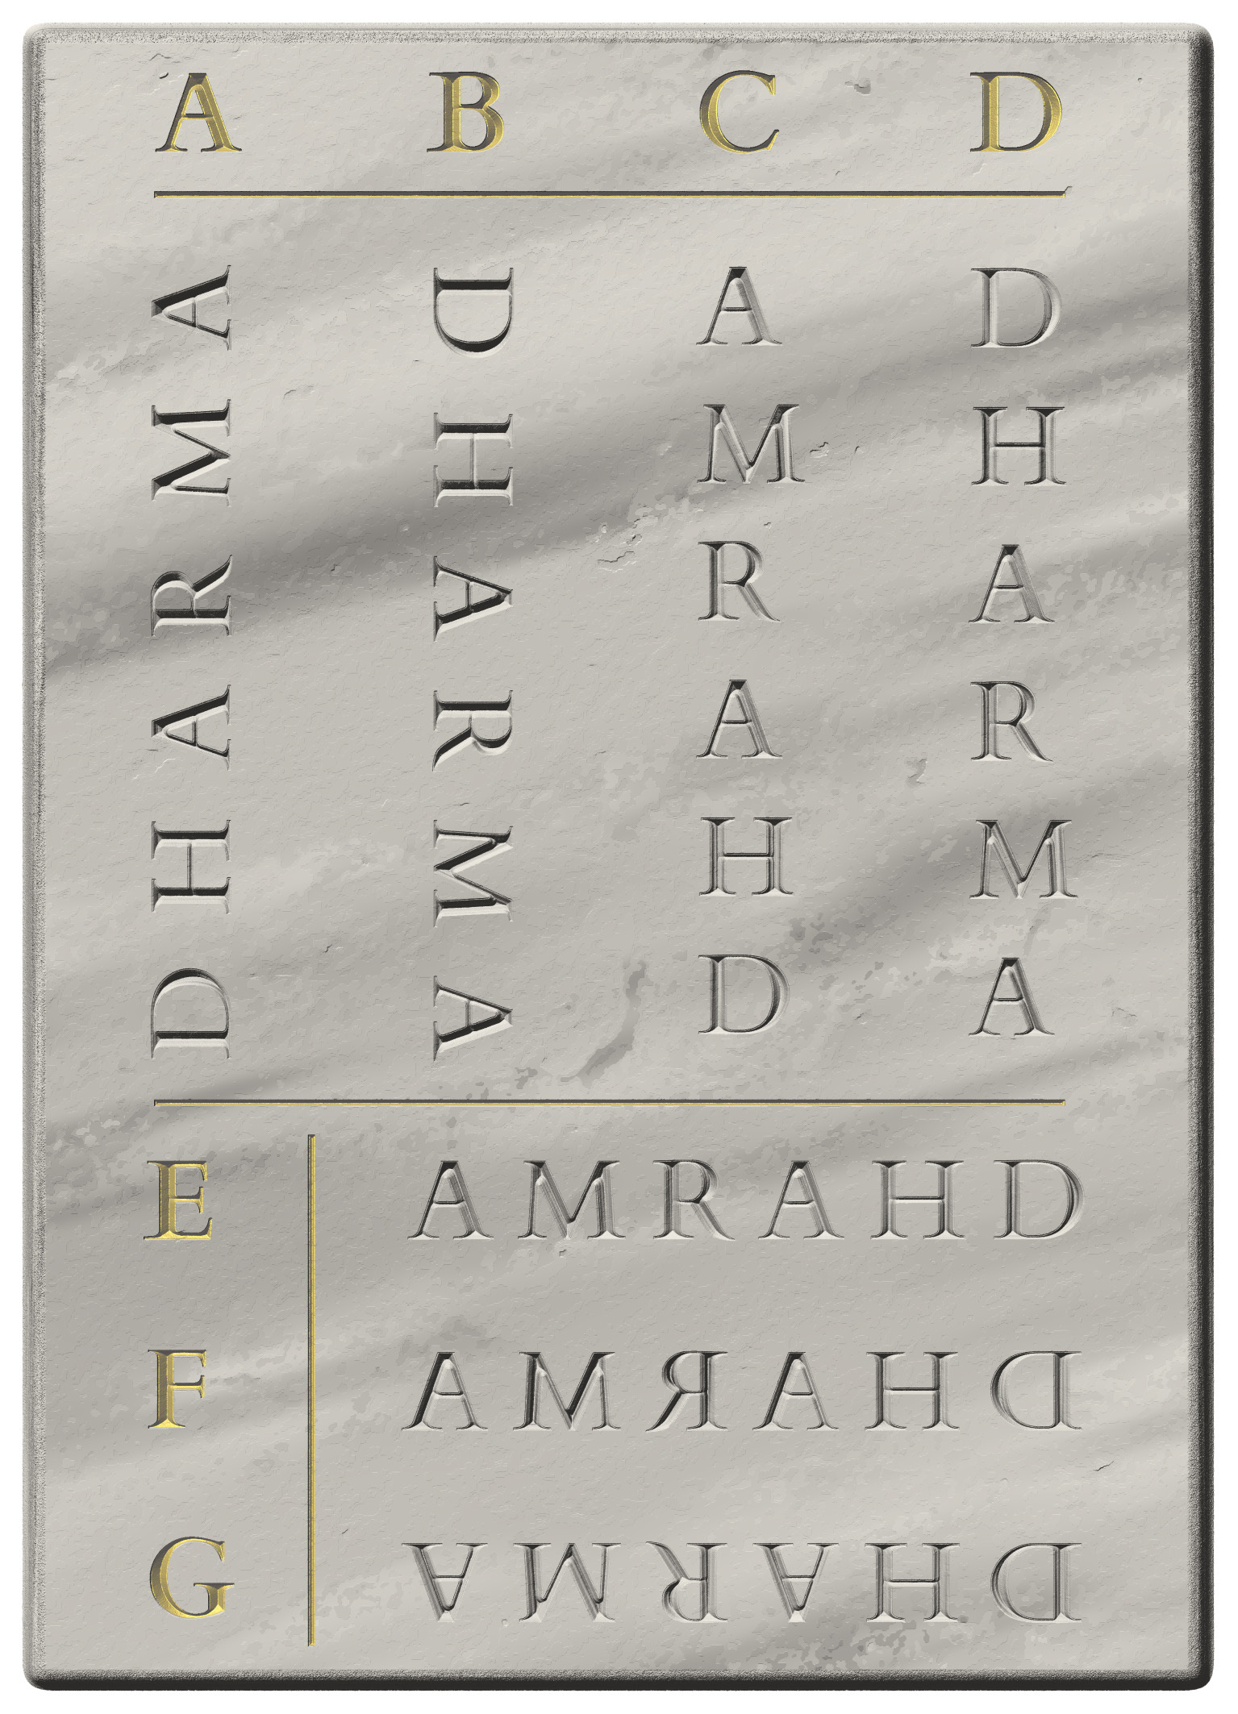
  - A. "bt-rotated" – bottom to top, with the tops of characters facing left
  - B. "tb-rotated" – top to bottom, with the tops of characters facing right
  - C. "bt-upright" – bottom to top, with the tops of characters facing upward
  - D. "tb-upright" – top to bottom, with the tops of characters facing upward
  - E. "rl-upright" – right to left, with characters in their regular orientation
  - F. "rl-flipped" – right to left, with characters mirrored around their vertical axis as in true boustrophedon
  - G. "rl-rotated" – right to left, with the tops of characters facing downward
  - should you encounter any other combination of directionality and orientation, leave it without encoding and describe it in your annotation

Interpretive and analytical markup
One of the great strengths of TEI is that it allows tagging specific chunks of the text (as interpreted by the editor) with information that can then be used for the analysis of semantic content, linguistic structures, narrative elements or other features. However, a documentary edition encoded in EpiDoc tends to contain a great amount of highly granular code, and attempting to combine this encoding with interpretive/analytical markup will in most cases result in a proliferation of overlapping hierarchies (§2.2.4). Therefore, in DHARMA editions we habitually encode only a minimum of interpretive information, namely that pertaining to numbers (§9.1) and, optionally, to abbreviations (§9.2). A number of other encoding methods useful for analytical purposes (§14.7.3) are permitted in the DHARMA schema and may be used in the editions as well as in other divisions of our XML documents, but their use is not encouraged in our editions and not provided for in these guidelines.

Numbers
TEI provides dedicated markup for the semantic tagging of numbers found in source documents. In addition to making it explicit that a certain chunk of text signifies a number, this allows us to record the value of the number for straightforward machine interpretability. The following subsections detail the use of this encoding in DHARMA editions.

Encoding numbers
- the element for the semantic tagging of numbers is <num> (for “number”)
- in DHARMA practice, <num> is used with the following attributes
  - in most cases, @value as per §9.1.1.1
  - as applicable, @cert as per §9.1.3
  - as applicable, @atLeast and @atMost as per §9.1.3
- this element is used as a single container for wrapping all the characters of the source that together signify a single number, not for individual numeral signs (unless they signify a number on their own)

The value of numbers
- the element <num> must, as a rule, have the attribute @value, recording in a machine-readable form the final value of the entire number within the element
- fractions shall be represented in this attribute as decimal fractions, never dropping the 0 before fractions smaller than 1 and always using a decimal point, not a different decimal marker, e.g. <num value="0.5">
  - round the value to three digits after the decimal point for any fractions that would require a longer (or infinite) sequence of digits, e.g. encode ⅓ as <num value="0.333"> and one sixteenth as <num value="0.063">

When and how to encode numbers

Numbers expressed by numeral signs
- semantic encoding with <num> is mandatory for all numbers recorded in numeral signs
  - this includes both decimal place-value notation and other numeral notation systems
  - note, however, that semantic encoding is not applicable when a glyph that normally represents a number is employed in a different function, as discussed in §5.2.3
- encoding with <num> does not replace the <g> element for numeral signs transliterated by something other than a single Unicode character (§5.3.5)
  - when <g> is present, <num> must contain <g>, not the other way round
- a single <num> element wraps all of the numeral signs that together express a single number
- examples of encoded numbers
  - “three” denoted by a numeral glyph
    - <num value="3">3</num>
  - “three” denoted by three vertical bars
    - <num value="3"><g type="numeral">III</g></num>
  - “one hundred and twenty-three” written in place value notation
    - <num value="123">123</num>
  - “one hundred and twenty-three” written in additive notation as |100| + |20| + 3
    - <num value="123"><g type="numeral">100</g> <g type="numeral">20</g> 3</num>
  - “eight thousand three hundred and ten” written in a combination of multiplicative and additive notation as |1000| × |8| + |100| × |3| + |10| (illustrated in Exhibit 5.2.B)
    - <num value="8310"><g type="numeral">1000</g> 8 <g type="numeral">100</g> 3 <g type="numeral">10</g></num>
  - “ninety” written as the Khmer digit 80 and digit 10
    - <num value="90"><g type="numeral">80</g> <g type="numeral">10</g></num>
  - “one thousand” written with one sign for |1000|
    - <num value="1000"><g type="numeral">1000</g></num>
  - “one half” written with a single fraction sign
    - <num value="0.5">½</num>
  - “one eighth” written with a single fraction sign
    - <num value="0.125"><g type="numeral">1/8</g></num>
  - “three and one third” written as a digit 3 and one sign standing for “one third”
    - <num value="3.333">3 ⅓</num>
  - “three and one eighth” written as a digit 3 and one sign standing for “one eighth”
    - <num value="3.125">3 <g type="numeral">1/8</g></num>
  - see also Exhibit 9.1.A
Exhibit 9.1.A: numerals in a date with full encoding
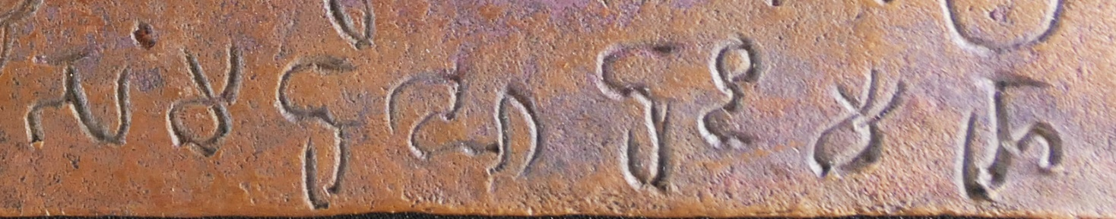
<abbr>saṁ</abbr> <num value="18"><g type="numeral">10</g> 8</num> <abbr>he</abbr> <num value="8">8</num> <abbr>di</abbr> <num value="15"><g type="numeral">10</g> 5</num>
- the date is saṁ 18 he 8 di 15, meaning the 15th day (divasa) of the 8th fortnight of the cold season (hemanta) in the year (saṁvat) 18
- the glyphs representing the numeral 10 are wrapped in <g> and are separated by a space from the adjacent text as well as from the adjacent numeric characters representing decimal digits
- for encoding the value of a number with <num>, see §9.1
- for the encoding of abbreviations, see §8.2.2

Numbers expressed in words
- words expressing numbers may be optionally encoded with <num>, including
  - numbers spelled out in words such as ekaḥ and aṣṭottaraśataṁ
  - “coded” numbers (bhūtasaṁkhyā, candrasengkala/sengkalan) as used for example in chronograms
- when a number is expressed in multiple words, preferably tag the entire phrase with <num> and encode the total value as its @value
  - in such cases, words not in themselves expressing a number may be included within the scope of <num> if they are intermingled with numeral words
  - note that numeral expressions extending across block-level elements (such as verse lines) cannot be tagged in this way without complicated encoding that we prefer to avoid
- adding <num> is recommended for numbers expressed with a combination of words and numeral signs, e.g.
  - <num value="557">slik· <g type="numeral">I</g> <g type="numeral">100</g> <g type="numeral">40</g> <g type="numeral">10</g> <g type="numeral">7<g></num>
  - <num value="186">sā rutuḥ 86</num>

Difficulties in reading numbers
- problems with reading numeral signs (e.g. lacunae, unclear and ambivalent readings) can and must be marked up in the same way as other legibility issues (§6)
- if a numeral sign is unclear or ambivalent, the applicable tags must be placed
  - outside any <g> elements applied to numeral characters
  - but inside the <num> element that wraps numbers as a whole
- numbers whose reading is problematic will usually not have a definite value that you can encode in the <num> element; to deal with this problem, choose one of the methods in the following subsections
  - whichever method you use, possible values and their relative probabilities may be elaborated in your annotation

Range of values
If you can establish a range that covers the possible values of a problematic numeral, encode as follows.
- instead of the attribute @value, use @atLeast and @atMost in the <num> element to record the lowest and highest possible value of the number as a whole
  - e.g. for three digits in place value notation, where the first two digits are 1 and 0, and the last digit is illegible: <num atLeast="101" atMost="109">10<gap reason="lost" quantity="1" unit="character"/></num>
- because of its relative simplicity, this method is also recommended for situations where only some figures in a relatively limited range are possible
  - e.g. for an unclear numeral sign that may be 80 or 90 with equal likelihood: <num atLeast="80" atMost="90"><choice><unclear><g type="numeral">80</g></unclear><unclear><g type="numeral">90</g></unclear></choice></num>
  - the EpiDoc Guidelines offer a further method for dealing with partly lost numerals whose gamut of possible values is not sequential, but we discourage the use of this method because we do not foresee that our project would benefit from the increased accuracy to an extent that would justify the complexity of the markup involved

Tentative value
If you can establish a single tentative value for a problematic numeral, encode as follows.
- use the tentative value in the attribute @value and add the attribute @cert with the value "low" to flag the value as uncertain
  - e.g. for three digits in place value notation, where the first two digits are 2 and 4, and the last digit seems to be 6: <num value="246" cert="low">24<unclear>6</unclear></num>

Tentative range
The above methods may be combined to encode a range of tentative values.
- e.g. for three digits in place value notation, where the first two digits are probably 1 and 0, and the last digit is illegible: <num atLeast="101" atMost="109" cert="low"><unclear>10</unclear><gap reason="lost" quantity="1" unit="character"/></num>

Unknown value
If none of the above seems adequate for a partially legible numeral, or if a numeral is wholly lost or illegible (yet you are certain it was a numeral), encode as follows.
- use the <num> element without @value around the partial reading or the lacuna
  - e.g. for one lost/illegible numeral character: <num><gap reason="lost" quantity="1" unit="character"/></num>

Editorial intervention and numerals
- occasionally, an editor may be able to restore a lost number, or even emend an incorrectly inscribed one, e.g. on the basis of the number being also written out in words
- tags for editorial restoration (§6.4) may be used inside or outside the <num> element depending on the scope of the restoration, but they must never be inside any <g> elements applied to numeral signs
  - a longer stretch of restored text may freely include both text and a numeral
  - the @value attribute of the <num> element should reflect only the restored value
- tags for editorial correction (§7.2) must be outside the <num> elements, which must separately encode both the pre- and post-correction number
  - e.g. <choice><sic><num value="6">6</num></sic><corr><num value="7">7</num></corr></choice>
  - as a corollary of this, the entire number must be included in the correction markup even when editorial correction affects only one digit of a multi-digit numeral (regardless of whether the digits are in place value notation or not)
    - e.g. <choice><sic><num value="18">18</num></sic><corr><num value="28">28</num></corr></choice>

Abbreviations
Abbreviations, i.e. strings of phonographic graphemes representing part of a word or phrase but understood to signify the entire word or phrase, may be tagged as such in TEI as per §9.2.1, which allows them to be interpretable by a computer. Markup is also available for expanding abbreviations, i.e. for resolving the abbreviation into (your editorial notion of) the full word or phrase it signifies, as per §9.2.2.

Tagging abbreviations
Encoding abbreviations is not mandatory in DHARMA editions, but it is generally recommended that you tag all abbreviations in your editions.
- to tag an abbreviation, wrap it in the element <abbr> without any attributes
  - e.g. <abbr>su</abbr> for the abbreviation of suvarṇa
  - see also Exhibit 9.1.A for a real-life illustration
- abbreviations comprised of parts of words in compound and in phrases or sequences that regularly occur together shall be tagged as a single unit or as separate abbreviations at your discretion, e.g.
  - <abbr>badi</abbr> for the abbreviation of bahula-divase
  - <abbr>grī pa</abbr> or <abbr>grī</abbr> <abbr>pa</abbr> for the abbreviation of grīṣma pakṣa

Expanding abbreviations
Expanding abbreviations is optional but recommended especially in cases where a certain abbreviation may be resolved in more than one way, and you wish to indicate a particular resolution. It is generally preferable not to resolve common abbreviations (whose meaning can be found in published reference works), especially if they allow multiple resolutions with the same ultimate meaning (differing for instance only in the choice of case ending or lack thereof).
- resolved abbreviations must be wrapped in the element <expan>, containing one or more instances (as necessary) of the following elements, and nothing outside the following elements:
  - <abbr> wrapping only graphemes present in the original, i.e. those that belong to the abbreviation
  - <ex> wrapping only graphemes supplied to resolve the abbreviation, i.e. those that belong to the editorial expansion
    - when you are unsure of an expansion but still wish to show it in the edition, add @cert="low" to the <ex> element
  - should the abbreviation contain any graphemes which must be suppressed to obtain the expanded form of the abbreviation, wrap these in <am> (for “abbreviation mark”) within the <abbr> element
    - the original purpose of this encoding was to allow suppressing actual abbreviation marks (TG §4.3.2) in resolved abbreviations
    - in EpiDoc usage it is also applied to phonographic graphemes added to an abbreviation to indicate a plural or another change of the abbreviated word, e.g. Latin augg abbreviating augusti duo or English pp abbreviating pages
    - so far, we have not encountered either of these phenomena in documents edited for DHARMA, but modern Indic writing systems do employ an abbreviation sign (e.g. Devanagari |॰|) and extra letters might conceivably be used in Indic abbreviations too, so the encoding option is available
- when resolving abbreviations in Sanskrit or another language with complex inflexion, feel free to resolve to stems (dictionary forms) when a specific fully inflected form cannot be predicted
  - e.g. the abbreviation grī pa is best resolved to grīṣma pakṣa, because a multiplicity of inflected forms are plausible (e.g. grīṣma-pakṣaḥ, grīṣma-pakṣe, grīṣmasya pakṣe)
- examples of resolved abbreviations
  - abbreviation of a word by its initial grapheme(s)
    - the string mā as an abbreviation of māṣa: <expan><abbr>mā</abbr><ex>ṣa</ex></expan>
  - abbreviation of a word by its final grapheme(s)
    - the string k· tandoṅ· as an abbreviation of jāk· tandoṅ·: <expan><ex>jā</ex><abbr>k·</abbr> </expan> tandoṅ
  - abbreviation of a word by its initial and final grapheme(s)
    - the string Im as an abbreviation of Iraṇṭum: <expan><abbr>I</abbr><ex>raṇṭu</ex><abbr>m</abbr></expan>
  - abbreviation of a compound word by the initial grapheme(s) of its members
    - the string kuvā as an abbreviation of kulyavāpa: <expan><abbr>ku</abbr><ex>lya</ex><abbr>vā</abbr><ex>pa</ex></expan>

The critical apparatus
The primary purpose of a critical apparatus in our project’s documentary editions is to record substantive alternative readings, restorations and emendations by previous editors. Unless a specific sub-corpus or a particular text requires this, a complete record of minor differences (e.g. typing and printing errors, orthographic normalisation or whether a reading is shown as unclear or tentatively read/reconstructed) is not desirable. Your own editorial emendations (§7) and restorations (§6.4) must be encoded within the edition rather than being shown in the critical apparatus. However, apparatus notes can and should be used to add details or reasoning to such choices, and to record highly tentative proposals you are not confident enough to include in the edition itself.
TEI and EpiDoc provide a variety of methods for encoding a critical apparatus for a scholarly edition. In DHARMA documentary editions we limit ourselves to an external apparatus criticus, meaning that the apparatus entries are encoded in a section separate from the edition, with each entry containing a reference to a locus of the text that is human-readable but not fully machine-actionable. For the sake of project-wide consistency and ease of processing, the external apparatus shall always be encoded as set out in this section.

Encoding the critical apparatus
- after your <div type="edition"> element, your document must include a <div type="apparatus">, without any attributes
- the direct child of this container must be the element <listApp>
- these skeleton containers are already present in our templates and will not need to be created by you
  - but if your edition division includes boxlike partitions (§4.2), then all corresponding textpart divisions must be replicated within the <div type="apparatus"> as described in §10.1.1, and <listApp> must be created separately for each textpart division within the apparatus
- within <listApp>, each apparatus entry must be individually wrapped in the element <app>
  - with the mandatory attribute @loc to indicate the location (epigraphic line) to which your entry pertains, as per §10.1.1 below
- each <app> element must contain <lem> as its first child element, containing a lemma encoded as per §10.3 below
- in addition to and after <lem>, each <app> element must normally contain at least one of the following
  - one or more <rdg> elements (one for each alternative reading/restoration/emendation), as per §10.4 below
  - one or more <note> elements containing a human-readable note in freeform text pertaining to that particular lemma, as per §10.7 below
- a lemma without either a reading or a note may be used to credit a previous editor for a reading as per §10.3.3
- the framework of the apparatus is illustrated in Exhibit 10.1.A
Exhibit 10.1.A: example of a critical apparatus
- a snippet from an edition
<div type="edition" xml:lang="san-Latn">
[...]
<lg n="3" met="anuṣṭubh">
<l n="a">brahma-svan tu viṣa<supplied reason="omitted">ṁ</supplied> ghora<supplied reason="omitted">ṁ</supplied></l>
<l n="b">na viṣa<supplied reason="omitted">ṁ</supplied> viṣam ucyate</l>
<l n="c">viṣa<lb n="25" break="no"/>m <unclear>e</unclear>kākin<choice><sic>ā</sic><corr>a</corr></choice>ṁ hanti</l>
<l n="d">brahma-svaM putra-p<choice><sic>avi</sic><corr>au</corr></choice>trikaM</l>
</lg>
[...]
</div>
- and from the corresponding apparatus
<div type="apparatus">
<listApp>
[...]
<app loc="24">
<lem>viṣa<supplied reason="omitted">ṁ</supplied> viṣam</lem>
<rdg source="bib:Gai1965-1966_01">viṣa<unclear>ṁ</unclear> viṣam</rdg>
<rdg source="bib:Venkataramanayya1974_01">viṣa<supplied reason="omitted">ṁ</supplied></rdg>
</app>
<app loc="24">
<lem source="bib:Gai1965-1966_01">ucyate</lem>
<rdg source="bib:Venkataramanayya1974_01">uc<surplus>c</surplus>yate</rdg>
</app>
<app loc="25">
<lem source="bib:Venkataramanayya1974_01">-p<choice><sic>avi</sic><corr>au</corr></choice>trikaM</lem>
<rdg source="bib:Gai1965-1966_01">-p<choice><sic>avi</sic><corr>au</corr></choice>tr<choice><orig>i</orig><reg>a</reg></choice>kaM</rdg>
<note>I prefer the normalisation <foreign>pautrikam</foreign>; I moreover wonder if the intent was not <foreign>paitr̥kam</foreign>.</note>
</app>
[...]
</listApp>
</div>

Textpart divisions in the apparatus
- if your edition includes boxlike partitions (§4.2), then all corresponding textpart divisions must be replicated within the apparatus
- inside <div type="apparatus">, create as many <div type="textpart"> elements as there are in the <div type="edition">
  - in the start-tag of these replicated divisions, include the same attributes (@subtype and @n as applicable) with the same value that they have in the edition division
  - if your edition’s textpart divisions have <head> elements, likewise replicate these in the apparatus, immediately after the start-tag of each textpart division
    - the @xml:lang attribute of the <head> element is not necessary within the apparatus (because the apparatus division, along with all its children, inherit the English language from the TEI container of the document), but copy-pasting the head and retaining the attribute does no harm
- the apparatus container <listApp> must in this case be enclosed within each <div type="textpart">
  - if you have apparatus entries for more than one textpart, then create a <listApp> within each textpart to wrap the <app> elements belonging to that textpart as in Exhibit 10.1.B
  - if one or more textparts have no pertaining apparatus entries, then the textpart division (with attributes) must still be created for these in the apparatus, but that division shall not contain anything (except, if applicable, <head>), i.e. there should not be a <listApp> wrapper, nor any <app> items there, as in Exhibit 10.1.C
Exhibit 10.1.B: critical apparatus with more than one textpart, each with content
<div type="apparatus">
<div type="textpart" n="A">
<head xml:lang="eng">Seal</head>
<listApp>
<app loc="1">
<lem>ku<unclear>mā</unclear>rāmātyādhikaraṇasya</lem>
<note>Our restitution ... </note>
</app>
</listApp>
</div>
<div type="textpart" n="B">
<head xml:lang="eng">Plate</head>
<listApp>
<app loc="2">
<lem>°bhi<supplied reason="omitted">ḥ</supplied> mekhalayā</lem>
<note>Absence of doubling ... </note>
</app>
...
</listApp>
</div>
</div>

Exhibit 10.1.C: critical apparatus with more than one textpart, one without content
<div type="apparatus">
<div type="textpart" n="A">
<head xml:lang="eng">Seal</head><!--Empty textpart.-->
</div>
<div type="textpart" n="B"><head xml:lang="eng">Plates</head>
<listApp>
<app loc="6">
<lem>-pu<unclear reason="eccentric_ductus">ñja</unclear></lem>
<note>While <foreign>puñja</foreign> must have been intended ... </note>
</app>
...
</listApp>
</div>
</div>

Indicating location in apparatus entries
The value of the attribute @loc must unambiguously specify the line to which the apparatus entry pertains. The primary purpose of this value is to be intelligible to a human reader, but some degree of machine-actionability may be desired in the future, therefore we adopt rigorous rules.
- locations shall normally be identified as epigraphic lines, using line numbers as reference, because they are (almost) ubiquitous in our editions and unique within each edition
  - therefore, the value of @loc shall normally be the line number, i.e. the value of the @n attribute of the <lb/> element representing the beginning of the target line
    - if the entry refers to a segment of text that extends across a line break, then @loc shall be the number of the line in which the segment begins
      - see also §10.6 below about the inclusion of line (and other) beginning tags in a lemma
- the sole exception to the ubiquitous presence of line numbers in our editions is forme work (§4.7.2)
  - it is therefore not possible to refer to the contents of forme work using line numbers
  - should you need to add an apparatus entry for a forme work item, the value of @loc shall be the number of the forme work item prefixed with the letters “fw”, e.g. <app loc="fw2r"> to refer to the forme work element with the number 2r
- the sole exceptions to the uniqueness of line numbers are editions comprised of textpart divisions (§4.2), where line numbers are restarted in each division
  - however, since the apparatus division of the document must replicate the textpart divisions of the edition division, @loc references in the apparatus still only need to include the @n of the target line and will remain unambiguous
- although some of us may be used to referring to stanza numbers in apparatus entries, we have chosen not to allow this in order to reduce the complexity of referencing
  - apparatus entries for lemmas in verse shall be referred to by line number like those in prose
  - notes concerning entire stanzas shall be added to the commentary (§12), not to the apparatus

Lemmas
The exact locus (i.e. segment of text) to which an apparatus entry pertains is specified by a lemma, tagged with the XML element <lem>.

The extent of lemmas
There are no strict rules for the extent of your lemmas. As with any critical apparatus, lemmas should be large enough to make them unambiguous within the line referred to in the @loc attribute and small enough to remain concise.
- lemmas should preferably consist of whole words separated in the edition by an editorial space
  - deviate from this only when such a lemma is not practicable, for instance because of long compounds, long words merged in vowel sandhi, or because the lemma needs to target a specific fixed morpheme or specific characters
  - in the latter case, the fact that the lemma is not a whole word shall be indicated with editorial hyphenation (TG §7.3.5) or truncation (TG §7.4) as follows
- if your lemma is only a part of a non-compound word
  - use the character ° to indicate truncation
  - e.g. text jāyate; lemma °yate
- when a boundary between independent words or compound members is obscured by sandhi
  - use the character ° to indicate truncation and cite the lemma as in the text (without resolving sandhi)
  - e.g. text yathāsmābhiḥ; lemmas yathā° or °āsmābhiḥ (not °asmābhiḥ)
- when a boundary between compound members is not obscured by sandhi
  - if the compound is not hyphenated in your edition, use the character ° to indicate truncation
    - e.g. text śrīpolekeśivallabhasya; lemmas śrī° or °polekeśi° or °vallabhasya
  - if the compound is hyphenated in your edition, include the hyphen in your lemma to indicate that it is in compound
    - e.g. text śrī-polekeśi-vallabhasya; lemmas śrī- or -polekeśi- or -vallabhasya
    - bear in mind that when a compound boundary coincides with a line break, the editorial hyphen must be placed in the edition at the beginning of the next line (§7.8.2)
    - such a hyphen must still be included in your lemma, but this does not necessitate incorporating the encoded line break in the lemma (as you would for lemmas stretching across line breaks, §10.6)
- avoid very long lemmas, if possible, by breaking them up into several smaller ones
- long lemmas that cannot be split up in this way may be abbreviated by replacing a section of them with <gap reason="ellipsis"/>

The content of lemmas
- the text within your lemma should replicate the text in your edition accurately, including editorial markup
  - see §10.6 for some concerns pertaining to the use of markup in lemmas
  - do not add any markup to the lemma that is not present in the edition
- when you revise the text of your digital edition, take care to check whether any of the revised text has been cited in the apparatus and revise lemmas accordingly

The source of lemmas
- <lem> may take the attribute @source to show that a previous edition has a reading identical to that adopted in your edition
  - the value of this attribute must be a bibliographic identifier as set out in §14.6.2
    - whenever you use @source on a lemma, the bibliographic citation of that publication in your bibliography division must include an encoded siglum for use in the apparatus, as per §13.3.2
  - see §10.5 below for guidance on the degree of similarity that counts identical
- if an apparatus entry contains alternative readings, then any previous editors who agree with the lemma (i.e. with your preferred reading) must be credited in this way
- if an apparatus entry contains only a note, but no alternative readings, then @source need not be indicated on the lemma (since in this case you and any previous editors agree on the reading)
  - nonetheless, you may choose to add @source in order to credit a particular previous editor for a difficult reading or an ingenious restoration
- an apparatus lemma may be created for the sole purpose of crediting a previous editor for a difficult reading or an ingenious restoration
  - in this case the <app> element need contain neither <rdg> nor <note>, but @source must be present on the lemma
  - such apparatus entries will be rare; only create them if you feel they are necessary

Alternative readings, restorations and emendations
Alternatives to your edited text offered by other editors shall be recorded in <rdg> elements within an apparatus entry.

The extent of alternative readings
The text segments cited as alternative readings must always correspond exactly to the extent of the lemma
- as described in §10.3.1 for lemmas, use ° or a hyphen at the beginning or end of a reading if its boundary does not coincide with the boundary of an independent word of the text
- if a previous edition shows nothing (i.e. not even a lacuna) at a locus where your edition has content (including a tentative reading or a lacuna), the reading of that edition may be represented by an empty element
  - e.g. <rdg source="bib:VenkatasubbaAyyar1943_01"/>

The content of alternative readings
- text cited within <rdg> must be Romanised according to the DHARMA transliteration scheme regardless of what transliteration system or script the cited edition employed
  - if an earlier editor uses ś to transliterate both Grantha ś and Tamil c, and you are unable to determine which is meant, choose in <lem> the interpretation you favour and add a <note> to the <app>, such as “The original editor’s reading could also be interpreted as …” (specifying the original editor by name if the <app> contains several <rdg>)
  - if an earlier editor’s transliteration scheme represents certain details of the script less accurately than ours, make reasonable effort to normalise their reading to the more accurate DHARMA system, e.g.
    - in particular, initial vowels and final consonants to the uppercase letters used in our transliteration, even if the earlier editor does not indicate these in any way (e.g. by using = adjacent to non-initial vowels and non-final consonants)
    - ḥ to ḫ or ẖ as applicable, if an earlier editor does not (consistently) distinguish upadhmānīya and jihvāmūlīya from visarga
- text within this element must be marked up with XML tags to clearly indicate what the cited editor deemed unclear, emended or supplied
  - that is to say, convert the original editor’s markup and/or additional explanation into XML tags endorsed by this guide as best possible
  - since the markup found in many printed editions is less expressive and/or less rigorously consistent than our EpiDoc conventions, you may need to interpret the intention of the original editor and mark up alternatives accordingly, for instance by distinguishing correction from normalisation
- never retain any traditional editorial markup (such as brackets or asterisks)
  - if you are unable to interpret the intent of an earlier editor, discuss it in an apparatus note instead of citing it as a reading
  - see also §10.6 for some concerns pertaining to the use of XML tags in readings, in particular about the encoding of line breaks within a reading
- feel free to silently correct obvious typographic errors and transliteration inconsistencies when citing an earlier editor’s reading
  - but when there is any doubt as to whether you are dealing with a typo or an erroneous reading, it is better to assume the latter
- keep in mind that all markup within <rdg> must represent the cited editor’s markup, not your markup pertaining to the cited edition; thus,
  - if your copy of the edition is unclear or illegible, this can be indicated in a note, but not with XML markup for unclear text or a lacuna
  - if the previous editor omits some text, this can be indicated by an empty <rdg> as above (§10.4.1), or by choosing a broader lemma that includes some text adjacent to the omission

The source of alternative readings
- alternative readings must always be credited to the editor(s) who proposed or endorsed them, using the attribute @source on <rdg>
  - the value of this attribute must be a bibliographic identifier as set out in §14.6.2
  - the bibliographic citation of the relevant publication in your bibliography division must include an encoded siglum for use in the apparatus, as per §13.3.2
  - see §10.5 below for guidance on deciding when two editors’ readings may be deemed identical
- if your apparatus includes at least one lemma with alternative readings and you have consulted more than one previous editor, then your apparatus entries must always be formulated as a positive apparatus
  - for any lemma with one or more alternative readings, clearly indicate (either under the lemma or under one of the alternative readings) what the readings of all previous editors were
  - however, keep in mind that your apparatus does not have to list every minor divergence from or between previous editions (§10)

Identical lemmas, identical readings
- in setting up your apparatus, you will need to judge whether two given readings are to be recognised as different or can be treated as identical
  - to decide whether a given previous editor’s reading agrees with yours or must be shown as an alternative reading
  - to decide whether a given previous editor’s reading agrees with that of another previous editor or must be shown as an additional alternative reading
- in this process, you should primarily consider the actual text shown in each edition, as read by each editor; thus,
  - ignore differences limited to the transliteration system (see also §10.4.2 above)
    - if an earlier editor does not distinguish initial vowels from dependent ones, or final consonants from those in akṣaras, you must still consider the readings identical
  - feel free to ignore minor orthographic mistakes that do not affect the meaning and that may well be typographic errors in a previous edition
    - but when there is any doubt as to whether you are dealing with a typo or an erroneous reading, it is better to assume the latter and show it as different from the reading you deem correct
  - ignore differences that consist only in the presence or absence of markup for unclear or restored characters
    - if one reading is ya<unclear>thā</unclear>smābhiḥ and another is yathāsmābhiḥ without any markup, then the two readings shall be deemed identical
    - if one reading is yathā<supplied reason="lost">smābhiḥ</supplied> and another is yathāsmābhiḥ without any markup, then the two readings may be deemed identical unless you consider it important to show that part of the text was apparently visible to one editor but lost when the document was studied by another
  - ignore the presence or absence of spaces, which are usually not indicated in printed editions
  - ignore previous editors’ emendations or normalisations if they do not affect the interpretation of the text
    - thus, if you (or another editor) have chosen only to flag a phenomenon as erroneous or non-standard, or chosen to ignore one, whereas a previous editor reads the same received text but emends or normalises it, then the readings are still to be deemed as identical
    - meaningful or text-critically significant differences in emendation (or lack thereof) must, however, be recorded in the apparatus
  - ignore differences in the strategy (or inconsistency) of editorial spacing and hyphenation unless they affect the interpretation of the text
    - thus, if a previous edition hyphenates a suffix, prints a clitic without a space between it and the adjacent word, this is not a reason to recognise their reading as different
    - meaningful differences (e.g. treating a word as in compound or free-standing) must, however, be recorded in the apparatus
- in all of the above cases, the recommendation of ignoring minor differences may be overridden for highly problematic spots of text, where you may find it best to faithfully reproduce each previous editor’s reading down to the last detail
- keep in mind that whenever multiple editions are cited as sources for a lemma, their citations must be listed within a single @source attribute in chronological order (§14.6.2)
- when more than one previous editor supports a reading, but the readings of these editors differ from one another in minor details you ignore as per the above guidelines, by preference show the reading as featured in the first of the cited editions

XML markup within lemmas and readings
When creating lemmas by copying and pasting text from your edition, you must make sure that encoding pertaining to these text snippets is correctly preserved. For readings cited from printed editions, applicable XML encoding must be created by you on the basis of the text-based markup in the editions.
- tags of block-level containers for intrinsic structure (§3.2) must never be included in lemmas or readings
  - for a problematic locus extending across a boundary between such containers, preferably create separate lemmas
  - if separate lemmas do not seem appropriate, then simply delete from your lemma the (start and end) tags belonging to such an element, i.e. cite the text as if the boundary of intrinsic structure were not present
- milestone elements for extrinsic structure (§4.3; including line and page breaks) shall, however, be included in both lemmas and readings
  - the purpose of this is primarily to show the fact that such a transition is present (or was indicated as present, not necessarily always in the right place, by a previous edition)
  - attributes of these elements present in the edition must be retained in the lemma
  - remember that when a lemma extends across a line boundary, the @loc of the apparatus entry must be the number of the line where the lemma begins
- forme work (§4.7.2) must not be included in lemmas
  - if an <fw> element is present after a page break that intervenes in your lemma, then delete it (along with its contents) from the contents of the lemma pasted from your edition
  - for lemmas within forme work, see §10.1.1
- philological markup (§5 to §7) must, as a rule, be retained in lemmas as it appears in your edition, and created in readings to represent the intent of the editor cited as far as possible
  - the start-tag or end-tag of such an element may be outside the range of your locus copied and pasted from your edition, but must be present in the lemma, so take care to
    - add the start-tag for markup commencing before and ending inside your lemma
    - add the end-tag for markup commencing inside your lemma and ending after it
    - add start and end-tags for a lemma snipped from within a longer stretch of phrase-level markup
- phrase-level markup that encodes additional information (§14.2.4 and §9) is indifferent for the purposes of the apparatus; thus:
  - it is recommended that you delete any such markup from your lemma in order to reduce code clutter
  - but feel free to leave such markup in a copied and pasted lemma if this is more convenient for you, provided that you pay attention to start-tags and end-tags as above

Freeform apparatus notes
- if you find the encoding within <lem> and/or <rdg> insufficient for recording certain details about your base reading or a cited alternative, add a <note> element as the last child element of the relevant <app> entry
  - see §14.5 for general guidance on notes
- editorial notes concerning a segment of text that cannot be conveniently identified by a line number and lemma should be placed in the commentary, not the apparatus
- if you feel the need to create more than one note to a single apparatus entry, you may do so, but
  - all notes must be at the end of the apparatus entry
  - a note cannot be nested within another note

The translation
Whenever possible, a translation should be included in your XML document along with your edition. Ideally, texts (re-)edited for DHARMA should be accompanied by a fresh translation; however, previously published translations may be optionally encoded in your file as per §11.5. Previous translations may be included in addition to a new translation, when such a translation is of particular interest for some reason (e.g. because of its relevance to the history of the scholarly understanding of the text), or used instead of a new translation, when your edition is not a substantive revision of an earlier edition accompanied by a satisfactory published translation.
A new translation created for DHARMA should be a convenient representation of the intent of the original. Translate as literally as seems useful, but as freely as seems appropriate. Your translation must reflect the text as you have edited it, including restorations and emendations. Feel free to ignore the original’s superficial irregularities/oddities of punctuation and spelling and in particular, normalise the spelling of original personal names, toponyms and terms.

Encoding the translation
- the translation must be wrapped in <div type="translation">, with the following attributes
  - as applicable, @xml:lang (as per §14.4.1) to encode the target language of translations into a language other than English
    - translations into English do not need and should not carry this attribute, since they by default inherit the English language from the <TEI> root element
  - mandatorily, either @source or @resp to encode the author of the translation as per §11.1.2
- this division follows the edition division and the apparatus division and is already present in our template for editions
  - if your edition division includes boxlike partitions (§4.2), then all corresponding textpart divisions must be replicated within the <div type="translation"> as described in §11.1.1
  - unlike the other content divisions in our files, the translation division may be iterated several times (one after the other) to accommodate multiple translations as per §11.1.3
- the translation division (or its textpart divisions when applicable) normally contains one or more <p> elements, which in turn contain the text of the translation
  - see §11.1.3 for further instructions on structuring the content

Textpart divisions in the translation
- if your edition includes boxlike partitions (§4.2), then all corresponding textpart divisions must be replicated within the translation
- inside <div type="translation">, create as many <div type="textpart"> elements as there are in the <div type="edition">
  - in the start-tag of these replicated divisions, include the same attributes (@subtype and @n as applicable) with the same value that they have in the edition division
  - if your edition’s textpart divisions have <head> elements, likewise replicate these in the translation, immediately after the start-tag of each textpart division
    - the @xml:lang attribute of the <head> element is not necessary within a translation into English (because division’s children inherit the English language from the translation division), but copy-pasting the head and retaining the attribute does no harm
    - for translations into another language, either add @xml:lang="eng" to the <head> elements or translate their contents to the target language
- if one or more textparts of the source are not translated, then the textpart division (with attributes) must still be created for these in the translation division, but such textparts shall not contain anything (except, if applicable, <head>)

Crediting the author of the translation
- the author of the translation must be indicated in the encoding using one of the following methods
  - @resp (§14.6.5) on the translation division, if the translation was at least in part made by you and/or another project member
  - @source (§14.6.2) on the translation division, if a published translation is adopted verbatim as per §11.5

Credit notes
When you feel that credit for a translation cannot be allocated correctly or fairly by using @source and @resp as above, you may clarify the situation by adding a credit note at the beginning of a translation.
- create the element <note type="credit"> as the first item within <div type="translation">, before any textpart divisions, if such are present
  - or as the second item, immediately after the custom <head> if one is used as per §11.2.3
- this @type of <note> will only be used in the translation division, for this particular purpose
- the contents of a credit note shall be free text consisting of one or more complete sentences (with a capital initial and final punctuation), clarifying the authorship of the translation in situations such as
  - collaborative translation involving people outside DHARMA
  - the partial revision of a previously published translation by you or other DHARMA members
    - the revised previous translation should in this case be properly cited (§14.6.1) in the credit note
    - note that if you create a new translation that does not differ in any essential contents from an earlier translation, this is still to be considered as your own new translation (and not a revision of the previous one), unless the majority of your translation is in fact verbatim identical to the previous translation
  - the use of an unpublished translation by a person outside DHARMA
- when a credit note is present, the translation division shall normally be credited to you, the editor, using @resp, but depending on the situation, you may instead choose to use @source on the translation division, or to use neither of these attributes

Attaching multiple translations
- if you wish to include more than one translation (e.g. by different persons or to different languages), simply iterate <div type="translation"> for each of them as in Exhibit 11.1.A
- there is no requirement to include multiple translations just because they are available
- when you include more than one translation in your XML document, these should be presented in an order of decreasing usefulness, prioritising those which are more recent, more accurate, and in more widely spoken languages
Exhibit 11.1.A: multiple translations
<div type="edition" xml:lang="ocm-Latn">
...
<ab>pu vyā</ab>
...
</div>
...
<div type="translation">
...
<p>Her majesty the queen</p>
...
</div>
<div type="translation" xml:lang="fra">
...
<p>Sa majesté la reine</p>
...
</div>
- the framework illustrated here must be completed with attributes indicating the author of each translation as per §11.1.2

Structuring the translation
The overall structure of a translation should, as far as practicable, imitate the intrinsic structure (§3) of the original document, as clarified in the following subsections. When the edition contains textpart divisions, these must always be replicated in the translation as per §11.1.1.

Reflecting extrinsic structure in the translation
The extrinsic structure (§4) of the original document should generally not be reflected in the translation, except that textpart divisions must be replicated as per §11.1.1 and the correspondence of translation passages to source line numbers should generally be encoded as per §11.3. Should you find it necessary to do so, other transition points in extrinsic structure can be optionally indicated in the translation as follows.
- pagelike partitions (§4.4) may be replicated by using the same milestone element with the same attributes as that used in your edition
  - if <label> elements are present in the edition, replicate these along with the milestones
    - if the label is in the same language as that of the translation as a whole, then the @xml:lang attribute of the <label> element does not need to be present (but does no harm)
    - if the translation is into a different language than the label, then either use @xml:lang on the label or translate it
- never replicate the following details of the source’s extrinsic structure:
  - gridlike partitions (§4.6)
  - offset opening and closing lines (§4.7.1)
  - forme work (§4.7.2)
  - line beginnings (correspondence to which can be encoded as per §11.3)

Reflecting intrinsic structure in the translation
The translation should be structured by block-level containers in a manner resembling the intrinsic structure of the source as far as feasible.
- the basic block-level container for translated text is the paragraph (<p> element)
  - other block-level containers in the edition (viz. <ab> and <lg>) shall be rendered as <p> elements in the translation
  - for paragraphs translating verse, add the attribute @rend with the value "stanza" to the <p> element
- normally, each and every block-level container of the edition (i.e. <p>, <ab> and <lg>) should have exactly one corresponding <p> element in the translation
  - however, feel free to use more or fewer containers at your discretion
  - should the intelligibility of the translation demand it, feel free to translate items in a different order than that in which they appear in the original
- finer structural divisions may be encoded in the translation as follows
  - if you translate verse line by line, optionally wrap each translated line in an <l> element within the <p> element corresponding to a stanza as per §14.3.2.2
  - if a paragraph of the original text is, or contains, a list (such as a list of donees or boundaries), optionally use a <list> element with <item>s within the corresponding <p> element of your translation as described in §14.2.4
    - you may encode a list in the translation even if a corresponding list is not encoded in the edition and you may choose to translate a list encoded in the edition with running prose

Headings in translations
- headings for translations as a whole will be generated automatically on the basis of the @xml:lang and @source or @resp attributes of the translation division
  - containing the language of the translation if it is encoded
  - containing the author of the translation unless it is identical to the creator of the edition (§15.1.2.1)
- if this basic header is insufficient, you may optionally create a custom heading for the translation as a hole
  - to do so, include the element <head> as the first item within <div type="translation">
    - containing free text that is to be displayed as a heading above the translation
  - such headings, if present, will replace the auto-generated heading, so it is recommended that you include the word “Translation” and a specification of the target language
- when textparts (§11.1.1) or elements representing extrinsic structure (§11.2.1) are encoded in the translation, headings will be automatically generated from their attribute values or their <head> or <label> elements as in the edition
- to add secondary headings to segments of a translation that do not correspond to a structural part of the edition, you may use the <label> element at any arbitrary point between two <p> elements
  - these will be displayed as headings
  - the attribute @xml:lang should only be added to this <label> element if the label is in a different language than that of translation as a whole

Indicating correspondence to the source
Correspondence of segments of the translation to the source document shall normally be indicated in a loose, human-readable manner using the attribute @n on the <p> elements of the translation as follows.
- in short texts best translated as a single paragraph of prose, you may choose at your discretion to omit numbering
- for <p> elements translating prose (i.e. corresponding to <p> or <ab> elements in the source), the value of @n shall indicate line numbers, i.e. reflect the value(s) of @n on the <lb/> element(s) of the corresponding line(s) in the original
  - these numbers will be displayed as inline labels in the translation
- for <p> elements translating verse (i.e. corresponding to <lg> elements in the source), the value of @n shall indicate stanza numbers, i.e. reflect the value(s) of @n on the <lg/> element(s) of the corresponding stanza(s) in the original
  - these numbers, distinguishable to the processing algorithm by the presence of @rend="stanza" on the <p> elements, will be shown in display as a heading for a numbered stanza
- the acceptable values of @n for both of the above are detailed in §11.3.1 and illustrated in Exhibit 11.3.A

Referring to lines and stanzas of the source
When using @n on the <p> elements of the translation to refer to line or stanza numbers of the source, all of the following variations are permitted.
- single values, for a translation paragraph coterminous with or smaller than an epigraphic line or stanza of the source, e.g.
  - <p n="1"> a paragraph translating prose that begins and ends within line 1 (without necessarily taking up all of line 1)
  - <p rend="stanza" n="6"> a paragraph translating verse that begins and ends within stanza 6 (usually, but not necessarily, taking up all of stanza 6)
- a range of values separated by a hyphen, for a translation paragraph corresponding to text that begins in one line or stanza and ends in a different, subsequent line or stanza, e.g.
  - <p n="1-3"> a paragraph translating prose located in lines 1 to 3 (not necessarily from the beginning of line 1 to the end of line 3)
  - <p rend="stanza" n="8-9"> a single paragraph translating verse that begins in stanza 8 and ends in stanza 9 (usually, but not necessarily, corresponding to the full text of both stanzas)
- a set of values delimited by commas and spaces, for a translation paragraph corresponding to text found in two or more non-contiguous lines or stanzas of the source, e.g.
  - <p n="1, 3"> a paragraph translating prose from lines 1 and 3 (but not 2)
  - <p rend="stanza" n="8, 10"> a paragraph translating (parts of) stanzas 8 and 10 together
- all of these references are for human readers and are not meant to be machine-actionable, therefore
  - feel free to refer to larger ranges of lines or to several stanzas for passages best translated in larger chunks
  - feel free to refer to the same line or stanza number in several translation elements, each of which includes parts of a single line or stanza of the original
Exhibit 11.3.A: numbering in translation to indicate correspondence to the original
<div type="translation">
<p n="1-9">Hail! From the victorious [...] </p>
<p n="9-15">There is this village [...] </p>
<p n="15-17">In the first year [...] </p>
<p rend="stanza" n="1">By numerous kings, many times land has been given. Whoever holds land at a given moment, to him does the fruit then belong.</p>
</div>

Markup within translations
Within the text (i.e. within the <p> elements) of the translation, all of the encoding methods listed in this section are available, but no other encoding may be used. Keep in mind that these encoding methods replace the text-based markup (such as brackets and asterisks) commonly used in scholarly translations.

Globally available markup
Translations may include the globally permitted miscellaneous markup elements discussed in §14. These include in particular the element <foreign> for marking up words or phrases in a different language as per §14.4.2. Because foreign words are common in translations, we summarise the key details here.
- all words in a language other than the language of the translation must be tagged as <foreign>
- words in a relevant source language do not require the attribute @xml:lang, but words in another modern language do
- source-language words generally appear in translations in the following ways
  - as technical terms which are not translated at all and thus require no additional markup
    - e.g. one <foreign>kulyavāpa</foreign> of land
  - as words of the source inserted for clarification as explanatory additions as per §11.4.2.2
  - as unintelligible text that is not translated, represented by a gap accompanied by an explanatory addition as per §11.4.3.2

Supplied text in the translation
Words, phrases and other chunks of text present in the translation that do not correspond to anything in the source text as received shall as a rule be tagged with the element <supplied>. The usage of this element is illustrated in in Exhibit 13.3.B.
- in the translation division, <supplied> shall be used with the following attributes:
  - mandatorily, @reason to indicate the nature of the editorial addition, as outlined in the following subsections
  - as applicable, @cert="low" to segments supplied tentatively (cf. §11.4.4)
Exhibit 11.4.A: phrase-level markup in translation
<div type="translation">
<p>Indeed <supplied reason="explanation"><foreign>asti</foreign></supplied>, with respect to vendible properties in this division, the sale of <supplied reason="explanation">a <foreign>kulyavāpa</foreign> of</supplied> waste land that is without revenue charges and yields no tax, to be enjoyed in perpetuity in accordance with the law on permanent endowments, is customary for one hundred <foreign>kārṣāpaṇa</foreign>s. And no conflict of interest <supplied reason="explanation"><foreign>virodha</foreign></supplied> whatsoever <supplied reason="subaudible">will result</supplied> through its sale: <supplied reason="subaudible">on the contrary,</supplied> for His Majesty <supplied reason="subaudible">there will be</supplied> increase of wealth and attainment of one sixth of the merit.</p>
</div>

Essential additions
By essential additions we mean words which are not present in the source but have been added to a translation because the syntax of the target language requires them, or because they improve the fluency or clarity of the text in the target language. Unlike explanatory additions (§11.4.2.2), essential additions are an integral part of the text in the target language. Such additions are often indicated in scholarly translations by square brackets, and this is how they will be displayed in our system.
As DHARMA translations are expected to sound natural in the target language and to prioritise readability over meticulousness, there is no requirement to mark up every minor essential addition such as articles, conjunctions and pronouns.
- for essential additions in the translation, use <supplied reason="subaudible">, for example
  - <p>He was generous to his subjects and <supplied reason="subaudible">therefore</supplied> loved <supplied reason="subaudible">by them</supplied> ... </p>
- as per §11.4.4, distinguish tentative additions by using @cert="low"

Explanatory additions
By explanatory additions we mean words which are not present in the source but have been added to a translation in order to clarify, elaborate or disambiguate the meaning (or your interpretation) of another word or phrase in the translation. Unlike essential additions (§11.4.2.1), explanatory additions need not be an integral part of the text in the target language (though they may be set up to be readable without interruption). Such additions are often indicated in scholarly translations by round parentheses, and this is how they will be displayed in our system.
- for explanatory additions to the translation, use <supplied reason="explanation">, for example
  - <p>... devotion to <supplied reason="explanation">Viṣṇu</supplied> the bearer of the discus and the mace ... </p>
  - in order to protect her <supplied reason="explanation">the earth</supplied> with his arms ...
- when words of the source language are added next to a translated word in order to highlight the specific terminology of the source or to help the reader match parts of the translation to parts of a difficult or ambiguous passage, these are also explanatory additions
  - as per §11.4.1, such additions must be encoded as <foreign> in addition to being encoded as explanatory additions
  - e.g. <p>Homage to that thousand-headed Person <supplied reason="explanation"><foreign>puruṣa</foreign></supplied> ... </p>
- as per §11.4.4, distinguish tentative additions by using @cert="low"

Restoration of lost text
From the perspective of the translation, lost text is any meaningful and translatable segment that is not present in the source as received but which was presumably written and subsequently lost or rendered illegible. While restored text in a translation usually corresponds to text restored in the edition, this is not necessarily the case. On the one hand, lacunae smaller than words do not have to be indicated in translations, although you may choose to mark up parts of translated words (and especially of names in the translation) as restored when you deem this useful. Otherwise, either forgo markup altogether (if the lacuna is inconsequential) or mark up an entire translated word as supplied (if the lacuna is substantial). On the other hand, it is sometimes possible and expedient to restore key words or notions in the translation even where your edition does not include a restoration because the choice of synonym or phrasing used in the original text cannot be predicted. A translation may thus contain supplied text where an edition contains a <gap> element instead of a restoration. In this latter case, the <gap> element in the edition may be illegible rather than lost (§6.5.1.1), but the encoding for the two is identical in the translation.
- for lost text restored in the translation, use <supplied reason="lost">, for example
  - The truest of <supplied reason="lost">kings</supplied>...
    - corresponding to <supplied reason="lost">nr̥pa</supplied>-sattamaḥ in the edition
  - The village named Vaṭatīrtha <supplied reason="lost">was granted</supplied>...
    - corresponding to ...vaṭatīrthaṁ nāma grāmaḥ <gap reason="lost" quantity="12" unit="character"/> in the edition
    - as well as to ...vaṭatīrthaṁ nāma grāmaḥ <gap reason="illegible" quantity="12" unit="character"/> in the edition
- as per §11.4.4, distinguish tentative restorations by using @cert="low"

Restoration of omitted text
From the perspective of the translation, omitted text is any meaningful and translatable segment that is not present in the source as received but, according to the editor, should have been written and was omitted due to scribal mistake. As with the restoration of lost text (§11.4.2.3), omissions smaller than words do not necessarily require markup in translation, and words may be restored in a translation even if they are not restored in the edition.
- for omitted text restored in the translation, use <supplied reason="omitted">, for example
  - The truest of <supplied reason="omitted">kings</supplied>...
    - corresponding to <supplied reason="omitted">nr̥pa</supplied>-sattamaḥ in the edition
- as per §11.4.4, distinguish tentative restorations by using @cert="low"

Gaps in the translation
Gaps in the translation, i.e. spots where there is no translated text even though text is or once was present in the source, are encoded using the element <gap>, with attributes as described in the following subsections.

Lacunae in the translated text
- when a translation has a gap because there is a lacuna in the source, use the element <gap> with the same values of @reason as those encoded on the lacuna in the edition (as per §6.5.1.1), namely "lost", "illegible" or "undefined"
  - it is not mandatory to encode the size of the lacuna in the edition, so <gap> may be used without any additional attributes
  - however, when you deem it essential to present accurate details of a lacuna in the translated text, you may optionally use the attributes @unit, @quantity and @precision as set out in §6.5.1.2, with the following additional considerations:
    - fractional numbers (decimal fractions) for @quantity are permitted in this case, even though they cannot be used in the edition
    - @unit may be "line" even if a multiline lacuna is represented in the edition as a series of inline lacunae
    - no other methods of lacuna markup shall be used in translations, i.e. avoid the use of @extent and the encoding of sub-akṣara lacunae

Unintelligible source text
- when a translation has a gap because part of the source text cannot be interpreted to produce even a tentative translation, use the element <gap> with @reason="ellipsis", without any further attributes
- after this element, insert either or both of the following
  - the verbatim received text encoded as an explanatory addition to the translation (§11.4.2.2)
    - e.g. To the east, the <gap reason="ellipsis"/> <supplied reason="explanation"><foreign>majjaya-paṭu</foreign></supplied> of Badirāla
  - a <note> element (§14.5) to explain the nature of the unintelligible segment

Passages omitted from translation
Translations, especially previously published translations, may contain gaps for no particular reason, primarily when a segment of the text was considered too trivial to translate.
- when a translation has a gap for reasons other than a lacuna in the source or unintelligible source text, use the element <gap> with @reason="ellipsis", without any further attributes
- preferably, after the <supplied> element, add a <note> element (§14.5) with an explanation of why the text has not been translated

Tentative translation
When the source is difficult to interpret and a word, phrase or passage of your translation is tentative or reflects only one of several possible interpretations, encode this as follows.
- for the tentative translation of words and phrases present in the source as received, wrap the relevant part of the translation in the element <seg> with the mandatory attribute @cert="low"
  - e.g. <p>Out of the hundred and <seg cert="low">twenty</seg> shares comprising this village ... </p>
  - use this method regardless of whether the tentativeness of your translation stems from the condition of the original (e.g. partly or wholly unclear, illegible or restored) or from the obscurity of its language
- for words and phrases not present in the received source but supplied in the translation (§11.4.2), add @cert="low" to the relevant <supplied> element to indicate its tentative nature
  - e.g. <p>On this day he <supplied reason="explanation" cert="low">Viṣṇuvardhana III</supplied> donated … </p>

Incorrect or unexpected text
When the source text is semantically inappropriate, incorrect or unexpected (e.g. on the basis of parallel texts) and you translate it literally, optionally wrap the corresponding translation in the element <sic> to indicate that the translation corresponds to the source even though it is problematic.

Bitextual translation
Our source texts frequently employ bitextuality (double entendre, śleṣa) as a poetic device. Depending on the nature of the bitextual phrase at hand and your personal translation style, double (or additional) meanings may be rendered in translation either as alternatives to specific parts of the translated text (as in Exhibit 11.4.B) or integrated into a semantic whole (as in Exhibit 11.4.C). Because of the potential complexity of such poetic expressions, we provide a single method for encoding the translation of bitextual readings. This encoding will not be machine-actionable and will occasionally leave some ambiguity that will have to be resolved by the human reader.
- in your translation, select one translation of the double entendre as the primary or more literal one
  - apply no markup to the primary translation
- any alternative translations of the same word or phrase will be designated as secondary
  - wrap the translations of all secondary meanings in <seg rend="pun">
Exhibit 11.4.B: translation with bitextual words dispersed across a stretch of text
meruṁ vividha-budha-samāśrayatayānukurvvaN
... he resembles Mount Meru in being a supporter <seg rend="pun">the abode</seg> of diverse learned men <seg rend="pun">gods</seg> ...
- display: … he resembles Mount Meru in being a supporter {the abode} of diverse learned men {gods} …

Exhibit 11.4.C: translation with bitextual interpretation integrated into one sentence
droṇa Iva kr̥pānugataḥ
... who is attended by mercy just as Droṇa <seg rend="pun">is followed by Kr̥pā</seg> ...
- display: … who is attended by mercy just as Droṇa {is followed by Kr̥pā} …

Original space in the translation
Spaces encoded in the edition (§5.3.5) generally need not and must not be preserved in the translation. However, spaces left blank in the original with the intent of subsequent filling (vacat, §5.4.2.1) may be optionally represented in the translation if you feel that this serves a useful purpose.
- in this case, use the <space/> element exactly as encoded in the edition division, e.g. <space type="vacat" quantity="3" unit="character"/>

Reproducing a published translation

Adapting a previous translation
When you make any improvement to a previously published translation, for instance by adding parts not translated there, revising parts based on a reading you have revised in the edition or on a new interpretation of the same reading, or simply increasing its accuracy or fluency, then for practical purposes you are the intellectual author of the new translation.
- encode your authorship with @resp (§11.1.2) and add a credit note (§11.1.2.1) to name the original translator and clarify the nature and extent of your contribution

Adopting a previous translation verbatim
It is sometimes desirable to create a “digital facsimile” of a previously published translation. When doing so, be mindful of the following considerations.
- the author of the translation must be credited with the attribute @source as per §11.1.2 and §14.6.2
- any character-based markup (brackets, etc.) in the translation must be converted to its encoding equivalent as far as feasible
  - translator’s markup for which our encoding provides no equivalent, or which cannot be interpreted confidently, may be exceptionally retained
    - clarify any such markup within a credit note (§§11.1.2.1) attached to the translation
- the transliteration of any words in a source language must be silently converted to the DHARMA transliteration whenever feasible
- when a published translation you are encoding omits a stretch of the text (for example because it is unintelligible or because the original translator considered a part of the text not worthy of attention), this shall be indicated in your encoding as per §11.4.3.3
- if a published translation is based on a reading, restoration or emendation different from what you show in your edition, it is highly recommended that you point this out in a note of your own (§11.5.3), attached to the spot where the translation is based on divergent text
- obvious typographic mistakes and errors of transliteration in a previous translation should be corrected silently in your digital version
  - unusual mistakes or anomalies, especially if they affect the interpretation of the text, should be left as in the original translation and preferably accompanied by a note of your own (§11.5.3)

Adopting and adapting notes to a translation
Any notes in a translation will by default be considered to have been written by the author of the translation indicated with @source or @resp on the translation division (§11.1.2). Complications shall be handled as follows.
- if you are technically the author of the translation (either because the translation is fully yours or because you have adapted a previous translation as per §11.5.1), but you wish to include a note written by someone else (who may be, but need not be the author of a translation you are adapting)
  - preferably paraphrase the note instead of using it verbatim, thus making it your own note
    - in the paraphrased note, credit the original author of the note
      - simply by name if the note is from a published translation you are adapting and have specified in the credit note of your translation, e.g. “Fleet observes that…”
      - by an encoded bibliographic citation (§14.6.1) otherwise
  - if you wish to reproduce a note from a previous translation verbatim, you must add @source to the <note> element as per §14.6.2
- if the translation is from a previous publication (encoded as the @source of the translation division),
  - notes from that publication can and must be duplicated verbatim and without any additional attribution
    - it is, however, not mandatory to reproduce all notes by the original translator
  - notes of your own added to a previously published translation must be credited explicitly to you, using @resp (§14.6.5) on each such note
  - should you wish to include notes from a different previously published translation, do one of the following
    - paraphrase the original note, encode it as your own note with @resp, and credit its original author with a bibliographic citation
    - reproduce the note verbatim and credit it with add @source on the <note> element

The commentary
A scholarly commentary on any aspect of the edition may be included as a separate division of the XML file.
- the commentary is not the ideal place for
  - palaeographic observations on the document as a whole
    - which belong in the <handDesc> section of the TEI header (§15.2.1)
  - remarks concerning specific small-scale loci in the text
    - which are better recorded in the apparatus as notes (§10.7), unless they are so long that they would disrupt the apparatus
- typical topics that do belong in the commentary include
  - remarks pertaining to specific loci when they are too long to put in the apparatus
  - discussion of metrical phenomena and uncertainty about verse metres
  - discussion of the interpretation as reflected in your translation and any alternatives
  - literal translations of phrases more elegantly translated in your translation, but for this reason, possibly obscure
  - pointing out parallel passages in other sources, especially if these are used as the basis of restoration in the present text

Encoding the commentary
- the commentary to your text must be wrapped in <div type="commentary">, without any attributes
  - this division follows the translation division(s) and is already present in our templates
- the commentary division shall contain only one or more <p> elements, which in turn contain freeform discursive English text

Textpart divisions within the commentary
Unlike the apparatus and the translation, the commentary accompanying an edition segmented into textpart divisions does not have to be likewise segmented. However, textpart divisions may be created as desired to break up a long commentary into sections (chapters).
- use any arbitrary number of textpart divisions, keeping in mind the requirement of tessellation (§4.7.3.4), i.e. that if a textpart division is present within your commentary, then all your commentarial text must be contained within textpart divisions
- always add the attribute @n to number commentarial textparts, using plain Arabic numerals as values
- always add a heading to commentarial textparts, by creating the element <head> (containing free text to be displayed as a heading) as the first item within each textpart division
  - the attribute @xml:lang is not required on these <head> elements, since they are in the same language as the rest of the commentary

Indicating reference to the text
We are not implementing any machine-actionable linking between the text and the commentary. As and when desired, commentarial passages may include human-readable references to the edition.
- as in any written commentary, refer to lines, stanzas, pādas or particular words/phrases as and when necessary, spelling out such references in a clear human-readable manner
- should you wish to create a structured commentary with entries referred to particular sections of the text, you may employ the human-readable linking method described for translations in §11.3.1 above, i.e.
  - add to any <p> element in the commentary the attribute @n, corresponding to a line number, a range of line numbers, or a set of non-contiguous line numbers in the text
  - add to any <p> element in the commentary the attribute @rend with the value "stanza" and the attribute @n, corresponding to a stanza number, a range of stanza numbers, or a set of non-contiguous stanza numbers in the text

Markup within the commentary
- the commentary may include the globally permitted miscellaneous markup elements discussed in §14, including in particular
  - lemmas and excerpts from the edition (§14.1)
  - bibliographic citations (§14.6.1)
- the commentary should not contain text-based markup such as brackets, asterisks and other signs

The bibliography
DHARMA editions must always be accompanied by a bibliography, with the encoding structure and content specified in this section. The present section of the Guide is not concerned with other bibliographic details such as
- the project’s master bibliography, which is maintained in Zotero and discussed in the ZG
- bibliographic citations, which are treated in §14.6.1

Encoding the bibliography
- the bibliography must be wrapped in <div type="bibliography"> without any attributes
- this division follows the commentary and is the last element within the <body> of your document, where its skeleton structure is already present in our templates
- in all DHARMA editions, the bibliography division mandatorily contains each of the following items, in this order, as pre-structured in our template and as illustrated in Exhibit 13.1.A
  - an “epigraphic lemma”, §13.2
  - a structured bibliography (§13.3) subdivided into
    - a primary bibliography, §13.3.1
    - a secondary bibliography, §13.3.2
Exhibit 13.1.A: encoding the bibliography division
<div type="bibliography">
<p>First edited by Cohen Stuart <bibl rend="omitname"><ptr target="bib:CohenStuart1875_01"/><citedRange unit="page">23</citedRange><citedRange unit="item">XIII</citedRange></bibl> with a lithographic reproduction in the accompanying volume of plates <bibl><ptr target="bib:Huart+Hooiberg1875_01"/></bibl>; edited again by Boechari <bibl rend="omitname"><ptr target="bib:Boechari1985-1986_01"/><citedRange unit="page">53</citedRange> <citedRange unit="item">E.16</citedRange></bibl>; re-edited here by Arlo Griffiths from the Leiden estampage of the plate.
</p>
<listBibl type="primary">
<bibl n="B">
<ptr target="bib:Boechari1985-1986_01"/>
<citedRange unit="page">53</citedRange>
<citedRange unit="item">E.16</citedRange>
</bibl>
<bibl n="CS">
<ptr target="bib:CohenStuart1875_01"/>
<citedRange unit="page">23</citedRange>
<citedRange unit="item">XIII</citedRange>
</bibl>
<bibl n="HH">
<ptr target="bib:Huart+Hooiberg1875_01"/>
</bibl>
</listBibl>
<listBibl type="secondary">
<bibl><ptr target="bib:NBG08_1870"/><date>1870</date><citedRange>72, 78</citedRange></bibl>
<bibl><ptr target="bib:Verbeek1891_01"/><citedRange unit="page">149-150</citedRange> <citedRange unit="item">276</citedRange></bibl>
<bibl><ptr target="bib:Damais1970_01"/><citedRange unit="page">48</citedRange><citedRange unit="item">86</citedRange><citedRange unit="note">13</citedRange></bibl>
</listBibl>
</div>

The epigraphic lemma
An epigraphic lemma (called by this name in Greek and Roman epigraphy) is a paragraph which explains the history of research leading up the present edition. Our epigraphic lemmas shall be encoded as a single <p> element that is the first child of the bibliography division, containing freeform discursive English text, as illustrated in Exhibit 13.1.A.
- the epigraphic lemma will normally be centred around a list of the principal publications pertaining to the study of the text and its translation, in ascending chronological order up to the one that most immediately precedes the present edition
  - principal publications are typically the same as the items of the primary bibliography (§13.3), but early reports, facsimiles and translations without an accompanying edition may also be mentioned here
  - each reference must be encoded as a bibliographic citation (§14.6.1)
    - the encoding can be copied and pasted from or to the structured bibliography, then edited as needed
  - each reference must be integrated into a sentence explaining the relevance of the item
    - specify whether the item includes an edition, a facsimile or a translation of the text
    - for any publication that includes visual documentation, give a full account of such documentation in the epigraphic lemma (reproduction method, print quality, missing parts, etc.)
    - for editions, specify the kind and source of the visual documentation on which the edition was based
- the epigraphic lemma shall end with the introduction of the present edition
  - this will be the only item of the epigraphic lemma for texts which have not been published before
  - include your name (along with the names of any collaborators) in this item, stating in human-readable form the same information that has been encoded in the <respStmt> (§15.1.2) and, if applicable, elaborating it
  - specify the kind and source of the visual documentation on which your edition is based
    - see also §13.2.1 and Exhibit 13.2.A

Markup within the epigraphic lemma
- as free text, the epigraphic lemma may include the globally permitted miscellaneous markup elements discussed in §14, including in particular
  - bibliographic citations (§14.6.1), which are mandatory as described in §13.2 above
  - notes (§14.5)
    - if you wish to add a note to a particular bibliographic citation, remember to place the <note> element outside, and immediately after, the <bibl> element
  - reference to websites (§14.6.4.2), especially when visual documentation or metadata have been made available in a public repository
  - see Exhibit 13.2.A for an illustration with various references
Exhibit 13.2.A: epigraphic lemma with encoded external links
<div type="bibliography">
<p>First published, with translation into Dutch, by F. D. K. Bosch (<bibl rend="omitname"><ptr target="bib:Bosch1919-1921_02"/></bibl>). A new edition by Arlo Griffiths was published, with translation into Indonesian, in <bibl><ptr target="bib:TitiSurtiNastiti+al2025_01"/></bibl>, making use of available surrogates, notably the OD estampage (447, captured in photograph <ref target="http://hdl.handle.net/1887.1/item:4101102">OD 3809</ref>), the EFEO estampage (n. 2247), and BRIN-EFEO <ref target="https://nakala.fr/10.34847/nkl.dccf5f0p">orthophotos</ref>. That edition is reproduced here, with addition of an English translation. For a full listing of photographs of the statue and of surrogates of the inscription, bibliographic references and other metadata, see <ref target="https://heurist.huma-num.fr/IDENK/INS-EN/00649">IDENK N. 649</ref>.</p>
...
</div>

The structured bibliography
The structured bibliography may not contain free text except in the form of notes. It is subdivided into a primary (§13.3.1) and a secondary section (§13.3.2), each of which is encoded as a <listBibl> container
- each such container must contain one <bibl> element for each bibliographic entry, and nothing else
  - the individual citations must be encoded as per §14.6.1
  - with the addition of a siglum (§13.3.3) for each item cited in your apparatus
- should there be no bibliographic references available for either the primary or the secondary bibliography (typically when encoding a previously unedited document, or during work in progress), create one empty <bibl/> element as a placeholder within the applicable <listBibl> element
- when necessary, notes may be added to the bibliography in the form of a <note> element encoded as per §14.5
  - such a note must be the last child of a <bibl> element, and may not be created between <bibl> elements, nor at a non-ultimate position within a <bibl> element

The primary bibliography
- the primary bibliography of a DHARMA edition collects any and all known independent integral editions of the document
- the container for the primary bibliography is the element <listBibl type="primary">, placed immediately after the <p> element containing the epigraphic lemma

The secondary bibliography
- the secondary bibliography of a DHARMA edition collects any publications relevant to the inscription other than independent integral editions, such as
  - re-publications of previous editions (without new insights)
  - reports (ARIE, etc.)
  - partial readings or translations
  - descriptions/discussions of the inscription’s content, the support, specific readings, etc.
- the container for the secondary bibliography is the element <listBibl type="secondary">, placed immediately after the primary bibliography

Bibliographic sigla
If your apparatus cites a previous publication as the @source of a lemma (§10.3.3) or an alternative reading (§10.4.3), then the full citation of each such publication in your bibliography division must include a manually encoded siglum (an abbreviation by which they will be shown in the apparatus). This applies regardless of whether the full citation is in your primary bibliography or the secondary one.
- the siglum must be encoded in the attribute @n on the relevant <bibl> item
- sigla may be assigned to publications arbitrarily, provided that they are unique within an XML document and reasonably straightforward for the reader to understand
- the following guidelines apply to creating sigla, but feel free to deviate from these whenever you feel you have good reason to
  - sigla should be kept as short and simple as feasible
  - for the sake of clarity, letters of the English alphabet and numbers are preferred in sigla, but symbol characters and letters with diacritics may be used whenever you feel they are necessary
    - except that the characters &, < and > must be avoided to eliminate interference with code processing
    - the character + will be transformed to & in the display of sigla, and is recommended for the sigla of multi-author editions
  - generally, use only the initial of the surname of the author, as in Exhibit 13.3.A
    - e.g. “F” for “Fleet”
  - for names beginning with Sh, Ch and aspirates, use only the first initial unless you find this disturbing
    - e.g. “C” for “Chhabra”
  - for publications with more than one author, use the initial of the surname of each author
    - it is recommended that you use a + sign between these initials, which will be rendered in display as an & sign
    - e.g. “S+G” for “Sircar and Gai”, displayed as “S&G”
  - feel free to use more than one initial whenever you find this desirable
  - additional initials are required (instead of optional) when this serves the purpose of disambiguation
    - e.g. “DRB” and “RGB” to distinguish “Devadatta Ramakrishna Bhandarkar” from “Ramakrishna Gopal Bhandarkar”
    - if initials are not sufficient for disambiguation, include part or whole of the authors’ last names in sigla, as most practicable
  - should you need sigla for two or more publications of the same author (or the same combination of authors), add disambiguation to the sigla in the form of a serial number (e.g. “C1”, “C2”) or the year of publication (e.g. “C1911”, “C1913”)
  - for publications that do not have a named author (as is the case with certain journal-type publications, for which see ZG §4.4.2), use the journal abbreviation, as in Exhibit 13.3.B
    - or, if disambiguation is needed, use the journal abbreviation and the year (i.e. the Zotero Short Title, ZG §4.10)
Exhibit 13.3.A: bibliographic citation with a siglum, within the primary bibliography
<bibl n="H">
<ptr target="bib:Hultzsch1913-1914_01"/>
<citedRange unit="page">225-226</citedRange>
<citedRange unit="item">B</citedRange>
</bibl>

Exhibit 13.3.B: bibliographic citation of ARIE with a siglum, within the primary bibliography
<bibl n="ARIE">
<ptr target="bib:ARIE1904-1905"/>
<citedRange unit="page">33, 39</citedRange>
<citedRange unit="appendix">B/1905</citedRange>
<citedRange unit="item">56</citedRange>
</bibl>

Globally available markup outside the edition
This section introduces markup solutions that may be used in various parts of the XML document other than the edition division. Some of the same solutions are also available within the edition division, but only in the specific circumstances explicitly discussed in the sections concerning the encoding of the edition.

Using editorial markup outside the edition
As a rule, the XML elements pertaining to the text edition (§3 to §9) should be avoided outside the edition division of your XML file, except as explicitly endorsed in the following sections of §14 and, for specific divisions of the XML file, viz. the apparatus (§10.6) and the translation (§11.4). When you cite an excerpt from your edition in other parts of the XML document, we generally recommend that you present the excerpt without any editorial markup, in its “curated” form obtained after any scribal and editorial interventions. However, sometimes you may deem it essential to cite a diplomatic reading with all its intricacies, particularly in a note or commentary section discussing the editorial difficulties connected to a reading, or in a translation when replicating an unintelligible stretch of text (§11.4.3). In such cases, you may use editorial markup outside the edition division, limited to features whose replication is deemed essential in the context (i.e. without an obligation to replicate all editorial markup).
- foreign-language citations within a stretch of modern-language text must always be tagged as <foreign> (§14.4.2), so all markup pertaining to the citation must be within these tags
- tags for the edition’s block-level containers (<p>, <ab>, <lg> and <l>) must not be included in citations
- the following encoding solutions may be included in citations
  - milestone elements for extrinsic structure (§4.3)
    - to reduce code clutter, feel free to remove all attributes from such elements
  - any markup pertaining to the received text (§5)
  - any markup pertaining to legibility issues (§6)
  - any markup pertaining to modern editorial intervention (§7)
  - any markup pertaining to language, script and visual characteristics (§7.9)
  - interpretive and analytical markup (§9)
- none of the above items are mandatory to retain: instead, reduce code clutter by retaining only markup relevant to the discussion of the citation
- when copying and pasting encoded text from your edition, pay attention to the beginning and end of phrase-level elements, which may not coincide with your excerpt
  - add the start-tag for retained markup commencing before and ending inside your citation
  - add the end-tag for retained markup commencing inside your citation and ending after it
  - add start and end-tags for retained markup in a citation snipped from within a longer stretch of phrase-level markup

Character formatting
Given the principle of conceptual markup (§2.2.1), it will not normally be necessary for you to apply character formatting as such: all essential formatting will be handled globally through external stylesheets and governed by the XML tags you create. For instance, instead of italicising foreign words and titles, you tag them as <foreign> (§14.4.2) or <title> (§14.7.1) respectively. That said, you may occasionally find it useful to encode simple local formatting instructions without any specific semantic classification. For this purpose, only outside the edition and mainly within the commentary division, you may use the element <hi> (signifying typographic highlighting) with attributes as specified in the following subsections.

Emphasis
- to add italic or bold emphasis to any segment of text, wrap it in <hi> with the attribute @rend taking one of the following values:
  - "italic"
  - "bold"

Subscript and superscript
- to format any characters as subscript or superscript, wrap them in <hi> with the attribute @rend taking one of the following values:
  - "italic"
  - "bold"
  - "subscript"
  - "superscript"

Grantha script
- in text cited from your edition or from another primary text, transliterated characters originally written in the Grantha script may be distinguished from surrounding characters by wrapping them in <hi rend="grantha">
  - doing so does not replace the <foreign> tag (§14.4.2) required for quoting such text outside the edition
  - within the edition itself, Grantha script must be encoded as per §8.2.3.5

Highlighting for review
You may sometimes want to highlight parts of your texts to which you wish to return later or draw the attention of a colleague reviewing your work.
- to highlight a segment of text for review, wrap it in <hi rend="check">
- highlighting is available in the edition division as well as elsewhere in your XML document
  - this encoding may be freely combined with other phrase-level markup so long as overlaps are avoided
  - if the segment you wish to highlight coincides with some editorial markup, preferably use <hi> on the outside and nest the other markup within that
    - e.g. vidvi<hi rend="check"><unclear cert="low">ṭsu</unclear></hi>
- as this encoding serves only for internal review, it is strongly recommended that you remove it from any digital editions you consider completed

Block-level containers outside the edition

Paragraphs
Segmenting text into paragraphs will usually not be necessary outside the sections where paragraphs are explicitly called for and pre-created in our encoding templates, namely the translation (§11.2.2), the commentary (§12.1) and the epigraphic lemma (§13.2).
- when you see the need to do so, paragraphs (i.e. <p> elements) may also be created within the following elements
  - notes (§14.5) in any part of the file except the critical apparatus
  - block quotes (§14.3.3)
  - hand notes (§15.2.1.2) in the TEI header
- if you wish to segment one of the above elements into several paragraphs, keep in mind that the <p> elements must tessellate
  - thus, if a <p> element is present within one of these containers, then all the content of the note or hand note must be wrapped within one <p> element or another

Verse containers

Stanza containers
- outside the edition, the use of the stanza container <lg> is only permitted in a block quote (§14.3.3), intended for the citation of verse from primary sources as illustrated in Exhibit 14.3.A
  - when using <lg> in this manner, add the attribute @xml:lang to encode the language of the stanza as per §14.4.2
  - unlike stanzas in the edition, no further attributes are required in this case
- to apply verse formatting to text in a modern language, such as a translated stanza, use a <p> element with the attribute @rend="stanza"
  - this is possible wherever <p> elements are permitted outside the edition (§14.3.1)

Verse lines
- outside the edition, verse lines encoded with the <l> element must be within an applicable container (§14.3.2.1) and can and must be encoded when you use a stanza container
- within the stanza container, <l> elements must tessellate, i.e. the container must not contain text outside an <l> element
- no attributes are required on <l> elements when used in this manner

Block quotes
As and when necessary, block quotes may be created at any point where a <p> element is permitted outside the edition (§14.3.1). To do so, use the following encoding as illustrated in Exhibit 14.3.A.
- within a pre-existing <p> or <note> element, encode a quote, using
  - either <q> for generic quoted text (§14.6.3.1)
  - or <quote> wrapped in <cit> for a quotation attributed to a source (§14.6.3.2)
- add the attribute @rend="block" to the <q> or <quote> element
- the parent element may contain additional text before as well as after the block quote
Exhibit 14.3.A: block quote with stanza quotation
<p>In further support ... crucial elements that we also see in ours:
<q rend="block">
<lg xml:lang="san-Latn">
<l>āsādya śaktiṁ vivudhopanītāṁ māheśvarīṁ jñānamayīm amoghām</l>
<l>kumārabhāve vijitārivarggo yo dīpayām āsa mahendralakṣmīm || </l>
</lg>
After attaining the Power of Maheśvara...
</q>
Mahendra is both the name of King Rājendravarman's father, Mahendravarman...</p>
- display:
In further support ... crucial elements that we also see in ours:
āsādya śaktiṁ vivudhopanītāṁ māheśvarīṁ jñānamayīm amoghām
kumārabhāve vijitārivarggo yo dīpayām āsa mahendralakṣmīm ||
After attaining the Power of Maheśvara...
Mahendra is both the name of King Rājendravarman’s father, Mahendravarman

Lists
Should you need to format some text as a structured list, the following markup may be used at any point where a <p> element is permitted outside the edition (§14.3.1), particularly in the commentary, translation or certain parts of the TEI header such as the hand description (§15.2.1). Special considerations for the use of lists in the edition division are given in §3.2.1.3.
- to encode a list, create a <list> element within an already existing <p> element
  - <list> elements are not required to tessellate, so a <p> element may contain text alongside (i.e. before and/or after) a list
- within <list>, create an <item> element as a container for each list item
  - <item> elements are required to tessellate, so a <list> cannot contain anything outside an <item> except for paired lists (§14.3.4.1)
- the formatting of the list may be specified by adding the attribute @rend to the <list> element, with one of the following values
  - "plain" for a plain list
    - this is the default value, so using <list> without @rend will produce a plain list and @rend="plain" need not be explicitly encoded
  - "bulleted" to create a bulleted list (illustrated in the nested list in Exhibit 14.3.C)
  - "numbered" to create an auto-numbered list

Paired lists
If and only if you deem this degree of complexity essential for presenting a translation or commentary clearly, lists may be set up so that headwords (such as names, terms or entries) are paired with extensions (such as roles, shares, definitions or descriptions). Such lists shall be encoded as described below and illustrated in Exhibit 14.3.B.
- use the <list> element with the attribute @rend="paired"
- wrap each headword in the element <label>
- wrap each extension in the element <item>
- unlike other lists, <label> and <item> elements alternate in this case
- all text within the <list> element must be contained either within <label> or within <item>
Exhibit 14.3.B: encoding a paired list
<p n="1r16-2r1">As for those who
<list rend="paired">
<label><foreign>mañambul</foreign></label><item>paint black</item>
<label><foreign>mañavriṅ</foreign></label><item>make muslin</item>
<label><foreign>maṅlākha</foreign></label><item>dye red</item>
<label><foreign>maṅapus</foreign></label><item>twist ropes</item>
<label><foreign>maṅubar</foreign></label><item>dye red</item>
...
</list>
Only the <foreign>rakryān</foreign> founder of the freehold herself shall have authority over all its royal revenues.</p>
- display:
As for those who
mañambul paint black
mañavriṅ make muslin
maṅlākha dye red
maṅapus twist ropes
maṅubar dye red
...
Only the rakryān founder of the freehold herself shall have authority over all its royal revenues.

Multi-level lists
If and only if you deem this degree of complexity essential for presenting a translation or commentary clearly, lists may be embedded within other lists. Such lists shall be encoded as described below and illustrated in Exhibit 14.3.C.
- within any <item> of a list, create another <list> element containing items in turn
Exhibit 14.3.C: encoding a multi-level list
<p n="4r11-4r20">... No one was left behind in taking part in feasting on the market place of Ālasantan:
<list>
<item>being regaled,</item>
<item>being offered dressed-up rice,</item>
<item>being ladled
<list rend="bulleted">
<item>cooked foods,</item>
<item>snacks,</item>
<item><foreign>kasyan</foreign>,</item>
</list>
</item>
<item>being relaxed with liquor, <foreign>atak</foreign> <supplied reason="subaudible">and</supplied> milk</item>
</list>
The total of containers per <supplied reason="subaudible">banana</supplied> leaf was nine, apart from the fish. ...
</p>
- display:
No one was left behind in taking part in feasting on the market place of Ālasantan:
being regaled,
being offered dressed-up rice,
being ladled:
- cooked foods,
- snacks,
- kasyan,
being relaxed with liquor, atak ⟨and⟩ milk
The total of containers per ⟨banana⟩ leaf was nine, apart from the fish. ...

Languages

Encoding language
The language of the contents of any XML element may be specified using the attribute @xml:lang. In DHARMA practice the permitted values of this attribute shall be ISO language tags, to be used as described in §14.4.1.1.
- when an XML element’s language has been encoded with @xml:lang, all descendants of that element are understood to inherit its language unless otherwise encoded
- the <TEI> container (§2.3) of our entire XML documents specifies English as the language of the document, which is thus by default inherited by everything in the document
- when a structural unit of the document is in another language, the attribute @xml:lang must be added to the start-tag of the corresponding structural element to specify the language:
  - the edition division of our XML files must normally be set to the primary source language as per §8.1.1
    - parts of the edition which are in a different source language must be encoded as per §8.2.3
    - editorial additions to the source document, such as headings (§4.2.1.3) and labels (§4.4.3.2) must be explicitly encoded as English, as by default they inherit the language of the edition
  - language must be explicitly encoded for the translation division(s) of our files (§11.1), except for translations into English, in which case no language attribute is needed, since English is inherited
  - the language of the critical apparatus (§10) is English as inherited, while lemmas and readings cited in the apparatus are understood to be in the primary source language encoded on the edition (even though by pure computer logic they too inherit the English language)
- anywhere outside the edition division, any pre-existing structural container (e.g. <note>, <p> and <q>) shall be tagged with @xml:lang if the language of its contents differs from the language of its containing element
- where a word, phrase or other short sequence is in a language other than the language of its containing element, this sequence shall be tagged with <foreign> as per §14.4.2, with or without @xml:lang

ISO language tags and script subtags
- for specifying languages by means of @xml:lang, the DHARMA project uses the language tags defined by the ISO standard 639-3, with a small number of additions for languages without such a standard tag
  - a dedicated list of the codes relevant to our project is available at https://github.com/erc-dharma/project-documentation/blob/master/DHARMA_languages.tsv
- script subtags defined by ISO 15924 are often subjoined to the language tag with a hyphen as a separator
  - in DHARMA practice, the use of script subtags shall be limited to mandatorily adding the suffix -Latn to the language tag of text originally written in an Indic script and edited in Romanised transliteration
    - e.g. @xml:lang="san-Latn" means Sanskrit text in Romanised transliteration
  - language tags without a script subtag are by default assumed to be in a script typical for the language; thus, in our practice, modern languages shall be encoded without a script subtag, including
    - modern languages written in some form of the Latin alphabet, such as English and French
      - e.g. @xml:lang="fra" means French text written in the form of the Latin alphabet used for French
    - modern south and southeast Asian languages, when cited in the script typically used for that language
      - e.g. @xml:lang="ind" means Bahasa Indonesia written in the form of the Latin alphabet normally used for Bahasa Indonesia, while @xml:lang="tam" means Tamil written in the Tamil script
- in all cases, script subtags in the value of @xml:lang encode the script of the contents of the element bearing this attribute, and not the original script in which the source document was written
  - the encoding of the source script, applicable only to the edition division, is covered in §8.2

Tagging foreign languages outside the edition
Segments of text which are in a language different from that of their surroundings and smaller than an already existing block-level container shall be wrapped in the element <foreign>. For the use of this element in the edition division, see §8.1.2.3. Outside the edition, such segments in a “foreign” language are handled in DHARMA practice as follows.
- words or phrases in a modern language other than that of the surrounding text (e.g. a French phrase in an English commentary) must normally be tagged as <foreign> with the language mandatorily encoded in @xml:lang as per §14.4.1
  - if the modern foreign language normally uses a non-Latin script, but you cite it in transliteration, then the subtag -Latn must be added to the language tag as per §14.4.1.1
  - however, do not overdo the tagging of international words: e.g. French or Latin loanwords commonly used in English need not be tagged at all
    - as a rule of thumb, if you would italicise a foreign word in print, then tag it as <foreign> (which will in fact be displayed in italics)
- when words or phrases from one of our project’s source languages (especially from the language[s] of the text being edited and Sanskrit) are used in a modern-language context, then
  - mandatorily tag them as <foreign>
  - while encoding their language with @xml:lang is optional and generally counter-recommended in order to reduce code clutter
- the optionality of @xml:lang applies in particular to
  - citations from the source in a translation, commentary or note (including apparatus notes), e.g. Two <foreign>kulyavāpa</foreign>s of land
  - strings of text that are not meaningful in and of themselves, such as
    - single (transliterated) characters mentioned in a palaeographic description, e.g. The scribe tends to use <foreign>ṅh</foreign> instead of <foreign>ṁh</foreign>
    - morphological components or unintelligible segments mentioned in a discussion, e.g. The suffix <foreign>-vat</foreign>
  - technical terms in Sanskrit or another major language applicable to the inscription’s context, e.g. a <foreign>bahuvrīhi</foreign> compound
  - terms cited in a dictionary reference (§14.6.1.2)
- in each of these cases, @xml:lang is not expressly prohibited, and you may choose to add it in any situation where you feel that the ambiguity arising from the lack of such encoding would be detrimental to the understanding of your work
  - when you choose to use @xml:lang in any of these non-mandatory cases, do not forget to include the subtag -Latn as per §14.4.1.1

Encoding source script outside the edition
- the encoding of the source script with @rendition (§8.2.3.4) should generally be avoided when citing text in a modern-language context
- but when text from an inscription is cited with full editorial markup for the sake of complete accuracy (§14.1), then such encoding may also be retained if there is good reason to do so
- text that was written in the Grantha script in the source may be encoded outside the edition as described in §14.2.3

Notes
In DHARMA digital editions, notes — encoded as per §14.5.1 — may only be used in the apparatus, the translation, the commentary, and the bibliography.
- in the critical apparatus, notes may only appear as the last child element(s) of an <app> element (§10.7), but not at any other place, for instance within the lemma or a particular reading
- in the structured bibliographies (§13.3), notes may only appear as the last child element of a <bibl> element, but not at any other place, for instance before a <citedRange> element or between <bibl> elements
- elsewhere, i.e. in the translation, the commentary and the epigraphic lemma, notes may appear at any point where free text is permitted

Encoding notes
- to create a note, add the element <note> at the point where the note should be anchored
  - as applicable, the attributes @resp or @source may be added to this element to encode the authorship of a note as per §14.5.1.1
  - this element may contain text as well as markup as described in §14.5.2
- <note> elements must always be within the structural containers applicable to the division, i.e. within <p> in a translation or commentary, within <app> in the apparatus, and within <bibl> in the structured bibliography
  - in freeform text (i.e. in a translation or commentary), place the <note> element after any adjacent punctuation mark, not before it
  - when attaching a note to text tagged with another element (e.g. <foreign>), put the note after the end-tag of the other element
    - this also applies to bibliographic citations other than those in the structured bibliographies: if you wish to attach a note to a bibliographic citation amid free text, place the <note> element after the end-tag </bibl>

The authorship of notes
The author of a note is by default understood to be the same person as the author of the note’s ancestor element. Thus, a note in the apparatus, commentary or bibliography is understood to be the product of the edition’s author(s) encoded in the responsibility statement (§15.1.2), while a note in the translation is understood to be the product of the author encoded on the translation division (§11.1.2). When a note from another person is adopted verbatim, this shall be encoded as follows.
- to attribute a note to a DHARMA contributor, use @resp (§14.6.5) on the note
- to attribute a note to a publication, use @source (§14.6.2) on the note
- paraphrased notes are regarded as the product of the person doing the paraphrasing and must not be attributed in this manner
  - the author of the original note shall be credited by including a regular citation (§14.6.1) in the paraphrase or, if the reference is obvious from the context, simply by referring to the original author by name

The content of notes
- notes shall be written as freeform text, preferably consisting of complete sentences in English, starting with a capital letter and ending with punctuation
- in general, notes may contain globally available encoding (§14) as and when applicable
  - in particular, proper encoding must be applied within notes to
    - bibliographic citations (§14.6.1), which should be present wherever you refer to a published opinion
    - <foreign> markup (§14.4.2) for text in a source language
  - while notes should generally be kept reasonably short and simple, long and complicated notes can and should be divided up using block-level containers (§14.3)
    - except apparatus notes, which (because they will be rendered for display as inline parts of apparatus entries) must not contain block-level containers
- in order to avoid complications in display, processing and interpretability, a <note> element must never contain another <note> element

Citation, quotation and reference

Encoding bibliographic citations
References to any published work shall be encoded as machine-interpretable citations using the element <bibl>. This encoding is available in any part of your XML document where free modern-language text is permitted.
- a citation is encoded in the form of the element <bibl> as illustrated in Exhibit 14.6.A
  - either without attributes
  - or, if applicable, with @rend taking values as per §14.6.1.6 to hide the name of the author and/or to display the citation as “ibid.”
- <bibl> must mandatorily contain the empty element <ptr/> (for “pointer”) as its first child, with the mandatory attribute @target
  - the value of this attribute shall be the Zotero Short Title (ZG §4.10) of the cited publication, prefixed with the string bib:
- as applicable, <bibl> may contain the element <citedRange> as its second child, to limit the citation to a specific part of the publication
  - using page numbers as set out in §14.6.1.1
    - this is the typical mode for making a citation specific
  - using other units of reference as set out in §14.6.1.2
    - this mode is chiefly for references that, by general scholarly convention, do not include a page range, such as dictionary entries, sections from grammars, and some anthologies of inscriptions
    - a combination of different reference units may be encoded as set out in §14.6.1.4
  - using a freestyle specification as set out in §14.6.1.5
    - this mode is for highly complex details that cannot be fitted to the constraints of the above modes
  - encoding the specifics of the cited locus or range in this way is generally mandatory unless you are citing a publication as a whole
    - however, when referring to an entire publication that is part of a volume (such as a journal article or book chapter), the page range for the whole publication need not and must not be encoded, as the range for such a publication as a whole is already featured in the relevant Zotero entry
Exhibit 14.6.A: encoding a basic citation
- Agrawala 1983
<bibl>
<ptr target="bib:Agrawala1983_01"/>
</bibl>

Specifying page numbers
Since <citedRange> will be understood by default to refer to page numbers, no further code is needed for creating references to pages unless they are combined with other units of reference as per §14.6.1.4.
- when specifying a reference through page numbers, simply enter the applicable number(s) within <citedRange>
- references to page numbers may be specified in any of the following ways
  - a single page number, e.g. <citedRange>12</citedRange>
  - a range of pages recorded as two numbers with an intervening hyphen, e.g. <citedRange>12-21</citedRange>
    - never drop digits from the number marking the endpoint of a range, e.g. <citedRange>123-124</citedRange> (not 123-4 or 123-24)
    - when referring to a range of pages, always indicate the full range rather than just the starting point (avoid forms like 123f. or 123ff.)
    - see Exhibit 14.6.B for an illustration
  - two or more non-consecutive pages separated by a comma (and a space), e.g. <citedRange>12, 24</citedRange>
- page numbers which are not Arabic numerals may need to be converted to Arabic numerals as per §14.6.1.3
Exhibit 14.6.B: encoding a basic citation with a page range
- Majumdar 1943: 23–28
<bibl>
<ptr target="bib:Majumdar1943_01"/>
<citedRange>23-28</citedRange>
</bibl>

Citation specifics other than pages
To use entities other than pages in the specification of a citation, add the attribute @unit to <citedRange> and formulate the contents of the element accordingly.
- in DHARMA practice, the following values of @unit may be used on <citedRange>
  - "appendix" for numbered appendices
  - "book" for numbered divisions within a single volume, especially when designated by the term “book” or an equivalent, where the reference system is restarted in each division
    - such as Sircar’s Select Inscriptions, where item numbers are restarted in each “book” of both volumes
    - distinguish this unit from “part” and “volume”
  - "entry" for an item in a dictionary or encyclopaedia (to be displayed as s.v.)
    - if the reference is to a dictionary entry, optionally enclose the contents of <citedRange> in <foreign> (as per §14.4.2)
      - this is not a technical requirement but a cosmetic option: the output will be italicised when wrapped in <foreign>, but not italicised without <foreign>
    - to encode a reference containing only “s.v.” (without the actual headword), use a freestyle specification (§14.6.1.5) or simply add “s.v.” in the text outside the encoded citation
  - "figure" for illustrations and other graphics
    - distinguish this unit from “plate”
  - "item" for a numbered item in an anthology of editions or an item in a numbered list (to be displayed as №)
    - see Exhibit 14.3.C for an illustration
  - "line" for a lineated work where citations are conventionally identified by line number
  - "note" for a numbered (foot or end) note
  - "page" for pages
    - this value is understood by default and, as noted in §14.6.1.1, need not be encoded except when more than one specification is given for a single citation as per §14.6.1.4
  - "part" to distinguish sections of publications where identical page numbers re-occur within a single volume (such as Epigraphia Carnatica)
  - "plate" for visual material designated by the term “plate” or printed on pages separate from text
    - distinguish this unit from “figure”
  - "section" for one of many numbered paragraphs or short sections where this form of citation is practicable, such as many grammars as well as the descriptive parts of many volumes of the Annual Report on Indian Epigraphy
  - "table" for material labelled as a table or presented in table form
  - "volume" for a specific (physically separate) volume of multi-volume publications
    - distinguish this unit from “book” and “part”
- only the above values are permitted (as well as "mixed", §14.6.1.5)
  - if the publication uses different terminology, find the best approximation among the acceptable values
  - if the publication uses a different language, use the English equivalent (e.g. "appendix" for an original bijlage)
  - if none of these solutions are satisfactory, encode a freestyle specification (§14.6.1.5)
- just as with page numbers, <citedRange> with any of the above values of @unit may contain an individual identifier, a range separated with a hyphen, or a list separated with commas and spaces
- no machine action will be performed on the specification of a citation, but strive to keep your reference as clear and unambiguous as possible
Exhibit 14.6.C: encoding a citation with an item number
- Shastree 1844: № 1
<bibl>
<ptr target="bib: Shastree1844_01"/>
<citedRange unit="item">1</citedRange>
</bibl>

Numeration style in bibliographic citations
For consistency and the convenience of the reader, we generally prefer numeration in Arabic numerals. As per ZG §4.6, we recommend that you convert any other numerals used in the publication to Arabic numerals unless this results in an ambiguity because Arabic and non-Arabic numerals are both used for the same kind of entity within the same publication.
- this is strongly recommended for publications in a non-European language that do not use Arabic page numbers anywhere
  - but if one part of the publication has Arabic page numbering and another part has a different numeration system, keep the numbers as they are in order to avoid ambiguity
- this is recommended, as far as deemed practicable, for units other than pages which are numerated in a non-Arabic system
  - for example if all appendices or all figures have Roman numeration, this can be converted to Arabic without any ambiguity

Combining citation specifics
In order to increase accuracy, reduce ambiguity and facilitate looking up references, citations specified with reference to a unit other than page numbers may be complemented with other details, as illustrated in Exhibit 14.6.D and Exhibit 14.6.F.
- this subsection applies only to cases where all of the specifications point to the same cited locus, e.g. “Figure 3 on page 26”
  - references to several loci specified by different units (e.g. “Figure 3 and page 26”) can only be expressed through a freestyle citation (§14.6.1.5)
- to use more than one unit of reference for identifying a cited locus, create two or more <citedRange> elements one after the other within your <bibl> element
  - if one of these refers to page numbers, then (unlike the situation where you refer only to page numbers) this must be explicitly encoded by using @unit="page" on the <citedRange> element
  - the <citedRange> elements must appear in the order in which they are eventually to be displayed
    - e.g. a volume number must precede a page number, and a page number must precede a note number
- citation of items in the appendices of the Annual Report on Indian Epigraphy should always involve the full specification illustrated in Exhibit 14.6.G and consisting of
  - the page number
  - the identifier of the appendix including the year (or range of years written out in full), separated with a slash from the letter of the appendix
  - the identifier of the item in the appendix
Exhibit 14.6.D: encoding a citation with a page and a figure number
- Majumdar 1943: 23–28, fig. 12
<bibl>
<ptr target="bib:Majumdar1943_01"/>
<citedRange unit="page">23-28</citedRange>
<citedRange unit="figure">12</citedRange>
</bibl>

Exhibit 14.6.E: encoding a citation with a volume and section number
- Edgerton 1953, vol. 1: §§34-36
<bibl>
<ptr target="bib:Edgerton1953_01"/>
<citedRange unit="volume">1</citedRange>
<citedRange unit="section">34-36</citedRange>
</bibl>

Exhibit 14.6.F: encoding a citation with a volume and page number
- Majumdar 1943, vol. 1: 23–28
<bibl>
<ptr target="bib:Majumdar1943_01"/>
<citedRange unit="volume">1</citedRange>
<citedRange unit="page">23-28</citedRange>
</bibl>

Exhibit 14.6.G: encoding a citation of the Annual Report on Indian Epigraphy
- ARIE 1962–63, p. 157, appendix C/1945–1946, № 1
<bibl>
<ptr target="bib:ARIE1962-1963"/>
<citedRange unit="page">157</citedRange>
<citedRange unit="appendix">C/1945-1946</citedRange>
<citedRange unit="item">1</citedRange>
</bibl>

Freestyle specification
It is sometimes desirable for a single citation to refer to several points in a publication where the points are identified by different units or different combinations of units (e.g. “notes 9 and 10 on page 291 and the body text on page 320”, “page 15 and appendix A”, or “pages 216–217 of Part I and Plate XI in Part II”). Encoding such citations rigorously would be greatly complicated with no tangible return as regards machine actionability, therefore we permit the “freestyle” specification of citations.
- to encode a freestyle specification, use <citedRange> with @unit="mixed"
- the contents of this element shall be a human-readable, non-rigorous but unambiguous conventional indication of the target of your citation, such as
    - p. 291 nn. 9, 10; p. 320
    - p. 15, App. A
    - part I, pp. 216–217; part II, pl. XI
  - see Exhibit 14.6.H for an illustration
Exhibit 14.6.H: encoding a freestyle citation
- ARIE 1938–39, p. 38, Appendix B/1938-1939, № 271; p. 91, §59
<bibl>
<ptr target="bib:ARIE1938-1939"/>
<citedRange unit="mixed"> p. 38, Appendix B/1938-1939, No. 271; p. 91, §59</citedRange>
</bibl>

Managing the appearance of displayed citations
In the DHARMA environment, encoded citations will be displayed as an author-date citation (except for specific publications for which our Zotero database specifies a display shorthand such as ARIE, cf. ZG §4.15). When encoding a citation in text (i.e. outside the structured bibliographies), the following considerations apply to the integration of the citation with the surrounding text.
- the specifics of a citation (page numbers and/or other units) will be automatically shown as conventional human-readable notation
  - when a range or list of page numbers or other specifications is encoded in <citedRange>, the notation will be automatically changed to the corresponding plural (e.g. pp. for pages, §§ for sections, etc.)
  - this automatic conversion may occasionally miss items that should be displayed in the plural or produce false positives and display a plural where a singular is desired
    - this should not be detrimental to the interpretability of our citations, but if the appearance bothers you after seeing the display transformation of your work, feel free to encode a freestyle reference (§14.6.1.5) instead
    - automatic plural display is not generated for @unit="appendix", because one rarely cites more than one appendix simultaneously, whereas some of the appendices we commonly refer to (particularly, ARIE appendices whose numbering contains a year range) would be misinterpreted by the algorithm as multiple values
- parentheses will not be automatically produced around citations
  - to show a bibliographic citation in parentheses, you must add the parentheses around the <bibl> element
- the name of the author(s) will always be shown (unless suppressed through a display shorthand in the Zotero record, ZG §4.15)
  - when the author name is an integral part of your text and you want only the year of publication and any applicable specifications shown in parentheses, proceed as follows
    - write the author name at the place and in the form you want it
    - enter the parentheses around the <bibl> element
    - add the attribute @rend with the value "omitname" to the <bibl> element to suppress the automatic display of the author name
    - see Exhibit 14.6.I below for an illustration
- if you wish to show “ibid.” instead of the name of the author(s):
  - add the attribute @rend with the value "ibid" to the <bibl> element, which will display “ibid.” instead of the name
  - this encoding may be used
    - with a page reference to refer to another part of a publication cited immediately before
    - without a page reference to refer to the same locus as that cited immediately before
  - as above, parentheses will not be automatically added and will have to be created by you if you need them
  - see Exhibit 14.6.J below for an illustration
Exhibit 14.6.I: encoding a citation with parentheses only around the year and pages
- Majumdar (1943: 23–28)
- note that the parentheses are added manually around the <bibl> element
Majumdar (<bibl rend="omitname">
<ptr target="bib:Majumdar1943_01"/>
<citedRange>23-28</citedRange>
</bibl>)

Exhibit 14.6.J: encoding a citation with ibid.
- ibid.: 23–28
<bibl rend="ibid">
<ptr target="bib:Majumdar1943_01"/>
<citedRange>23-28</citedRange>
</bibl>

Crediting publications with @source
The attribute @source may be used on certain elements to accredit the content of the element to a particular source such as a publication. Unlike bibliographic citations (§14.6.1), accrediting by means of @source applies specifically to an XML element (rather than to unspecified adjacent text), and cannot specify a particular locus within the source.
- in DHARMA practice, @source is used only in the following conditions
  - in a critical apparatus, for lemmas (§10.3.3) and alternative readings (§10.4.3)
  - notes in translations (§11.5.3) and elsewhere (§14.5.1.1)
  - translations as a whole (§11.5.2)
- to credit a previous publication, the attribute @source must be added to the XML entity representing the item you wish to credit
- the value of @source shall be the Zotero Short Title (ZG §4.10) of the publication containing the reading you are crediting, prefixed with the string bib:
- to credit more than one publication (e.g. because more than one scholar has suggested or endorsed a certain reading, or because a note was published in several publications), list all relevant short titles, each with the prefix bib:, within a single @source attribute, separated by a space (and nothing else)
  - list the publications in chronological order
  - e.g. <rdg source="bib:Devadatta1863_01 bib:Doe2019_01">

Quotation

Generic quotes
Quotations which are not accredited to a publication shall normally be wrapped in the element <q> (for “quoted”), available at any point in the XML document where free modern-language text is permitted. Quotation marks will be automatically displayed and must not be entered manually when <q> is present.
- if the quotation is in a modern language other than that of the surrounding text, use @xml:lang on the <q> element, as per §14.4.1
  - text quoted from a primary source in the original language, to be displayed in italics without quotation marks, shall not be marked up in this way, but must be tagged as <foreign> as per §14.4.2
- by default, a quotation tagged with <q> will be displayed inline
  - to create a block quote, add the attribute @rend="block" as described in §14.3.3 and illustrated in Exhibit 14.3.A
- encoding with <q> is acceptable but not essential for situations which conventionally involve the use of quotation marks but are not actually quotation, for example with technical terms or glosses
  - if you opt for entering quotation marks instead of encoding, preferably use the printer’s quotes applicable to the language and context („...” “...” ‘...’ «...») rather than generic typewriter quotes or apostrophes

Quotations attributed to a source
Quotations from a published source, especially from scholarly literature, may be encoded in a structured manner as follows. Alternatively, the quotation may be encoded as a generic quote (§14.6.3.1) and a bibliographic reference may be integrated into the surrounding text. Both are illustrated in Exhibit 14.6.K.
- within the <p> or <note> element in which you quote a publication, create the wrapper <cit>
  - within <cit>, as its first child, create the element <quote> (for “quotation”)
    - enter the quoted text within <quote>
    - do not add quotation marks to the text, as these will be automatically produced in display
  - also within <cit>, as its second child immediately after <quote>, create a bibliographic citation as per §14.6.1 identifying the source of the quotation
- if the quotation is in a modern language other than that of the surrounding text, use @xml:lang on the <quote> element, as per §14.4.1
- by default, a quotation encoded in this manner will be displayed inline, with the citation following the quoted text
  - to create a block quote, add the attribute @rend="block" to the <quote> element as described in §14.3.3
- when citing text from a publication with <quote>, any transliterated words in the cited text shall be retained in their original form rather than being converted to our transliteration system
  - but any text adopted without <quote>, for example in apparatus readings, translations and paraphrased/summarised opinions, should be converted to the DHARMA transliteration system
Exhibit 14.6.K: attributing quotations to a publication
- encoded as an attributed quotation
<note> Hultzsch notes: <cit><quote>The genitive bhagavato refers to Chittarathasâmi, the first member of the following compound. This is of course a grammatical blunder of the officer who drafted the inscription</quote><bibl><ptr target="bib:Hultzsch1907-1908_03"/>: <citedRange>59</citedRange></bibl></cit>. The same “blunder” is found...</note>
- encoded with a separate citation
<note> Hultzsch (<bibl rend="omitname"><ptr target="bib:Hultzsch1907-1908_03"/>: <citedRange>59</citedRange></bibl>) notes: <q>The genitive bhagavato refers to Chittarathasâmi, the first member of the following compound. This is of course a grammatical blunder of the officer who drafted the inscription</q>. The same “blunder” is found...</note>

Referring to web resources
References to electronic resources available on the internet shall be encoded with the element <ref>, as described in the following subsections. Unlike the <ptr/> element used in bibliographic citations (§14.6.1), <ref> must contain the text that is to be shown with a hyperlink to the digital resource. The contents are technically free text, but we strongly recommend that you use short and clear human-readable conventional references in the form that is best integrated into the context. Detailed specification of the reference, such as a line or verse number, is best added outside this markup in plain text for human consumption. Such references may be encoded at any point in the XML document where free modern-language text is permitted.

Referring to editions in the DHARMA corpus
- to refer to another edition in the DHARMA corpus, use the element <ref> in the following manner
  - add the attribute @target with a value that is the full filename of the edition
  - as the contents of <ref>, enter a human-friendly identifier or title of the edition
- examples:
  - <ref target="DHARMA_INSPallava00002.xml">Pallava 2</ref>
  - <ref target="DHARMA_INSVengiCalukya00048.xml">London plates of Maṅgi Yuvarāja</ref>

Referring to websites
- to refer to an external website or other web resource, use the element <ref> in the following manner
  - add the attribute @target with a value that is the full URL of the resource
  - as the contents of <ref>, enter the title of the site or page or simply repeat the URL
- examples
  - <ref target="http://museumsofindia.gov.in/repository/record/im_kol-A20050-9085-18">Baigram fragment</ref>
  - <ref target="https://tei-c.org/">https://tei-c.org/</ref>

Crediting a DHARMA contributor with @resp
The attribute @resp (for “responsibility”) may be added to any XML element to encode the fact that a particular entity is the author of that particular item. In regular DHARMA practice this is done only to attribute the authorship of translations (§11.1.2) and of individual notes in translations (§11.5.3) as well as elsewhere (§14.5.1.1) to a DHARMA contributor, but the same encoding may also be used for the tracking and crediting of revisions and improvements to editions encoded by someone else.
- the value of @resp shall be the personal identifier of a DHARMA contributor, with the prefix part: (as an abbreviated reference to the file listing participants of the project)
  - our personal identifiers are available at https://dharmalekha.info/contributors
  - to credit more than one contributor, simply include several personal identifiers (each prefixed as above) within a single @resp attribute, separating them with a space and nothing else

Identifying elements with @xml:id
The attribute @xml:id may be used to assign a unique identifier to any XML element, which can then be used in computer processing to target that element precisely. Although future developments may call for more extensive use of such identification, present DHARMA practice utilises @xml:id only for the identification of scribal hands as described in §15.2.1.2.
- the following technical requirements apply to @xml:id
  - all @xml:id values used within a document must be unique in order to be able to provide unequivocal identification
  - the value of @xml:id must start with a letter or an underscore (_) and can contain only letters, digits, hyphens, periods (full stops), and underscores
  - the value is case-sensitive, so for instance @xml:id="hand1" is not equivalent to @xml:id="Hand1"

Analytical and interpretive markup
The encoding prescribed for numbers and abbreviations in §9 shall only be used in the edition division or in text cited verbatim from the edition as per §14.1. Conversely, the encoding of titles (§14.7.1) is only applicable outside the edition. In DHARMA practice, names (§14.7.2) are only tagged in the TEI header (§15.1.2). Additional semantic encoding (§14.7.3) is permitted but not encouraged in DHARMA editions.

Encoding titles
Any titles you mention outside the edition division (for instance in a note or commentary) shall be tagged as such with the element <title>.
- titles to be tagged in this way include
  - non-epigraphic primary sources (literary texts), e.g. <title>Harivaṁśa</title>
  - secondary sources (scholarly literature), regardless of whether the title is cited
    - in full, e.g. <title>Early History of the Deccan</title>, or
    - in abbreviated form, e.g. <title>Mahâbodhi</title> for the title Mahâbodhi, or the great Buddhist temple under the Bodhi tree at Buddha-Gaya, or
    - as a widely known acronym, e.g. <title>OJED</title> for the title Old Javanese-English dictionary
- “titles” designating inscriptions shall not be encoded in this way
  - but inscriptions edited in the DHARMA corpus are to be encoded as per §14.6.4.1
- by default, all titles tagged with this element will be displayed in italics; when this is not desired, choose the applicable from the following options
  - for titles of chapters (e.g. in a multi-author book) and articles (e.g. in a journal), add the attribute @level with the value "a" (for “analytic”)
    - e.g. <title level="a">Grants from Valabhî</title>
    - titles tagged in this way will be displayed in regular type, but with quote marks added around them
  - for any other titles that you wish to display without italics for whatever reason, add the attribute @rend with the value "plain"
    - titles tagged in this way will be displayed without any typographic distinction from the surrounding text

Encoding names
Names may, in principle, be tagged anywhere in a document, but we do not recommend doing so in any content except the Responsibility Statement (§15.1.2). Both modern and historic names may be tagged for analytical purposes as indicated in §14.7.3. The required encoding for modern names in the Responsibility Statement is as follows, illustrated in Exhibit 14.7.A
- when a contemporary name requires a tag, wrap the entire name in the element <persName>
  - if the name is that of a DHARMA project participant (such as your own name), add the attribute @ref
    - the value of this attribute shall be the personal identifier of the contributor, with the prefix part: (as an abbreviated reference to the file listing participants of the project)
    - our personal identifiers are available at https://dharmalekha.info/contributors
  - persons who are not DHARMA contributors will not be identified with a machine-readable reference
- within this element
  - either apply the tags <forename> and <surname> to the respective components of the name
  - or apply <name> to the whole of a name if it cannot be broken down in this way
Exhibit 14.7.A: encoding the name of a project participant
- with forename and surname
<persName ref="part:argr">
<forename>Arlo</forename>
<surname>Griffiths</surname>
</persName>
- with a name that resists breaking down into forename and surname
<persName ref="part: dapu">
<name>I Gde Agus Darma Putra</name>
</persName>

Other interpretive and analytical encoding
As noted in the introduction to §9, interpretive tagging other than the kinds explicitly prescribed by this Guide is not encouraged in DHARMA editions because it greatly increases the presence of overlapping hierarchies in our documents. While project members as well as others adopting the DHARMA encoding scheme are free to experiment with encoding additional interpretive detail, on the whole we recommend that analytical tags should only be added to editions once an entire subcorpus has been encoded as documentary editions and once the precise range of interpretive elements and the conditions of their use has been determined after ripe reflection on the texts and consideration of a particular (set of) research question(s). Even in such a case, it may be desirable to create a fork of the subcorpus, strip it of most of the documentary encoding, and add interpretive encoding to this stripped version.
Interpretive tags may be used in the editions or, with a smaller potential for conflict with other elements, in modern-language translations and annotations. Any such tagging that you do choose to apply should be implemented in accordance with the workflow of your task force as determined by and in consultation with the PI of your task force. It is your responsibility as encoder to ensure that overlapping hierarchies are properly handled, without disrupting editorial encoding such as that for reading difficulties and structural containers.

The DHARMA schema permits the following potentially useful interpretive tags, which shall be used in the manner and with the attributes endorsed by the TEI guidelines.
- <persName> – for proper nouns referring to a person, e.g. <persName type="human" ref="#Rajaraja1">Arumoḻivarmaṉ</persName>
- <placeName> – for proper nouns and other terms referring to a place <placeName type="territorialDivision" subtype="village">cārukūr</placeName>
- <roleName> – for a name component which indicates that the referent has a particular role or position in society, e.g. <roleName type="king">mahārājādhirāja</roleName>
- <date> – for dates in any form, e.g. <date calendar="saka" notBefore="0921" notAfter="0923">śaka-vatsareṣu vedāṁburāśi-nidhi-varttiṣu</date>
- <measure> – for quantities of an object or commodity, e.g. <measure unit="kaḻañcu" quantity="100" commodity="gold">nūṟṟu-k kaḻañcu poṉṉum</measure>
- <rs> – for general-purpose “referring strings” not covered by the specific elements above
- <anchor/> – for marking arbitrary points in the document, which may be used as boundary markers for segments of analytic interest without generating overlapping XML hierarchies

The TEI Header
The TEI header (introduced in §2.3.2) presents marked-up metadata about the XML document and about the inscription and artefact(s) it concerns. The header may be composed of several high-level elements, the most prominent of which is the File Description. The following subsections outline the header elements and their contents that you will need to engage with. These guidelines are intended to help you understand the functions and structure of the TEI header, but you need not be able to create such a header from scratch. Instead, rely on our encoding template and add data to the header only where comments in the template instruct you to do so.

Describing the XML document
The mandatory File Description is enclosed in the element <fileDesc>. The first part of this section describes the current digital edition, with the following mandatory contents in DHARMA editions, illustrated in Exhibit 15.1.A
- a Title Statement, wrapped in the element <titleStmt>, with the following items
  - information about the title of the digital document (§15.1.1)
  - information about the persons responsible for its content (§15.1.2)
- a Publication Statement, tagged as <publicationStmt> and serving to group together information concerning the publication of the digital document (§15.1.3)
Exhibit 15.1.A: the title statement and the publication statement
@add latest template code

The title
The mandatory <title> element shall contain the primary title assigned to the text in the DHARMA corpus.
- the primary title shall be plain text in English including any applicable diacritical characters but without any additional markup
- use a title that clearly and unambiguously identifies the inscription
  - Appendix B gives additional guidance for assigning titles to epigraphic texts

Alternative titles
If an inscription is known by more than one designation, for example because you have given it a different title than that under which it has been published before, or because it has been published under several different titles, then alternative titles can and by recommendation should be encoded in the TEI header. Doing so allows end users to find your edition when they search for it by an alternative title.
- to encode alternative titles, add one or more instances of <title type="alt"> after the primary <title>

The responsibility statement(s)
After the title but still within <titleStmt>, the wrapper <respStmt> is used for crediting those who have contributed to the current digital edition. This excludes the authors of any previously published editions, even when you are encoding printed editions or ingesting digital editions without substantive revision. The rationale of this approach is that the responsibilities in the TEI header concern primarily the authorship of this particular XML file and not intellectual credit for previous work that allowed this file to come into being. Credit to previously published editions will be given in the epigraphic lemma (§13.2) and nowhere else. In complex cases with several authors and/or contributors, the nature and degree of their contributions must also be clarified in the epigraphic lemma.
As per TEI conventions, a separate responsibility statement must be created for each sphere of responsibility, with the possibility of more than one person or entity being named in each such statement. In order to keep things manageable, DHARMA editions only use a mandatory responsibility statement for the creation of the digital edition (§15.1.2.1), an optional responsibility statement for contributions (§15.1.2.2), and a specialised statement crediting the funder (§15.1.2.3).

Creators
For our purposes, the creator or creators of a DHARMA digital edition are the person or people who has created or have collaboratively created the XML document, in particular its edition division, without regard to the magnitude of scholarly effort this has involved.
- all of the following actions qualify as creation:
  - producing a born-digital edition of a previously unpublished inscription
  - producing an unencoded or partially encoded draft edition as a first step toward the creation of a born-digital edition (rather than as a publication on its own)
  - applying or finalising encoding in an unpublished draft edition prepared by another team member
  - creating a digital edition on the basis of one or more previous publications, with or without consulting visual documentation directly
  - revising the encoding of a previous digital edition created outside DHARMA to match the DHARMA encoding conventions
- the creator’s role is encoded with the element <resp key="creator"/>, which must be the first child of the first <respStmt> within the <titleStmt>
- after this, add the name of the creator encoded with the tag <persName> as per §14.7.2
- add further <persName> elements for any additional creators, preferably in a decreasing order of the magnitude of their effort
- when multiple creators have acted in different ways or degrees, their roles may (and preferably should) be clarified in the epigraphic lemma (§13.2)

Contributors
Contributors are those who have contributed to a DHARMA digital edition in a capacity other than that of a creator. Contributors may be optionally encoded in the TEI header at the discretion of the creator(s).
- all of the following actions may qualify as contribution:
  - adding a full or partial commentary to the edition
  - providing consultation or advice to the creator(s), for example on difficult readings, interpretations or context
  - checking, correcting, revising or improving a DHARMA digital edition created by another team member
- to add contributors to the TEI header, create a second <respStmt> (after the first one encoding the creator) within the <titleStmt>
- the contributor’s role is encoded with the element <resp key="contributor"/>, which must be the first child of the second <respStmt> within the <titleStmt>
- after this, add the name of the contributor encoded with the tag <persName> as per §14.7.2
- add further <persName> elements for any additional contributors, preferably in a decreasing order of the importance of their contribution
- when multiple contributors have contributed in different ways or degrees, their roles may (and preferably should) be clarified in the epigraphic lemma (§13.2)

Funder
In addition to the generic <respStmt> element, TEI provides a number of specialised elements for common responsibilities, among which our editions contain <funder>.
- the item <funder>European Research Council (ERC), grant agreement no 809994</funder> is hard-coded into DHARMA edition templates and need not be edited
- for texts encoded according to these conventions outside and after the DHARMA project, this element may be removed or its contents may be replaced as applicable

The publication statement
- the structure and most of the contents of this statement will be provided in our template, but you will have to add the following data as instructed by comments in the template
  - in the element <pubPlace>, enter the place (city) where you (the creator of the edition) work
    - more than one place name may be listed within this element if applicable (for example in the case of multiple creators)
  - in the element <idno type="filename">, the exact name (including the extension .xml) of your XML file, e.g. DHARMA_INSPallava00001.xml

Describing the original document
The second section of the <fileDesc> is the Source Description, encoded as the element <sourceDesc>. This mandatory element records details (metadata) of the original from which the digital text is derived. TEI permits the use of various elements in a Source Description, but in the case of epigraphic documents its only child element is the Manuscript Description, <msDesc>, applicable to any text-bearing object besides manuscripts in the strict sense. The DHARMA project recorded object metadata outside the XML files in order to ensure flexibility and to avoid complications applicable to objects bearing multiple inscriptions and inscriptions borne on multiple objects. Unfortunately, a final database for managing object data and linking them to the editions of inscriptions could not be developed in the lifetime of the project and remains a task for the future. Post-DHARMA editions using the conventions of this Guide may choose whether to record metadata separately or to encode them here in a manner endorsed by TEI.
For editions created in the DHARMA project, our template contains a minimum framework for source description, of which the hand description (§15.2.1) is the only item that needs the attention of encoders.

The hand description
The element <handDesc> is a child (in DHARMA editions, the only child) of <physDesc> (for “physical description”) within the <sourceDesc> section of the TEI header. In our template, the <handDesc> contains an empty <p> element, where you may write the palaeographic description of the source document as per §15.2.1.1 and, if applicable, describe multiple hands used in the source as per §15.2.1.2.

The palaeographic description
- writing a palaeographic description is not mandatory
- if you write one, make it as terse or extensive as you wish, creating additional <p> elements as needed
- items that you may wish to touch upon include
  - a characterisation of the source script beyond the basic classification encoded as per §8.2.1
  - the manner in which the source handles vowelless consonants (virāma/puḷḷi, special final consonant forms)
  - the use of ornamental lettering in whole or part of the text
  - the appearance of anusvāra and the manner of its use (vis-à-vis class nasals)
  - whether upadhmānīya and/or jihvāmūlīya are distinguished from visarga
  - the occurrence of rare glyphs
  - unusually formed glyphs and their interpretation
  - perceived similarity to hands seen in other inscriptions
- to refer to specific loci in the edited text, simply add a human-readable reference to a line number, which you may complement with a lemma
- to refer to other inscriptions in the DHARMA corpus, encode a reference as per §14.6.4.1
- preferably use <foreign> (§14.4.2) on characters and words cited from the source
- other encoding solutions as per §14 are available but should be used considerately

Documents written in more than one hand
In addition to a <p> element with free text, the <handDesc> element may include a structured description of scribal hands. In DHARMA practice this method is only resorted to when more than one hand can be clearly identified within a single document. In this case, use the following encoding illustrated in Exhibit 15.2.A.
- within <handDesc>, wrap the <p> element(s) containing the palaeographic description (§15.2.1.1) in the element <summary>
  - the palaeographic description should in this case contain only observations that apply to the entirety of the inscription
  - the overall palaeographic description may also be left empty, but the skeleton structure of <summary><p/></summary> must be preserved
- after the <summary> element, create one <handNote> element for each hand, with the mandatory attribute @xml:id to serve as a unique identifier for each hand
  - as per §14.6.6, the values of @xml:id must consist of simple alphanumeric characters and be unique throughout your XML file
  - the recommended values are "hand1", "hand2" and so on for the required number of hands
- in the contents of each <handNote> element, write a concise, freeform description of the hand
- once the hands have been encoded in the header as above, use <handShift/> within your edition to indicate hands, as described in §8.3
Exhibit 15.2.A: hand description with multiple hands
<handDesc>
<summary>
<p>Final <foreign>T</foreign> looks like a full-sized <foreign>ta</foreign> without a headmark (. l21, l. 47) ... </p>
<p>Original punctuation marks are plain straight verticals ... </p>
<p><foreign>Anusvāra</foreign> is a dot after the character to which it belongs ... </p>
</summary>
<handNote xml:id="hand1">The hand responsible for most of the inscription, characterised by relatively small and squarish character bodies and a very large number of scribal mistakes ... </handNote>
<handNote xml:id="hand2">A hand characterised by characters which are are bolder and more evenly written, have a more cursive ductus and a slant to the right ... </handNote>
</handDesc>

Keeping track of file history
From the moment it is created, the life-cycle of any XML file is liable to include any number of changes, such as additions, updates, corrections, or transformations. The history of the file is to be recorded in the Revision Description, encoded in <revisionDesc> as the final high-level element in the TEI header, illustrated in Exhibit 15.3.A. Once the initial encoding of a file has been completed, or the unfinished file is put aside to pick up later, any substantive alterations (extensive changes, deletions and additions) should be recorded in the revision description. Doing so at a manageable yet still meaningful level of detail can become an asset for the management and control of the files, for instance by helping to resolve issues regarding the encoding choices that can arise when files are being edited by multiple team members, and to gain a quick overview of the latest changes made when you return to work on a file after some time. We therefore recommend that you always check this part of the file before resuming your work to be sure that you have a clear understanding of the state of the encoding and avoid undoing changes made by others.
- each substantive change shall be recorded as a <change> element with the following attributes:
  - mandatorily, @who, the value of which shall be the personal identifier of the person(s) making the change, i.e. normally yours, with the prefix part: (as an abbreviated reference to the file listing participants of the project)
    - our personal identifiers are available at https://dharmalekha.info/contributors
    - to record multiple identifiers for a single change, prefix each as above and separate them by a space
  - mandatorily, @when, the value of which shall be the date of the change in ISO format, i.e. YYYY-MM-DD
  - optionally as applicable, @status with one of the following values, to help keep track of significant milestones in the process of editing, especially when the work is done by a less experienced contributor under supervision
    - "draft"
    - "candidate"
    - "approved"
    - "published"
    - "withdrawn"
- the contents of <change> shall be a freeform description of the modification
  - please be concise, but avoid generic formulations and favour precise ones
- when first beginning to work on a file using a blank template or recycling one of your other editions
  - delete all but one of the <change> elements already present
  - edit the retained <change> element’s attributes and content to record the event of initial encoding
  - the date shall be the start of your work on the file
    - if initial encoding is completed within a reasonable period of time, the completion of initial encoding need not be recorded as a separate event
- whenever you return to the file and make a substantive change
  - create a new <change> element (or replicate an existing one)
  - the new <change> element must always be at the top, so that events are listed in a reverse chronological order with the most recent at the top
  - fill or edit the contents of the new <change> element to record the details of the change
Exhibit 15.3.A: the revision description
<revisionDesc>
<change who="part:daba" when="2024-07-05" status="published">Re-collation with new photos</change>
<change who="part:daba" when="2020-03-10" status="published">Adding translation</change>
<change who="part:daba" when="2019-12-01" status="draft">Initial encoding</change>
</revisionDesc>

Good encoding practice

White space
In coding terminology, white space (or whitespace) means a blank space in a document, i.e. any combination of spaces, tabs and new line (carriage return) characters. White space that affects the processing and transformation of an XML document is called significant, while white space that does not is called insignificant. While editing an XML file, take care to use significant white space correctly, adding no more and no less than necessary, to ensure that processing and displaying take place correctly.
Exhibit 16.1.A: white space in tags
1 | <lb n="1" break="no"/>
2 | <lb n="1" break = "no" / >
3 | <lb  n="1"  break="no"/>
4 | <lb n="1"break="no"/>
5 | <lb n=" 1" break="no"/>
6 | <lb n="1" break="no "/>
- white space inside XML tags is as generally insignificant
  - thus, rows 1 through 3 in Exhibit 16.1.A are equivalent
  - some form of white space must, however, be present before all attribute names, so the code in row 4 of Exhibit 16.1.A is not equivalent to those above: it is incorrect XML because it has no space before the second attribute
  - white space within attribute values is significant, so the code in rows 5 and 6 of Exhibit 16.1.A are also not equivalent to those above
    - the value " 1" in row 5 begins with a space, which is valid, but different from "1"
    - the value "no " in row 6 has a space at the end, which is not meaningful in TEI
Exhibit 16.1.B: white space in elements without text
1 | <p><lb n="1"><gap reason="lost" extent="unknown"/></p>
2 | <p> <lb n="1"/> <gap reason="lost" extent="unknown"/> </p>
3 | <p>  <lb n="1"/>  <gap reason="lost" extent="unknown"/>  </p>
- when an element contains only other elements and white space, this space is as a rule insignificant
  - thus, each of the rows in Exhibit 16.1.B perfectly equivalent
- the handling of white space within text-containing elements is a complex matter controlled by the software processing and transforming the XML document; for our purposes
  - in general, white space in content is significant, but it is collapsed and trimmed in the course of processing
Exhibit 16.1.C: white space in elements with text
1 | <p>In a hole in the ground there lived a hobbit.</p>
2 | <p> In a hole in the ground there lived a hobbit. </p>
3 | <p>  In a hole in the ground  there lived a hobbit.  </p>
    - collapsing means that any type and quantity of white space is reduced to a single space character
    - trimming means that space is stripped from the beginning and end of the text content of an element
  - thus, each of the rows of Exhibit 16.1.C will normally produce the same transformed text
  - moreover, the transformed text generated from <p><lb n="1"/>In a <unclear>hole</unclear> <supplied reason="omitted">i</supplied>n the ground there lived a hobbit<g ref="sym:floret"/>*</g></p> will normally not be affected by any of the following alterations:
    - ... <unclear> hole </unclear> ...
      - the space at the beginning and end of the text content of the <unclear> element is trimmed
    - ...<supplied reason="omitted"> i </supplied>n the...
      - the space at the beginning and end of the text content of the <supplied> element is trimmed
  - however, each of the following alterations will affect the output:
    - <p><lb n="1"/> In a …
      - the space before “In” will not be trimmed as is not at the beginning of an element’s content (because <lb/> is not a container, while the container <p>’s content begins with <lb/>, not with the space)
    - <p><lb n="1"/>In a<unclear> hole</unclear>
      - the space moved from a position after “a” to one before “hole” within <unclear> will be trimmed, since it is now the first in that element
    - ...<unclear>hole</unclear><supplied reason="omitted">i</supplied>n the...
      - the deleted space between </unclear> and <supplied> will not be automatically added in processing
    - ... there lived a hobbit <g ref="sym:floret"/>*</g></p>
      - the added space after “hobbit” is not the last in the content of any element, so it will not be trimmed

Top to bottom hierarchy
- while applying markup to encode various features, it is useful to keep in mind the rough hierarchy outlined below
  - the tiers presented below comprise an arbitrary hierarchy practical for our purposes, which does not wholly coincide with the XML hierarchy of TEI documents in general
  - any element of a particular tier may contain elements of a lower tier and in many cases also elements of the same tier, but may not contain elements of a higher tier
  - in case of overlap, elements lower in the hierarchy must give way to higher-tier elements, i.e. the lower-tier element must be split into two parts across the boundary of the higher-tier element (examples below)

Tier 1, block-level elements representing XML structure and extrinsic structure
- text divisions: the edition <div> wraps everything within your edition
- if textpart divisions (§4.2) are present, then these are the direct children of the edition <div> and wrap everything else

Tier 2, block-level elements representing intrinsic structure
- all text in your edition must be contained in one of the block-level elements representing intrinsic structure: <p>, <ab>, or <lg> and <l>
- these elements must appear directly within the divisions, never outside them
- these elements must never be nested inside another element of this tier, except that <l> elements must always be nested in <lg> elements
- as a special block-level container, <fw> will normally be nested within one of the above regular block-level containers, but may in some unlikely cases be outside them (§4.7.2)
- as a special block-level container, <list> will always be nested within <p>

Tier 2A, phrase-level elements representing semantic information
- elements belonging to this tier include those used in encoding
  - language (§8.1) and script (§8.2)
  - interpretive markup, e.g. for numbers (§9.1) and abbreviations (§9.2)
- such phrase-level markup encoding semantic or descriptive information about specific characters must
  - always be contained within tier-2 elements
  - split into parts when they overlap a boundary between tier-2 elements
- there is no technical reason preventing such elements from containing any lower-tier element, but since the semantic properties encoded by these elements do not in fact pertain to tier-3 elements, it is good practice to split these elements into parts around tier-3 elements when feasible

Tier 3, empty elements representing extrinsic structure
- elements marking transition points, namely line beginnings (§4.5.1), page beginnings (§4.4.2) and pagelike milestones (§4.4.2.1), must normally be placed within tier-2 elements
  - except special cases where such transition points cannot be integrated into the text following them, namely
    - page beginnings for the first and last blank pages of a set of copper plates (§4.4.2.2), which have no associated text
    - reconstructed transition points (of any kind) in massive initial or medial lacunae (§6.5.4)

Tier 4, empty elements representing local features
- elements belonging to this tier are spaces (§5.3.5) and unrestored lacunae (§6.5) including lacunae with known metre (§6.5.2.3)
- these empty elements with a spatial extent must by default be contained within tier-2 elements and must not be placed before the first tier-3 element of a document
  - except that when necessary, lacuna markup may appear outside an element of intrinsic structure and before the first tier-3 element (§6.5.4)
- these empty elements with a spatial extent must give way to elements of tier 3 and above in case of conflict
  - thus, a space or lacuna interrupted by the start-tag or end-tag of any element of intrinsic structure (e.g. a verse line) or by an element of extrinsic structure (e.g. a line break) must be encoded as two separate instances, as in Exhibit 16.2.A
Exhibit 16.2.A: lacuna split across line break
<lb n="1"/><gap reason="lost" extent="unknown"/>devyām utpanna<gap reason="lost" extent="unknown"/><lb n="2"/><gap reason="lost" extent="unknown"/>ṭṭārikā-devyām utpannaḥ śrī-mahārājeśvaravarmmā...
- here, the lacuna between utpanna and ṭṭārikā is encoded as two separate lacunae, one at the end of line 1, and another at the beginning of line 2; the line beginning element stands between these two

Tier 5, phrase-level elements representing changes to the text
- elements belonging to this tier include those used in encoding
  - scribal intervention (§5.5)
  - editorial intervention (§7.2) and restoration (§6.4)
- such phrase-level markup must
  - always be contained within tier-2 elements
  - in case of conflict give way to elements of tier 4 and above
- thus, such a phrase-level element interrupted by the start-tag or end-tag of any element of intrinsic structure or by an element of extrinsic structure must be encoded as two separate instances as in Exhibit 16.2.B
- these phrase-level elements may be nested inside other tier-5 elements when doing so is essential, so long as overlaps are avoided
Exhibit 16.2.B: editorial restoration split across verse lines
<lg n="1" met="anuṣṭubh">
<l n="a">svadattām para-dattām vā</l>
<l n="b">yo hareta va<supplied reason="lost">sundharām</supplied></l>
<l n="c"><supplied reason="lost">sa viṣṭhāyāṁ kr̥mir bhūtvā</supplied></l>
<l n="d"><supplied reason="lost">pitr̥</supplied>bhiḥ saha pacyate</l>
</lg>
- the lost and supplied text in the middle of the stanza is encoded as three separate instances of supplied text: the end of pādas b, all of pāda c, and the beginning of pāda d

Tier 6, unclear
- the element <unclear> must, by EpiDoc rules, contain only text and may never contain any markup elements except <g>; thus,
  - when unclarity overlaps with another encoded feature, it is always <unclear> that must be split into separate parts inside and outside the other element, as in Exhibit 16.2.C
  - when an unclear stretch contains another encoded feature (other than <g>), then <unclear> must be split into separate parts as in Exhibit 16.2.D, to allow the nesting of <unclear> within the other element instead of the other way round
Exhibit 16.2.C: unclear with an overlapping element
uktañ ca bhagavatā veda-vyāsena vyāsena vyāsena
- the stretch struck out in the text above represents unclear text in the original
- the last iteration of vyāsena is scribal dittography, which you as editor suppress
uktañ ca bhagavatā ve<unclear>da-vyāsena vyāsena</unclear> <surplus><unclear>vyā</unclear>sena</surplus>
- the <unclear> element is split into two parts, one in the retained text and one in the suppressed segment

Exhibit 16.2.D: unclear with a nested element
puṇyābhivriddhaye
- the stretch struck out in the text above represents unclear text in the original
- the spelling ri is non-standard and you, as editor, flag it as such
puṇyābhi<unclear>v</unclear><orig><unclear>ri</unclear></orig><unclear>ddhaye</unclear>
- the <unclear> element is split into three parts, one before the flag, one for the flagged segment within the <orig> tag, and one after it

Graphemes and the granularity of encoding
As discussed in §2 of the TG (expanding on the quick definitions of the grapholinguistic terminology in TG §1.6), our original inscriptions are written in a complex script where most characters (akṣaras) are comprised of more than one grapheme, while our editions are in Romanised transliteration where characters coincide with a single grapheme but some source graphemes are represented by two target graphemes (digraphs like <au> and <kh>). This situation has the potential to create confusion in our encoding, whose minimal units are always source graphemes. This section addresses that confusion in order to pre-empt it.

Grapholinguistic recap
- recall from TG §2.3.1 that graphemes are signifiers of minimal units of abstract linguistic information pertaining to a given domain of analytic interest
  - phonographic graphemes, which comprise most of our texts, are signifiers of information pertaining to abstract archetypal phonemes, whose mapping to the actual phonemes of spoken language depends on varyingly complex rules in the Indic writing systems of various languages
  - for reasons discussed in the TG, among the phonographic graphemes of Indic writing systems we recognise not only the straightforward “letters” such as <u> and <k>, but also
    - the inherent vowel <a> (TG §2.3.2.1), even though it does not correspond to an isolable graphic sign
    - the vowel killer virāma <·> (TG §2.6.3)
- recall from TG §2.3.1 that a grapheme is an emic (i.e. abstract) entity, not an actual graphic sign
  - the etic (concrete) graphic signs corresponding to graphemes are called graphs
- recall from TG §2.4.1 that the autonomous graphic segments of writing are what we call characters
  - characters are not the same as graphemes: the two normally coincide in the Latin writing system but tend not to coincide in the Indic writing system
  - the characters of the Indic writing system, called akṣaras in Sanskrit, are thus not graphemes (TG §2.3.1.1)
    - typical akṣaras such as <ka> and <rddhe> are comprised of two or more graphemes
    - although some akṣaras, such as <A> and <K> are comprised of a single grapheme
- digraphs, such as au and kh in our transliteration scheme or sh and th in the English writing system, are neither graphemes nor characters
  - instead, they are simply clusters of graphemes (and, in the Latin writing system, of characters) which, when occurring together, are mapped to a particular spoken phoneme
  - however, the digraphs of our transliteration represent single source graphemes, such as the graphemes <au> and <kh> of the Indic writing system
- like graphemes, characters are emic units
  - their etic counterparts, i.e. their concrete written manifestations, are called glyphs
  - the term akṣara may refer either to a character or a glyph of the Indic writing system
- as discussed in TG §2.4.3, the Indic writing system’s characters and glyphs can both be complex, and the former (graphemic complexity) and the latter (graphetic complexity) do not always coincide, although they usually do so
- the constituent graphs of complex glyphs can themselves consist of several parts, which we call graphic elements or simply elements
  - graphic elements are not graphs because they do not manifest graphemes, i.e. they do not signify linguistic information in a given domain of analytic interest
  - some graphic elements can, however, look identical to certain graphs because of the phenomenon called dual patterning (TG §2.4.4.1)
    - for example, Devanagari |ा| is a graph (corresponding to the grapheme <ā>) in the glyph |का| (corresponding to the character <kā>)
    - but in the glyph |को| (<ko>), the same shape |ा| is merely an element (of the graph |ो| corresponding to the grapheme <o>)
    - analogously, Latin |l| in itself is a graph (corresponding to the grapheme <l>), but in the graph |k| the same shape |l| is merely an element

Encoding Indic documents in Romanised transliteration
The minimal units of our encoding are always source graphemes, meaning that encoding can never apply to anything that is smaller than a source grapheme, and alterations to the text below the level of source graphemes must be represented as alterations at the level of source graphemes. In the light of the grapholinguistic concepts summarised in §16.3.1 above, this has the following implications. Because encoding a change in the text is most prone to confusion over graphemic units, the potential problems are also discussed separately and explicitly for the encoding of scribal intervention (§5.5.4) and editorial intervention (§7.7.1).
- encoding cannot apply to individual target graphemes which are members of a digraph in our transliteration system, such as au and kh
  - digraphs are for our purposes atomic units, as their members do not, in themselves, represent a source grapheme
  - for example, the glyphs for <pa> and <pha> look rather similar in many Indic scripts, but in a hypothetical situation where the editor is uncertain which of these was inscribed, encoding p<unclear cert="low">h</unclear>a is not an option
    - (instead, encode the more likely reading as unclear or both as an ambivalent choice)
- encoding can apply to source graphemes which are components of a complex character in the source, even if it would be impossible to single them out in the original script
  - while a printed edition in an Indic script such as Devanagari often applies editorial markup (such as brackets) to entire akṣaras, this need not and should not be done in a digital edition of a transliterated text unless of course the markup in question is applicable to all the graphemes of an akṣara
  - for example, if the subscript part of the glyph |dvi| is unclear while the rest of it is clear, the correct encoding is d<unclear>v</unclear>i, and not <unclear>dvi</unclear>
- when encoding scribal and editorial intervention, modifications that involve the addition or deletion of a source graph (such as a vowel marker or a virāma) cannot be encoded as addition or deletion because on the graphemic level it results in the swapping of one grapheme for another
  - instead, they must be encoded as a substitution (of the inherent vowel with another vowel or the virāma, or vice versa), as discussed in more detail with examples in §5.5.4 and §7.7.1
- because our transliteration treats the independent forms of vowels and consonants as graphemes distinct from their in-akṣara forms, when encoding editorial intervention, modifications that involve the addition or deletion of a grapheme may require an adjacent grapheme to be changed from its in-akṣara form to its independent form or vice versa
  - this is discussed in more detail with examples in §7.7.1

Appendices

Case Studies in encoding complex layout

Slab in two non-contiguous fragments
- here we have two fragments of a slab, which are clearly from the top and bottom of a single inscription, but there is no way to know how much text is lost between the two
- therefore the fragments have been encoded as textpart divisions as per §4.7.3.2
- the lost text in between is not encoded, as per §6.5.4
- the incomplete semantic paragraphs are encoded as per §3.2.3.1
<div type="textpart" subtype="fragment" n="A">
<p part="I">
<lb n="1"/>In a hole in the ground there lived a hobbit. Not a
<lb n="2"/>nasty, dirty, wet hole, filled with the ends of worms
<lb n="3"/>and an oozy smell, nor yet a dry, bare, sandy h<unclear>ol</unclear><supplied reason="lost">e</supplied
<lb n="4"/>with nothing in it to <unclear cert="low">sit</unclear> down on or to eat: it <unclear>w</unclear><supplied reason="lost">as a</supplied>
<lb n="5"/>hobbit-h<unclear>ol</unclear><supplied reason="lost">e</supplied> <gap reason="lost" quantity="18" unit="character" precision="low"/><unclear>f</unclear><gap reason="lost" quantity="12" unit="character" precision="low"/>
</p>
</div>
<div type="textpart" subtype="fragment" n="B">
<p part="F">
<lb n="1"/><gap reason="lost" quantity="12" unit="character" precision="low"/><unclear>w</unclear>as a very well-to-do hobbit, and his
<lb n="2"/><gap reason="lost" quantity="5" unit="character" precision="low"/><unclear>w</unclear>as Baggins. The Bagginses had lived in the
<lb n="3"/><unclear>n</unclear>eighbourhood of The Hill for time out of mind, and
<lb n="4"/>people considered them very respectable
</p>
</div>

Copperplate charter with seal and other goodies

- this imaginary set of copper plates consists of
  - an inscribed seal
  - three plates, the first and the last inscribed only on their inner faces
    - with foliation marks on the recto faces of the second and third plate
    - with an inset initial text on the first page
    - with a visually separated colophon on the last page
- the seal and the plates comprise a boxlike partition that must be encoded as two textpart divisions (§4.2)
- the second division is a virtual zone subdivided into pagelike partitions (§4.4), which are actual pages and must thus be encoded as <pb/> elements (§4.4.2)
  - the blank outer pages must also be encoded (§4.4.2.2)
- within the second division,
  - text begins with a floating incipit, which must be marked up as a special line (§4.7.1.1)
  - the foliation numbers comprise forme work (§4.7.2), each attached to the relevant page
  - the special alignment of the colophon may optionally be encoded (§8.5.1)

<div type="textpart" n="A"><head xml:lang="eng">Seal</head><!--Seal as a division. Since the two divisions are different in nature, @subtype is not used; instead, a <head> is added for identification, §4.2.1.3.--><!--By project convention, the seal is encoded before the text of the plates.-->
<ab><!--Seal text wrapped in a block-level element, in this case <ab> because it does not qualify as a paragraph, §3.2.1.2.-->
<lb n="1"/>J R R
<lb n="2"/>Tolkien
</ab>
</div>
<div type="textpart" n="B"><head xml:lang="eng">Plates</head>
<pb n="1r"/><!--Blank outer page; the page beginning is not inside a block-level element, §4.4.2.2.-->
<ab>
<pb n="1v"/><!--This page beginning is inside the first block-level container of the text, which happens to be the <ab> wrapper for the incipit. This does not imply that the page break is part of that <ab>.-->
<lb n="01"/>The Hobbit<!--Line numbers are restarted in the second textpart, §4.2.1.4. The specially positioned incipit has the line number 01, §4.7.1.1.-->
</ab>
<p><!--First semantic paragraph of the text.-->
<lb n="1"/>In a hole in the ground there lived a hobbit. Not
<lb n="2"/>a nasty, dirty, wet hole, filled with the ends of worm
<lb n="3"/>and an oozy smell, nor yet a dry, bare, sandy hole with
<pb n="2r"/>
<!--Within a textpart, line numbers are continued on subsequent pages as recommended under §4.5.2.1. Alternatively, they could be reset to 1 on each page, provided that the number of the current page is incorporated into each line number to maintain uniqueness, 4.5.2.2.-->
<fw place="bot-left" n="2r">
<!--Foliation encoded right after the page beginning, §4.7.2.-->
<num value="2">2</num>
</fw>
<lb n="4"/>nothing in it to sit down on or to eat: it was a
<lb n="5"/>hobbit-hole, and that means comfort.
</p><!--Ending a semantic paragraph here and starting a new one.-->
<p>It had a perfectly
<lb n="6"/>round door like a porthole, painted green, with a shiny
<pb n="2v"/>
<lb n="7"/>yellow brass knob in the exact middle. The door opened
<lb n="8"/>on to a tube-shaped hall like a tunnel: a very
<lb n="9"/>comfortable tunnel without smoke, with panelled walls,
<pb n="3r"/>
<fw place="bot-left" n="3r">
<!--Foliation right after the page beginning.-->
<num value="3">3</num>
</fw>
<lb n="10"/>and floors tiled and carpeted, provided with polished
<lb n="11"/>chairs, and lots and lots of pegs for hats and coats.
</p>
<ab><!--The colophon is an incomplete sentence, so it gets an <ab> wrapper.-->
<lb n="12" style="text-align: right"/><!--Optionally marking up right-aligned line.-->
<num value="29">29</num> September <num value="2019">2019</num>
</ab>
<pb n="3v"/><!--Blank outer page; the <pb/> element is not inside a block-level container.-->
</div>

Copperplate charter with a lost plate reconstructed
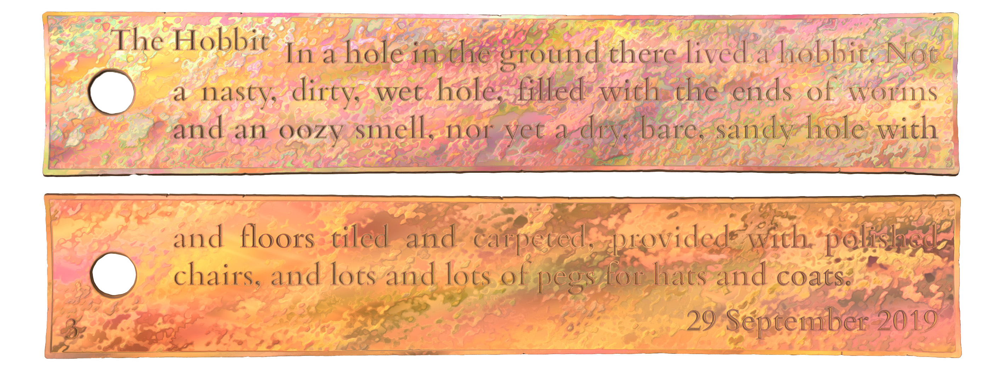
- as a variation on Appendix A.2, we now have a partial set of plates where the middle plate is missing along with the seal
- from the presence of foliation marks (and from our intimate knowledge of the Middle Earth copper plate corpus) we can infer that exactly one plate was lost, therefore we include the lost plate in our edition instead of creating textpart divisions (§6.5.5.3)
  - we can also infer that the lost plate would have been inscribed with exactly three lines on both faces, so this is also encoded in the edition
- extant details are encoded as in Appendix A.2 above

<pb n="1r"/>
<ab>
<pb n="1v"/>
<lb n="1v0"/>The Hobbit
</ab>
<!--In this edition, line numbering is restarted on each page, and page numbers are incorporated in line numbers as per §4.5.2.2. Since the number of lines per page is known, we could also have opted to number lines consecutively, logically continuing line numbers after the lacuna §6.5.5.3.-->
<p part="I"><!--The incomplete paragraph is marked as an initial part.-->
<lb n="1v1"/>In a hole in the ground there lived a hobbit. Not
<lb n="1v2"/>a nasty, dirty, wet hole, filled with the ends of worm
<lb n="1v3"/>and an oozy smell, nor yet a dry, bare, sandy hole with
</p><!--The open block-level container is closed before the lacuna.-->
<pb n="2r"/><!--Although a foliation mark was in all probability present on the lost plate, we do not restore one.-->
<gap reason="lost" quantity="3" unit="line"/>
<!--Individual line beginnings are not reconstructed on a lost page, only recorded as a lacuna of known size. -->
<pb n="2v"/>
<gap reason="lost" quantity="3" unit="line"/>
<p part="F"><!--A new block-level container, marked as a final part, is opened after the lacuna, before the next extant page beginning.-->
<pb n="3r"/>
<fw place="bot-left" n="3r">
<num value="3">3</num>
</fw>
<lb n="3r1"/>and floors tiled and carpeted, provided with polished
<lb n="3r2"/>chairs, and lots and lots of pegs for hats and coats.
</p>
<ab>
<lb n="3r3" style="text-align: right"/>
<num value="29">29</num> September <num value="2019">2019</num>
</ab>
<pb n="3v"/>

Copperplate charter with a lost plate not reconstructed

- as another variation on Appendix A.2, we again have a partial set of plates where the middle plate is missing
- this time, however, the seal is extant and there are no foliation marks, nor are we sufficiently familiar with any other Middle Earth plates, so we cannot confidently reconstruct the structure of the lost section
- our edition must therefore be divided into three textparts: one for the seal, one for the initial plate, and one for the final plate (§6.5.5.3)
- extant details are encoded as in Appendix A.2 above

<div type="textpart" n="A"><head xml:lang="eng">Seal</head>
<ab>
<lb n="1"/>J R R
<lb n="2"/>Tolkien
</ab>
</div>
<div type="textpart" n="B"><head xml:lang="eng">Initial plate</head>
<pb n="1r"/>
<ab>
<pb n="1v"/>
<lb n="01"/>The Hobbit
</ab>
<p part="I"><!--Incomplete paragraph marked as an initial part. -->
<lb n="1"/>In a hole in the ground there lived a hobbit. Not
<lb n="2"/>a nasty, dirty, wet hole, filled with the ends of worm
<lb n="3"/>and an oozy smell, nor yet a dry, bare, sandy hole with
</p>
</div>
<!--Nothing is encoded for the lacuna itself, since the use of textparts makes it clear that text is lost between the two; details go in the layout description and the commentary. -->
<div type="textpart" n="C"><head xml:lang="eng">Final plate</head>
<p part="F"><!--Incomplete paragraph marked as a final part. -->
<pb n="1r"/>
<!--Page and line numbering are reset to 1 in the second textpart §4.2.1.4. -->
<lb n="1"/>and floors tiled and carpeted, provided with polished
<lb n="2"/>chairs, and lots and lots of pegs for hats and coats.
</p>
<ab>
<lb n="3" style="text-align: right"/>
<num value="29">29</num> September <num value="2019">2019</num>
</ab>
<pb n="1v"/>
</div>

Four-faced stele
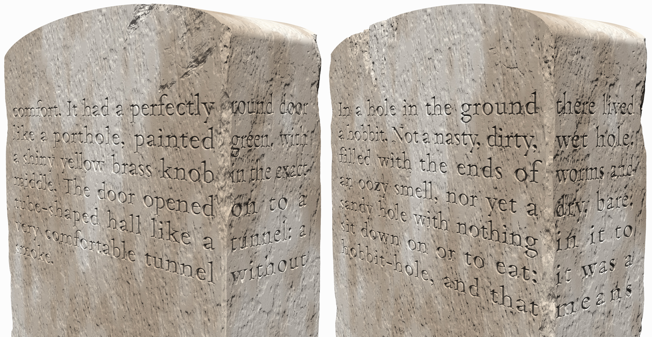
- this imaginary stele is an oblong quadrangle in cross-section
- all four sides are inscribed, with text starting on one of the broad faces
  - each line of the text runs across one edge, onto the adjacent narrow face
  - subsequent lines fill up the inscribed field of this pair of faces
  - the text then flows on to the top of the next broad face and proceeds to fill up that face and the adjacent narrow face in the same way as the first pair of faces
- thus, the partition between the two face pairs is pagelike (§4.4), therefore the virtual zones must be marked up using pagelike milestone elements (§4.4.2.1)
- the boundary between a wide face and the adjacent narrow face comprises a gridlike partition, since the text disregards the physical transition to a new surface
  - such a pair of faces thus constitutes a single virtual zone, whose partition into two physical surfaces may be ignored in the markup or may be encoded by means of a gridlike milestone element (§4.6)

<p><!--All milestones come within paragraphs.-->
<milestone type="pagelike" unit="faces" n="Ab"/><!--An optional <label> could have been added at this point and for the second facepair, as per §4.4.3.2. -->
<!-- This encoding example uses the repetitive scheme of line numbering §4.5.2.2, in accordance with SE Asian epigraphic conventions. Alternatively, lines could have been numbered starting from 1 and continuing from 8 on face Cd.-->
<lb n="Ab1"/><milestone unit="face" n="A"/>In a hole in the ground <milestone unit="face" n="b"/>there lived
<lb n="Ab2"/><milestone unit="face" n="A"/>a hobbit. Not a nasty, dirty, <milestone unit="face" n="b"/>wet hole,
<lb n="Ab3"/><milestone unit="face" n="A"/>filled with the ends of <milestone unit="face" n="b"/>worms and
<lb n="Ab4"/><milestone unit="face" n="A"/>an oozy smell, nor yet a <milestone unit="face" n="b"/>dry, bare,
<lb n="Ab5"/><milestone unit="face" n="A"/>sandy hole with nothing <milestone unit="face" n="b"/>in it to
<lb n="Ab6"/><milestone unit="face" n="A"/>sit down on or to eat: <milestone unit="face" n="b"/>it was a
<lb n="Ab7"/><milestone unit="face" n="A"/>hobbit-hole, and that <milestone unit="face" n="b"/>means
<milestone type="pagelike" unit="faces" n="Cd"/>
<lb n="Cd1"/><milestone unit="face" n="C"/>comfort.
</p><!-- The text has been broken up into two semantic paragraphs, §3.2.1.1.-->
<p>It had a perfectly <milestone unit="face" n="d"/>round door
<lb n="Cd2"/><milestone unit="face" n="C"/>like a porthole, painted <milestone unit="face" n="d"/>green, with
<lb n="Cd3"/><milestone unit="face" n="C"/>a shiny yellow brass knob <milestone unit="face" n="d"/>in the exact
<lb n="Cd4"/><milestone unit="face" n="C"/>middle. The door opened <milestone unit="face" n="d"/>on to a
<lb n="Cd5"/><milestone unit="face" n="C"/>tube-shaped hall like a <milestone unit="face" n="d"/>tunnel: a
<lb n="Cd6"/><milestone unit="face" n="C"/>very comfortable tunnel <milestone unit="face" n="d"/>without
<lb n="Cd7"/><milestone unit="face" n="C"/>smoke.
</p>

Stele with two inscribed faces, an incipit and quasi-columns
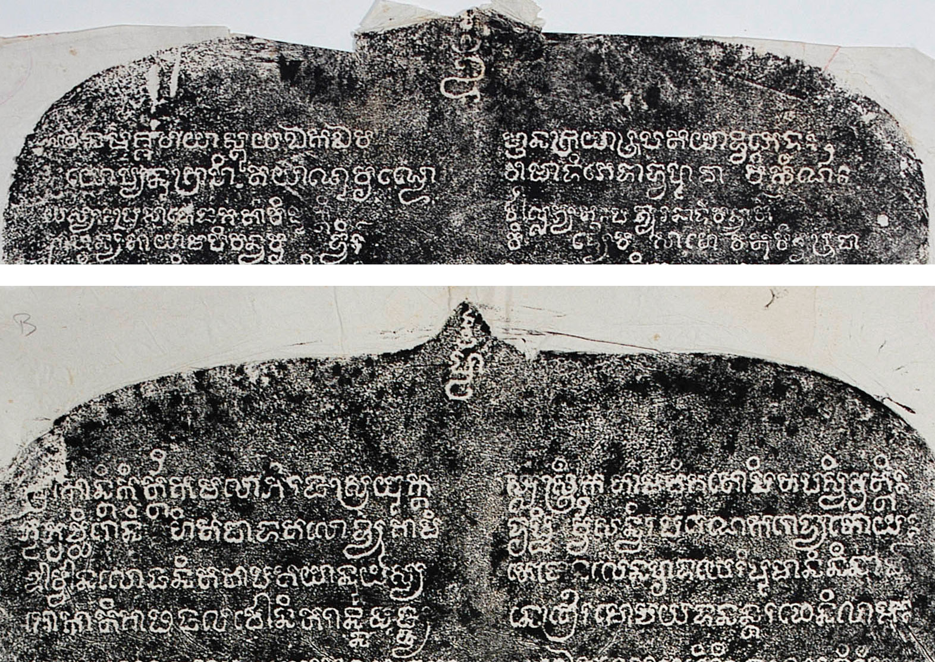
- this is the inscription DHARMA_INSCIK00191, the Phnom Sandak inscription, Preah Vihear province (K. 191, 1032 Śaka), a stele inscribed on two faces
  - the image above shows only the upper portion of each face
  - each face begins with an invocatory syllable offset from the main body of text
  - the text is in verse, laid out in quasi-columns where each line must be read all the way from left to right across both columns
  - after reading all of face A, the reader is expected to continue on face B
  - a fly in the soup is the invocatory syllable at the top of face B, which does not truly belong in the sequence of text between the two faces
- encoding the physical and logical arrangement with complete accuracy would be very complex without any tangible gain, so it has been decided that
  - the two faces will be encoded as a pagelike partition (§4.4), as for similar stelae without an incipit on the second face
  - the incipits will be handled as usual, i.e. as visually offset opening lines (§4.7.1.1), without regard for the fact that the second incipit is not part of the logical flow
  - the lines will, as a matter of course, be encoded as a gridlike partition (§4.6), as recommended for text laid out in this fashion (§4.7.5.3)

<div type="edition" xml:lang="san-Latn">
<ab>
<milestone type="pagelike" unit="face" n="A"/><label xml:lang="eng">Face A</label>
<lb n="A0" style="text-align: center"/>Oṁ
</ab>
<lg n="1" met="upajāti">
<l n="a"><lb n="A1"/><milestone unit="column" n="a"/><g ref="sym:flourish-taperOut">*</g> namaś śivāyāstu ya Eka Eva</l>
<l n="b"><milestone unit="column" n="b"/>jñānakriyārūpatayā dvibhedaḥ</l>
<l n="c"><lb n="A2"/><milestone unit="column" n="a"/>bhūyo py anugrāhitayāṇuvr̥ṇde</l>
<l n="d"><milestone unit="column" n="b"/>vāmādibhedād vahudhā <space type="descender"/> vikīrṇaḥ</l>
</lg>
<lg n="2" met="upajāti">
<l n="a"><lb n="A3"/><milestone unit="column" n="a"/>yasyāḥ prasāde jagatāṁ vimuktir</l>
<l n="b"><milestone unit="column" n="b"/>vāllabhyataḥ patyur anādivandhāt·</l>
<l n="c"><lb n="A4"/><milestone unit="column" n="a"/>bhāvānyatāyām api vandhavr̥<space type="descender"/>ddhir·</l>
<l n="d"><milestone unit="column" n="b"/>vi<space type="descender"/>dyaiva <space type="descender"/> sā vo <space type="descender"/> vatu viśvarūpā</l>
</lg>
...
<ab>
<milestone type="pagelike" unit="face" n="B"/><label xml:lang="eng">Face B</label>
<lb n="B0" style="text-align: center"/>hūṁ
</ab>
<lg n="25" met="vasantatilakā">
<l n="a"><lb n="B1"/><milestone unit="column" n="a"/>hr<supplied reason="lost">ī</supplied>kāntikīrttikamalābhir ajasrayuktas</l>
<l n="b"><milestone unit="column" n="b"/>sastrīkatām adhigato pi tapasvivr̥ttiḥ</l>
<l n="c" enjamb="yes"><lb n="B2"/><milestone unit="column" n="a"/>bhūbhr̥cchironi<space type="descender"/>hitapādatalo dyugāmi</l>
<l n="d"><milestone unit="column" n="b"/>dr̥ṣṭi<space type="descender"/>r vvisandhir apareṇa karodyato yaḥ</l>
</lg>
<lg n="26" met="vasantatilakā">
<l n="a"><lb n="B3"/><milestone unit="column" n="a"/>Aurvvānalo janitatāpatayā nu yasya</l>
<l n="b"><milestone unit="column" n="b"/>tejonalena hr̥daye ripumāninīnām·</l>
<l n="c"><lb n="B4"/><milestone unit="column" n="a"/>śokātigāḍhajaladhau nitarān nimajjya</l>
<l n="d"><milestone unit="column" n="b"/>netrair amocayad anantaraphenilāmbhaḥ</l>
</lg>

Titling conventions
When assigning a title to the inscription you are encoding, it is in general recommended that you try to remain faithful to established names for inscriptions that have been edited before. In cases where established names in a corpus follow significantly varying models, so that the need for some harmonisation is felt, the team member(s) responsible for the corpus in question has/have the option to design a new system and apply it rigorously to all members of the corpus in question. New inscriptions should, as a rule, be named on the analogy of established names within the same corpus. In all cases, variant names applied to the inscription in question in previous publications shall be recorded as per §15.1.1.1.
When creating new titles, it is recommended (but not mandatory) that you compose your title by combining the following elements, in this order.
- place: start your title with a place name, using (if possible) one of the following options
  - internal: attempt to identify the name of the place(s) that is (or are) most fundamentally concerned by the transaction recorded in the inscription
      - resort to a less important but more distinctive internal toponym if the toponym resulting from the above test is insufficiently distinctive
      - if you are dealing with Indonesian inscriptions, represent the internal toponym free of diacritics, in EYD spelling (e.g., Sobhamerta for śobhāmr̥ta), and for further guidance, see Damais 1952: 6-9
  - based on provenance: use the name of the findspot, e.g. “Nalanda”
      - provenance-based places may, if necessary, be complemented with the specification of a topographic feature or a monument, e.g. “rock”, “cliff”, “victory pillar”, “Cave 16”, “Vedānteśvara temple pillars”, etc.
  - based on custody: a reference to the place or institution where the support is currently kept, e.g. “BBRAS”
      - place names based on custody should only be employed if neither a provenance-based, nor an internal place name is available
- artifact type or document type: add a word or two describing the nature of the support or the text, using the cover term “inscription” only if no more satisfactory term can be found.
    - use document type (e.g., “grant”, “dedication” or “dedicatory inscription”, “foundation”, “label”, “graffito”, “eulogy”) if the place name used in the title is an internal toponym
      - e.g. “Raktamālā grant”
    - use artifact type (e.g., “plate”, “stele”, “slab”, “pillar”, etc.) if the place name used in the title is based on provenance or custody
      - e.g. “Nalanda plates”, “British Museum pillar”
- the principal protagonist of the inscription, if named in the text
    - this is usually the person who issued/commissioned the inscription and/or the work commemorated in it, but may be another named person, such as the reigning ruler if the commissioner is another person who is not named
    - preferably, use “of” before the name of the issuer
    - preferably, use “of the time of” before the name of a reigning ruler who is not the protagonist
- supplementary details: after the above elements, add further information whenever necessary for disambiguation, potentially including:
    - calendrical or regnal year, if mentioned within the text
      - optionally including further dating specifics noted in the text, if necessary for disambiguation, e.g. month and day in the case of several charters of the same provenance, same king, same year, and where a title based on the content does not work
      - optionally using “undetermined year” if a year is mentioned in the text, but is lost or illegible
    - any additional distinction, e.g.
      - “Set 1” and “Set 2” to distinguish two sets of copper plates with the same provenance, issued by the same ruler on the same date
      - “north column” and “south column” to distinguish two copies of an inscription engraved in duplicate
- the above items may be listed with commas or connected to one another by short English phrases as seems most suitable
- some examples of titles composed or elaborated along the above lines:
  - Nalanda plate of Samudragupta (provenance, type and issuing ruler)
  - Raktamālā grant of the time of Budhagupta, year 159 (internal place, type, reigning ruler, date)
  - Vallam, Vedānteśvara temple pillars, foundation by Kantacēṉaṉ of the time of Mahendravarman I (provenance with monument details, type of inscription, issuing person, reigning ruler)
  - Uttiramērūr, Sundaravaradaperumāḷ temple, southern wall of vimāna, donation of the time of Nandivarman II, year 16 (provenance with monument details, additional specification of location, type, reigning ruler, regnal year)
  - Uttiramērūr, Vaikuṇṭhaperumāḷ temple, larger platform, southern base, inscription of the time of Dantivarman, year 8, larger platform, southern base (provenance with monument details, additional specification of location, no clear text type, reigning ruler, regnal year)
  - Gunung Wukir stele of Sañjaya
  - Hampran dedication of Bhānu

Creating DHARMA editions from other editions

Converting CII/EI markup conventions to EpiDoc
The instructions in this Appendix explain how the character-based markup used in most printed epigraphic editions of Indic texts correspond to our encoding scheme. Guidelines for adopting previously published translations are given in §11.5.
- word segmentation
  - spaces (indicating non-compound word separation) remain spaces
  - hyphens
    - used for compound segmentation between words fused in vowel sandhi (e.g. parākkram-āṅka = parākkrama+aṅka) are discarded (parākkramāṅka)
    - used for compound segmentation and not affected by sandhi fusion are optionally retained as per TG §7.3.5
    - inserted at the ends of printed lines (when an epigraphic line is too long to fit in one printed line) are normally discarded
      - if they also serve for compound segmentation, they may be optionally retained as above
    - inserted at the ends of epigraphic lines (when a line end is not the end of a word) are to be converted into markup by adding @break="no" to the following <lb> element
      - if such a hyphen also serves for compound segmentation, optionally retain the hyphen, but move it after the line beginning tag
  - double hyphens (or equals signs) normally become spaces
    - but when used between words fused in vowel saṁdhi (e.g. c=āpi), they are discarded
- round parentheses ()
  - with only text inside, to mark an editorial correction of the text preceding the parenthetical text
    - the corresponding markup in EpiDoc is correction or normalisation by substitution (§7.5.1.2)
    - the scope of the correction is normally the same number of akṣaras as there are within the parentheses (in most cases, exactly one akṣara)
      - but if only part of an akṣara is actually corrected, encode substitution only for the relevant graphemes
  - with a question mark inside, (?) to flag the preceding text (usually one akṣara) as very uncertainly read
    - in our terms, this is unclear with low certainty (§6.3.1.3)
  - with text and a question mark inside, used in some publications as follows:
    - (?abc), with the question mark before the text, to indicate a possible alternative reading (§6.3.2)
    - (abc?), with the question mark after the text, to indicate a tentative emendation (which we do not encode as such; the tentativeness of an emendation encoded as per §7.5 may be indicated in an apparatus note)
- square brackets []
  - 1. wrapping “letters which are much damaged and nearly illegible in the original”
    - this normally corresponds to our “unclear” category (§6.3.1), in some cases with low certainty
  - 2. wrapping “letters … which, being wholly illegible, can be supplied with certainty”
    - i.e. normally “supplied” in our terminology (§6.4)
    - it is usually not possible to distinguish 2 from 1 without studying a facsimile of the inscription; if you cannot do this and you are only transcribing a printed edition to EpiDoc, encode both as unclear
  - 3. containing text followed by a question mark, [abc?] is used by some editors to indicate tentatively or conjecturally read text
    - this usually corresponds to <unclear> with low certainty (§6.3.1.3)
  - 4. containing text followed by an asterisk, [abc*] in principle means editorial restoration of characters omitted by the original scribe, but in the actual practice of some editors it seems to be used for function 2 above
    - for the editorial restitution of omission, see §7.5.3
      - note that earlier editors usually supply punctuation marks and numbers in stanzas, which you should not do (§7.8.3)
    - if possible, look at a facsimile to check whether this editorial markup stands for a scribal omission or for lost and supplied text; if this is not possible, assume that square brackets with an asterisk stand for scribal omission
  - 5. prosodic notation in square brackets indicates a lacuna of known metre, to be marked up as per §6.5.2.3
- plain transliterated text
  - bear in mind that unclear markup in EpiDoc should be used when the interpretation of a character would be ambiguous without its context, i.e. more frequently than in most earlier printed editions
  - the same applies, to a lesser degree, to restorations: if a character (or component) is completely indistinct in a good facsimile or the original support, feel free to mark it up as supplied even if the print edition shows it as merely unclear or clearly read
- dots or other signs indicating lacunae
  - CII normally uses dots for lacunae, roughly indicating their size by the rule of “two dots correspond to one akṣara” (single dots may mean a lost vowel or a lost consonant)
  - other editors may use asterisks or underscores, each corresponding to an akṣara, though this correspondence may be extremely inaccurate in some editions
  - see §6.5 about handling lacunae in EpiDoc

Assimilating Pre-existing Corpora into DHARMA

Crediting the previous digital editor(s)
As per §15.1.2, the responsibility statement in the TEI header need only mention the people who have worked on the current DHARMA edition. Credit to the creator of a pre-existing digital edition shall be given in the form of free text in the epigraphic lemma (§13.2) in the same way as for pre-existing printed editions.
- if you use an unencoded e-text as a starting point for your edition, choose at your discretion whether or not to mention the creator of the e-text, based on the amount and quality of work that had gone into it
- the same part of the epigraphic lemma should also mention whether you, as the creator of the DHARMA edition, have only updated the encoding to the DHARMA standard or also revised the edition

Referring to the ingested digital edition
The preferred manner of referring to digital editions encoded before or outside the DHARMA project and reused for a DHARMA edition is to create a Zotero entry (item type: dataset) for a long-term archival version of the corpus in question (such as one stored on Zenodo), and then to refer to specific editions as “items” (§14.6.1.2) within that corpus. This ensures that the ingested edition can still be accessed at a future time, and be accessed exactly in the form in which it was used as a starting point for a DHARMA edition. Conversely, project websites where digital editions were originally published may become defunct or evolve over time. That said, feel free to deviate from this recommendation after considering the nature and foreseeable future of the digital edition you are ingesting.
- an encoded example of the preferred form of reference: <bibl><ptr target="bib:Balogh2019_03"/><citedRange unit="item">IN00070</citedRange></bibl>
- such a reference shall be included in the primary bibliography of the DHARMA edition with a siglum (§13.3.3) that allows citing its readings in the apparatus if applicable
  - whether or not you cite readings of the earlier digital edition in your apparatus shall be decided on a case by case basis depending on
    - how you judge the extent of intellectual contribution of the earlier editor to the edition
      - if the earlier digital edition is just a “digital facsimile” of a printed edition, then preferably cite the readings from that printed edition instead
    - and on whether or not you collaborate with the earlier editor in creating the DHARMA edition
      - if the earlier editor is one of the creators of the current DHARMA edition, then citing to earlier readings by the same person is usually not essential

Manual revision of the encoding
- what kind of revision is necessary depends on the specific encoding conventions of the ingested document, but in general you will probably need to pay attention to the following details
  - check editorial punctuation (§6.3.6) and change as desired or remove where not applicable (e.g. at the ends of stanzas and hemistichs)
  - check encoded spaces (§4.3) and supply as applicable
  - encode abbreviations (§9.2) as desired and applicable
  - check editorial avagrahas (§6.3.7) and supply as desired
- any <revisionDesc> content present in the ingested document shall be deleted and replaced with a single <change> element for the creation of the DHARMA edition as per §15.3
  - if the revision of the encoding takes place in steps separated by time, add further <change> elements as applicable

References
Apte, Vaman Shivaram. 1957. Revised and enlarged edition of Prin. V. S. Apte’s The practical Sanskrit-English dictionary. Edited by P. K. Gode and C. G. Karve. Poona: Prasad Prakashan.
Arnold, Edward Vernon. 1905. Vedic Metre in Its Historical Development. Cambridge: Cambridge University Press.
Birnbaum, David J. 2015. What is XML and why should humanists care? An even gentler introduction to XML. http://dh.obdurodon.org/what-is-xml.xhtml
Bodard, Gabriel. 2010. ‘EpiDoc: Epigraphic Documents in XML for Publication and Interchange’. In Latin on Stone: Epigraphic Research and Electronic Archives, edited by Francisca Feraudi-Gruénais, 101–18. Lanham: Lexington Books. https://blog.stoa.org/files/2010/09/Chapter05_EpiDoc_Bodard.pdf
Damais, Louis-Charles. 1952. ‘Études d’épigraphie indonésienne, III: liste des principales inscriptions datées de l’Indonésie’. Bulletin de l’École française d’Extrême-Orient 46 (1): 1–105.
Fleet, John Faithfull. 1888. Inscriptions of the Early Gupta Kings and Their Successors. Corpus Inscriptionum Indicarum, III. Calcutta: Superintendent of Government Printing.
Roueché, Charlotte and Julia Flanders. n. d. The Gentle Introduction to Mark-up for Epigraphers, https://epidoc.stoa.org/gl/latest/intro-eps.html
Tanselle, George Thomas. 1989. A Rationale of Textual Criticism. Philadelphia: University of Pennsylvania Press.
TEI Consortium, eds. 2023. TEI P5: Guidelines for Electronic Text Encoding and Interchange. Version 4.6.0, last updated 4 April 2023, accessed November-December 2023. TEI Consortium. http://www.tei-c.org/Guidelines/P5/

https://docs.google.com/document/d/1hjWrrwRZQp4hmEqw4jBhhqoXdwJvRlw3EWboJteOPw0
https://epidoc.stoa.org/gl/latest/
https://tei-c.org/release/doc/tei-p5-doc/en/html/index.html
TEI Consortium (2023, §v).
The use of single quote marks (' apostrophe) is also permitted by the XML standard. However, for the sake of consistency, we shall always use double quote marks.
In Oxygen, press CTRL + SHIFT + , (comma) to turn selected text into a comment or to uncomment text around the cursor.
https://github.com/erc-dharma/project-documentation/blob/master/templates/inscriptions/DHARMA_INSencodingTemplate.xml
Outside the edition, paragraphs may also contain block quotes which in turn may contain stanzas and lines as per §14.3.3.
See the TG, especially TG §7.3.2 on editorial segmentation interacting with akṣaras.
DHARMA_prosodicPatterns_v01.xml in our Project Documentation GitHub repository, displayed at https://dharmalekha.info/prosody
The seeming contradiction between the element’s name and the fact that it indicates uncertainty is that this element would normally take the attribute @cert to indicate a degree of certainty. However, in EpiDoc and thus in our encoding practice, <certainty> is only used for indicating uncertainty, and is by default understood to mean <certainty cert="low">.
The TEI element <caesura> does not take the attribute @break (nor @type). Since our use of conventional metre names leaves open the possibility to automatically determine the location of caesuras at the prescribed points, the only reason why we might want to encode them is to facilitate research on non-standard caesuras and yatibhaṅga, hence our suggestion to use <milestone> instead.
This follows and generalises the EpiDoc convention “Any @rend or numbering attributes on … <lb> refer to all text between the current and the following line-break” (https://epidoc.stoa.org/gl/latest/trans-linebreak.html).
In addition to the kinds of milestone discussed here, our project also employs <milestone/> elements for a few other purposes (§3.3.4.3, §11.3).
It is possible in TEI to encode uncertainty regarding the location of an element in a machine-readable way, but we foresee no gain from doing so that would compensate for the resulting increase of encoding complexity.
In rare cases it is possible for a page or zone beginning not to be followed by a line beginning (e.g. when a medial plate of a set is lost, but the page structure is reconstructed for it, §6.5.5.3).
The single exception applies again to massive medial lacunae (§6.5.4), where reconstructed structural milestones may be placed outside block-level containers.
This will not be the case if you follow the numbering schemes recommended by this Guide, but other numbering schemes are permitted for all partition types when there is good reason for their use.
We must resort to this compromise because the internal logic of EpiDoc does not permit <space> or <lb> elements inside <unclear>, so it is not possible to encode alternative readings which include an interruption, even if the location of that interruption with respect to the text is different in the alternatives.
https://en.wiktionary.org/wiki/gaiji
The management of symbols has changed radically from earlier DHARMA practice, so project members are requested to read this section attentively.
https://en.wiktionary.org/wiki/gaiji
In addition to these values, "numeral" is used for numeral glyphs that cannot be represented in transliteration with a single Arabic digit, as per §5.2.1. The DHARMA schema also allows the value "phonographic", which is not used in our present encoding practice, but is included as a provision for the future when it might become desirable to use encoding to classify alternative shapes (graphetic allographs) of phonographic glyphs.
To view the file rendered for display, visit https://dharmalekha.info/glyphs. To view and, if necessary, edit the raw XML, go to DHARMA_glyphTaxonomy.xml in the project-documentation repository.
https://www.tei-c.org/release/doc/tei-p5-doc/en/html/PH.html#PHSP
In fact, the tradition of Indic epigraphic editions is also quite in line with the EpiDoc approach. Even in the Corpus inscriptionum indicarum, Fleet (1888,194) uses the same editorial markup for “letters which are much damaged and nearly illegible in the original, or which, being wholly illegible, can be supplied with certainty.”
https://epidoc.stoa.org/gl/latest/trans-ambiguous.html
In the interest of preserving your sanity, it is advised that you avoid encoding the full spectrum of possibilities, k<choice><unclear>ā</unclear><unclear>ara</unclear><unclear>ar</unclear><unclear>ra</unclear></choice> unless all are indeed plausible and worth recording.
The same element is used in TEI in other situations where text is absent. In our practice, it is put to use when text omitted by the scribe cannot be restored by the editor (§7.7) and when the editor omits some text from a critical apparatus (§10.3) or a translation (§11.4.3).
The EpiDoc schema permits the use of @extent without @unit.
In Sanskrit quantitative verse, the number of lost syllables may be estimated at 75% of the number of missing morae. Thus, if a 12-mora chunk is missing from a verse line, estimate the length of the lacuna at 9 characters if you have no better indication. This figure is based on a quick statistical look at a small sample; feel free to use a better approximation if you can, and do not worry too much about the accuracy of the character count.
The explanation for the apparent contradiction between the element’s name and the fact that it indicates uncertainty is that this element would normally take the attribute @cert to indicate a degree of certainty. However, in EpiDoc and thus in our encoding practice, <certainty> is only used for indicating low certainty, and is by default understood to mean <certainty cert="low">.
As noted in §5.5, ‘scribe’ means any person involved in the creation of a written document before it became an object of modern study.
For other uses of this element with different values of @reason, see §6.4.1.
https://opentheso.huma-num.fr/opentheso/?idc=84154&idt=th347
https://opentheso.huma-num.fr/opentheso/?idc=84156&idt=th347
The reason why the attribute is named “new” is presumably the fact that it identifies the hand taking over at the shift. TEI guidelines note that this attribute may be renamed in a subsequent major release.
Although the TEI guidelines (https://www.tei-c.org/release/doc/tei-p5-doc/en/html/WD.html#WDWMEG) recommend the use of @style with CSS styling instructions to encode text directionality and orientation, these instructions provide no clear solution for handling case C in the illustration below and handle cases A and B very differently from D. To minimise complexity, we prefer to introduce custom values of @rend for this purpose, since our objective is to document the way the original text was written, and not to create machine-actionable code for reproducing the source’s writing mode on screen or in print.
https://epidoc.stoa.org/gl/latest/trans-numnoncongruent.html
See §8.4 about the use of <hi> in the edition.
https://iso639-3.sil.org/code_tables/639/data
https://en.wikipedia.org/wiki/ISO_15924
See https://wiki.tei-c.org/index.php/XML_Whitespace for a more detailed discussion of white space in XML.
This is not a technical requirement and its violation does not result in your code becoming invalid. However, since in many cases these elements will have to appear within block-level containers, we consider it better practice to always place them so, for consistency’s sake.
Double hyphens are used in CII convention to indicate non-compound word separation where the end of the first and the beginning of the second word belong to the same akṣara of the original. Their primary function is to distinguish regular akṣaras from halanta consonants and initial vowels (e.g. तदाहुः > tad=āhuḥ; तद् आहुः > tad āhuḥ). We achieve this distinction by means of uppercase characters and explicit virāma in the transliteration (e.g. तदाहुः > tad āhuḥ; तद् आहुः > tad· Āhuḥ).

